**Data Migration Guide**

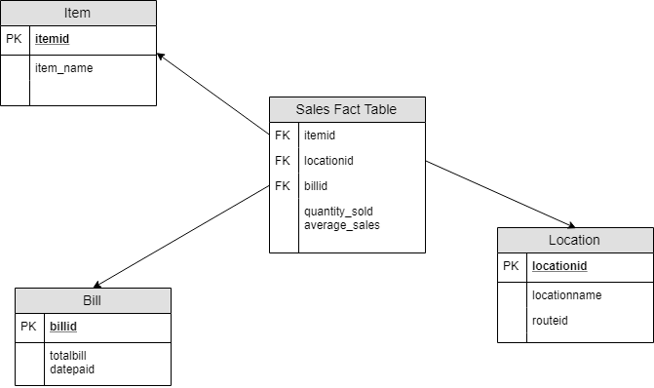

* **Fact Table**

We, as a company, want to visualize the sales data based on items, location, and orders. The facts would be like quantity_sold, average_sales per month, average_sales per location, average_sales per item etc.

* **Extract:**

Extract the data of bill (totalbill, datepaid), location (locationname, routeid), and item (item_name) from the production database and the extracted data is kept in files which is then sent into the staging area for transformation.

* **Transformations:**

In the staging area, we clean and transform the data in the required format. We want average sales for each month so we transform the datepaid attribute of bill table to contain only the month number(1-12) rather than storing the entire date. We also clean up by replacing all the null values to 0 for numeric data.

* **Loading and Migration Process:**

After the transformation in the staging area, the transformed data is loaded into the warehouse. All the analysis of the fact table is performed in the warehouse. The frequency of the migration would be **every six months** since we want the trend information for forecasting future sales information to be prepared for the situations.