**Context**

We are writing to describe the work conducted to improve the waste management system in the State of Optimization. The State of Optimization was looking to enhance its waste management system through tactical and strategic solutions for a growing population. Its three main priorities during this process are to enhance the quality of life, deploy smart city technologies, and promote sustainable development.

In support of these priorities, the Department of Environmental Affairs had already made progress by acquiring new fleets and optimizing collection routes. Our goal was to support the department in exploring opportunities for installing sanitary landfills across the state. We focused specifically on finding an optimized solution for the construction of sanitary landfills and transfer stations, fulfilling the waste needs of various urban and rural communities while balancing tradeoffs between construction and transportation costs.

**Approach**

Potential sanitary landfill and transfer station sites had already determined and were provided along with the locations and varying waste amounts of waste generation sites. Due to the large number of landfills, generation sites and transfer stations, optimal construction decisions were not immediately obvious.

We used the provided data to first generate a model that balanced between two objectives only: the number of sanitary landfills constructed and the total transportation cost in terms of vehicle miles traveled. Construction cost was minimized by minizing the number of landfills chosen and transportation cost was minimized by reducing the distance travelled by garbage trucks from site to landfill. Since these factors represent different kinds of costs – up front construction costs compared to ongoing fuel and maintenance costs – and can be in direct competition with each other, we sought to provide our client with guidance on the tradeoffs associated. Figure 1 illustrates these tradeoffs for the basic model.

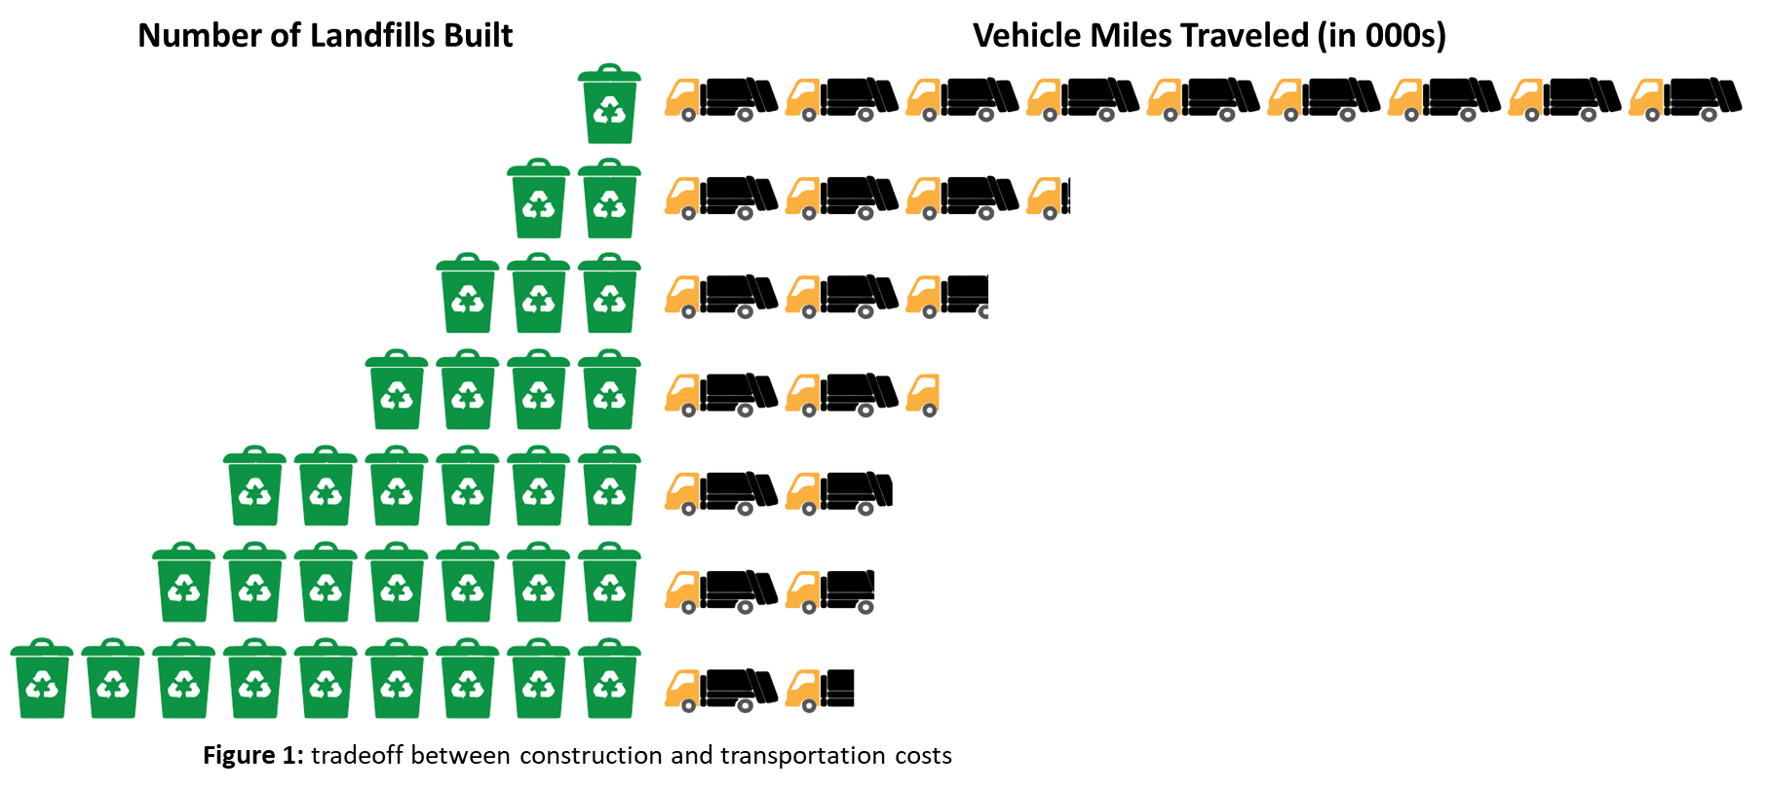

Estimated costs were then obtained based on market research and a projection was created to compare construction costs over different ongoing cost time horizons and an optimal recommendation was made.

Transfer stations were incorporated as an added layer of complexity in a separate model. Transfer stations represent a higher construction cost than landfills but can reduce vehicle miles traveled by increasing the amount of waste that can be carried in each garbage truck. Our goal in this model was to find a “sweet spot” that balanced this third type of cost with the other two. An added benefit of the models was that the constraints captured a secondary outcome by showing which waste generation sites should be assigned to which landfill or transfer station.

**Results**

Figure 2 illustrates the tradeoffs found in the second model. Due to high construction costs and the prevalence of available sanitary landfill sites, transfer stations were found to be prohibitive expenses. We do see the same pattern, however, that an increase in the number of landfills, and now transfer stations - built represents a decrease in vehicle miles traveled and vice versa.

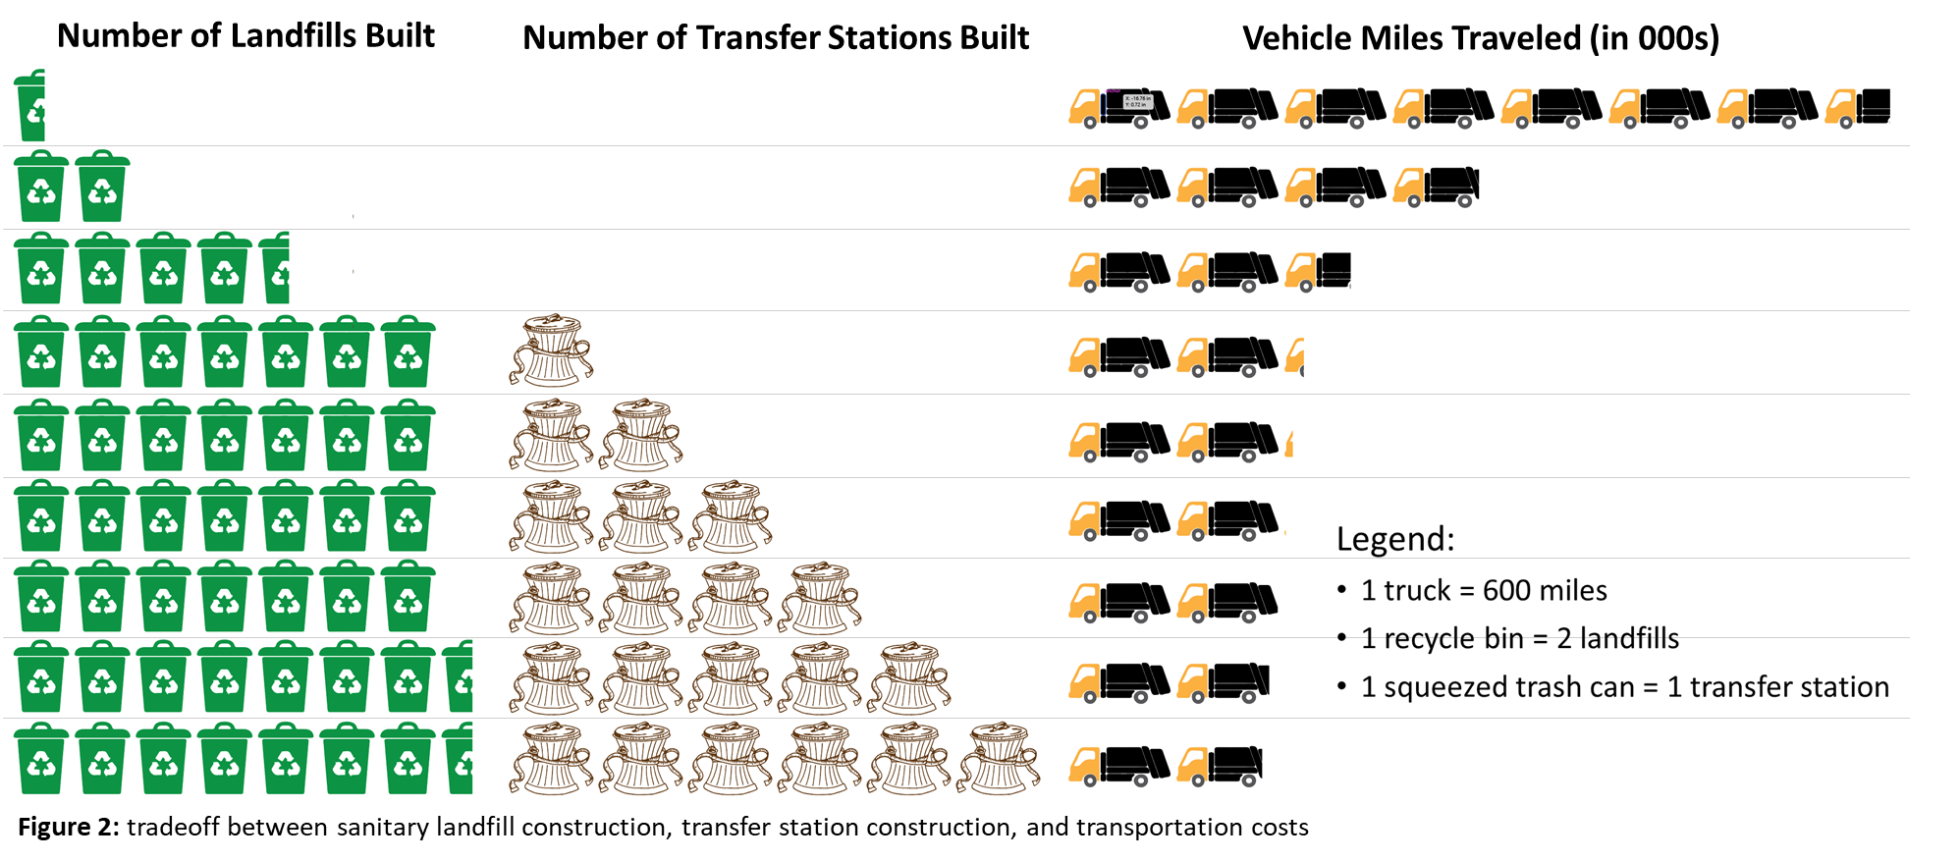

Based on the metric referenced previously, where estimated construction costs and ongoing costs are added together to represent total costs, we projected costs for the State of Optimization over a one-year time horizon and selected the minimum value. This resulted in a recommendation to build two landfills and no transfer stations.

**Future Applications**

Our models can be applied to any other city’s waste management system to optimize landfill locations, assignment of each site to a landfill and minimize total costs. The model would require inputs of existing waste generation sites, approximate amounts of waste per site, available landfill construction sites and available transfer station construction sites.

The models and recommendations could be made more precise by including daily capacities of transfer stations, landfills, and garbage trucks, as well as more accurate estimated construction and travel costs. They can be extended to incorporate new factors, such as social equity, environmental or regulatory considerations. Results can be used to help select optimal waste management sites as well as strategically assign trash generation sites to optimal transfer stations and landfills.

We are optimistic about the applicability of this model to new states with differing constraints, sites and needs, and happy to answer any questions you may have.