**Background and Scope**

The State of Optimization is looking to enhance its waste management system through tactical and strategic solutions. Its three main priorities during this process are to enhance the quality of life, deploy smart city technologies, and promote sustainable development. The state has a population of 10 million and is looking to grow by attracting young professionals and expanding its economic activities.

In support of these priorities and growth efforts, the Department of Environmental Affairs is looking to revamp the state’s waste management system. Progress has already been made by way of acquiring new fleets and optimizing collection routes. The department would now like to explore opportunities for installing sanitary landfills across the state. The efforts in this paper focus on finding an optimized solution for the construction of sanitary landfills, fulfilling the waste needs of various urban and rural communities while balancing tradeoffs between construction and transportation costs.

Specifically, the models created aim to identify the optimum number of sanitary landfills to build, the locations of those landfills and the possible placement of transfer stations for further waste compaction. Recommended solutions have been determined based on the original brief, conversations with the client, and further critical thinking to identify outcomes that may best fulfill client needs.

**Approach and Computational Experience**

Figure 1 shows the complexity of the decision being explored. There are 95 waste generation centers (grey squares), 22 potential landfill sites (orange circles), and 84 potential transfer station locations (blue triangles). The optimum number and location of landfills and transfer stations is not readily apparent.

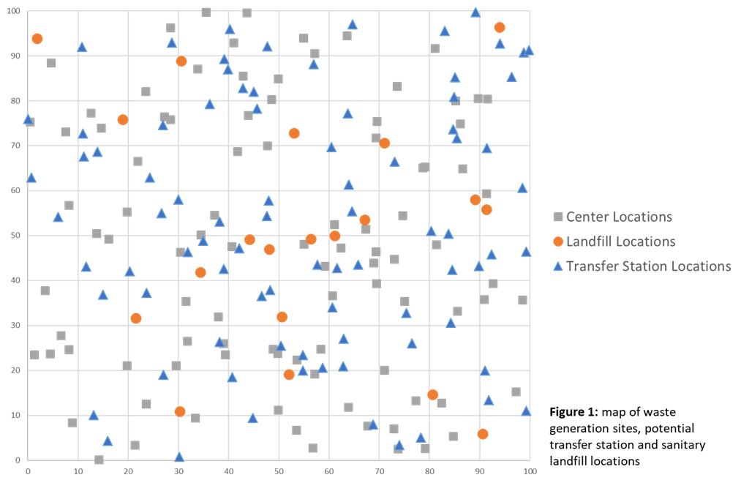

Given this complexity, we began our approach with a basic model, designed to capture the core needs of the state. The basic model evaluates sanitary landfills only (no transfer stations) in a multi-objective weighted sum approach that explores the tradeoff between the number of landfills built and the total distance waste collection vehicles would be required to travel.

This model was fairly simple to develop and then implement computationally. The processing times were not extensive and the results made practical sense. Upon successful execution of this model, we expanded to a new model with added complexity.

We determined that this second model should include transfer stations, since determining the number and location of transfer stations is another decision on which the state wanted assistance. The results of this model show the tradeoffs between the number of transfer stations built, the number of sanitary landfills built and the number of vehicle miles traveled (VMT). This model allows us to see how the higher construction cost but increased capacity stemming from transfer stations fit into the basic evaluation of landfill construction and travel distance.

This model was more difficult to develop and took longer to run computationally. At first, we tried to incorporate waste quantities in terms of different scenarios, but quickly realized that the additional scenario complexities made the model difficult to troubleshoot. Since all decisions occur prior to the scenarios taking place and our model did not include capacity constraints, we opted to take the average of waste scenarios in favor of running through each of them. Later, we’ll recommend incorporating this type of uncertainty into a future extension of the model.

**Basic Model**

We started the process of optimizing sanitary landfill locations by identifying and building a basic model that would capture the core constraints of the state. We determined that it would be best not add complexity at this point, as we verified that our initial assumptions and parameters were correct. Specifically, we set a goal to only optimize sanitary landfill locations and vehicle miles traveled.

Appendix A shows the formulation of the basic model. We used a weight-based approach, where changing the relative cost of landfills compared to vehicle miles traveled changes the optimal solution. The objective was to minimize total landfills built and travel distance.

The core parameters captured are the locations of each waste generation site and landfill, the trash generated at each site and a big number representing unlimited landfill capacity.

We have two binary decision variables and two positive decision variables in the model:

* Whether the landfill will be selected and whether the waste generation site will be assigned to a specific landfill are the two binary variables.
* The total distance between all waste generation sites and their assigned landfills as well as the total number of landfills to build are the two positive variables.

Constraints:

* The trash generated in each waste generation site will be transfer to only one landfill
* The total amount of trash transferred from waste generation sites into one landfill will not exceed the capacity of the landfill (We use 4,000,000 to induce infinite capacity in this model).

It was important to do a multi-objective model because the minimizing construction costs and minimizing vehicle miles traveled are competing priorities. The more landfills built means less distance required from fleet vehicles, but higher construction costs. Importantly, the cost of landfill construction represents large upfront costs, whereas the cost of vehicle miles traveled represents presumably more steady ongoing costs to the state. What the State of Optimization is willing or able to invest at different points in the process will be a critical factor in selecting the most suitable outcome.

This model ultimately gives us a good idea of the basic landfill needs, including quantity and location, and how those would change based on different cost scenarios when compared to VMT. The results appear in figure 2, where VMT is represented by the number of trucks and the number of sanitary landfills constructed is represented by recycling cans. As the number of landfills increases, total travel distance decreases because more landfills means that landfills can be closer to their assigned waste generation sites.

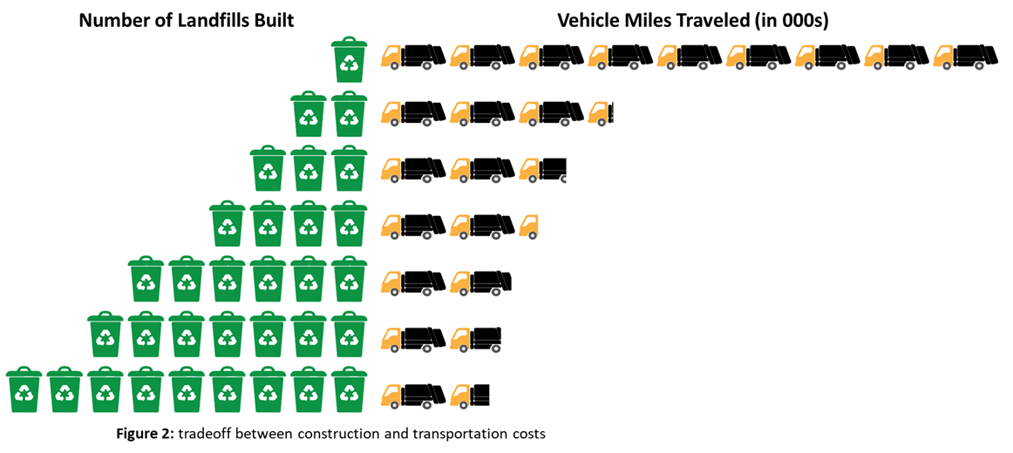

In order to evaluate these results, we created a metric that would combine landfill construction costs and fuel cost for VMT. Based on industry research, we presume the construction cost of each sanitary landfill will be $1,000,000.[1] Since we are working with a newer fleet of vehicles, we anticipate gas mileage will be on the high end, but still presume an all-diesel fleet since electric garbage trucks are still new technology.[2] We used an expected rate of 3 MPG (industry average is 2-3 MPG) and project $3.01 per gallon of diesel fuel in 2019.[3] Although these are estimated and projected numbers, the model is not extremely sensitive to fluctuations between different construction, fuel and efficiency numbers so we feel confident in the solutions it provides. Based on these expected costs and a cost horizon of 1 year (VMT*365), we got the results shown in figure 3.

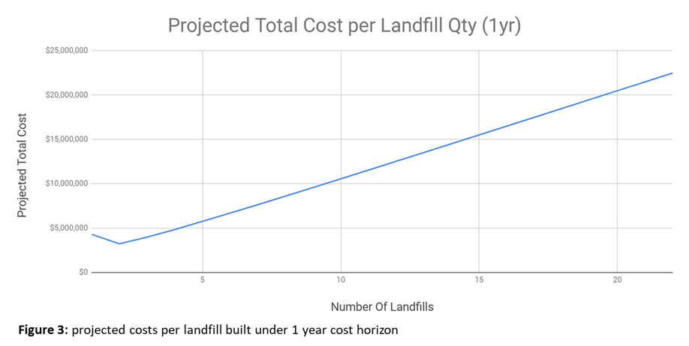

Given the high construction costs and relatively affordable fuel, the relationship between number of landfills and total projected cost is almost linear. These results tell us that the State of Optimization should build two landfills in order to minimize total cost in the first year. Figure 4 illustrates in which sites these landfills should be built and which sites are assigned to each.

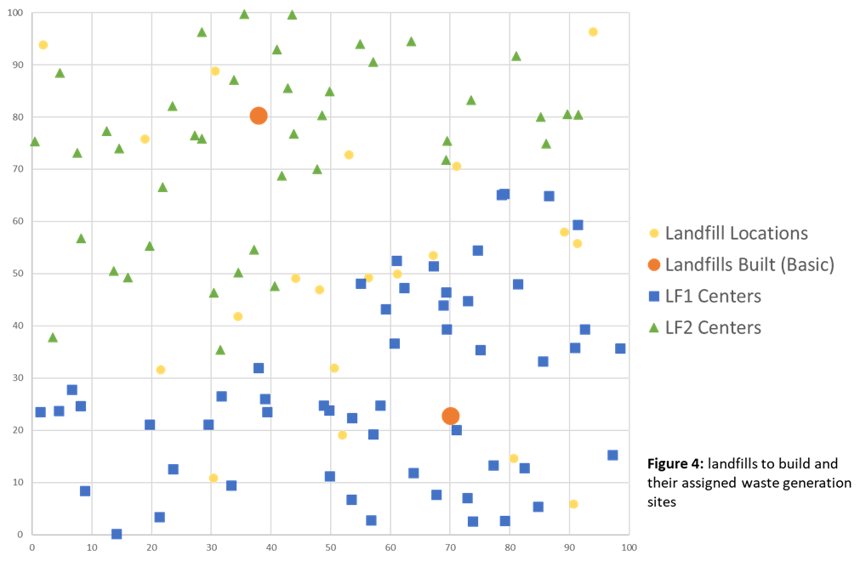

Obviously, there are many additional factors that go into selecting the appropriate number of sites for our client. They could, for example, extend the time horizon over which they wanted to calculate total costs. A 5-year horizon expands the optimum number of landfills to 3, as travel costs grow larger and construction costs remain the same. Similarly, a 10-year horizon says to build 4 landfills and a 15-year horizon (shown in figure 5) says to build 6. We chose the shorter time horizon because there are unknown maintenance and depreciation costs associated with longer time windows and we wanted to capture the most accurate cost estimates possible.

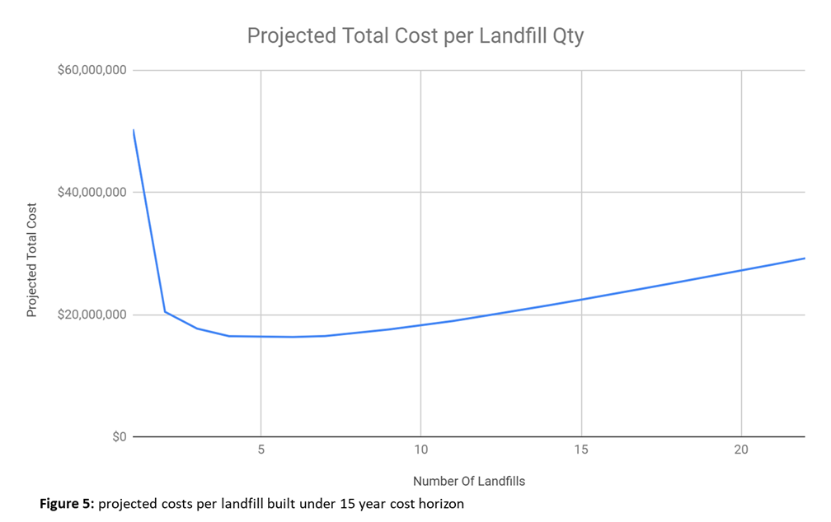

Different scenarios might also yield different results, depending on the client’s preference. For example, if the state anticipates policy enthusiasm to be high now but waver in future years, they might prefer higher up-front costs, knowing that long-term money for vehicle fuel and maintenance may be limited. This would mean they should build more landfills. Conversely, if the client anticipates high upkeep cost for the sanitary landfills compared to VMT costs, they may want to opt for less landfills. Finally, if we anticipate highly fluctuating fuel costs in the future, we may want to gauge our client’s tolerance for risk in order to offer the best possible recommendation.

Some assumptions that we made in the design of this basic model (and its extension) are that landfills and trucks both have unlimited capacity. This allowed us to more easily capture core parameters of the question at hand. However, if we think that capacity will be an issue for either trucks or landfills, then our model will be limited in capturing true VMT. More trips may need to be taken from sites that generate more waste, and trash may need to be allocated differently among constructed landfills if they can only process a certain amount of waste per day. This is certainly a limitation to be aware of as policy decisions are made.

**Model Extension**

The next model we built incorporates transfer stations as a new decision variable. We wanted to evaluate the optimum number and location of transfer stations to build. Transfer stations are more expensive to construct at $4,000,000 compared to the $1,000,000 price tag of sanitary landfills, but compact trash by 50% so that more can be transported.[4] To account for this, we made the weight of transfer stations four times higher than the weight of landfills in our formulation. The full formula is shown in appendix B and summarized as follows:

Objective: Minimize the cost of landfills, transfer stations, and transportation cost

Decision Variables:

* Binary: landfill selection, transfer station selection, assignment from site to transfer station, assignment from site to landfill, assignment from transfer station to landfill
* Positive: the amount of trash from site to transfer station, amount of compacted trash from transfer station to landfill, amount of trash from site to landfill, total distance, total number of landfills to build, total number of transfer stations to build

Constraints:

* the amount of trash generated in generator i transferred to transfer station k must be less than the total amount of trash generated in generator i
* the amount of trash compacted in transfer station k transferred to landfill j must be less than the amount of trash transfer station k receives (We use 5,000,000 to induce infinite capacity in this model))
* the amount of trash generated in generator i transferred directly to landfill j must be less than the total amount of trash generated in generator i
* the amount of trash generated in generator i transferred directly to landfill j and the amount of trash compacted in transfer station k transferred to landfill j must be less than the capacity of landfill j (We use 4,000,000 to induce infinite capacity in this model)
* the amount of trash generated in generator i transferred to transfer station k must be less than the capacity of transfer station k (We use 4,000,000 to induce infinite capacity in this model)
* total distance = distance from generator i to assigned transfer station k + distance from generator i to assigned landfill j + distance from transfer station k to assigned landfill j
* the trash leaves from generator i must go to either transfer station k or landfill j
* according to our client, the compaction rate is 50%, so half of the trash coming from generator i will be transferred to landfill j after it's compacted in transfer station k

The results of this model were interesting in that they didn’t change much from the original basic model. The high cost of transfer stations was prohibitive compared to relatively low VMT. Figure 6 shows the tradeoff between all three decision elements.

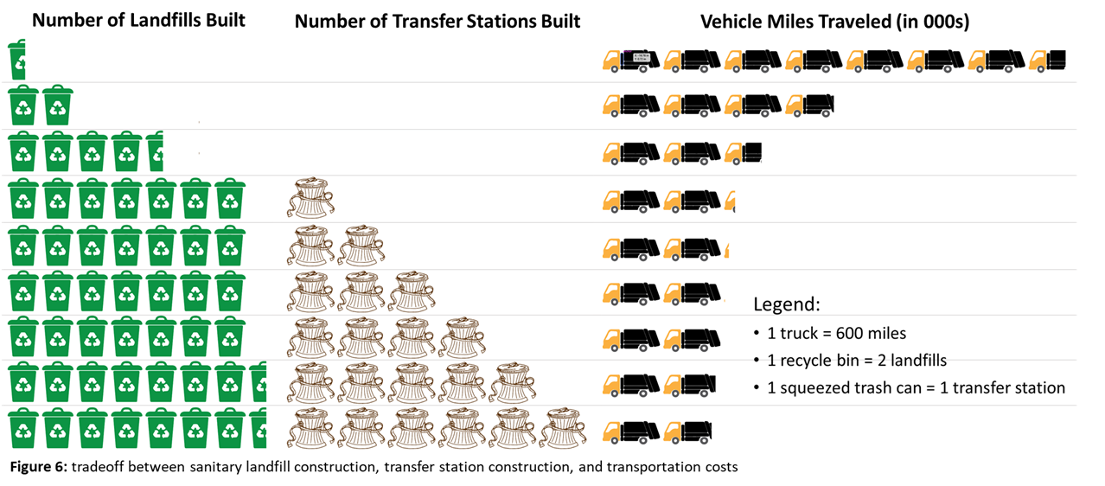

Figure 7 shows how the projected cost curve changes with the addition of transfer stations. From one to 14 landfills constructed, the relationship between total cost and number of landfills constructed remains basically linear. At 14 landfills, the first transfer station is built to reduce VMT. This point is represented by a spike in the graph, where transfer stations one through four are built while sanitary landfills remains constant at 14. As VMT is pushed to further reduce, transfer stations and landfills are built intermittently and reflected in construction cost spikes.

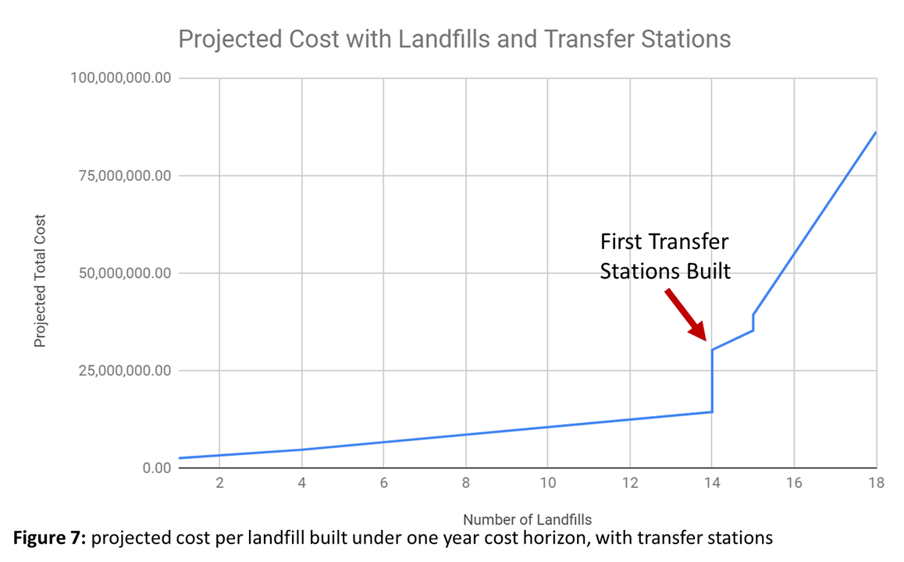

Given the results of this model, we recommend that the state foregoes transfer stations due to prohibitive upfront costs. The initial results are the same as those in the basic model, so we make to same recommendation to build two landfills based on the calculated cost metric. At no point between one and 35 years does the metric advocate for a solution with transfer stations as the minimum cost option.

For reference, figure 8 shows what an optimal solution with transfer stations would have looked like, had they been built. These transfer stations are concentrated in one area rather than centrally located.

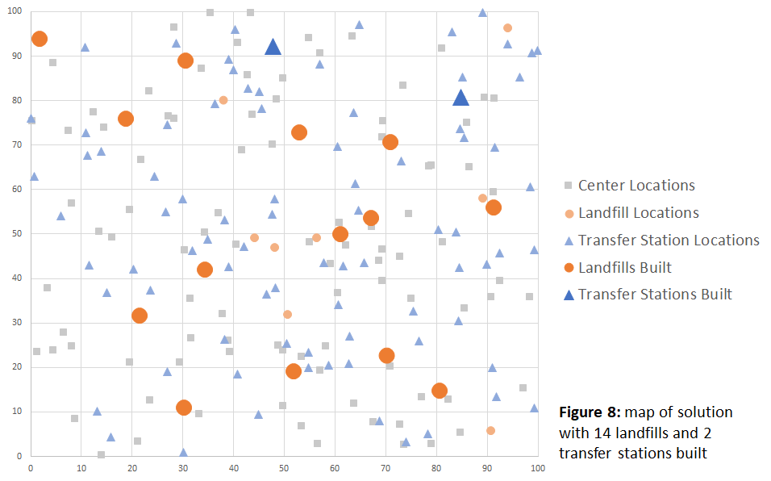

If transfer stations had been cheaper to build, the model may have yielded different results. However, the construction costs would need to be significantly lower in order for transfer stations to make their way into a realistic optimal solution.

In this model, we made the same assumptions as before. Additionally, we assumed that transfer stations had unlimited capacity and that they would reduce waste volume by 50%. We do not anticipate that changes to these assumptions would affect our model because reduced capacity would make transfer station construction more prohibitive than it already is and increased compaction would likely not be significant enough to outweigh either of these factors with respect to the relatively low cost of VMT.

**Conclusion and Next Steps**

Given the models explored here, we recommend the two-landfill solution illustrated under the basic model, with the caveat that differing client priorities may shift the optimal solution. We would ultimately want to explore our clients values and preferences further. Having these results, assumptions and flexible cost equations gives us the tools to explore variability in decision-maker priorities.

We believe that there are also still areas for further analysis and expansion of these models. One might include restricting the truck capacity so that VMT varies depending on the amount of waste being transported and the amount of trucks needed to transfer it all. Adding the distance for each truck from waste generation site to destination together may give us a more accurate distance metric and affect the optimal number of landfills built.

Another potential variation would be to account for future population. Since the state is looking to grow, it may be beneficial to analyze who its new residents might be, where they might move, and how much additional waste they might contribute from their given site. This could be done in a scenario-based approach to account for even more complexity if drivers might be directed to a different landfill on a given day depending on its load.

Finally, the state may want to consider elements of environmental justice and social equity as different landfill options are explored. Building landfills, even cleaner sanitary landfills, near areas already experiencing social inequality may exacerbate their circumstances by potentially increasing health risks and decreasing property values. Prior to construction, the state should evaluate the equity and optics of final landfill placement and allow the model to reoptimize under a restricted selection of sites as needed.

**Appendix A: Basic Model Formulation**

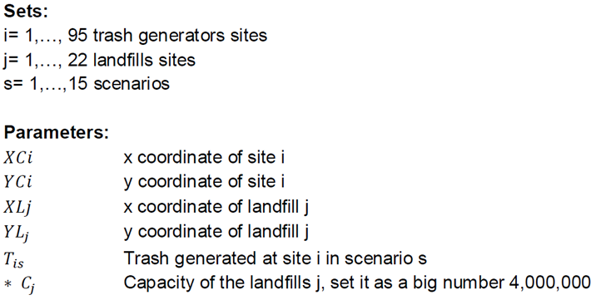

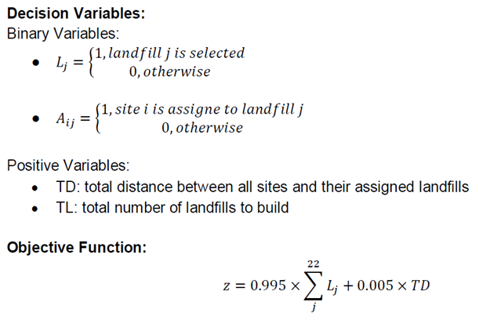

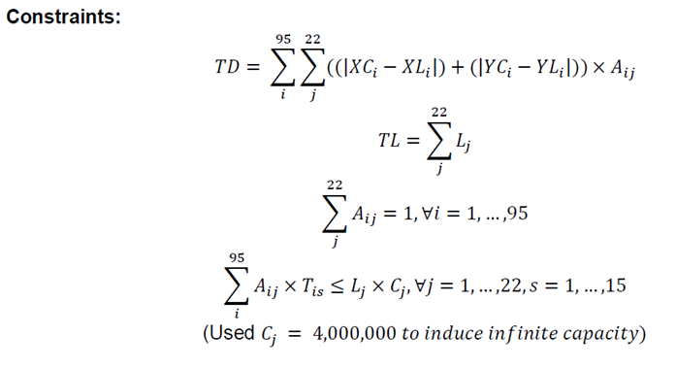

**Appendix B: Model with Transfer Stations Formulation**

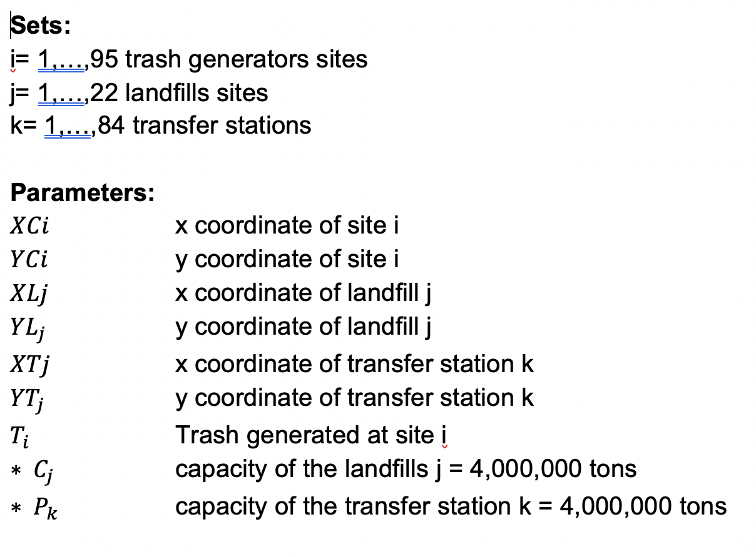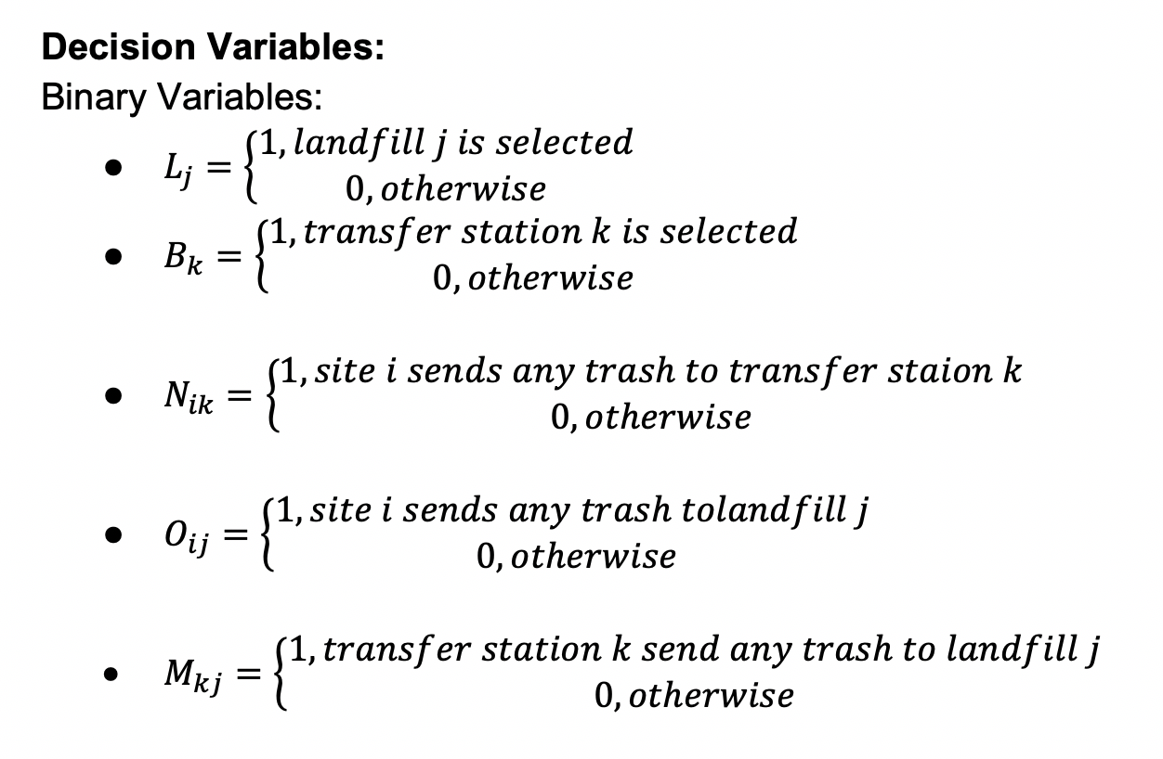

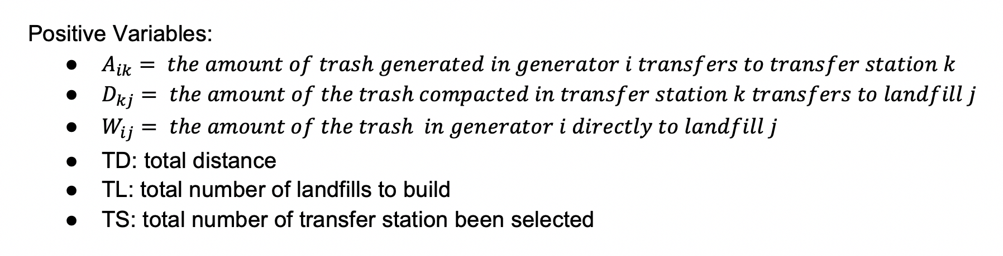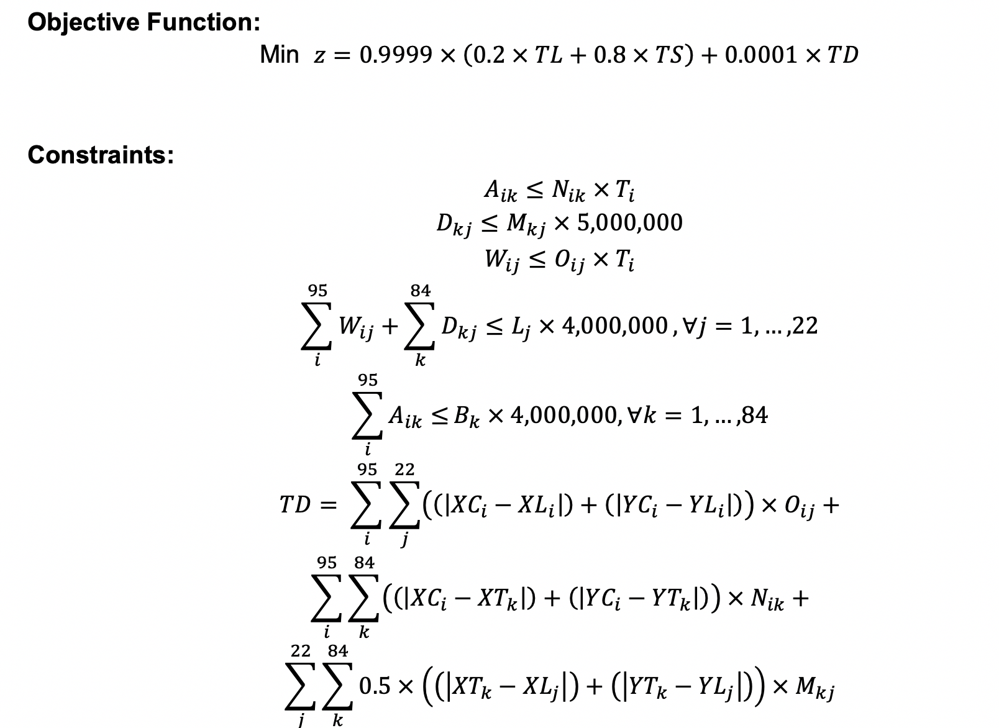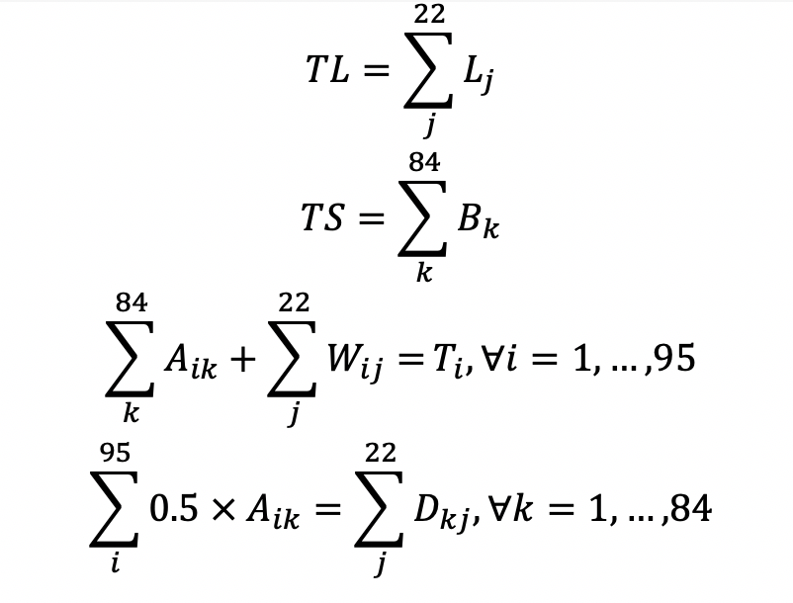

1. <https://earth911.com/eco-tech/the-lowdown-on-landfills/>
2. <http://www.motivps.com/motivps/pressreleases/californias-first-all-electric-garbage-truck-headed-to-sacramento-equipped-with-motiv-all-electric-powertrain/>
3. <https://qz.com/749622/the-economics-of-electric-garbage-trucks-are-awesome/> ; <https://www.truckinginfo.com/301063/energy-department-raises-diesel-gasoline-price-forecasts>
4. <https://www.bcgov.net/archives/county-government/public-works/solid-waste-and-recycling/2014-costprojects-wastedisposal.pdf>