南华大学
计算机科学与技术学院
实 验 报 告

（ 2022 ~2023 学年度 第 1学期 ）

课程名称 | C++程序设计
实验名称 | 学生成绩管理系统

姓名 | 曾庆杰 | 学号 | 20220440333

专业 | 计算机类 | 班级 | 本22计类03班

地点 | 略 | 教师 | 罗江琴

1.实验题目及要求
实现简单的学生的成绩管理系统。
老师端能实现简单的学生数据查看，增删查找，学生端能够查看数据。使用C++的文件管理。
2.实验设计

程序流程图 ，类的定义和实现，
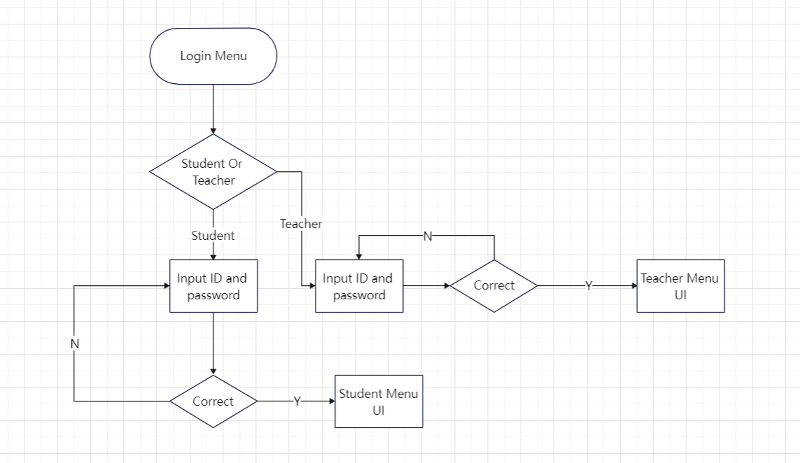

3. 实验内容 Github仓库
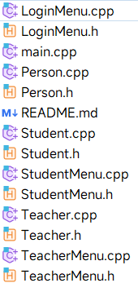
程序的文件结构，主函数及其他相关函数的实现 结构：

// main.cpp
#include <iostream>
#include "LoginMenu.h"
#include "TeacherMenu.h"
#include "StudentMenu.h"
int main() {
while (true) {
Ajunie::LoginMenu login;
system("cls");
auto option {login.run()};
switch (option) {
case Ajunie::LoginMenu::menu_id::Exit :
return 0;
case Ajunie::LoginMenu::menu_id::LoginFailed :
continue;
case Ajunie::LoginMenu::menu_id::TLoginSuccessfully : {
Ajunie::TeacherMenu TMenu(Ajunie::LoginMenu::num);
system("cls");
TMenu.run();
continue;
}
case Ajunie::LoginMenu::menu_id::SLoginSuccessfully : {
Ajunie::StudentMenu SMenu(Ajunie::LoginMenu::num);
system("cls");
SMenu.run();
continue;
}
default:
std::cerr << "Invalid Option!" << std::endl;
system("pause");
std::cout << std::endl;
return 0;
}
}
}

//LoginMenu.h
#ifndef SCHOOLSYSTEM_LOGINMENU_H
#define SCHOOLSYSTEM_LOGINMENU_H
#include <string>
#include <fstream>
#include <iostream>
#include <format>
#include <filesystem>
#include <cctype>
#include <limits>
namespace Ajunie {
class LoginMenu {
public:
size_t run();
static inline std::string num {};
static size_t menu();
bool login_teacher();
bool login_student();
enum menu_id{
Exit,
Teacher,
Student,
TLoginSuccessfully,
SLoginSuccessfully,
LoginFailed
};
private:
std::string m_account_id_;
std::string m_account_password_;
std::ifstream m_teachers_account_;
std::ifstream m_students_account_;
const std::filesystem::path m_teachers_account_path_ {R"(.\assets\teachers_account.ajunie)"};
const std::filesystem::path m_students_account_path_ {R"(.\assets\students_account.ajunie)"};
};
}
#endif //SCHOOLSYSTEM_LOGINMENU_H

//LoginMenu.cpp
#include "LoginMenu.h"
size_t Ajunie::LoginMenu::run() {
while (true) {
size_t option {menu()};
switch (option) {
case Exit :
return Exit;
case Teacher :
if (login_teacher()) {
return TLoginSuccessfully;
} else {
return LoginFailed;
}
case Student :
if (login_student()) {
return SLoginSuccessfully;
} else {
return LoginFailed;
}
default:
std::cerr << "Invalid Option!" << std::endl;
system("pause");
std::cout << std::endl;
break;
}
system("pause"); std::cout << std::endl;
}
}
size_t Ajunie::LoginMenu::menu() {
size_t option {};
std::cout << std::endl;
std::cout << std::format("{:#^30}\n", "Login Menu");
std::cout << std::format("{:*<30}\n", "0. Exit");
std::cout << std::format("{:*<30}\n", "1. Login As a Teacher");
std::cout << std::format("{:*<30}\n", "2. Login As a Student");
std::cout << std::format("{:#<30}\n", '#');
std::cout << "Choose An Option: ";
std::cin >> option;
std::cin.clear();
std::cin.ignore();
return option;
}
bool Ajunie::LoginMenu::login_teacher() {
while (true) {
m_teachers_account_.open(m_teachers_account_path_, std::ios::in);
if (!m_teachers_account_.is_open()) {
std::cout << "Failed to open the " << m_teachers_account_path_ << std::endl;
system("pause");
std::cout << std::endl;
exit(-1);
}
std::cout << std::endl;
std::cout << std::format("{:*^30}\n: ", "Input Account");
std::getline(std::cin, m_account_id_);
std::cout << std::format("{:*^30}\n: ", "Input Password");
std::getline(std::cin, m_account_password_);
std::string temp;
while (std::getline(m_teachers_account_, temp)/*!m_teachers_account_.eof()*/) {
// std::getline(m_teachers_account_, temp);
if (temp.starts_with("[id]") && temp.substr(4, temp.length() - 4) == m_account_id_) {
std::getline(m_teachers_account_, temp);
if (temp.starts_with("[password]") && temp.substr(10, temp.length() - 10) == m_account_password_) {
std::cout << "Login Successfully!" << std::endl;
std::getline(m_teachers_account_, temp);
num = temp.substr(5, temp.length() - 5);
system("pause");
return true;
} else {
break;
}
}
}
std::cerr << "ID or Password Wrong!" << std::endl;
system("pause");
std::cout << std::endl;
char temp_1 {};
std::cout << "Try again?(Y/N)\n: ";
std::cin >> temp_1;
if (std::toupper(temp_1) == 'Y') {
std::cin.clear();
std::cin.ignore();
continue;
}
std::cin.clear();
std::cin.ignore();
m_teachers_account_.close();
return false;
}
}
bool Ajunie::LoginMenu::login_student() {
while (true) {
m_students_account_.open(m_students_account_path_, std::ios::in);
if (!m_students_account_.is_open()) {
std::cout << "Failed to open the " << m_students_account_path_ << std::endl;
system("pause");
std::cout << std::endl;
exit(-1);
}
std::cout << std::endl;
std::cout << std::format("{:*^30}\n: ", "Input Account");
std::getline(std::cin, m_account_id_);
std::cout << std::format("{:*^30}\n: ", "Input Password");
std::getline(std::cin, m_account_password_);
std::string temp;
while (std::getline(m_students_account_, temp)/*!m_students_account_.eof()*/) {
// std::getline(m_students_account_, temp);
size_t start {};
auto end {temp.find_first_of(' ')};
num = {temp.substr(start, end)};
start = temp.find_first_not_of(' ', end + 1);
end = temp.find_first_of(' ',start + 1);
auto id {temp.substr(start, end - start)};
start = temp.find_first_not_of(' ', end + 1);
end = temp.length();
auto password {temp.substr(start, end - start)};
if (id == m_account_id_ && password == m_account_password_) {
std::cout << "Login Successfully!" << std::endl;
system("pause");
return true;
}
}
std::cerr << "ID or Password Wrong!" << std::endl;
system("pause");
std::cout << std::endl;
char temp_1 {};
std::cout << "Try again?(Y/N)\n: ";
std::cin >> temp_1;
if (std::toupper(temp_1) == 'Y') {
std::cin.clear();
std::cin.ignore();
continue;
}
std::cin.clear();
std::cin.ignore();
m_students_account_.close();
return false;
}
}

//TeacherMenu.h
#ifndef SCHOOLSYSTEM_TEACHERMENU_H
#define SCHOOLSYSTEM_TEACHERMENU_H
#include <iostream>
#include <format>
#include <vector>
#include <fstream>
#include <filesystem>
#include "Teacher.h"
#include "Student.h"
namespace Ajunie {
class TeacherMenu {
public:
explicit TeacherMenu(std::string_view num) : m_num{num} {}
void run();
size_t menu();
void readData();
void writeData();
void viewStudents();
void viewStudentsFailed() const;
void sortStudents();
void addStudent();
void deleteStudent();
void modifyStudent();
void findStudent();
enum menu_id {
Exit,
ViewStudents,
ViewStudentsFailed,
SortStudentsGradesByTotal,
AddStudent,
DeleteStudent,
ModifyStudent,
FindStudent
};
~TeacherMenu() {writeData();}
private:
std::vector<Teacher> m_teachers_;
std::vector<Student> m_Classes_;
Teacher m_teacher_;
std::ifstream m_teachers_info_in_;
std::ofstream m_teachers_info_out_;
std::ifstream m_teachers_account_in_;
std::ofstream m_teachers_account_out_;
std::ifstream m_students_info_in_;
std::ofstream m_students_info_out_;
std::ifstream m_students_account_in_;
std::ofstream m_students_account_out_;
const std::filesystem::path m_path_teachers_info_ {R"(.\assets\teachers_info.ajunie)"};
const std::filesystem::path m_path_teachers_account_ {R"(.\assets\teachers_account.ajunie)"};
const std::filesystem::path m_path_students_info_ {R"(.\assets\students_info.ajunie)"};
const std::filesystem::path m_path_students_account_ {R"(.\assets\students_account.ajunie)"};
std::string m_num;
};
}
#endif //SCHOOLSYSTEM_TEACHERMENU_H

//TeacherMenu.cpp
#include "TeacherMenu.h"
void Ajunie::TeacherMenu::run() {
while (true) {
readData();
for (const auto& i : m_teachers_) {
if (m_num == i.getTeacherID()) {
m_teacher_ = i;
break;
}
}
auto option{menu()};
switch (option) {
case Exit :
return;
case ViewStudents :
viewStudents();
continue;
case ViewStudentsFailed :
viewStudentsFailed();
continue;
case SortStudentsGradesByTotal :
sortStudents();
continue;
case AddStudent :
addStudent();
continue;
case DeleteStudent :
deleteStudent();
continue;
case ModifyStudent :
modifyStudent();
continue;
case FindStudent :
findStudent();
continue;
default :
std::cerr << "Invalid Option!" << std::endl;
system("pause");
std::cout << std::endl;
break;
}
}
}
size_t Ajunie::TeacherMenu::menu() {
system("cls");
size_t option {};
m_teacher_.show_info();
std::cout << std::format("{:#^30}\n", "Teacher Manage Menu");
std::cout << std::format("{:*<30}\n", "0. Exit");
std::cout << std::format("{:*<30}\n", "1. View Students' Basic Info");
std::cout << std::format("{:*<30}\n", "2. View Students Failed");
std::cout << std::format("{:*<30}\n", "3. Sort Students Grades");
std::cout << std::format("{:*<30}\n", "4. Add Student");
std::cout << std::format("{:*<30}\n", "5. Delete Student");
std::cout << std::format("{:*<30}\n", "6. Modify Student");
std::cout << std::format("{:*<30}\n", "7. Find a Student");
std::cout << std::format("{:#<30}\n", '#');
std::cout << "Choose An Option: ";
std::cin >> option;
std::cin.clear();
std::cin.ignore();
return option;
}
void Ajunie::TeacherMenu::readData() {
m_teachers_info_in_.open(m_path_teachers_info_, std::ios::in);
m_students_info_in_.open(m_path_students_info_, std::ios::in);
if (!m_teachers_info_in_.is_open()) {
std::cerr << "Failed to open" << m_path_teachers_info_ << std::endl;
system("pause");
std::cout << std::endl;
exit(-1);
}
if (!m_students_info_in_.is_open()) {
std::cerr << "Failed to open" << m_path_students_info_ << std::endl;
system("pause");
std::cout << std::endl;
exit(-1);
}
std::string temp;
while (std::getline(m_teachers_info_in_, temp)/*!m_teachers_info_in_.eof()*/) {
Teacher sense;
// std::getline(m_teachers_info_in_, temp);
size_t start {0};
auto end {temp.find_first_of(' ')};
auto id {temp.substr(start, end - start)};
start = temp.find_first_not_of(' ', end + 1);
end = temp.find_first_of(' ', start + 1);
auto name {temp.substr(start, end - start)};
start = temp.find_first_not_of(' ', end + 1);
end = temp.length();
auto Class {temp.substr(start, end - start)};
sense.readData(name, id, Class);
m_teachers_.push_back(sense);
}
while(std::getline(m_students_info_in_, temp)/*!m_students_info_in_.eof()*/) {
// std::string temp;
Student Gakuse;
// std::getline(m_students_info_in_, temp);
size_t start {0};
auto end {temp.find_first_of(' ')};
auto id {temp.substr(start, end)};
start = temp.find_first_not_of(' ', end + 1);
end = temp.find_first_of(' ',start + 1);
auto name {temp.substr(start, end - start)};
start = temp.find_first_not_of(' ', end + 1);
end = temp.find_first_of(' ',start + 1);
auto Class {temp.substr(start, end - start)};
start = temp.find_first_not_of(' ', end + 1);
std::vector<float> grades {};
while (start != std::string::npos) {
end = temp.find_first_of(' ', start + 1);
if (end == std::string::npos) {
end = temp.length();
}
grades.push_back(std::stof(temp.substr(start, end - start)));
start = temp.find_first_not_of(' ', end + 1);
}
Gakuse.readData(name, id, Class, grades);
m_Classes_.push_back(Gakuse);
}
m_students_info_in_.close();
m_teachers_info_in_.close();
}
void Ajunie::TeacherMenu::writeData() {
m_students_info_out_.open(m_path_students_info_, std::ios::trunc | std::ios::out);
if (!m_students_info_out_.is_open()) {
std::cerr << "Failed to open" << m_path_students_info_ << std::endl;
system("pause");
std::cout << std::endl;
exit(-1);
}
for (auto& val : m_Classes_) {
auto info = val.getFormatInfo();
m_students_info_out_.write(info.c_str(), info.length());
}
m_students_info_out_.close();
}
void Ajunie::TeacherMenu::viewStudents() {
system("cls");
std::cout << std::format("{:-^12}|{:-^15}|{:-^9}|{:-^9}|{:-^9}|{:-^9}|{:-^9}|{:-^9}|{:-^9}|{:-^9}|{:-^9}|{:-^9}|{:-^9}\n", "ID", "Name", "Class", "Chinese", "Math", "English", "Physics", "Chemistry", "Biology", "Politics", "History", "Geography", "Total");
for (auto& val : m_Classes_) {
if (val.getStudentClass() == m_teacher_.getClass()) {
auto grades {val.getGrades()};
std::cout << std::format("{:^12}|{:^15}|{:^9}|{:^9.2f}|{:^9.2f}|{:^9.2f}|{:^9.2f}|{:^9.2f}|{:^9.2f}|{:^9.2f}|{:^9.2f}|{:^9.2f}|{:^9.2f}\n", val.getStudentID(), val.getName(), val.getStudentClass(), grades[0].second, grades[1].second, grades[2].second, grades[3].second, grades[4].second, grades[5].second, grades[6].second, grades[7].second, grades[8].second, val.getTotalScores());
}
}
system("pause");
}
void Ajunie::TeacherMenu::viewStudentsFailed() const {
system("cls");
std::cout << std::format("{:-^12}|{:-^15}|{:-^9}\n", "ID", "Name", "Class");
for (const auto& val : m_Classes_) {
if (val.getStudentClass() == m_teacher_.getClass()) {
if (!val.isFail()) {
continue;
}
std::cout << std::format("{:^12}|{:^15}|{:^9}\n", val.getStudentID(), val.getName(), val.getStudentClass());
}
}
system("pause");
system("cls");
}
void Ajunie::TeacherMenu::sortStudents() {
while (true) {
bool isSorted {false};
for (size_t i {}; i < m_Classes_.size() - 1; ++i) {
if (m_Classes_[i].getTotalScores() < m_Classes_[i + 1].getTotalScores()) {
isSorted = true;
std::swap(m_Classes_[i], m_Classes_[i + 1]);
}
}
if (!isSorted) {
break;
}
}
system("cls");
std::cout << std::format("{:-^12}|{:-^15}|{:-^8}|{:-^15}\n", "ID", "Name", "Class", "Total Points");
for (auto& val : m_Classes_) {
std::cout << std::format("{:^12}|{:^15}|{:^8}|{:^15.1f}\n", val.getStudentID(), val.getName(), val.getStudentClass(), val.getTotalScores());
}
system("pause");
system("cls");
}
void Ajunie::TeacherMenu::addStudent() {
system("cls");
Student temp;
temp.setID();
temp.setName();
temp.setClass();
temp.setGrades();
m_Classes_.push_back(temp);
writeData();
system("pause");
system("cls");
}
void Ajunie::TeacherMenu::deleteStudent() {
system("cls");
std::string temp;
std::cout << std::format("{:#^30}\n: ", "Input the ID");
std::getline(std::cin, temp);
auto it {std::find(m_Classes_.begin(), m_Classes_.end(), Student(temp))};
if (it != m_Classes_.end()) {
m_Classes_.erase(it);
writeData();
system("pause");
system("cls");
} else {
std::cerr << "Not Found!" << std::endl;
system("pause");
}
}
void Ajunie::TeacherMenu::modifyStudent() {
system("cls");
std::string temp;
std::cout << std::format("{:#^30}\n: ", "Input the ID");
std::getline(std::cin, temp);
auto it {std::find(m_Classes_.begin(), m_Classes_.end(), Student(temp))};
if (it != m_Classes_.end()) {
while (true) {
std::cout << std::endl;
std::cout << std::format("{:#^30}\n", "What do you want to modify");
std::cout << std::format("{:-^30}\n", "0. Exit");
std::cout << std::format("{:-^30}\n", "1. Name");
std::cout << std::format("{:-^30}\n", "2. ID");
std::cout << std::format("{:-^30}\n", "3. Class");
std::cout << std::format("{:-^30}\n", "4. Grades");
size_t option{};
std::cout << ": ";
std::cin >> option;
std::cin.clear();
std::cin.ignore();
switch (option) {
case 0 :
return;
case 1 :
it->setName();
writeData();
continue;
case 2 :
it->setID();
writeData();
continue;
case 3 :
it->setClass();
writeData();
continue;
case 4 :
it->setGrades();
writeData();
continue;
default:
std::cerr << "Invalid Option!" << std::endl;
system("pause");
continue;
}
}
} else {
std::cerr << "Not Found!" << std::endl;
system("pause");
}
}
void Ajunie::TeacherMenu::findStudent() {
system("cls");
std::string temp;
std::cout << std::format("{:#^30}\n: ", "Input the ID");
std::getline(std::cin, temp);
auto val {std::find(m_Classes_.begin(), m_Classes_.end(), Student(temp))};
if (val != m_Classes_.end()) {
std::cout << std::format(
"{:-^12}|{:-^15}|{:-^9}|{:-^9}|{:-^9}|{:-^9}|{:-^9}|{:-^9}|{:-^9}|{:-^9}|{:-^9}|{:-^9}|{:-^9}\n", "ID",
"Name", "Class", "Chinese", "Math", "English", "Physics", "Chemistry", "Biology", "Politics", "History",
"Geography", "Total");
auto grades{val->getGrades()};
std::cout << std::format(
"{:^12}|{:^15}|{:^9}|{:^9.2f}|{:^9.2f}|{:^9.2f}|{:^9.2f}|{:^9.2f}|{:^9.2f}|{:^9.2f}|{:^9.2f}|{:^9.2f}|{:^9.2f}\n",
val->getStudentID(), val->getName(), val->getStudentClass(), grades[0].second, grades[1].second,
grades[2].second, grades[3].second, grades[4].second, grades[5].second, grades[6].second,
grades[7].second, grades[8].second, val->getTotalScores());
system("pause");
system("cls");
} else {
std::cerr << "Not Found!" << std::endl;
system("pause");
}
}

//StudentMenu.h
#ifndef SCHOOLSYSTEM_STUDENTMENU_H
#define SCHOOLSYSTEM_STUDENTMENU_H
#include <iostream>
#include <vector>
#include <string_view>
#include <fstream>
#include <filesystem>
#include "Student.h"
namespace Ajunie {
class StudentMenu {
public:
StudentMenu() = default;
explicit StudentMenu(std::string_view num) : m_num_{num} {}
~StudentMenu() {writeData();}
enum menu_id {
Exit,
ModifyName,
ViewGrades
};
void run();
size_t menu();
void modifyName();
void viewGrades();
void readData();
void writeData();
private:
std::string m_num_;
Student m_self_;
std::vector<Student> m_Classes_;
std::ifstream m_students_info_in_;
std::ofstream m_students_info_out_;
const std::filesystem::path m_path_students_info_ {R"(.\assets\students_info.ajunie)"};
};
}
#endif //SCHOOLSYSTEM_STUDENTMENU_H

//StudentMenu.cpp
#include "StudentMenu.h"
void Ajunie::StudentMenu::run() {
while (true) {
readData();
for (const auto& val : m_Classes_) {
if (val.getStudentID() == m_num_) {
m_self_ = val;
}
}
auto option {menu()};
switch (option) {
case Exit :
return;
case ModifyName :
modifyName();
continue;
case ViewGrades :
viewGrades();
continue;
default:
std::cerr << "Invalid Option!" << std::endl;
system("pause");
std::cout << std::endl;
break;
}
}
}
size_t Ajunie::StudentMenu::menu() {
system("cls");
size_t option {};
m_self_.show_info();
std::cout << std::format("{:#^30}\n", "Student Manage Menu");
std::cout << std::format("{:*<30}\n", "0. Exit");
std::cout << std::format("{:*<30}\n", "1. Modify name");
std::cout << std::format("{:*<30}\n", "2. Display grades");
std::cout << std::format("{:#<30}\n", '#');
std::cout << "Choose An Option: ";
std::cin >> option;
std::cin.clear();
std::cin.ignore();
return option;
}
void Ajunie::StudentMenu::readData() {
m_students_info_in_.open(m_path_students_info_, std::ios::in);
if (!m_students_info_in_.is_open()) {
std::cerr << "Failed to open" << m_path_students_info_ << std::endl;
system("pause");
std::cout << std::endl;
exit(-1);
}
std::string temp;
while(std::getline(m_students_info_in_, temp)/*!m_students_info_in_.eof()*/) {
// std::string temp;
Student Gakuse;
// std::getline(m_students_info_in_, temp);
size_t start {0};
auto end {temp.find_first_of(' ')};
auto id {temp.substr(start, end)};
start = temp.find_first_not_of(' ', end + 1);
end = temp.find_first_of(' ',start + 1);
auto name {temp.substr(start, end - start)};
start = temp.find_first_not_of(' ', end + 1);
end = temp.find_first_of(' ',start + 1);
auto Class {temp.substr(start, end - start)};
start = temp.find_first_not_of(' ', end + 1);
std::vector<float> grades {};
while (start != std::string::npos) {
end = temp.find_first_of(' ', start + 1);
if (end == std::string::npos) {
end = temp.length();
}
grades.push_back(std::stof(temp.substr(start, end - start)));
start = temp.find_first_not_of(' ', end + 1);
}
Gakuse.readData(name, id, Class, grades);
m_Classes_.push_back(Gakuse);
}
m_students_info_in_.close();
}
void Ajunie::StudentMenu::writeData() {
m_students_info_out_.open(m_path_students_info_, std::ios::trunc | std::ios::out);
if (!m_students_info_out_.is_open()) {
std::cerr << "Failed to open" << m_path_students_info_ << std::endl;
system("pause");
std::cout << std::endl;
exit(-1);
}
for (auto& val : m_Classes_) {
auto info = val.getFormatInfo();
m_students_info_out_.write(info.c_str(), info.length());
}
m_students_info_out_.close();
}
void Ajunie::StudentMenu::modifyName() {
system("cls");
auto it {std::find(m_Classes_.begin(), m_Classes_.end(), m_self_)};
if (it != m_Classes_.end()) {
it->setName();
writeData();
system("pause");
system("cls");
} else {
std::cerr << "Not Found!" << std::endl;
system("pause");
}
}
void Ajunie::StudentMenu::viewGrades() {
system("cls");
std::cout << std::format("{:-^12}|{:-^15}|{:-^9}|{:-^9}|{:-^9}|{:-^9}|{:-^9}|{:-^9}|{:-^9}|{:-^9}|{:-^9}|{:-^9}|{:-^9}\n", "ID", "Name", "Class", "Chinese", "Math", "English", "Physics", "Chemistry", "Biology", "Politics", "History", "Geography", "Total");
auto grades {m_self_.getGrades()};
std::cout << std::format("{:^12}|{:^15}|{:^9}|{:^9.2f}|{:^9.2f}|{:^9.2f}|{:^9.2f}|{:^9.2f}|{:^9.2f}|{:^9.2f}|{:^9.2f}|{:^9.2f}|{:^9.2f}\n", m_self_.getStudentID(), m_self_.getName(), m_self_.getStudentClass(), grades[0].second, grades[1].second, grades[2].second, grades[3].second, grades[4].second, grades[5].second, grades[6].second, grades[7].second, grades[8].second, m_self_.getTotalScores());
system("pause");
system("cls");
}

//Person.h
#ifndef SCHOOLSYSTEM_PERSON_H
#define SCHOOLSYSTEM_PERSON_H
#include <iostream>
#include <string>
#include <format>
#include <string_view>
namespace Ajunie {
class Person {
public:
Person() = default;
virtual void show_info() const = 0;
void readData(std::string_view name);
void setName();
[[nodiscard]] std::string getName() const;
private:
std::string m_name_;
};
}
#endif //SCHOOLSYSTEM_PERSON_H

//Person.cpp
#include "Person.h"
std::string Ajunie::Person::getName() const {
return m_name_;
}
void Ajunie::Person::readData(std::string_view name) {
m_name_ = name;
}
void Ajunie::Person::setName() {
std::cout << std::format("{}{:<30}\n", "Origin Name: ", m_name_);
std::cout << std::format("{:#^30}\n: ", "Input the name");
std::getline(std::cin, m_name_);
}

//Teacher.h
#ifndef SCHOOLSYSTEM_TEACHER_H
#define SCHOOLSYSTEM_TEACHER_H
#include <format>
#include <vector>
#include "Person.h"
#include "Student.h"
namespace Ajunie{
class Teacher : public Person {
public:
Teacher() = default;
void show_info() const override;
void readData(std::string_view name, std::string_view teacherID, std::string_view Class);
[[nodiscard]] std::string getTeacherID() const;
[[nodiscard]] std::string getClass() const;
std::string getFormatInfo();
private:
std::string m_teacher_id;
std::string m_class_;
std::string m_format_info_;
};
}
#endif //SCHOOLSYSTEM_TEACHER_H

//Teacher.cpp
#include "Teacher.h"
void Ajunie::Teacher::show_info() const {
std::cout << std::endl;
std::cout << std::format("{:#^30}\n", '#');
std::cout << std::format("Teacher: {}\n", getName());
std::cout << std::format("Teacher Num: {}\n", getTeacherID());
std::cout << std::format("Class in charged: {}\n", getClass());
}
void Ajunie::Teacher::readData(std::string_view name, std::string_view teacherID, std::string_view Class) {
Person::readData(name);
m_teacher_id = teacherID;
m_class_ = Class;
}
std::string Ajunie::Teacher::getTeacherID() const {
return m_teacher_id;
}
std::string Ajunie::Teacher::getClass() const {
return m_class_;
}
std::string Ajunie::Teacher::getFormatInfo() {
m_format_info_ = m_teacher_id + ' ' + getName() + ' ' + m_class_;
return m_format_info_;
}

//Student.h
#ifndef SCHOOLSYSTEM_STUDENT_H
#define SCHOOLSYSTEM_STUDENT_H
#include <format>
#include <string>
#include <vector>
#include <algorithm>
#include <array>
#include "Person.h"
namespace Ajunie {
class Student : public Person {
public:
Student();
explicit Student(std::string ID);
void show_info() const override;
void readData(std::string_view name, std::string_view studentID, std::string_view Class, const std::vector<float>& Grades);
[[nodiscard]] bool isFail() const;
void setID();
void setClass();
void setGrades();
[[nodiscard]] std::string_view getStudentID() const;
[[nodiscard]] std::string_view getStudentClass() const;
double getTotalScores();
[[nodiscard]] std::array<std::pair<std::string, float>, 9> getGrades() const;
std::string getFormatInfo();
bool operator==(const Student& rhs) const;
bool operator>(const Student& rhs) const;
bool operator<(const Student& rhs) const;
private:
std::string m_student_id_;
std::string m_student_class_;
std::array<std::pair<std::string, float>, 9> m_grades_ {};
std::string m_format_info_;
};
}
#endif //SCHOOLSYSTEM_STUDENT_H

//Student.cpp
#include "Student.h"
#include <utility>
void Ajunie::Student::readData(std::string_view name, std::string_view studentID, std::string_view Class, const std::vector<float>& Grades) {
Person::readData(name);
m_student_id_ = studentID;
m_student_class_ = Class;
for (size_t i {}; auto &val : Grades) {
m_grades_[i++].second = val;
}
}
bool Ajunie::Student::isFail() const {
for (const auto& i : m_grades_) {
if (i.first == "Chinese" || i.first == "Math" || i.first == "English") {
if (i.second < 89.0) {
return true;
} else {
continue;
}
}
if (i.second < 60.0) {
return true;
}
}
return false;
}
std::string_view Ajunie::Student::getStudentID() const {
return m_student_id_;
}
std::string_view Ajunie::Student::getStudentClass() const {
return m_student_class_;
}
double Ajunie::Student::getTotalScores() {
double total_scores_ {};
for (const auto& i : m_grades_) {
total_scores_ += i.second;
}
return total_scores_;
}
std::array<std::pair<std::string, float>, 9> Ajunie::Student::getGrades() const {
return m_grades_;
}
std::string Ajunie::Student::getFormatInfo() {
m_format_info_ = m_student_id_ + ' ' + getName() + ' ' + m_student_class_ + ' ';
for (auto& i : m_grades_) {
m_format_info_ += std::to_string(i.second) + ' ';
}
m_format_info_ += '\n';
//m_format_info_.erase(m_format_info_.length() - 2);
return m_format_info_;
}
void Ajunie::Student::show_info() const {
std::cout << std::endl;
std::cout << std::format("{:#^30}\n", '#');
std::cout << std::format("Name: {}\n", getName());
std::cout << std::format("ID: {}\n", m_student_id_);
std::cout << std::format("Class: {}\n", m_student_class_);
}
void Ajunie::Student::setID() {
std::cout << std::format("{}{:<30}\n", "Origin ID: ", m_student_id_);
std::cout << std::format("{:#^30}\n: ", "Input the ID");
std::getline(std::cin, m_student_id_);
}
void Ajunie::Student::setClass() {
std::cout << std::format("{}{:<30}\n", "Origin Class: ", m_student_class_);
std::cout << std::format("{:#^30}\n: ", "Input the class");
std::getline(std::cin, m_student_class_);
}
void Ajunie::Student::setGrades() {
std::cout << std::format("{:#^30}\n", "Origin Grades ");
std::cout << std::format("{:-^9}|{:-^9}|{:-^9}|{:-^9}|{:-^9}|{:-^9}|{:-^9}|{:-^9}|{:-^9}\n", "Chinese", "Math", "English", "Physics", "Chemistry", "Biology", "Politics", "History", "Geography");
std::cout << std::format(" {:^9.2f}|{:^9.2f}|{:^9.2f}|{:^9.2f}|{:^9.2f}|{:^9.2f}|{:^9.2f}|{:^9.2f}|{:^9.2f}\n", m_grades_[0].second, m_grades_[1].second, m_grades_[2].second, m_grades_[3].second, m_grades_[4].second, m_grades_[5].second, m_grades_[6].second, m_grades_[7].second, m_grades_[8].second);
std::cout << std::format("{:#^30}\n", "Input the grades");
// std::cout << "In the order of \"Chinese\", \"Math\", \"English\", \"Physics\", \"Chemistry\", \"Biology\", \"Politics\", \"History\", \"Geography\"\n";
for (auto& val : m_grades_) {
std::cout << std::format("{}: ", val.first);
std::cin >> val.second;
}
}
Ajunie::Student::Student(std::string ID) {
m_student_id_ = std::move(ID);
}
bool Ajunie::Student::operator==(const Ajunie::Student &rhs) const {
return m_student_id_ == rhs.m_student_id_;
}
bool Ajunie::Student::operator>(const Ajunie::Student &rhs) const {
return m_student_id_ > rhs.m_student_id_;
}
bool Ajunie::Student::operator<(const Ajunie::Student &rhs) const {
return m_student_id_ < rhs.m_student_id_;
}
Ajunie::Student::Student() {
m_grades_[0].first = "Chinese";
m_grades_[1].first = "Math";
m_grades_[2].first = "English";
m_grades_[3].first = "Physics";
m_grades_[4].first = "Chemistry";
m_grades_[5].first = "Biology";
m_grades_[6].first = "Politics";
m_grades_[7].first = "History";
m_grades_[8].first = "Geography";
}

4.实验结果

程序运行结果截图，
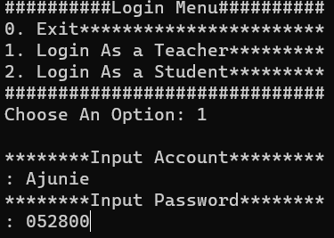

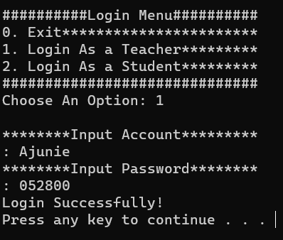

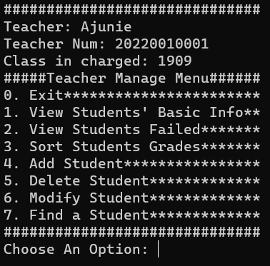
(1) 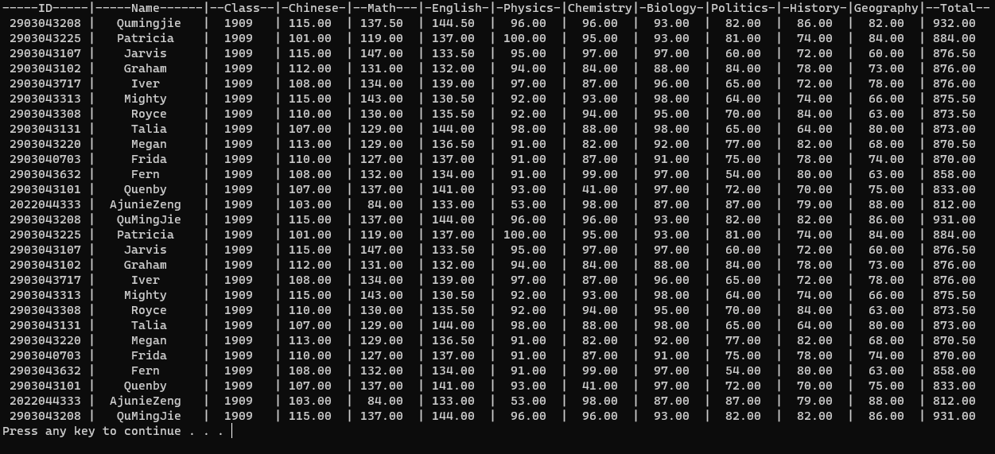

(2) 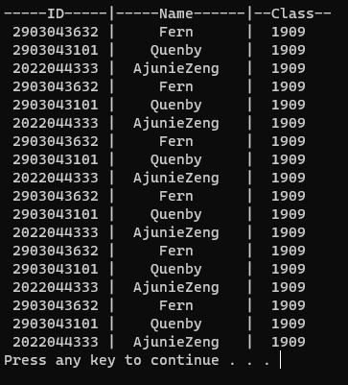
(3) 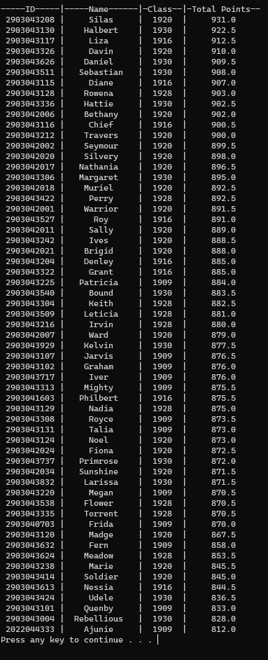
(4) 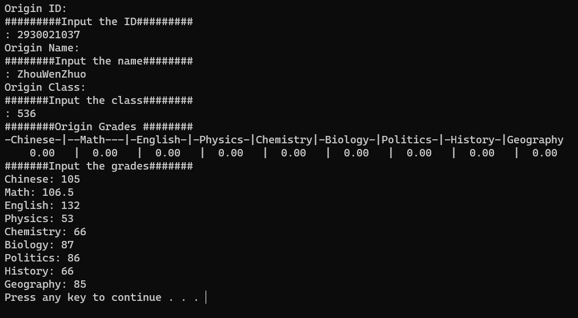
(5) 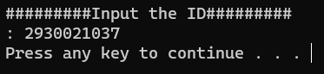
(6) 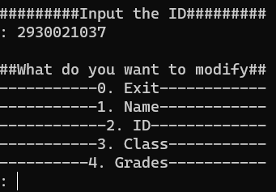
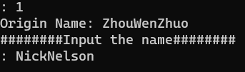
(7) 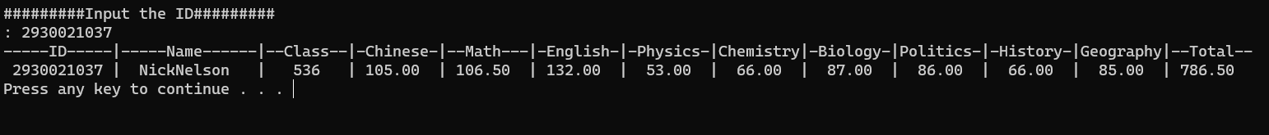

学生界面：
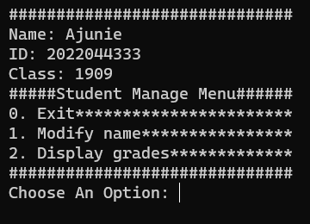

(1) 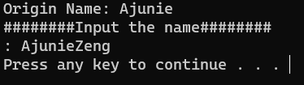
(2)
5. 实验总结分析
本次实验使用C++20进行编写，使用了各种STL库的实现方法，熟练运用了std::vector容器进行存储教师和学生的类对象，并运用std::fstream和C++17的std::filesystem进行文件的读写操作，运用C++20的std::format库进行格式化输出和std::string_view进行不复制和不创建临时对象的std::string来传递对象。在面向对象方面，对Person类进行抽象化，写成抽象类，使用虚函数在Student类和Teacher类进行多态信息输出，并熟练运用运算符重载以及迭代器进行学号的查找。体现了各种编程能力，深深的提高了计算思维和程序编写能力，以及信息查找能力。

