Assignment 5
This assignment aims to cement your techniques learned about sequence data structures. Each question is 10 points.
- Mode. Convert the mode.py on PPT slide# 47 to a function structured module, by refencing the conversion example median.py (slide #23 slide 33). Note, the main() contains the mainline logic, and it should be conditionally executed.

- Server Identification. You have a text file listing the server names as shown below on the left column in the table. Please create a script to read the file and generate a report identifying the type of server based on the server name, as shown on the right column in the table.
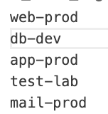 | 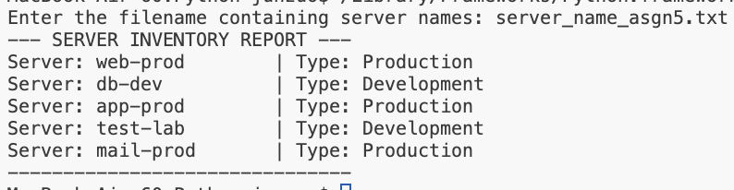

- Server Sentinel Report. You have a server log file (.txt) listing the raw data as shown in the left column, with log_time, user, action, status in such sequence. Please create a script to read, process and then save the user action statistics in a text report, as shown on the right column:
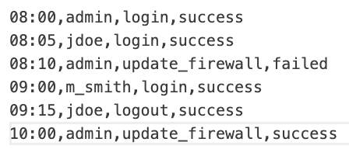 | 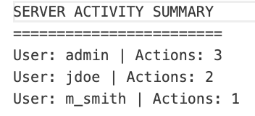

Additionally, this script generates the output on monitor for:
- Total number of entries being processed.
- If there is failed action from ‘Admin’, print a warning message
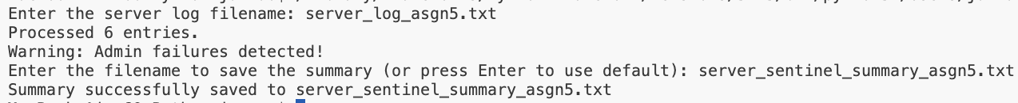
[Hint: Use a tuple to contain each line read from the log file and place these tuples in a list. Use a dictionary to calculate your statistics.]

Technical Requirement for Question 2 and 3:
- Use function-based script structure you learned in chapter 5 and practiced in the 1st question “Mode”. Reference PPT slide #32 for the structure.
- The function main() should illustrate the mainline logic, but the specific tasks should be distributed in the individual helper functions. Make the main() conditionally executed.
- In the DocString of this script, explain the sequence data structures applied in this script and what they are used for.
Quality Requirement:
- Please use the learned skills covered in our lectures (the purpose is to cement your understanding of the concepts and the fundamental techniques). Don’t advance with techniques we haven’t covered or beyond the scope of the lecture. I reserve the right to ask further questions or deduct points if you go too far.
- Follow conventional function-based structure learned in this week.
- Coding style:
- Aligned indentation
- Proper space between functions.
- Code quality:
- Logic clarity
- Expected output
Submission Requirement:
Use Visual Studio Code introduced last week for script editing and execution. We shall move to GitHub for next assignment. Take screenshots of your source code and running result and submit them. Make sure your screenshots are clear and easy to read. If the screenshots are vague, I will have to ask you re-submit.

