# Simulating required teachers for the UW Bothell CSS department

By:

Julio Perez  
William Borom  
Carl Martinez

## Summary of program

The algorithm simulates and tries to answer the problem of how many teachers are required year after year with increasing student population. The steps of the algorithm are as follows:

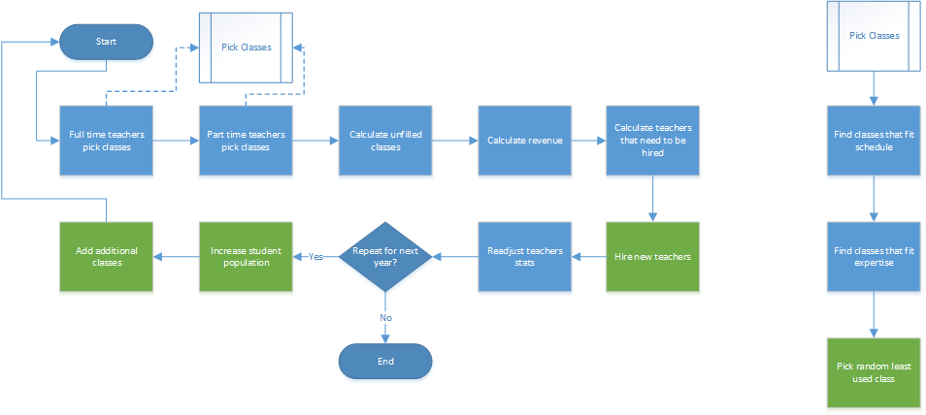

## How to Run Program

To run the program you first must have Python installed on your computer.

* Download files from <https://github.com/juperez0614/css458finalproject>
* Open Scheduling_algorithm_with_course_cruncher.py
* Edit the variables at the top of the file. This includes the download path of the git repository.
* Run the program

The simulation will print out cost, profit, the fulltime teachers, part time teachers, and empty classes for each year.