Part 4

* Valg module

First of all, I have added valg menu in dashboard top menu.

When we click this menu, we can see form to create election.

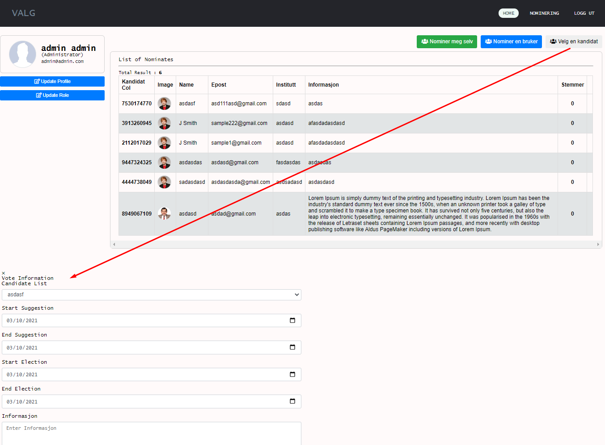

Here we fetch candidate list from db and make election for selected candidate.

This valg module can only be accessible to Administrators.

dashboard/valg_candidate.php

* Added function for changing user type.

This also can only be done for Administrators.

dashboard/update-profile.php

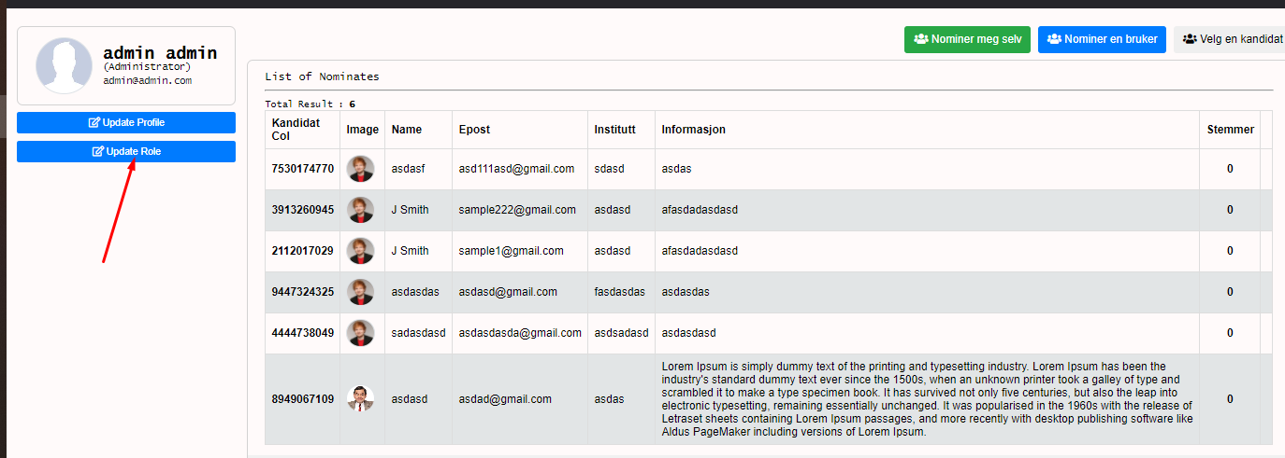

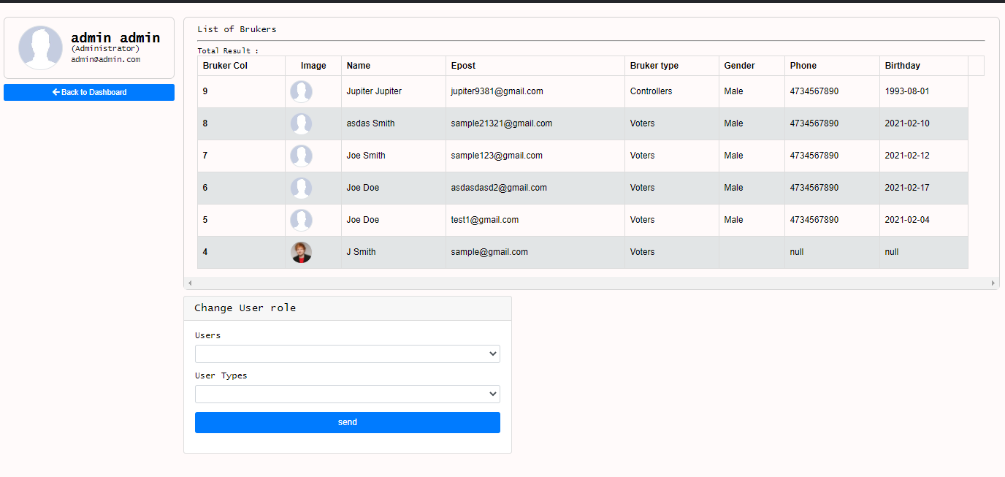

Here Administrators can appoint users and usertype in below form and update.

* Made valg list page

I showed valg list as table.

This table also includes candidate information.

All users can reach to that page no matter user type.

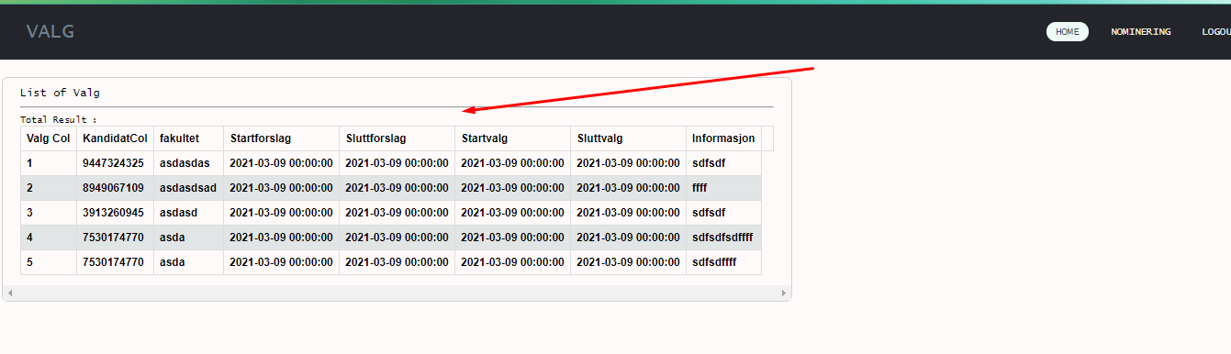

election.php

* All functions are coded in includes/dashboard.php (part 4)

1. To get users

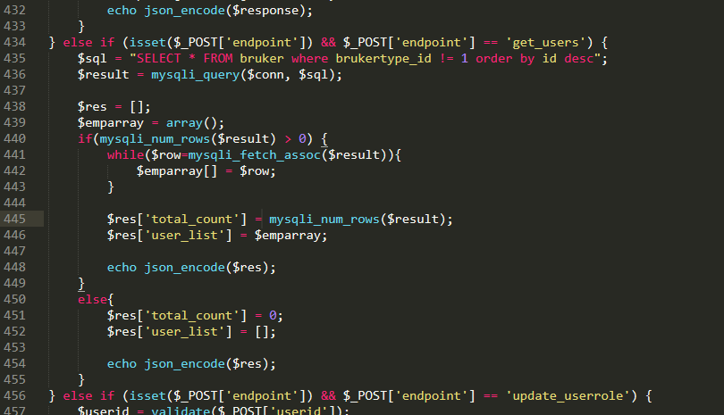

This is for getting all users except administrators.

1. To update user roles

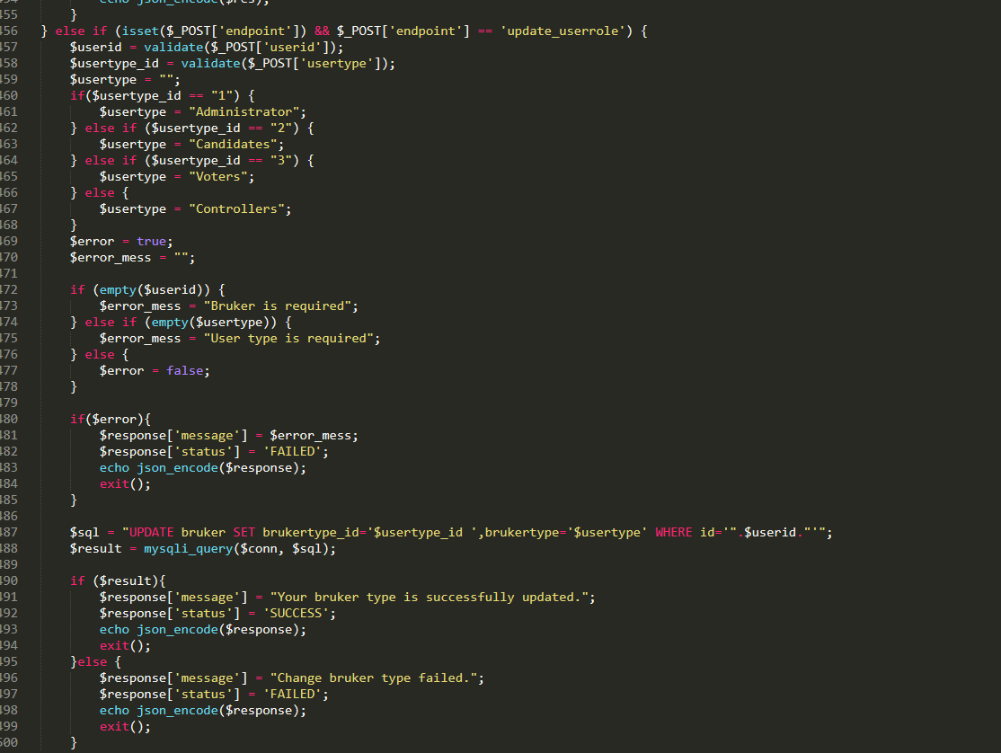

1. To get vote results

