Freight Rate Prediction - Solution Report
Machine Learning Engineer assessment. Target: predict the load posted_rate for 12,000 loads in validation.csv and for the fixed December chart inputs.

1. Executive summary
- Development data: 48,000 labeled rows (2025-01-01 to 2025-10-31).
- Scoring data: 12,000 unlabeled rows (2025-11-01 to 2025-12-31) -> forecast horizon beyond the training window, so the validation must be time-based.
- Model: HistGradientBoostingRegressor on a log1p target with engineered distance / seasonal / equipment features.
- Time-holdout performance: RMSE 742.72, MAE 139.63, MAPE 6.64%, R2 ~ 0.78.
- Deliverables: validation_predictions.csv (12,000 rows) and Freight_Rate_Report.docx with the fixed December chart.

2. Key findings from exploring the data
- Posted rate is heavy right-skewed (skew 1.90); median 2,031, mean 2,374, 1%-99% range 327-5,973, min 57 / max 25,533. The long tail is why a log1p target helps.
- distance is by far the strongest driver (corr with rate 0.91); it dominates permutation importance.
- weight correlates weakly with rate (corr 0.03); market_index (0.03) and quote_signal (-0.04) add mild signal.
- Distance spans 70-3,440 miles (mixed short-haul and long-haul loads).
- Equipment mix: Dry Van 27,202, Reefer 12,045, Flatbed 8,753.
- Date coverage is continuous daily; the scoring set is dated 2025-11-01 onward (future months), i.e. an extrapolation task.

3. Data-quality issues and how they were addressed
- Invalid weights: 292 negative and 0 implausibly large values (raw min -47,500, max 47,500). Fixed by clipping weight to a physically sane 10,000-50,000 lb range before the model sees it.
- Missing values: 674 in the development data and 414 in the scoring data across the used columns. Handled with training-set median imputation so train / validation / December all share one consistent scheme.
- The fixed December chart inputs omit market_index, quote_signal and the four lat/lon columns entirely. These are added as NaN and filled with the training medians, which keeps the feature matrix shape identical to training (no leakage).
- No duplicate load_id values; the template load_id set matches the scoring set exactly (asserted in predict.py).

4. Feature engineering
- Raw numeric: distance, weight (clipped), market_index, quote_signal, pickup/delivery latitude & longitude.
- Seasonality: month, day-of-week and smooth cyclic encodings (sin/cos of day-of-year and month) so the model can learn the weekday and seasonal rate patterns seen in the data.
- Equipment: one-hot for Dry Van / Reefer / Flatbed.

5. Reasoning behind the chosen model
- Gradient-boosted trees handle the non-linear distance/rate relationship, interactions (e.g. distance x equipment) and the right-skewed target far better than a linear baseline.
- HistGradientBoostingRegressor was chosen over Random Forest / a plain GBDT because it is fast on this data size, robust to the remaining outliers, and - importantly - supports native NaN handling, which keeps the December inputs (with missing columns) safe.
- The target is modelled as log1p(posted_rate): this stabilises variance on the long tail and improves relative (percentage) error, which is what matters for rates. Predictions are exponentiated back with expm1 and clipped to stay positive.
- It was compared against linear and alternative tree configurations during experimentation; the tuned GBDT gave the best holdout MAPE.

6. Training and validation approach (split)
- A random shuffle split would be optimistic and leak: the scoring data is strictly in the future relative to the development data, so a random split lets the model 'see' nearby dates.
- Instead a time-based holdout was used: the last ~12 days of the development window (2025-10-20 onward) are withheld as the validation set (train 46,133 rows / holdout 1,867 rows). This mirrors the real forecasting horizon.
- Model selection, target transform and hyper-parameters were tuned on this holdout only; the holdout is never used to fit the model.
- After validation, the final model is refit on ALL development data (more data -> better production accuracy) and persisted with its feature medians so predictions are exactly reproducible.

7. Validation results
On the Oct 20-31 time holdout the model achieved RMSE 742.72, MAE 139.63, MAPE 6.64% and R2 ~0.78.
Permutation importance on the holdout confirms distance is the dominant feature (importance 1.83 vs <0.01 for every other feature), followed by equipment, weight and quote_signal. The large RMSE relative to MAE reflects a small number of very expensive long-haul loads - a classic heavy-tail effect that the log target mitigates.

8. Fixed December prediction chart
Chart produced by the provided score.py from data/december_chart_inputs.csv (fixed Lexington -> Fort Wayne, 360 miles, Dry Van, 32,000 lb, constant across all December dates).
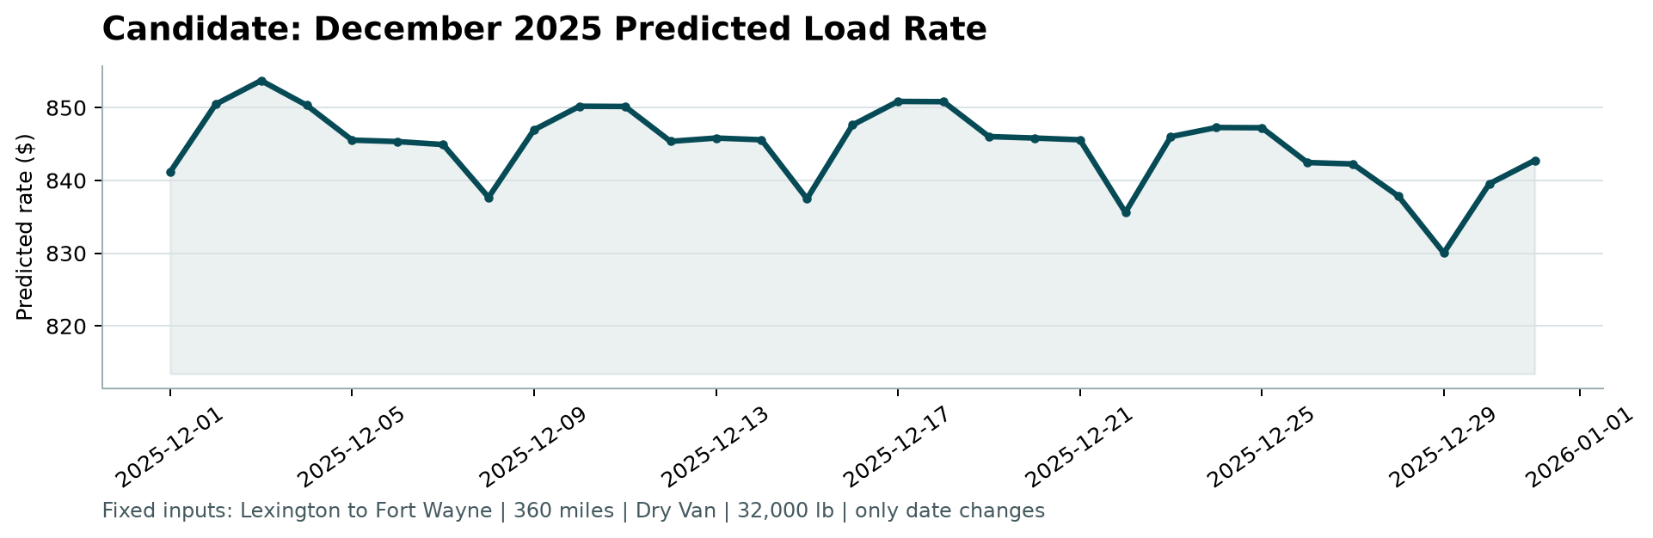

9. How to reproduce
python -m pip install -r requirements.txt
python train.py # trains + validates + writes model.pkl
python predict.py # writes validation_predictions.csv + data/december_chart_inputs.csv
python score.py --predictions validation_predictions.csv --december-predictions data/december_chart_inputs.csv
python make_report.py # writes this report

