Self-organizing map
Juraj Mašlej
Project2

1. Implenentation of SOM: we used our implementation from lecture

2. Parameters:
Map size
We used different map sizes, mostly of square topology.
Metric
We had implenented 3 different metric functions on lecture, for project we choose to use l_max.
l_max(a, b) = max(a[0] – y[b], a[1] - b[1])
Alpha, Lambda
As for alpha_s we experimented with values between 0.2 and 0.8, for alpha_f we used 0.01. Regarding lambda, we used 0.1 for lambda_f, lambda _s was dependent of map size,
lambda_s = metric(diagonal distance in map) * 0.5

3. Params used for graph-generating data:

metric = l_max
epochs = 100
alpha_s = 0.7
alpha_f = 0.01
lambda_f = 0.1

4. Graphs:

4.1. Counts
size = how many times neuron was activated
color = for which class of data is neuron being activated

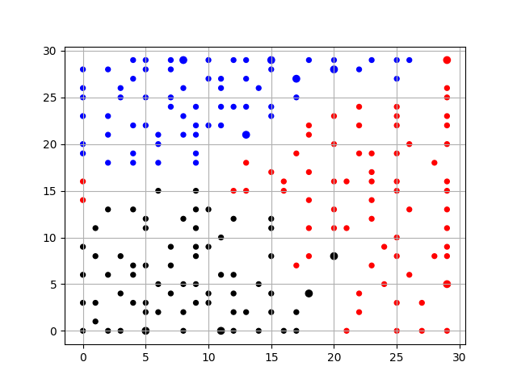

4.2. Average adjustment of neuron positions per epoch
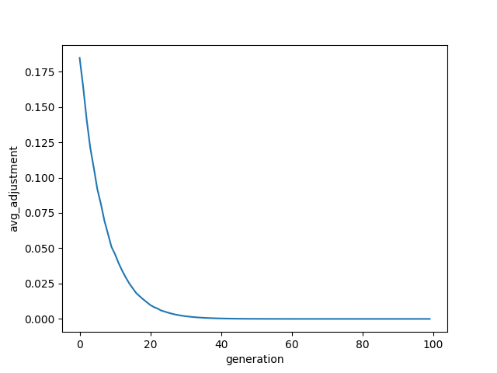

4.3. Average quantization error per epoch
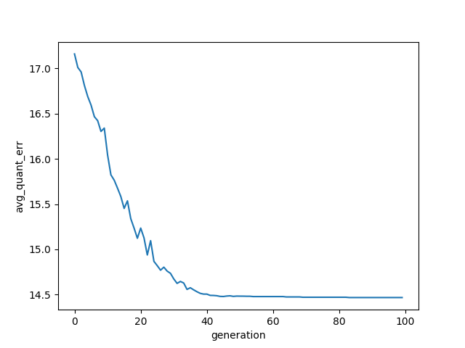

4.4. Heatmaps, sorted by atributes 1 to 7

Heatmap for atribute 1.

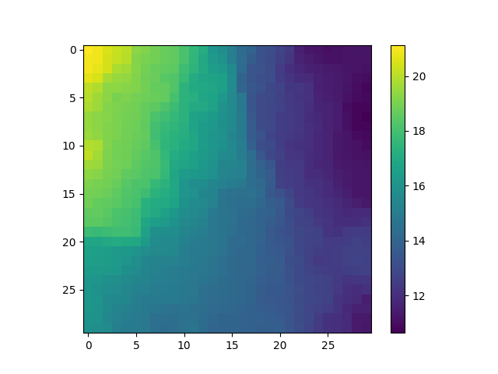
Heatmap for atribute 2.
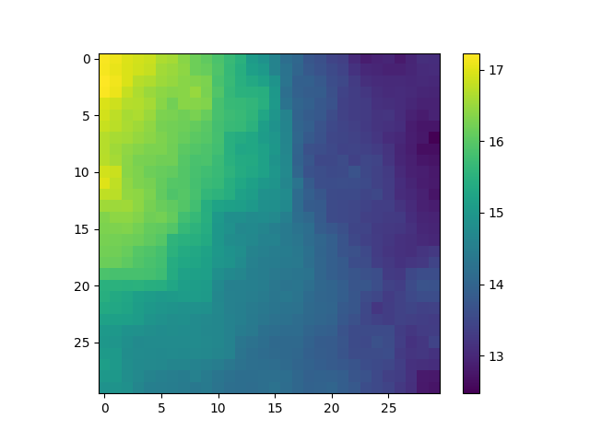

Heatmap for atribute 3.
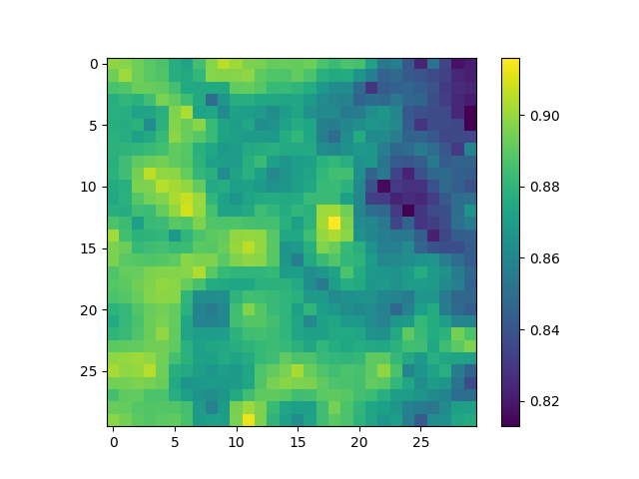

Heatmap for atribute 4.

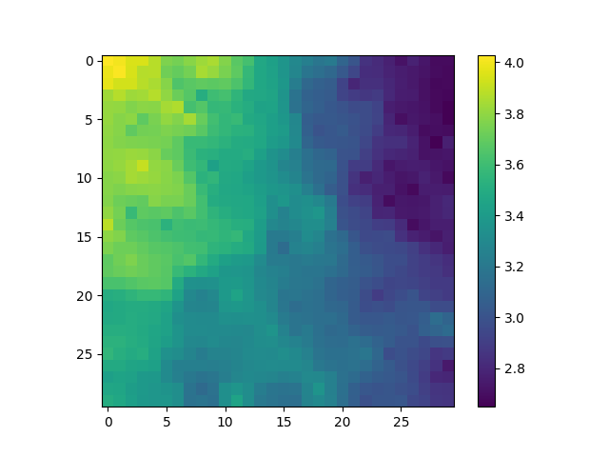

Heatmap for atribute 5.
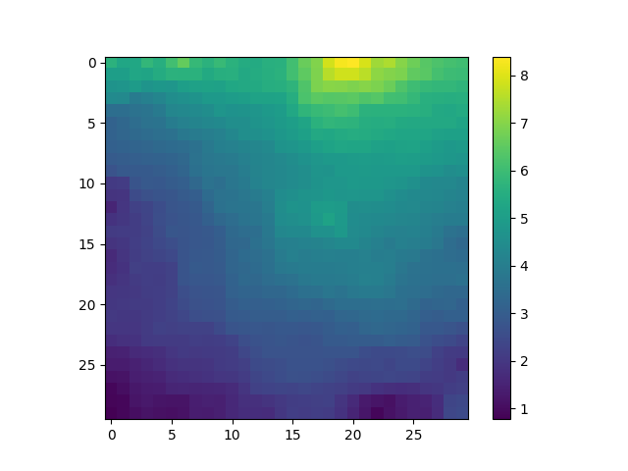
Heatmap for atribute 6.

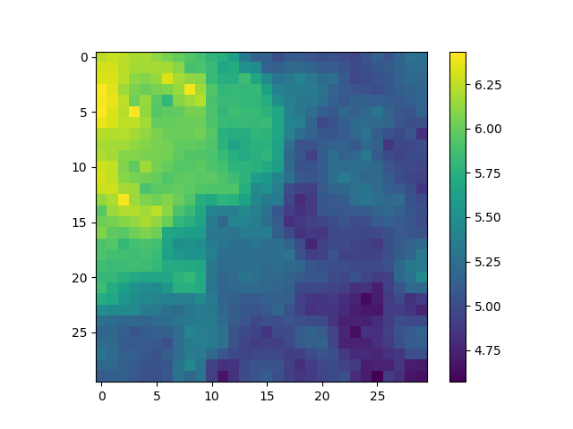

4.5. U-matrices, horizontal and vertical

Horizontal

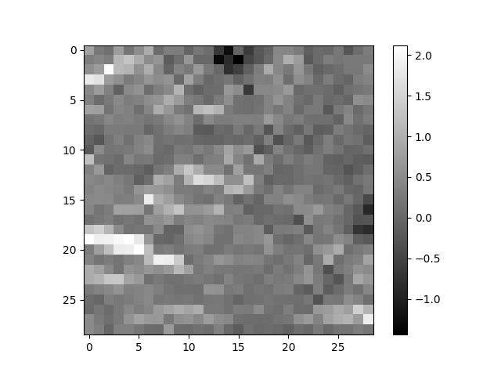
Vertical

