CESG 505 Bonus Assignment

Ran Ju

1. Create a class that displays the GUI shown on the next page. Follow specifications on the subsequent pages.
2. Make sure the overall appearance is preserved as the window is rescales (use QLayouts)
3. Create callback functions for the “Save” Button and the “Cancel” Button.
4. Create callback functions that Check one and uncheck the other QRadioButtons (items 5,6,7).
5. The last callback should also update the QComboBox (example names for the assignments are OK)

Tasks 3, 4, 5 require the use of the **connect** method.

This is my default interface:

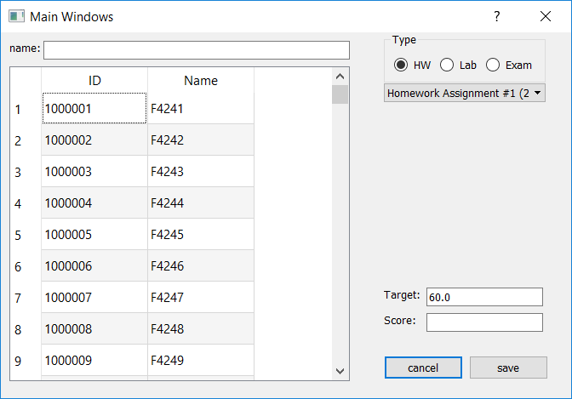

When I change radio Button from HW to Lab, the content of combo box and target score can be changed .

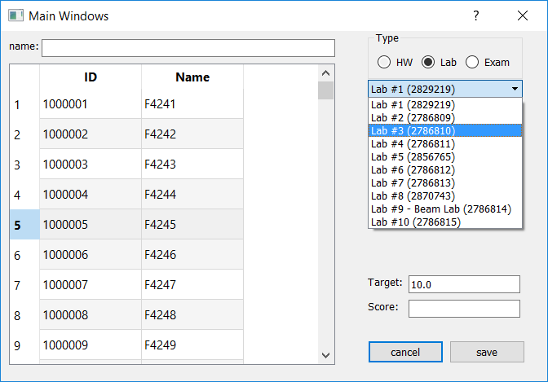

Using name line edit, it can search all students who can match the content.

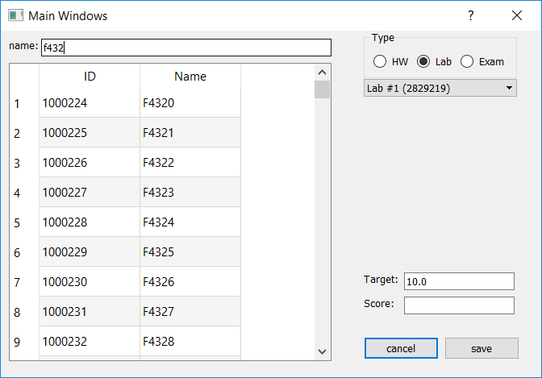

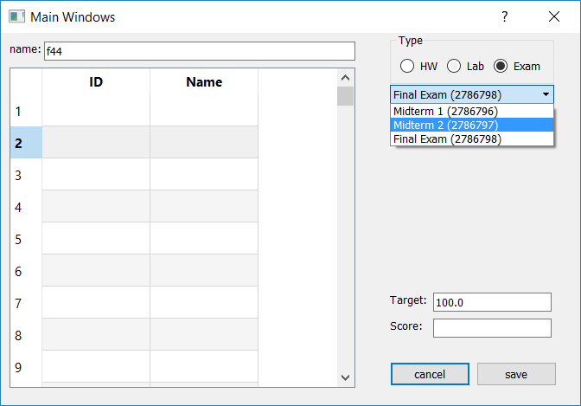

No student’s name contains ‘f44’

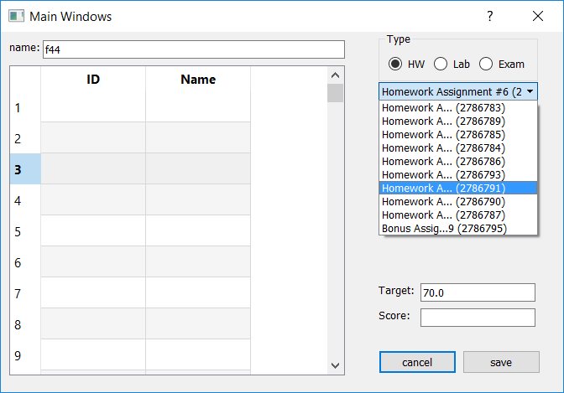

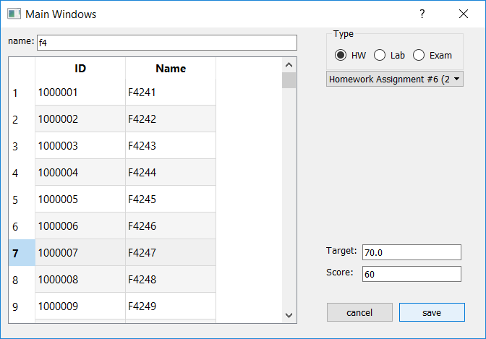

Entering the ‘cancel’ button, all line edit can be cleared.

