ECE 2660 Spring 2015

## LAB 7B OpAmp Function Generator

## 06 February 2014

Joseph Urbanek – Circuit Constructor and Did Calculations

Daniel Drangstveit - Team Leader and Data Recorder

Samuel Kwong – MatLab and Virtual Bench Technician

### Laboratory Purpose

Operational amplifiers are a multistage two-input differential amplifier that is designed to specifically be a voltage-controlled voltage source.  It contains three stages that make up the functionality of the Op Amp.  There were three stages of operational amplifier circuitry used in this lab.  One stage was the integrator operational amplifier circuit, which causes the output to respond to changes in the input voltage over time.  In essence, the output voltage is proportional to the integral of the input voltage.  The second stage, was an amplified operational amplifier circuit which produces an output potential numerous times larger than the input potential difference.  The last stage was a operational amplifier voltage comparator which functions as such, when the non-inverting input is at a higher voltage than the inverting input, the high gain of the op amp causes the output to saturate at the highest positive voltage it can output.

The overall purpose of this lab was to focus on these particular functions of the Op Amp and design a way to test a simple function generator.  In particular, the Op Amp itself will generate a square and triangle wave without the use of a function generator on the Virtual Bench.  Considering the Op Amp in this case, an inverting amplifier, has a resistor between the non-inverting input and ground ultimately reduces the input offset voltage and the distortion level.  This lab will show how the Op Amps can generate a transient response on its own according to the various constructions that were implemented for each Op Amp.

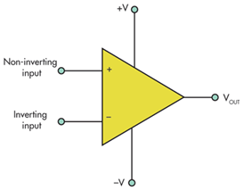

Example of an Operational Amplifier

### Experimental Equipment Employed

The following were used to construct this experiment:

* Virtual Bench
* Bread board
* 3 TL072ACD Op Amps
* 1 Y5V104Z Capacitor (0.1uF)
* Resistors

o   470 kΩ resistor

o   940 kΩ resistor

o   20 kΩ resistor (2)

o   1 kΩ resistor

o   10 kΩ potentiometer

* Wires of various size
* Oscilloscope probes for input and output

### Experimental Procedures

**Procedure of Designing the Circuit:**

Before the actual construction of the circuit occurred, our group collectively made a design of the specified circuit (Figure 7.1) using Multisim, a circuit design software.

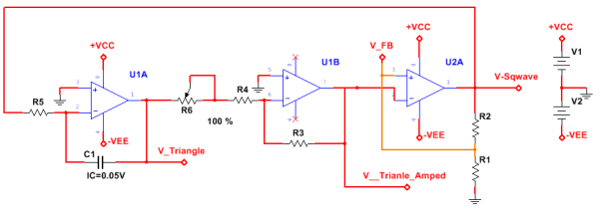

Figure 7.1: The specification for the circuit design, the circuits from left to right being the integrator, the amplifier, and the comparator

The first task we assumed was to find a sufficient value for R4 and R3 that satisfies the specified conditions. Because the specification states that R4 must have a resistance of 10% the maximum value for the potentiometer, and the potentiometer has a maximum value of 10kΩ, we concluded that a sufficient value for R4 is 1kΩ. To find the resistance for R3, we used the fact that the specified gain of Op Amp U1B is -20. Because the setup of this Op Amp is inverting, R3 must have a value 20 times the value of R4, giving R3 a resistance 20kΩ. Because there were no 20kΩ resistors in the provided laboratory kit, we combined two 10kΩ in series as a substitute.

Our next task was to find values for resistors 2 and 1. Because the voltage division ratio given was 3:1 – the voltage at before the voltage divider has to be three times the voltage after the first resistor in the divider – we calculated that the voltage drop across the R2 must be twice the voltage drop across the drop across R1. Thus, the resistance of R2 must be twice R1. Because the current must be under 1mA across R2, our group decided to pick fairly large resistances for resistors 1 and 2, being 470kΩ 940kΩ respectively. Because we were not provided a 940kΩ resistor, we used two 470kΩ resistors in parallel for R2. Our final design for the circuit can be shown below (Figure 7.2), which we used to simulate the transient response using Multisim.

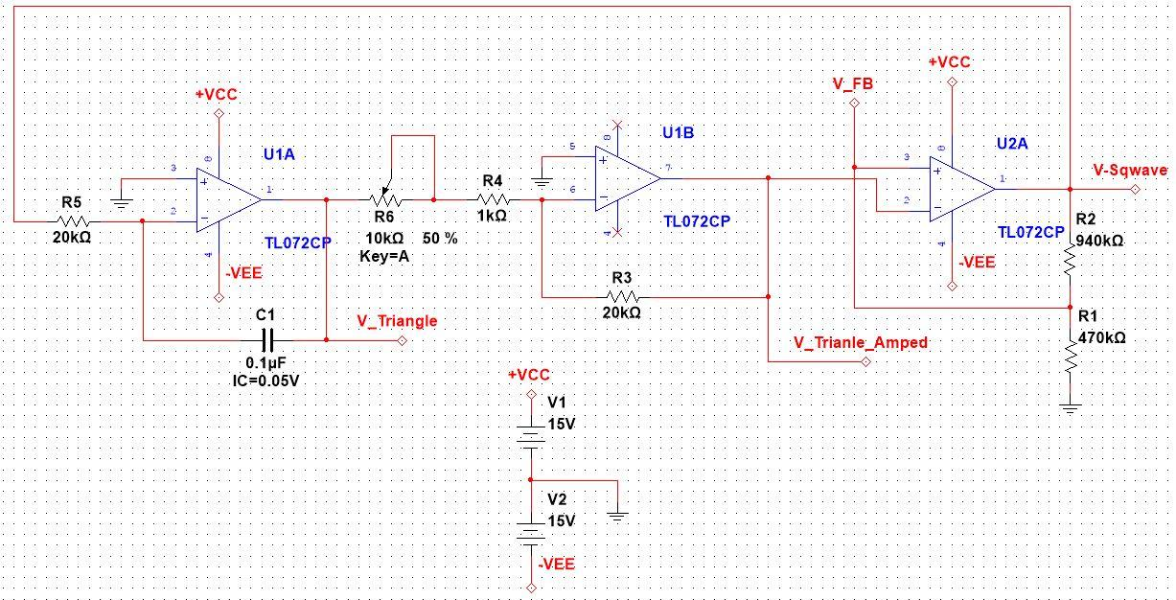

Figure 7.2: Our Multisim design of the specified circuit

**Procedure of Recording the Experimental Transient Response:**

After designing the circuit using Multisim, we constructed the circuit using the provided laboratory kit (Figure 7.3). This included the DC input of +15 volts and -15Volts for the Opamp bounds.

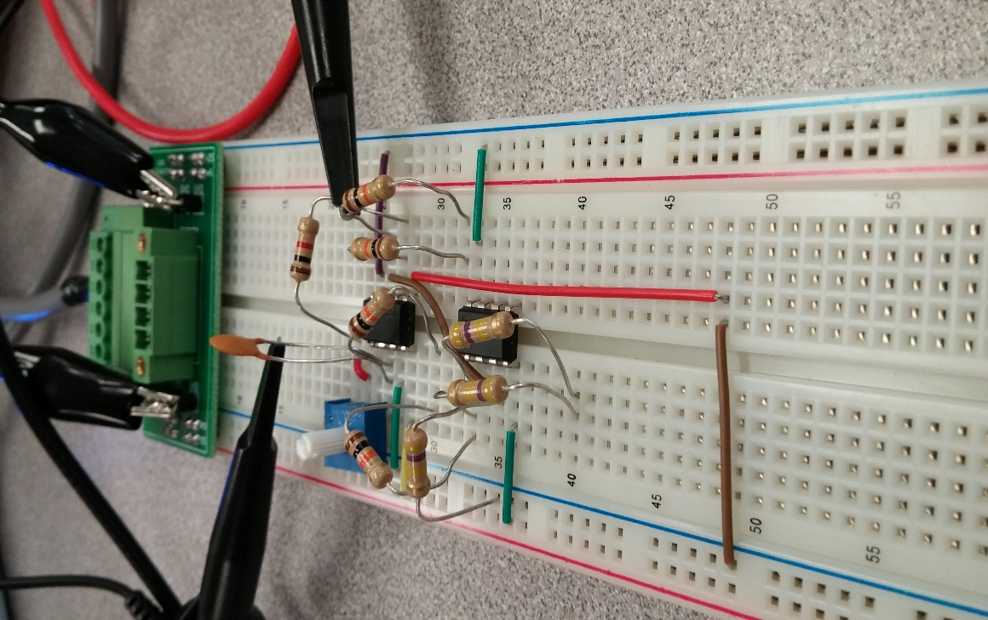

Figure 7.3: Picture of the circuit constructed for the Function Generator

Using the oscilloscope probes, we first measured the functions generated at the V_Triangle and V_Triangle_amped, as shown in Figure 7.2. The oscilloscope probes were then repositioned to measure the output at the nodes labeled V_FB and V_Square.  To measure the effect of the resistance on the voltage gain of V_triangle_amped versus V_triangle, we changed the resistance of the potentiometer to discrete values differing by 2.5kΩ.

### Results

Before performing the experiment outlined in the procedure, we used MultiSim to simulate the circuit and obtain the expected results shown in the figure below (Figure 7.4)

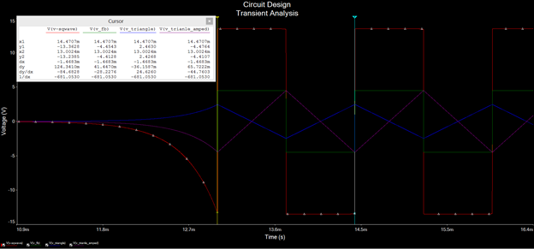

**Figure 7.4:**  MultiSim simulation of the circuit showing the expected output voltage waveforms

The following screenshots show the various output voltage waveforms observed from the circuit shown in Figures 7.5a and 7.5b. The circuit was under the default settings detailed in the procedure. We initially set the potentiometer to 100% such that R6 was 10k Ω, which resulted in the waveforms shown below. We then varied the potentiometer to observe the output waveforms at various R6 values, and thus at different operating frequencies. Table 7.1 shows the data taken from these different potentiometer settings.

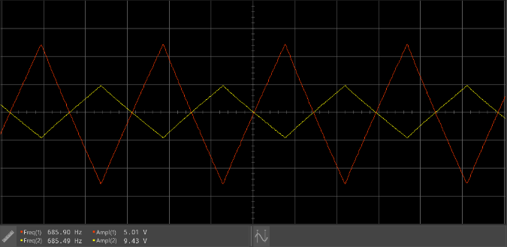 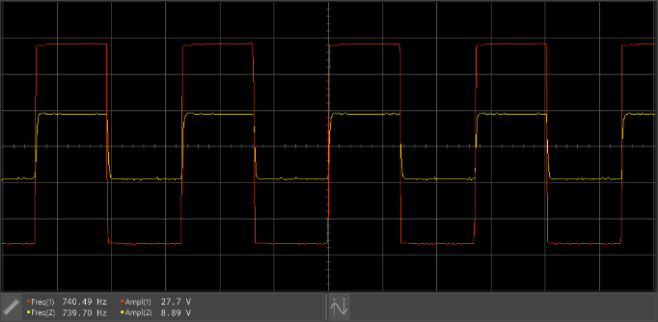

**Figure 7.5**: Figure 7.5a (left) is the output observed at the V_Triangle (yellow) and V_Triangle_Amped (red) nodes.  Figure 7.5b is the output is the output observed at the  V_FB(yellow) and V_Sqwave(red) nodes.

|  |  |  |  |  |  |  |
| --- | --- | --- | --- | --- | --- | --- |
| **R6 (kΩ)** | **Expected Frequency (Hz)** | **Actual Frequency (Hz)** | **V_Triangle (V)** | **V_Triangle_Amp (V)** | **V_FB (V)** | **V_Sqwave (V)** |
| 10 | 678 | 686 | 5.01 | 9.43 | 8.89 | 27.7 |
| 7.5 | 871 | 882 | 4.09 | 9.42 | 8.93 | 27.7 |
| 5 | 1244 | 1279 | 2.90 | 9.58 | 8.94 | 27.6 |
| 2.6 | 2114 | 2109 | 1.81 | 9.96 | 9.06 | 27.6 |
| 0 | 6775 | 6917 | 0.609 | 10.9 | 9.37 | 27.3 |

**Table 7.1**: The frequency and various output voltages obtained from varying the resistor R6 from 0k to 10k Ω.

From the circuit in Figure 7.2, the voltage gain ratio of the middle stage is: R3 / R4 + R6.  Using this ratio and the data from Table 7.1, we can compare the expected voltage gain of different R6 values and the voltage gains we actually got (Table 7.2).

Expected Gain = Gain Ratio

Actual Gain = V_Triangle_Amp / V_Triangle

|  |  |  |
| --- | --- | --- |
| R6 (kΩ) | Gain Ratio (x : 1) | Actual Gain |
| 10 | 1.82 | 1.80 |
| 7.5 | 2.35 | 2.30 |
| 5 | 3.33 | 3.30 |
| 2.6 | 5.56 | 5.50 |
| 0 | 20 | 17.9 |

**Table 7.2**: The voltage gain comparison between experimental and theoretical based on the change in the potentiometer resistance.

### Conclusions and Explanations

The theoretical and experimental values, though inspection, look fairly similar except for when the potentiometer is set to 0kΩ.  One source that may cause this error is the high frequency at this level for the potentiometer.  Because the frequency is so high, there may not be enough samples per second from the probe may not have been high enough to record an accurate peak for the amplitudes.

After recognizing the effect of the change of the frequency from a change in resistance of the potentiometer, finding other sources that could change the frequency could help determine which components affect and make up the operational frequency.  Varying the values for each of the components in Multisim and performing transient analysis helped find these components.  This analysis concluded that any change of the values of the resistors or the capacitors in the circuit change the operational frequency.  The reason for this could be the rate of discharge and charge in the capacitor.  A change in the resistance in the overall circuit would change the time constant RC, which directly affects the rate of discharge.

Using the same technique, we attempted to find what makes up the amplitude of the square wave output.  We concluded that the DC inputs of the operational amplifiers determine the amplitude of the square wave output, while the voltage divider ratio of R2 and R1 determine the square wave output at V_FB.  The first conclusion can be verified by the Ideal Operational Amplifier Abstraction (IOAA).  This abstraction states that the signal output, even though the potential gain could be to a degree of 106, is limited by the DC input bounds.  Although the IOAA is not a reliable abstraction when dealing with real world situations, this idea that the bounds limit the output extend beyond the IOAA into the real world.

Although here we changed the amplitude of the square wave, our changes in the DC input actually changed the frequency.  Our group attempted to find a value for both VCC and VEE that could modify the amplitude while maintaining the operating frequency.  Testing multiple values, we concluded that operational frequency could be maintained if the DC inputs were changed by the same multiple.  For example, if VCC1 = 15V and VEE1 = -15V, changing the input to VCC2=20V and VEE2 = -20V would result in the same operating frequency but will change the amplitude of the square wave.

One concept we have discussed in class is linear and time-invariant systems (LTI system). This is a way to classify the effect that a system has on an inputted circuit. The integrator operational amplifier circuit portion of the function generator is a linear and time invariant circuit because this circuit essentially performs an integral over the bounds of the signal input. Because we know that integration is linear and time invariant, this integrator circuit is a LTI system. The amplifying circuit is clearly a LTI system because its function is to invert and magnify the inputted function, which is simply multiplying the inputted signal by a constant. The comparator circuit is not linear because if the signal input increases by a constant, the output would not increase by that same amount because the amplitude is determined by VCC and VEE, the DC inputs. However, it is time invariant because the output signal is a binary output based on the input signal, which would not vary with a change in time.

The order in which these stages were put in place does appear to be important because of the placement of the amplifier circuit and the comparator circuit. If stage two and stage three were interchanged, although the frequency would remain the same, the square wave would be at the level of the DC input. This would then be amplified by the amplifier circuit to an even higher amount, which would then be integrated to have a higher slope. Therefore, the overall amplitude of the new, interchanged circuit would increase, proving that the change in order of the stages would make a difference.

**General Discussion, History, and Possible Anomalies**

           This lab posed a deep anomaly of which the function generator was absent from the experiment.  A function generator normally generates different types of waveforms like sine, square, and triangular waves for example, but this particular experiment the Operational Amplifier circuit started on its own.  The controlling signal was produced in part from the potentiometer which is a three-terminal resistor that acts as a voltage divider used to measure voltage.  Throughout the lab, it was difficult to “kick start” the circuit to produce the V_Triangle, V_Triangle_Amped, V_FB, and V_Sqwave waveforms.  This was in part due to the extensive process of applying the circuit design to the actual breadboard used.  To fix this problem, a repeated check from multiple lab members were done to make sure the probes connected to the correct places and the components were correctly placed to and from the right pins.

Another problem that arose in this lab was that we forgot to measure the different voltage gains according to varying the potentiometer at different resistances.  This was necessary to compare our results to the transient response waveforms in the lab procedure.  Nevertheless, this helped broaden our understanding of the operational amplifier in terms of how a change in resistance affects the gain.

In regard to the historical use of operational amplifier, it originated in analog computers used to do mathematical operations in linear, non-linear, and frequency-dependent circuits.  Today, the Op Amp is one of the most used electronic devices in the industrial and consumer industry.  In particular, it is of course used in signal processing circuits, control circuits, and instrumentation.

In terms of discussing the operational amplifier itself, it is important to understand the basic functionality of the different parts (stages) that make up an amplifier.  The first stage is the input stage, which gives the Op Amp its high input resistance, and a high gain.  There is a non-inverting input (+) and inverting input (-) of which no current flows into these terminals and the difference between the input voltage is zero also called “virtual ground”.  This part additionally converts the input voltage to a single ended output.   The second stage provides additional amplification and level shifts the output voltage to zero when both inputs are equal.  Lastly, the Op Amp has an output stage which gives itself low output impedance.