Geo-information Science and Remote Sensing

Thesis Report GIRS-2021-xx

**SENSING REMOTELY**

***Developing a water quality sensing platform***

Jurrian Doornbos

**P I C T U R E**

01-05-2021



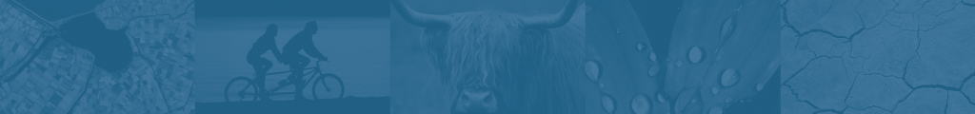

**Sensing Remotely**

**Developing a water quality sensing platform**

Jurrian Doornbos

Registration number xx xx xx xxx xxx

Supervisors:

João Valente

Jan Clevers

A thesis submitted in partial fulfilment of the degree of Master of Science

at Wageningen University and Research,

The Netherlands.

01-05-2021

Wageningen, The Netherlands

Thesis code number: GRS-80436

Thesis Report: GIRS-2021 -xx

Wageningen University and Research

Laboratory of Geo-Information Science and Remote Sensing Foreword

INDEX

Table of content

# Introduction (max 6 pages)

# Data and methods (max 8 pages)

# Results (max 15 pages, )

# Discussion (max 8 pages)

# Conclusion (max 2 pages)

# Recommendation (max 2 page)

**Appendix 1** of the thesis report

Table of Content of the zip file that accompanies the thesis report.

* Documentation of what is where in the file (including folder structure; Word, PDF)
* Report (Word, PDF)
* Midterm & Final presentation (PPTX)
* Animations (in case of)
* Datasets used and created
* Figures/Maps/Tables (in case of)
* Scripts /code/exe (in case of)
* Questionnaires ( in case of)
* Literature (PDFs of used articles / preferable Endnote)
* Other (additional sources)