Equations of Motion:
Referring to glider’s body centered reference frame centered at aircraft's CG
Translation:

Rotation:

Source:
Modeling and Simulation of Autonomous Thermal Soaring with Horizon Simulation Framework
by Zhenhua Morton Li

Script:
The glider entering its thermal can be considered under a few reference frames:
It can be considered as a point relative to the Earth’s Inertial reference frame
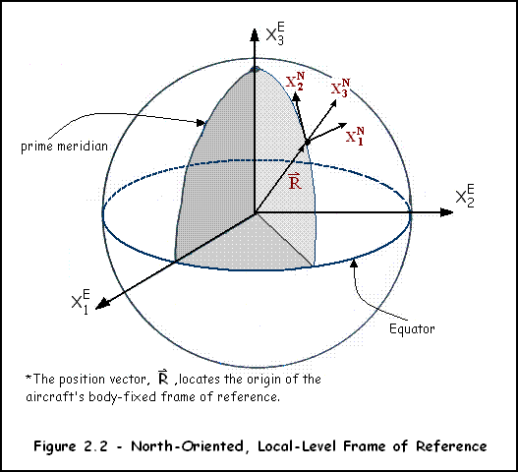

It can be considered as a point relative to a specific point on Earth’s surface, i.e. the runway

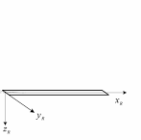

A glider’s motion can be shown relative to its center of gravity. This is called its body-centered reference frame. Its motion can be described relative to its stable flight path with deviations from its steady horizontal state disregarded.

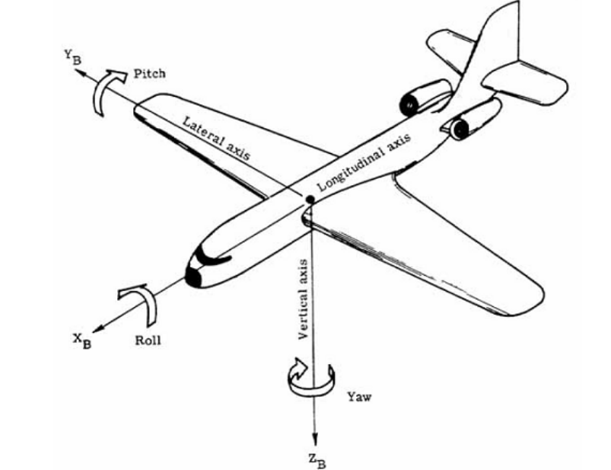

Equations of Motion:
The following equations of motion are for a glider with respect to its body-centered reference frame.

These equations are used for governing the glider’s translational motion:

Each equation is true where
The glider’s acceleration in the x-y-z directions are represented by udot vdot & wdot respectively
The glider’s velocity in the x-y-z directions are shown by u v & w
The Forces applied to the glider in x-y-z directions are F_x F_y & F_z
The gilder’s roll rate, pitch rate, and yaw rate are denoted by p, q, r

These equations can be shown more concisely as
the glider’s translational acceleration vector = force applied vector / mass – its local angular velocity vector crossed with its velocity vector
where the components of each of these vectors are shown below

The following equations are used for governing the glider’s rotational motion:

where the first equation determines the acceleration of the glider’s roll,
the second equation determines the acceleration of the glider’s pitch,
and the third equation determines the acceleration of the glider’s yaw
where each I component in the above equations is a component of the glider’s inertial matrix
where L M & N are the moments about the x-y-z axes
and p q & r are the bodies roll, pitch and yaw rates

Autopilot:
A thermal from the glider’s perspective can be represented using any radially decreasing function. For ease, let’s take
where represents the strength of the thermal in any radial direction.
Notice, the equation above is not an accurate representation of a thermal; however, it is easier to manipulate mathematically and shares the radially decreasing property of thermals.

Inputs:
From sensors on a glider’s wings, one can find the change in thermal strength along its wingspan. Let’s call this. Assume the glider’s body fixed reference frame’s x-axis points parallel to its wingtips. By taking the average of the two strengths , we receive the strength of the thermal at an initial time step. By doing the same at additional time steps, we receive a change in thermal strength in the axis parallel to the fuselage of the glider. Thus assuming the y axis extends parallel to the fuselage of the glider.

Finding the Direction to the Center: (Desired Bank Angle)

In order to find the direction of the thermal center, we can perform a simple calculation finding the slope of the thermal plot in the x-y plane:

From the slope of the thermal we can find the direction to the center of the thermal in the form of a unit vector pointing to its center:

whereis the angle to the center of the thermal

Likewise, one can use the fzero() function on this equation to find the angle to the center of the thermal. This equation was derived through taking partial derivatives to the function.
Either of these equations output the angle of the glider’s travel to the center of the thermal.

in order to find the approximate distance the center of the thermal is from glider in the current x-y plane:
or

Another method is the use of extrapolation: By extending the unit vectors pointing to the center of the thermal at multiple time steps, we receive a number of linear lines of infinite length which intersect at the thermals center,
By finding their intersection point on the x-y plane one can approximate the exact location of the center of the thermal
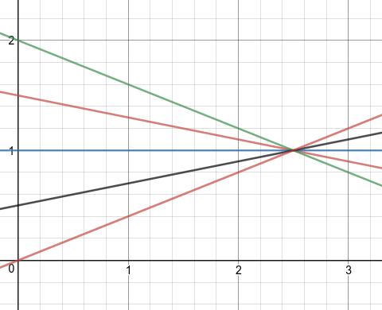
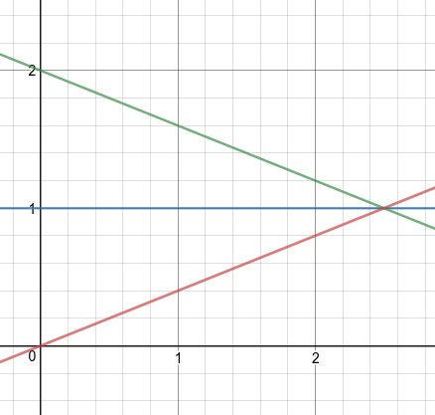

Simulations:

Questions:
Reference Frames:
Body-fixed; Stability;Earth Fixed
System is continuous
Inputs: Thermal Strength and change in thermal strength wrt radius
Outputs: Roll, Pitch, Yaw rates
Uses PID controller
Unused:

where:

