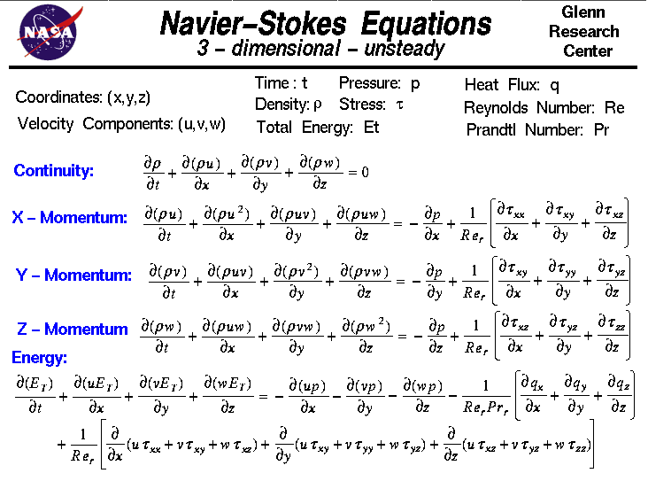

Apply assumption: steady, incompressible, 1D flow

Source:

Sink:

Distance:

Boundary Parabola Function:

Tunnel Width:

Find Final Velocity:

Where

Interpolation: