- Name:
- Student ID:

- Login to your Hadoop cluster <http://149.165.168.141:8080>

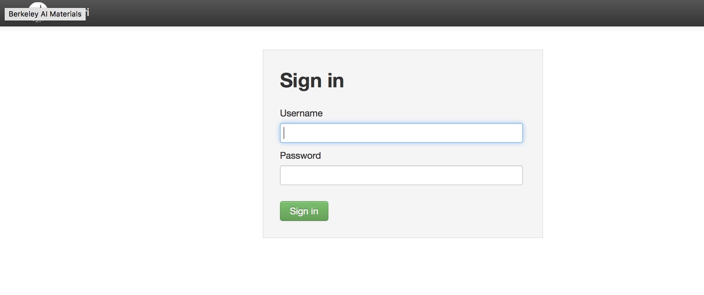
username/password
maria_dev/maria_dev

- Click on “Hive View 2.0”

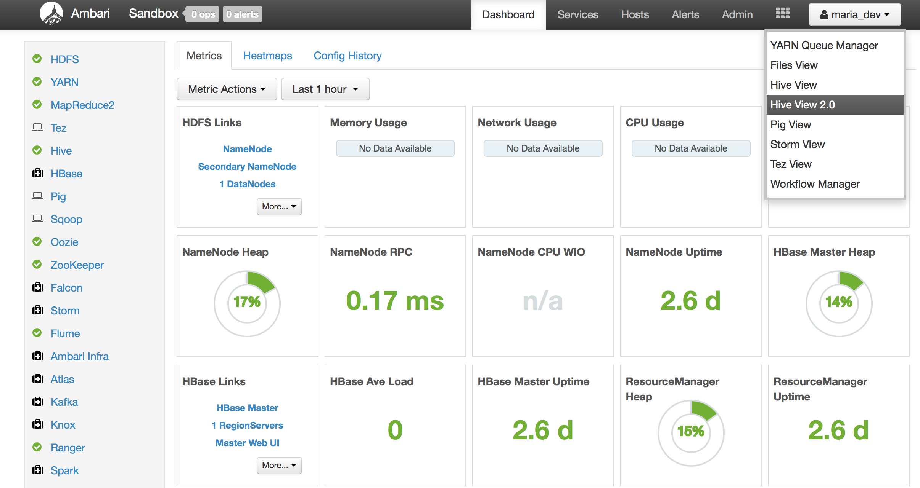

- Select Database: foodmart

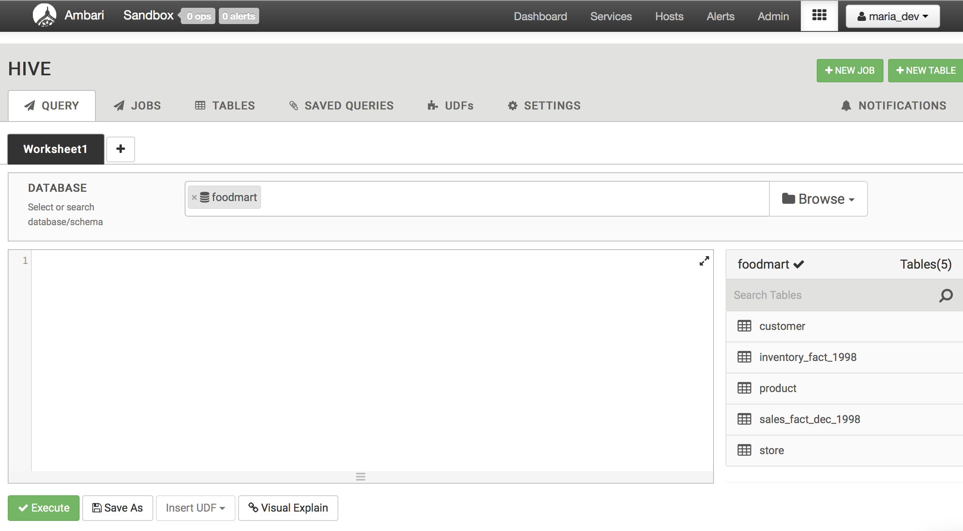

- Write a SQL program to find the Top 10 selling products from sales_fact_dec_1998 Table.

- Print the SQL program

