Assignment 4 Due Date:
Student Name:
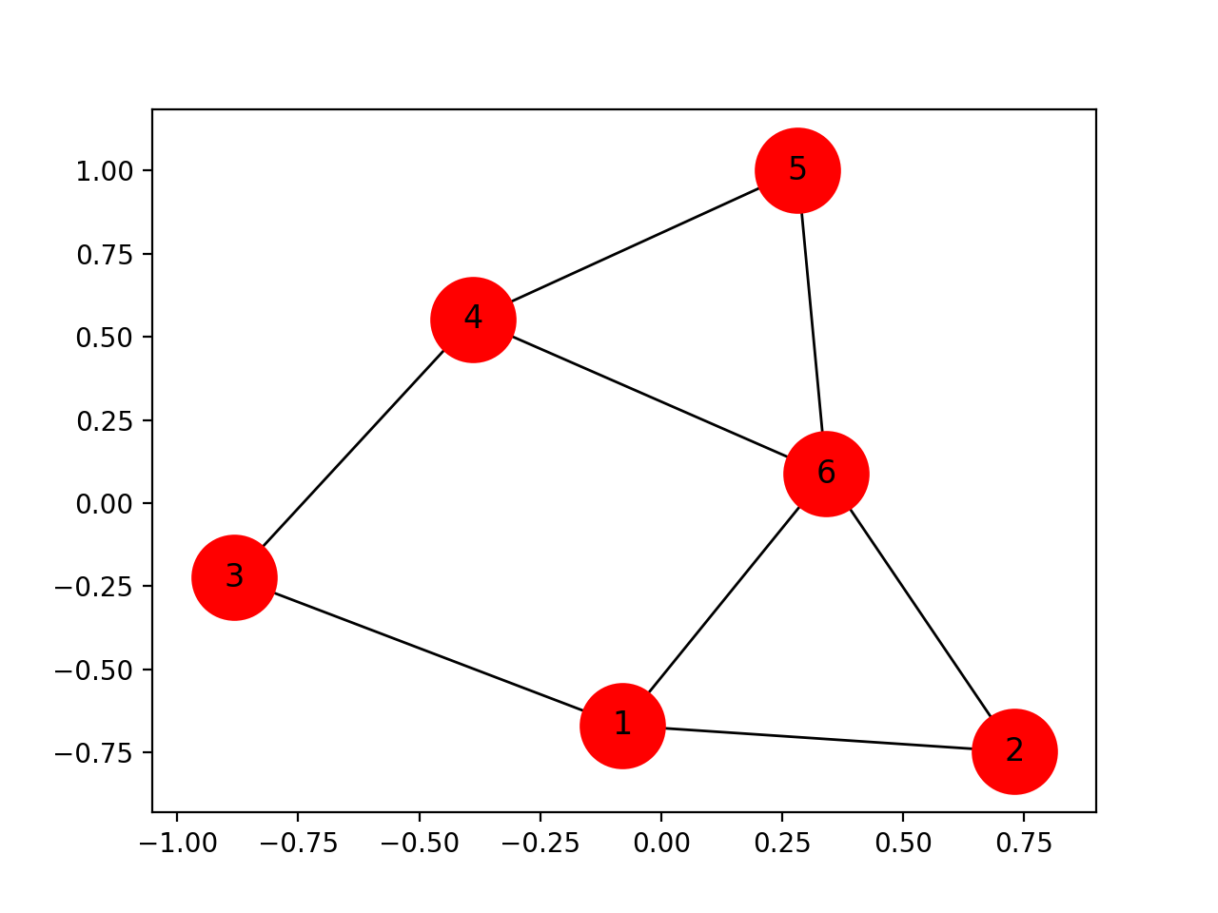
2.1) Calculate by hand
- Degree Centrality
- Betweeness Centrality
- Closeness Centrality

2.2) What is the diameter of this network?
2.3) Who would you target for collection? And why?
2.4 Who would you target for capture? Why?

3. Write a Python program using Networkx to build the above graph and compute:
- Degree Centrality
- Betweeness Centrality
- Closeness Centrality

