Assignment 6

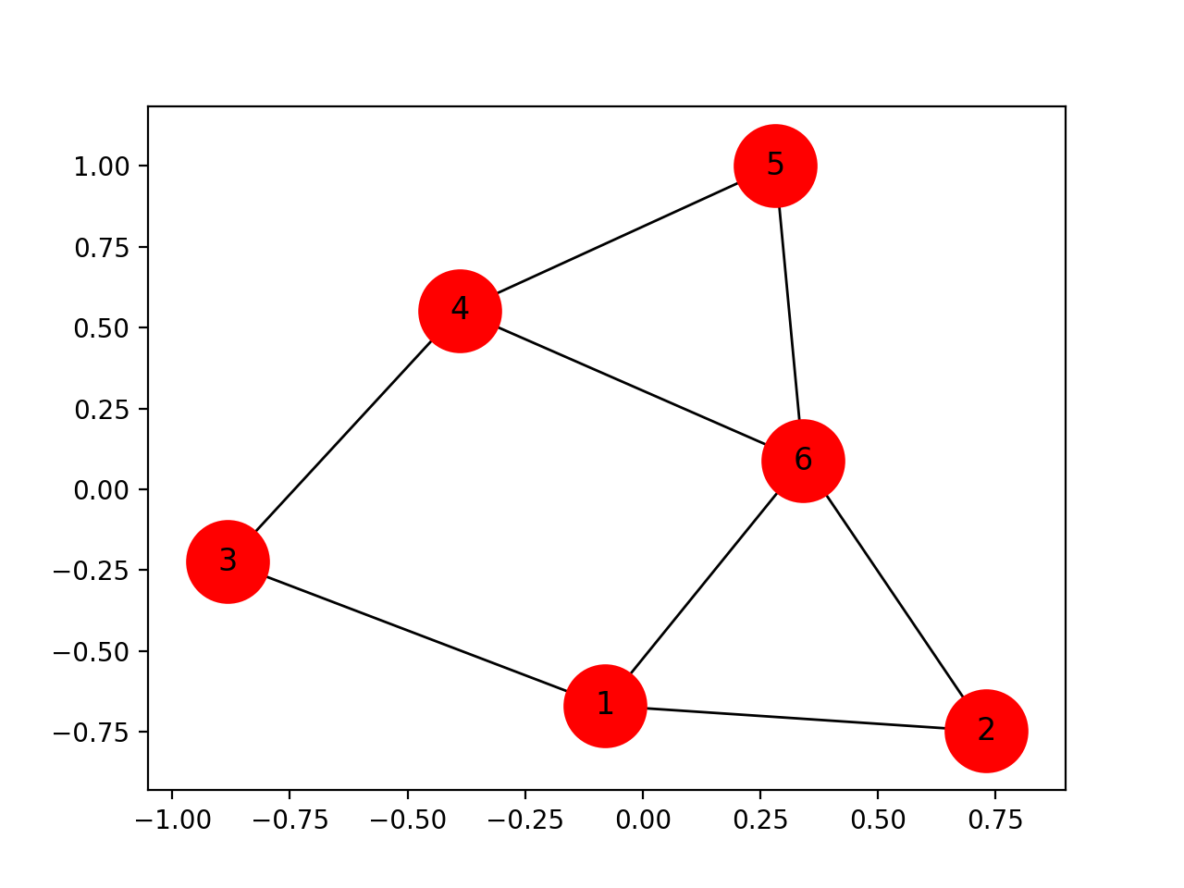
2) Calculate by hand
- Degree Centrality
- Betweeness Centrality
- Closeness Centrality

3) Write a Python program using Networkx to build the above graph to calculate:
- Degree Centrality
- Betweeness Centrality
- Closeness Centrality

