**JOHN SEBASTIAN ABLAY – A221 IM-ACTIVITY 11/21/22**

1.

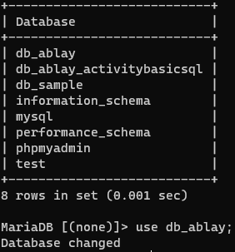

2.



4.



5.



6.



7.





8.

9.



10.

11.

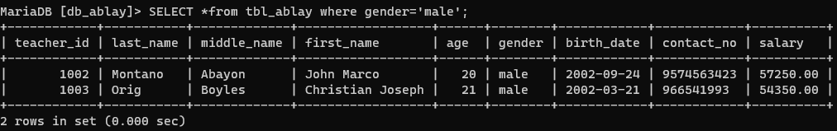

12.



13.

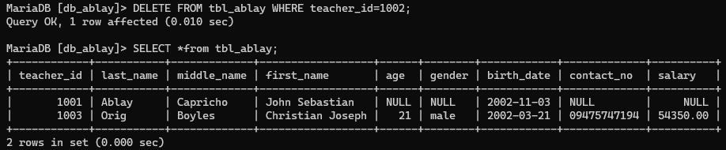

14.

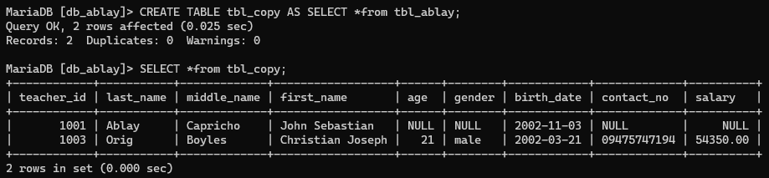

15.

