In the context of database application development (aka database engineering), what are the aims of data modeling?

* In the context of database application development, the objectives of imposing data modelling are to construct and establish relationship between entities in accordance with its business rules. This may also visualize the situation and what necessities the business must focus on to have A successful progress in achieving their goal. This is to produce high quality and steady data which are structured for operating business that can accomplish reliable results.

What is a business rule, and what is its purpose in data modeling?

* A business rule is a result from interviewing what the concept or vision of the clients. This identifies numerous concerns such as business policies, their intended practices, and valuable assets. This can be produced in both ways. These are Chen or Crow’s model. One of the purposes of business rule in data modelling is to affirm business structure or to advocate the behavior of the business. It can define the operations and present the possibilities of constraints a business had on its organization.

Create a data model based on the business rules that are as follows:

a. Each sales representative writes many invoices.

b. Each invoice is written by one sales representative.

c. Each sales representative is assigned to one department.

d. Each department has many sales representatives.

e. Each customer can generate many invoices.

f. Each invoice is generated by one customer.

4. Write a business rule based on the data model below, as shown.

**ADVISOR ← → STUDENT**

* Each advisor teaches many students. Each student must have one advisor.

**STUDENT ← → VEHICLE**

* Each student owns one vehicle. Each vehicle is owned by one student.

**STUDENT ← → CLASS**

* Each student can attend many classes. Each class can accommodate many students.

5. Researchers work on different research projects, and the connection between them can be modeled by a WorksOn relationship. Consider the following two different ER diagrams to represent this situation. Which do you think is the most appropriate model for this scenario?

Chosen model: Model A

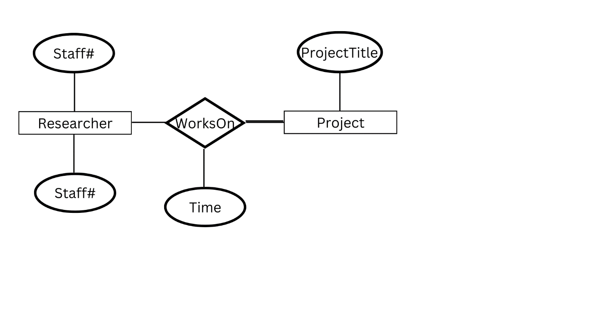

The more appropriate model for this scenario in my opinion is the model A. The time attribute is attached to the WorksOn relationship rather than Project. This means that the model associates both researcher and the project they have been working on. In essence, we measure the time the researchers have spent in making each project that they have been tasked with. Rather than the model B, in which the time is binded on the project, it does not actually specify what aspect of time it measures when compared to the first model.

|  |
| --- |
| **Insights:**  I have learned that having a concrete and stable knowledge about database application development helps with building a foundation with business rules. This lesson helps me realize that each possibility in terms of the situation a business might have is explored here to achieve stable results. This cannot be achieved if the company does not identify the needs of the client, so they must perform that to formulate their business rules. This will help them regulate their business behaviors. In constructing data models, I have learned how to assemble it with the given business rules, alongside identifying the necessary symbols to identify whether it would be **operational** or **mandatory**. Thus, connection within the entities is related within one another and will affect each and every one any other way. |