1. 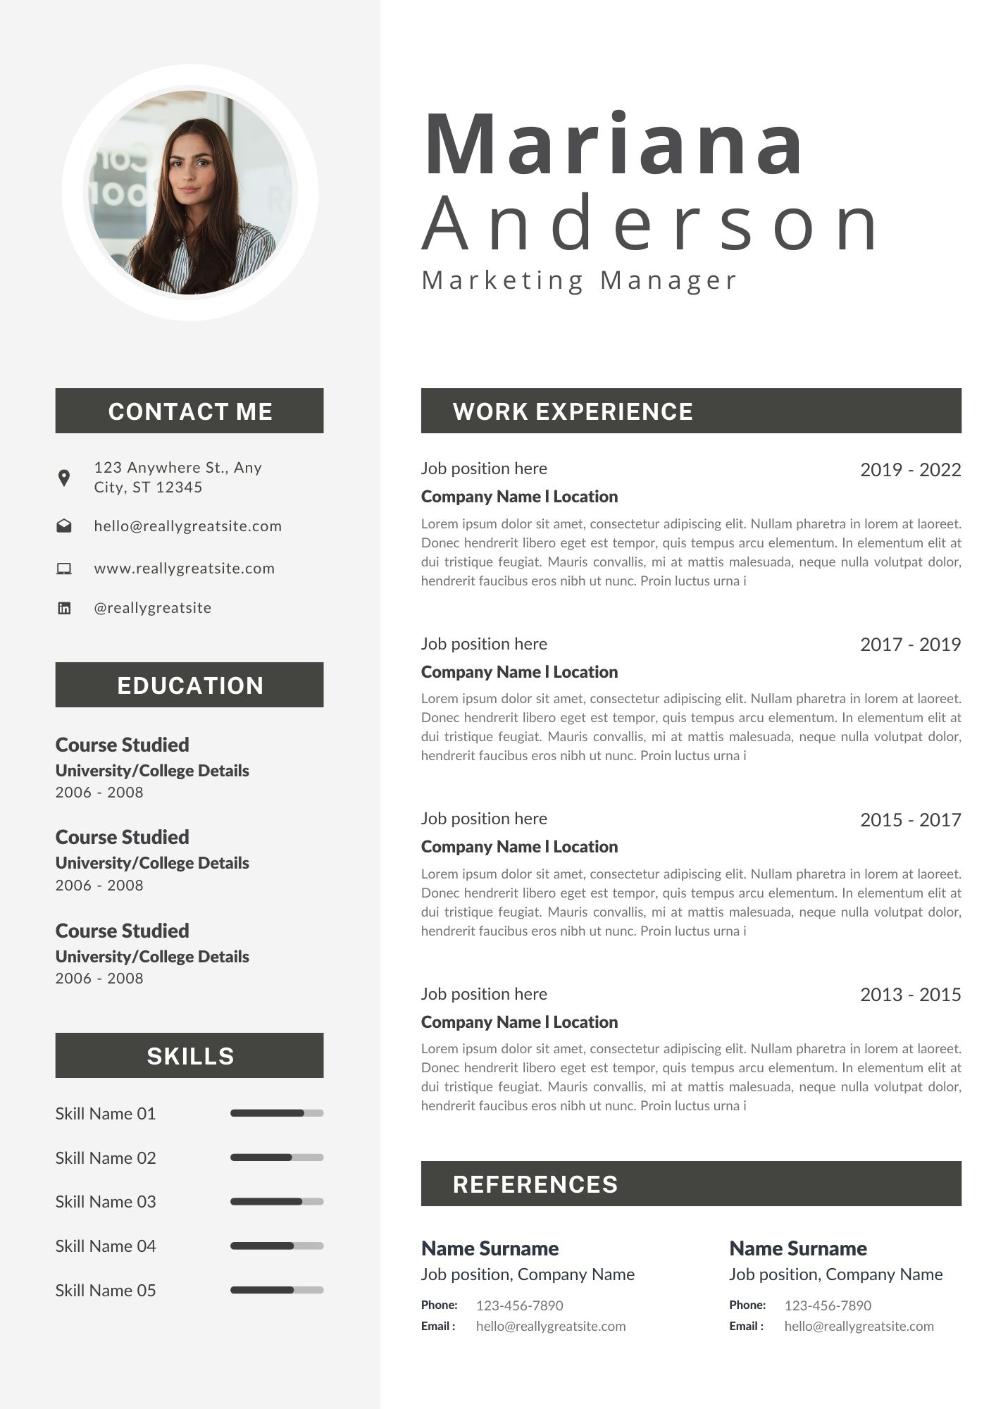Create a web page for your curriculum vitae using the following design. On the right column, some information about the markup and the visual presentation is provided.
   1. The tag requirements to utilize for the above design are as follows:
      1. Table
      2. Paragraph
      3. Font
      4. Background
      5. Img
      6. Br
      7. Black diagram