# My Budget App

## Javascript

Hey there! My wonderful technologists. I hope you’re excited to start your Javascript application. In this app we will implement different concepts of Javascript that you have learnt in class. If there are concepts you are unfamiliar with, go ahead go to your best friend, GOOGLE!

So here is a snap of what we are trying to build:

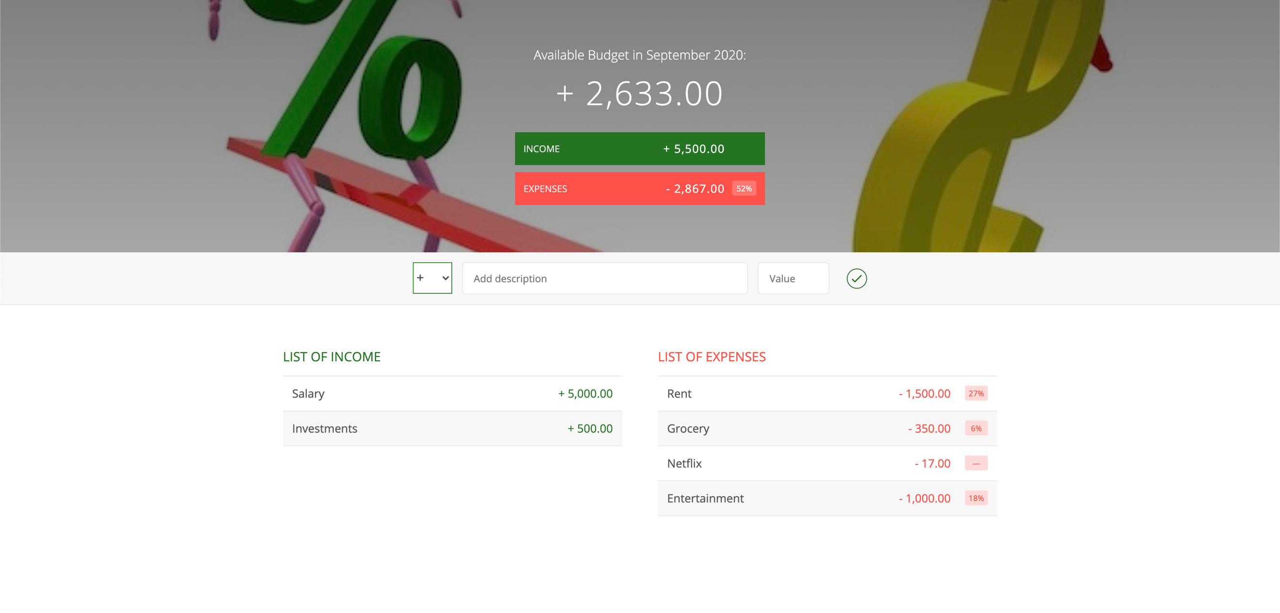

At this point go ahead create you git repo and initialize it.

And then take your starter project and get started with the code.

The starter project has a defined structure. Feel free to modify it based on your need. You are also given the HTML and CSS file

## Requirements:

1. The app should have the option of showing total Income and total Expense.
2. The app should let you add Income and subtract expenses
3. The add and subtract should be in form of a dropdown.
4. User should be able to view the income/expense once they add/subtract it

## Optional: Take it a step further:

1. Have the capability of removing income/ Expenses
2. Have the capability of which month the budget is being created for.
3. Change the design(HTML/CSS) and make the UI unique.