Meta Analysis: Research criteria

Contents:
Data.xlsx The extracted data from the papers
Meta_Papers.xlsx The documentation of the Screening Process according to PRISMA
MetaAnalysis_Zotero (Folder) Exported data of the unused Additional Screening
MetaAnalysis_BibTex (Folder Exported data of the unused Additional Screening

Identification:

Papers were identified through keyword search in web of science or as papers that were part of previous meta-analyses that dealt with similar research questions.

Screening:
The screening followed a process with several steps according to the guidelines for literature search proposed by the PRISMA 2020 statement.

Removal of duplicates:

All papers that have a duplicate DOI number. For papers without DOI number the title was used.
Also excluded papers that are reporting findings from other studies, that are already contained in our paper list.
Special case: Source paper -> marked as source under “relevant”

Eligibility

Inclusion criteria:
- Is the paper relevant?
  - Were plants inoculated with mycorrhizae or bacterial communities? Inside soil / ground, not some kind of agar growth medium etc.
  - Not relevant: Studies that solely inoculate a pathogen like root rot
  - Levels: yes / no / source -> one of the source papers / ? -> references some other potentially interesting studies
- Missing?
  - Was the full text of the paper available online?
  - Levels: yes / no / no translation / no access
- Commercial inoculum / single strains used?
  - Papers were excluded that solely performed inoculation with commercial or single strains.
  - Papers that do a comparison between commercial inocula and soil were included
  - Papers that used more than two individual fungal or bacterial strains in combination were included. Papers that performed a single or dual inoculation were excluded but prepared for a potential future data extraction.
  - Papers that used roots, leaf litter, microbial washes, rhizobia etc. were included. Papers that inoculated with biocrusts, nematodes, arthropods etc. were excluded.
  - Levels: single / commercial / dual inoculation / combination of single fungi (maybe change to single strains) /no
- Target variables?
  - As soon as any of the following target variables was measured and reported in the paper, it was included:
    - Plant height (cm)
    - Biomass (above ground, below ground or total)
    - Plant survival (%)
    - Plant cover (%)
    - Species richness
    - Shannon diversity
    - Germination%
  - Levels: yes / no
- Control?
  - Addition of sterilized field soil or no addition at all. Sterilization could happen via gamma-irradiation, autoclaving, etc. (-> it may be necessary to clarify what happens in the case of soil fumigation or fungicides as those have
  - Excluded reciprocal transplant experiments that perform inoculation of a soil with a home vs. away or conspecific vs. heterospecific setup and had no proper control.
  - Levels: yes / no

Inclusion of Papers:

Of the 1152 papers in the list originally, 108 were removed as duplicates which left 1044 papers. From these, 31 were missing(19), inaccessible(6) or were not published in English(6).
395 papers were not relevant, there are an additional 54 papers that use results from other studies or performed meta-analyses which might could be relevant as a source. These papers will have to be reevaluated in the future. Additionally, four of our source papers showed up in other sources and were therefore removed from further analysis.
This left 560 relevant papers which we further evaluated for the afore mentioned criteria.
The following papers were omitted:
11 used soil conditioning, 218 used single or dual inoculation, one didn’t report what kind of inoculum it used, 49 papers had no control, 45 had no target variables.
In the end, there were 236 papers for data extraction that fulfilled all criteria.
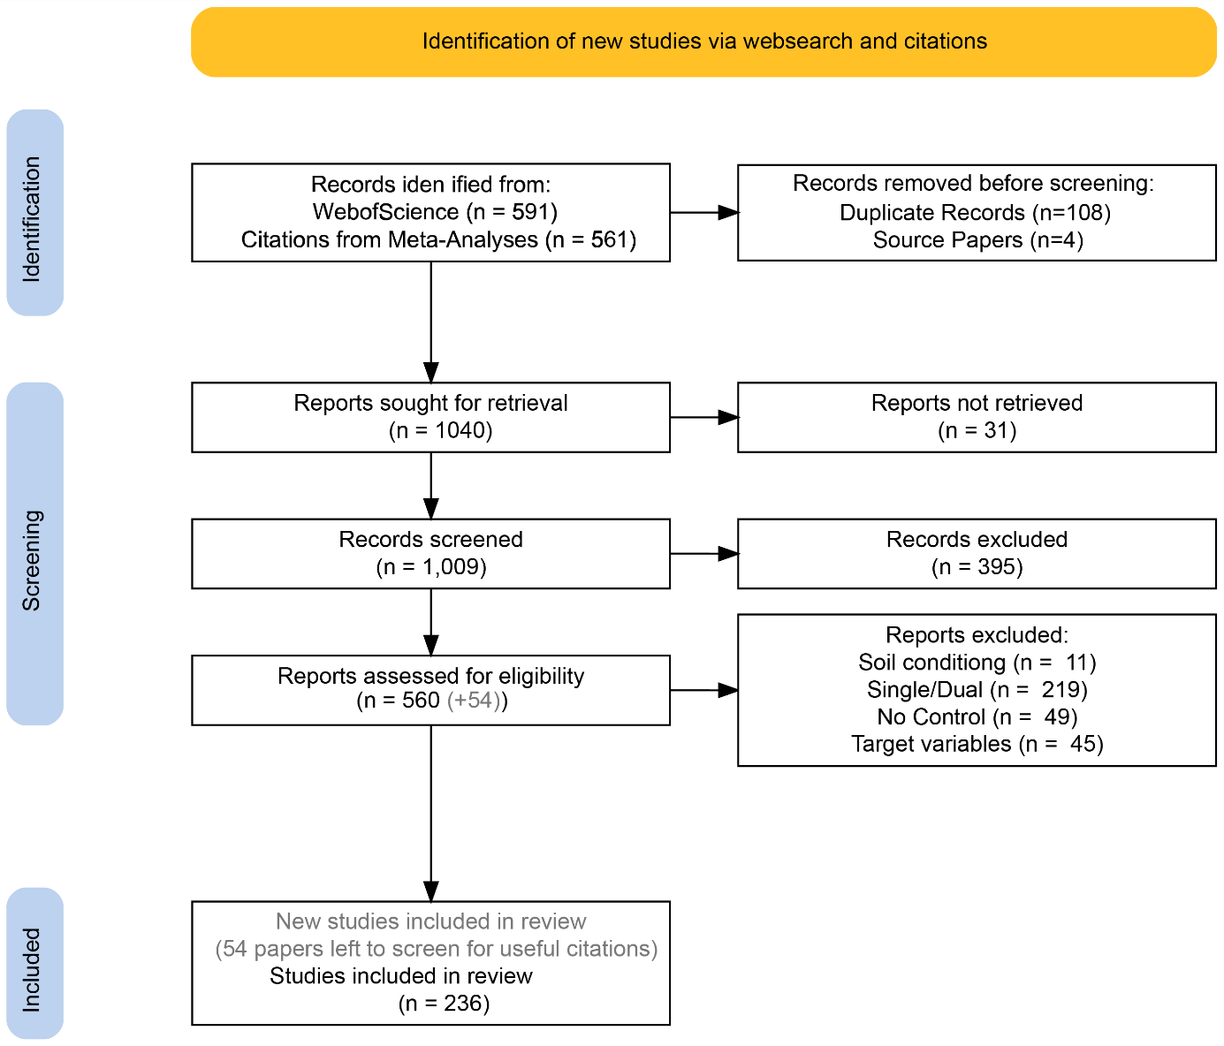

Other details:

Studies were included if text referenced relevant response variables in the supplementary material and the supplementary material was available.
For the extraction of data from graphs, WebPlotDigitizer-4.5 for Windows was used.

Explanation of the database (Meta_Papers.xlsx):
Rows 1-100 were screened and extracted by Eliane. The screening process of these papers was done again and documented here because the original screening was not documented. When the entries in the column “keep” are marked with color, there was a difference in the assessment, e.g. was screened as keep -> ”yes” in the new screening but not in the old screening and therefore not extracted. These entries need to be reevaluated and probably extracted.

Number: The number the paper had originally before the removal of duplicates.
DOI number
URL
Source: the Source of the paper as a number
List of Search queries and source used:

1:
Web of Science
"Soil inocul*" AND seedling
Searched: 07.04.2022

2:
Web of Science
"plant AND soil AND feedback AND inocul*"
Searched: 16.04.2022

3:
Is plant performance limited by abundance of arbuscular mycorrhizal fungi? A meta-analysis of studies published between 1988 and 2003
https://onlinelibrary.wiley.com/doi/abs/10.1111/j.1469-8137.2005.01490.x

4:
Home-field advantage? evidence of local adaptation among plants, soil, and arbuscular mycorrhizal fungi through meta-analysis
https://doi.org/10.1186/s12862-016-0698-9

5:
Sources of inocula influence mycorrhizal colonization of plants in restoration projects: a meta-analysis
https://onlinelibrary.wiley.com/doi/10.1111/rec.12231

6:
Ecotechnology as a tool for restoring degraded drylands: A meta-analysis of field experiments
https://www.sciencedirect.com/science/article/pii/S0925857413004126#tbl0015

7:
Benefits of mycorrhizal inoculation to ecological restoration depend on plant functional type, restoration context and time
https://www.sciencedirect.com/science/article/pii/S175450481830182X

8:
A meta-analysis of context-dependency in plant response to inoculation with mycorrhizal fungi
https://onlinelibrary.wiley.com/doi/abs/10.1111/j.1461-0248.2009.01430.x

9:
Sensitivity to AMF species is greater in late-successional than early-successional native or nonnative grassland plants
https://onlinelibrary.wiley.com/doi/abs/10.1002/ecy.2855

Relevant: Was the paper classified as relevant or not? Papers that are tagged with a question mark probably have some useful papers mentioned somewhere.
Missing: Is the paper available online, is it in English? Are there any access issues?
Treatment: Slightly unsystematic column to note if there is something special with the experimental design. For example, an experiment that also involves the inoculation of pathogens to see if mycorrhizae can inhibit pathogens. If the paper is not relevant and the treatment row says “pathogen inoculation”, the paper only performed pathogen inoculation and was therefore not relevant.
“Soil conditioning” is an exclusion criterion unlike “conditioned soil inoculation”. Soil conditioning means that following inoculation, one plant was planted in a pot to condition the soil community for that species and then another plant was added to the same pot in the existing AMF community following removal of the first plant. Conditioned soil inoculation on the other hand means that e.g. soil was added to a pot and a plant was added to condition the soil community to that specific plant. Afterwards the conditioned soil was used as inoculum source. Studies that do this qualify.
Commercial / Single: has some more tags now, refers to inoculum source that is either not commercial or from single strains -> “no” or used commercial or single inoculum (dual: two strains, combination of single fungi: Single strains added together upwards from two). Single means just one stain was used for inoculation. If the inoculum was from a commercial supplier, it will always be tagged as commercial even if it makes use of single strains.
Target variable: Are any target variables contained in the paper?
Response variables
Plant height (cm)
Plant biomass (g) <- Yield does also count (Amount of harvested grains, etc.)
Plant survival %
Plant cover %
(Plant) Species richness
(Plant) Shannon diversity
Germination %

Control: Was there a control for the inoculation?
Keep: Did paper fulfill all screening criteria?
Done: Finished data-extraction
Title
Abstract
Author
DataExtractionIssues: For papers that passed the screening but have some other issue that turned up during the data extraction, for example using soil fumigation as a control or non-extractable data due to the format of the data.
Further: Remarks about data that is still in the papers but wasn’t relevant for the current analysis – maybe in the future
Notes: Interesting stuff, problems, etc.

Explanation Extraction Database (Data.xlsx):

Excel
Sheet1: Data extracted by Seraina Nohl (03.07.2022)
Sheet2: Data extracted by Eliane Hirt (18.02.2022)
Unfortunately, there is no documentation of the screening process for the second sheet.

datapointID
DOI: Some papers don’t have DOIs, in that case it is just the link (jstor etc.)
inocType: For inoculum either “soil” or another source, “no” for no inoculum addition and “sterile” for the addition of sterilized inoculum as control
FieldGreenhouse: either “greenhouse”, “field” or “mesocosm” -> mesocosm mainly for pot experiments with several plant species or for pot experiments that were conducted outside in an experimental garden etc.
Treatment: The inoculum source used, other treatments
noteTreatments: some additional information like the supplier of a commercial inoculum
location: When possible, in coordinates, otherwise placename. Some studies don’t report their locations well.
Ecosystem: The specific ecosystem where the experiment took place, can be more specific like “dry perennial grassland”
EcoGeneral: The more general ecosystem for statistical analysis, mainly “grassland”, “forest” and “other” at the moment
EcoRegion: “Temperate”, “Tropical”, “Boreal” and “Subarctic” (difference between boreal and subarctic is not exactly clear, could possibly be fused). Roughly the border between temperate and tropical was assumed at 30°N/S and the border between subarctic and temperate around 60°, some papers with 58° classified themselves as boreal
FungalType: either “AM”, “EM” or “both”
dominantFungiSource: “paper” or “other”. If the paper did not report if the fungi used for inoculation were ecto- or arbuscular mycorrhizal, the dominant fungal type was estimated for either the reported mycorrhizal interactions of the used plant species or from DOI: 10.1038/s41467-019-13019-2 using the region and ecosystem
plantSoil: The soil to which inoculum was added, background soil, only if it is not mentioned in the treatments or somewhere else already
managed/restoration
LocationSoilData: The available location soil data,
priorLandUse: mostly for field experiments, greenhouse experiments often use potting material
plantSpecies
notes
IsLatestTimePoint: Some experiments recorded a time series. In that case all measurements that are not the latest point in the experiment are marked with 0.
comparisonGroup: For the statistical analysis, every difference in the treatment that is more than one factor from the inoculation treatment should be a new comparison group. For example:
- Comparison Group 1: Plant species 1, Inoculum A, B, Control
- Comparison Group 2: Plant species1, Inoculum A, B, Control, Fertilizer
- Comparison Group 3: Plant species 2, …
When possible, every comparison group should be 1:n inoculation treatments compared to one control, that makes it easier to calculate the inoculation effect.
Treatment2: 1 for any kind of inoculation, 0 for no inoculation/sterile control
soilOrigin: “con” or “hetero” if inoculum is from a conspecific or heterospecific plant
Time
TotBiomass: Total Biomass
TotBioError
AboveBio: Aboveground Biomass / shoot weight
AboveBioError
BelowBio: Belowground Biomass / root weight
BelowBioError
Yield: Some agricultural inoculation experiments don’t report biomass but some other Biomass related measure
BioErrorType: The Error Type, usually SE
biomassN: How many plants were measured
height
heightError
heightErrorType
heightN
CoverPerc: Cover Percent
CoverPercError
CoverPercErrorType
coverPercN
V2a: SpeciesRichness
V2a: Error
V2b: ShannonDiversity
V2b: Error
V2: ErrorType
V2: N
seedlingSurvPerc
seedlingSurvPercError
seedlingSurvPercErrorType
seedlingSurvPercN
LeafArea(cm^2)
LeafPhosphorous(mg/kgDryWeight)
BasalAreaGrowthSeedlings(mm^2)
Stem diameter
CommunityMycorrhizationIndex
EMFcolonization%
AMFcolonization%
Bray-CurtisDistance
NumberOfMycorrhizalRootTips
Mycorrhizal infection (%): AMF and EMF colonization were in the Dataset before, but often it is not reported what kind of mycorrhizae, so this was added -> some overlap. Whether AMF or EMF could also be assumed from FungalType
Germination%
NumberofGerminatedSeedlings: Some experiments that use e.g. Orchids with high seed numbers and low germination success report this instead of Germination% because it is not possible to say how many seeds were even sown

Additional Screening (MetaAnalysis_Zotero, MetaAnalysis_BibTex):
Additionally, a backward-search of 10 relevant papers (Citation) was performed at the beginning of the project. The search was then discontinued in favour of the previously mentioned search strategy.
The data of this search performed in Zotero (Citation) is available in various formats and could potentially be integrated in a future extended search as the methodology used in the screening process basically represents the "relevant"-criteria that was used in the main screening (Records screened -> Records excluded). Therefore the papers could be integrated in the screening process at the point: "Reports assessed for eligibility" after checking for duplicates to the existing dataset.
The screening included an abstract / text screening for papers that are relevant to the research (papers that performed inoculation with mycorrhizal fungi or a source of mycorrhizal inoculum like soil). The papers where then marked with tags according to their assessment.
The data is organized in Zotero the following way:
- Manual tags:
  - not relevant (161)
  - maybe (40)
  - missing information (9)
  - not relevant - title: Records excluded based on the title without abstract or text screening (26)
  - relevant - forest: Inoculation experiments related to forests (30)
  - relevant - other (116)
  - relevant - missing: same as "missing" criteria, no full-text access but abstract suggests papers are relevant (4)
- Related:
The citations of one of the 10 main papers show up in the related tab when looking at one of those papers inside the Zotero application. This is not complete for every entry as the data was not cleaned up after the screening due to the discontinuation.

