Duck War 1: The Quackening

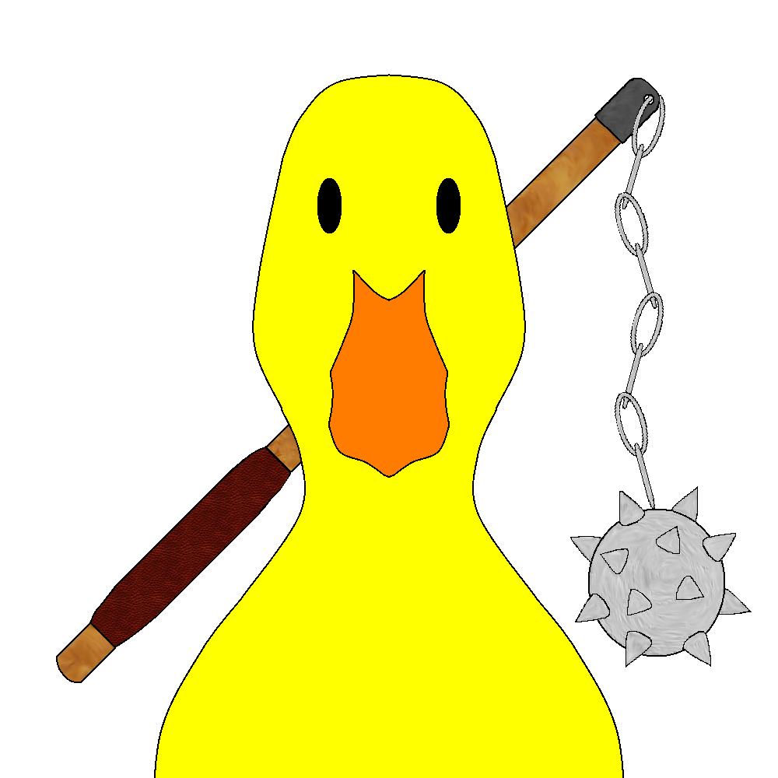

***‘Quack back at them, or get quacked”’*** – JN Games

This page: Table of Contents and Team Member Listing

|  |  |  |
| --- | --- | --- |
| Table of Contents  [1 Game Overview](https://n-xovwktmtjsnaxyc2mwes2xu7pohqedmdm6zjw5q-2lu-script.googleusercontent.com/userCodeAppPanel)  [2 High Concept](https://n-xovwktmtjsnaxyc2mwes2xu7pohqedmdm6zjw5q-2lu-script.googleusercontent.com/userCodeAppPanel) / Genre  [3 Unique Selling Points](https://n-xovwktmtjsnaxyc2mwes2xu7pohqedmdm6zjw5q-2lu-script.googleusercontent.com/userCodeAppPanel)  [4 Platform Minimum Requirements](https://n-xovwktmtjsnaxyc2mwes2xu7pohqedmdm6zjw5q-2lu-script.googleusercontent.com/userCodeAppPanel)  [5 Competitors / Similar Titles](https://n-xovwktmtjsnaxyc2mwes2xu7pohqedmdm6zjw5q-2lu-script.googleusercontent.com/userCodeAppPanel)  [6 Synopsis](https://n-xovwktmtjsnaxyc2mwes2xu7pohqedmdm6zjw5q-2lu-script.googleusercontent.com/userCodeAppPanel)  [7 Game Objectives](https://n-xovwktmtjsnaxyc2mwes2xu7pohqedmdm6zjw5q-2lu-script.googleusercontent.com/userCodeAppPanel)  [8 Game Rules](https://n-xovwktmtjsnaxyc2mwes2xu7pohqedmdm6zjw5q-2lu-script.googleusercontent.com/userCodeAppPanel)  [9 Game Structure](https://n-xovwktmtjsnaxyc2mwes2xu7pohqedmdm6zjw5q-2lu-script.googleusercontent.com/userCodeAppPanel)  [10 Game Play](https://n-xovwktmtjsnaxyc2mwes2xu7pohqedmdm6zjw5q-2lu-script.googleusercontent.com/userCodeAppPanel)  [10.1 Game Controls](https://n-xovwktmtjsnaxyc2mwes2xu7pohqedmdm6zjw5q-2lu-script.googleusercontent.com/userCodeAppPanel)  [10.2 Game Camera](https://n-xovwktmtjsnaxyc2mwes2xu7pohqedmdm6zjw5q-2lu-script.googleusercontent.com/userCodeAppPanel)  [10.2.1 HUD](https://n-xovwktmtjsnaxyc2mwes2xu7pohqedmdm6zjw5q-2lu-script.googleusercontent.com/userCodeAppPanel)  [10.2.2 Maps](https://n-xovwktmtjsnaxyc2mwes2xu7pohqedmdm6zjw5q-2lu-script.googleusercontent.com/userCodeAppPanel)  [11 Players](https://n-xovwktmtjsnaxyc2mwes2xu7pohqedmdm6zjw5q-2lu-script.googleusercontent.com/userCodeAppPanel)  [11.1 Characters](https://n-xovwktmtjsnaxyc2mwes2xu7pohqedmdm6zjw5q-2lu-script.googleusercontent.com/userCodeAppPanel)  [11.2 Metrics](https://n-xovwktmtjsnaxyc2mwes2xu7pohqedmdm6zjw5q-2lu-script.googleusercontent.com/userCodeAppPanel)  [11.3 States](https://n-xovwktmtjsnaxyc2mwes2xu7pohqedmdm6zjw5q-2lu-script.googleusercontent.com/userCodeAppPanel)  [11.4 Weapons](https://n-xovwktmtjsnaxyc2mwes2xu7pohqedmdm6zjw5q-2lu-script.googleusercontent.com/userCodeAppPanel)  [12 Player Line-up](https://n-xovwktmtjsnaxyc2mwes2xu7pohqedmdm6zjw5q-2lu-script.googleusercontent.com/userCodeAppPanel)  [13 NPC](https://n-xovwktmtjsnaxyc2mwes2xu7pohqedmdm6zjw5q-2lu-script.googleusercontent.com/userCodeAppPanel)  [13.1 Enemies](https://n-xovwktmtjsnaxyc2mwes2xu7pohqedmdm6zjw5q-2lu-script.googleusercontent.com/userCodeAppPanel)  [13.1.1 Enemy States](https://n-xovwktmtjsnaxyc2mwes2xu7pohqedmdm6zjw5q-2lu-script.googleusercontent.com/userCodeAppPanel)  [13.1.2 Enemy Spawn Points](https://n-xovwktmtjsnaxyc2mwes2xu7pohqedmdm6zjw5q-2lu-script.googleusercontent.com/userCodeAppPanel)  [13.2 Allies / Companions](https://n-xovwktmtjsnaxyc2mwes2xu7pohqedmdm6zjw5q-2lu-script.googleusercontent.com/userCodeAppPanel)  [13.2.1 Ally States](https://n-xovwktmtjsnaxyc2mwes2xu7pohqedmdm6zjw5q-2lu-script.googleusercontent.com/userCodeAppPanel)  [13.2.2 Ally Spawn Points](https://n-xovwktmtjsnaxyc2mwes2xu7pohqedmdm6zjw5q-2lu-script.googleusercontent.com/userCodeAppPanel)  [14 Art](https://n-xovwktmtjsnaxyc2mwes2xu7pohqedmdm6zjw5q-2lu-script.googleusercontent.com/userCodeAppPanel)  [14.1 Setting](https://n-xovwktmtjsnaxyc2mwes2xu7pohqedmdm6zjw5q-2lu-script.googleusercontent.com/userCodeAppPanel)  [14.2 Level Design](https://n-xovwktmtjsnaxyc2mwes2xu7pohqedmdm6zjw5q-2lu-script.googleusercontent.com/userCodeAppPanel)  [14.3 Audio](https://n-xovwktmtjsnaxyc2mwes2xu7pohqedmdm6zjw5q-2lu-script.googleusercontent.com/userCodeAppPanel)  [15 Procedurally Generated Content](https://n-xovwktmtjsnaxyc2mwes2xu7pohqedmdm6zjw5q-2lu-script.googleusercontent.com/userCodeAppPanel)  [15.1 Environment](https://n-xovwktmtjsnaxyc2mwes2xu7pohqedmdm6zjw5q-2lu-script.googleusercontent.com/userCodeAppPanel)  [15.2 Levels](https://n-xovwktmtjsnaxyc2mwes2xu7pohqedmdm6zjw5q-2lu-script.googleusercontent.com/userCodeAppPanel)  [15.3 Artificial Intelligence NPC](https://n-xovwktmtjsnaxyc2mwes2xu7pohqedmdm6zjw5q-2lu-script.googleusercontent.com/userCodeAppPanel)  [15.4 Visual Arts](https://n-xovwktmtjsnaxyc2mwes2xu7pohqedmdm6zjw5q-2lu-script.googleusercontent.com/userCodeAppPanel)  [15.5 Audio](https://n-xovwktmtjsnaxyc2mwes2xu7pohqedmdm6zjw5q-2lu-script.googleusercontent.com/userCodeAppPanel)  [15.6 Minimum Viable Product (MPV)](https://n-xovwktmtjsnaxyc2mwes2xu7pohqedmdm6zjw5q-2lu-script.googleusercontent.com/userCodeAppPanel)  [16 Wish List](https://n-xovwktmtjsnaxyc2mwes2xu7pohqedmdm6zjw5q-2lu-script.googleusercontent.com/userCodeAppPanel)  17 Bibliography   |  | | --- | |  | | Game Development Team Members    PRODUCER  Justin Ngo    PRODUCTION MANAGER  Justin Ngo    PRODUCTION COORDINATOR  Justin Ngo  GAME DESIGNERS  Justin Ngo  SYSTEMS/IT COORDINATOR  Justin Ngo  PROGRAMMERS  Justin Ngo  TECHNICAL ARTISTS  Justin Ngo  AUDIO ENGINEERS  Justin Ngo  UX TESTERS  Justin Ngo |

|  |
| --- |
|  |

# 1 Game Overview

Title: Goose War 1 : The Quackening

Platform: Windows 10

Genre: Tower Defense

Rating: (10+) ESRB

Target: Casual gamer (aging from 12 - 30)

Release date: November 2021

Publisher: JN Games

Description: Plunge into the war against the birds! Defend your tower from being pecked by geese and ducks.

# 2 High Concept / Genre

Genre: Tower Defense

This game is strictly a tower defense game. With each level, the towers that you go against become stronger and throw stronger units at you. Each level also introduces different terrain and obstacles for your units. Defeat the enemy tower(s) to win the level.

# 3 Unique Selling Points

Each environment that you face the opposing tower in will have randomized obstacles. It will not be playing the same game repeatedly. Rather than going against 1 tower, you will be able to go against multiple towers, where challenges are presented. Most importantly, this is a very light game, and it’s free.

# 4 Platform Minimum Requirements

Processor: Intel i3-6000 or better

Memory: 2 GB of RAM

Storage: 140 MB

Graphics: Integrated or better

OS: Windows 7,8,10 or Mac IOS

Network: none

# 5 Competitors / Similar Titles

Competitors: None found

Similar Titles: Battle Cats (on Apple/Android)

League of Legends

# 6 Synopsis

The force of the ducks awakens! Run through 5 different trials of the Quackening; show that the human forces can go face to face with the ducks and show them that your forces are superior!

# 7 Game Objectives

The objective is to beat all 5 levels in this game. To beat a level, you must send the enemy’s tower to 0 HP. Summoning units to destroy your opponent’s towers is the key to victory. Players are expected to complete each level in chronological order; a player cannot start the game for the first time and jump straight to level 5 (or > 1).

# 8 Game Rules

Most importantly, there exists 4 different types of units both you and the enemy can summon. These consist of:

* Idle
* Light
* Medium
* Heavy

units. Idle units are stationary and deal damage/slowness if the player runs into it. Light units are treated as infantry, being the first units the player can purchase (and also the enemy); they serve as a way to kill time, but they do not offer damage. Medium units are a balance of health, distance, and damage; being able to withstand a few hits while also a good amount of damage. Heavy units, as the name implies, does a lot of damage at longer distances; however, this comes with one drawback: low health.

Selecting “n” level will set up a level with “n” enemy towers. For example, if you start at the first level, you only go against 1 tower; if you do level 5, you go against 5 towers. Units summoned by the enemy tower depend on what the player has access to.

Accessing new units can be done in a shop. You win a certain number of credits every time you beat a level (after beating a level for the first time, you only gain 50% of the reward the next time you complete it).

# 9 Game Structure

Starting on the left side of the screen, the player will start at 0 credits and will start at a rate of 1 credit / sec. The player has access to light and idle units at the start. The player also has access to upgrading their credit rate. Most importantly, the player must be mindful of what the enemy tower(s) will be throwing at his/her tower.

# 10 Game Play

## 10.1 Game Controls

Players are encouraged to use the number keys:

- 1: Increase Income

- 2: Summon Idle Unit

- 3: Summon Light Unit

- 4: Summon Medium Unit

- 5: Summon Heavy Unit

## 10.2 Game Camera

### 10.2.1 HUD

**Main Menu**:

**Quit** – Quits the game

**Credits** – Access the Credits Page

**Levels** – Access the Levels Menu

**Shop** – Access the Shop Menu

**Credits**:

Displays information about the assets used to create this game.

**Back** – goes back to Main Menu

**Levels**:

Instructions are displayed in a small text box.

**Levels 1-5**: Takes you to the level corresponding to its number

**Back** – goes back to Main Menu

**Shop**:

**Top right corner** – number of credits the player has.

Icons of units will be displayed for buying. Clicking on the button will try to initiate a purchase. This purchase can be new units or upgrades for existing units. If the player does not have enough, then the purchase is rejected.

**Back** – goes back to Main Menu

**Levels 1-5**:

Top Left:

Health and number of Credits

Top Right:

Pause Button

Bottom:

Buttons for Idle, Light, Medium, and Heavy Units. They are grayed out until the player has access to them and has enough credits to buy them.

Center:

Win Message: displays a win message, shows the number of credits earned, and prompts the user to go back to the menu

Lose Message: displays a lose message and prompts the user to go back to the menu

### 10.2.2 Maps

N/A

# 11 Players

## 11.1 Characters

Player Tower, player’s units, and enemy counterparts to the player’s characters.

## 11.2 Metrics

Player HP, Enemy HP, Player Credits

## 11.3 States

Every Unit (except idle units):

- Move : moves the unit

- Attack : unit stops moving and starts attacking

- Death : Death Animation

- Stun : after a certain amount of damage, the unit becomes stunned, being unable to attack.

Every Tower:

- Attack : shoots a cannon towards any units attacking it.

## 11.4 Weapons

N/A

# 12 Player Line-up

Player is on the left side of the map, with an auto cannon that can only cover a certain radius. Unlike the enemy, the player can choose what units to summon, and the player can choose to upgrade/buy their units from the main menu (just for an advantage).

# 13 NPC

## 13.1 Enemies

### 13.1.1 Enemy States

See **11.3 States**

### 13.1.2 Enemy Spawn Points

Fixed, always to the right of the player’s spawnpoint

## 13.2 Allies / Companions

N/A

### 13.2.1 Ally States

N/A

### 13.2.2 Ally Spawn Points

N/A

# 14 Art

## 14.1 Setting

## 14.2 Level Design

Level Design is from Justin Ngo. Background obtained by opengameart.org.

## 14.3 Audio

See **15.5 Audio**

# 15 Procedurally Generated Content

## 15.1 Environment

All menu screens and menu backgrounds are created by Justin Ngo. Level Backgrounds are from opengameart.org. Towers, button icons, and art for some of the units are created by Justin Ngo

## 15.2 Levels

Levels are constant, but will be filled with different numbers of towers.

## 15.3 Artificial Intelligence NPC

Units are summoned by a random number.

## 15.4 Visual Arts

All physics are done via Unity. Sprites and animations from opengameart.org and Justin Ngo

## 15.5 Audio

Audio is from kenney.nl and various recordings by Justin Ngo.

## 15.6 Minimum Viable Product (MPV)

# 16 Wish List

N/A

## 17 Bibliography

1. **Menu Backgrounds:**
   * Created by Justin Ngo
2. **Level 1-5 Game Background**
   * Artwork by Luis Zuno (@ansimuz)  
     Copyright under a CCO License  
     <https://opengameart.org/content/mountain-at-dusk-background>  
     <https://opengameart.org/content/forest-background>  
     <https://opengameart.org/content/industrial-parallax-background>
3. **Tower Sprites:**
   * Created by Justin Ngo
4. Human Units:
   * Used sanderfrenken Universal LPC Character Generator  
     Original Sprites from opengameart.org and Liberated Pixel Cup.  
     Artwork is under a CC-BY-SA 3.0 License.  
     <https://sanderfrenken.github.io/Universal-LPC-Spritesheet-Character-Generator/#>
5. Duck Units:
   * Artwork by Marcos (@Ulti)  
     Copyright under a CCO License  
     <https://opengameart.org/content/character-spritesheet-duck>
6. Game Logo Art:
   * Created by Justin Ngo
7. **Art Software Used:** GIMP, Paint Dot Net, Paint 3D
8. **Audio Software Used:** Microsoft Applications, Audacity
9. **Game Created with:** Unity Engine Version 2020.3.17f1
10. **Code/Scripts Created with**: Visual Studio 2019 Community Edition, C#
11. **Additional Sources Used**:
    * Brackeys (Youtube Channel)
    * Unity Forums
    * Unity Docs