准备清单

1. 环境准备

* 安装环境， 下载地址：<https://www.anaconda.com/download/>， 请下载左下角Python 3.6版本
* 安装

点击安装后请注意更改安装路径如下

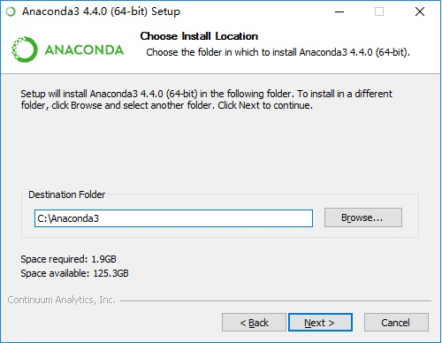

安装完毕后在开始菜单中启动”Jupyter Notebook”

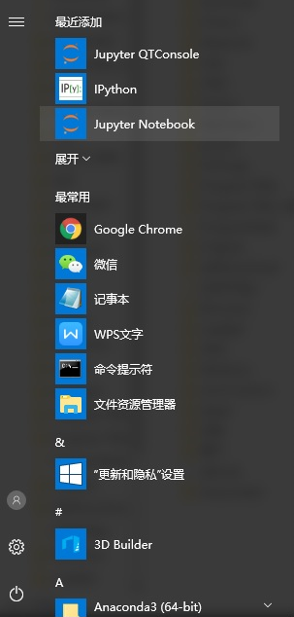

启动后默认浏览器会打开新页面，在新页面中点击右上角”new”-->”Python 3”

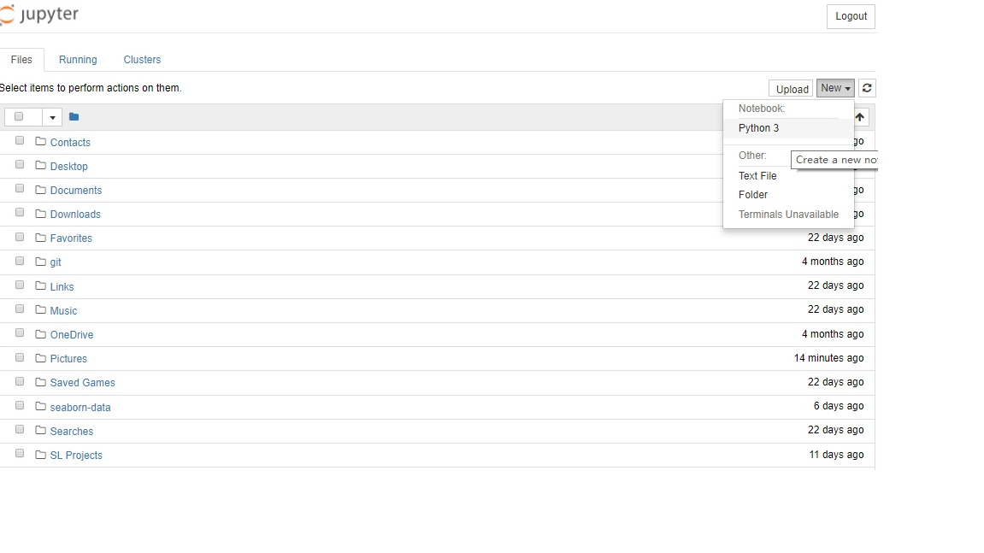

在新开页面中输入以下代码

import numpy as np

import seaborn as sns

import matplotlib.pyplot as plt

sns.set(style="white", context="talk")

rs = np.random.RandomState(7)

# Set up the matplotlib figure

f, (ax1, ax2, ax3) = plt.subplots(3, 1, figsize=(8, 6), sharex=True)

# Generate some sequential data

x = np.array(list("ABCDEFGHI"))

y1 = np.arange(1, 10)

sns.barplot(x, y1, palette="BuGn_d", ax=ax1)

ax1.set_ylabel("Sequential")

# Center the data to make it diverging

y2 = y1 - 5

sns.barplot(x, y2, palette="RdBu_r", ax=ax2)

ax2.set_ylabel("Diverging")

# Randomly reorder the data to make it qualitative

y3 = rs.choice(y1, 9, replace=False)

sns.barplot(x, y3, palette="Set3", ax=ax3)

ax3.set_ylabel("Qualitative")

# Finalize the plot

sns.despine(bottom=True)

plt.setp(f.axes, yticks=[])

plt.tight_layout(h_pad=3)

plt.show()

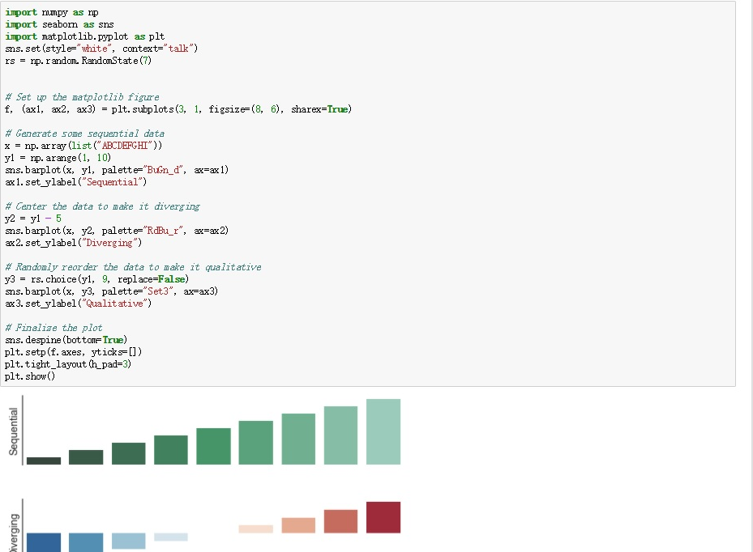

恭喜你，你已经的环境已正确安装并且在新环境中首个报表

1. 数据准备

链接:https://pan.baidu.com/s/1o8DWczg 密码:17er

链接:https://pan.baidu.com/s/1pLyvct9 密码:alww

链接:https://pan.baidu.com/s/1slQHpa1 密码:vnp0