🫁 PNEUMONIA DETECTION
FROM CHEST X-RAYS USING DEEP LEARNING

EfficientNetB3 | Transfer Learning + Fine-Tuning | Grad-CAM Explainability
Binary Classification: Normal vs Pneumonia
Model | EfficientNetB3 (ImageNet)
Dataset | Kaggle Chest X-Ray (5,863 images)
Test Accuracy | 94.87%
Recall (Sensitivity) | 97.44%
AUC-ROC | 0.9686

April 2025

1. Pneumonia: Disease Overview
Pneumonia is an acute inflammatory condition of the lung parenchyma, typically caused by infection from bacteria, viruses, or fungi. It results in the filling of the alveoli — the tiny air sacs of the lungs — with fluid, pus, or cellular debris, impairing the exchange of oxygen and carbon dioxide. Pneumonia is one of the leading causes of death worldwide, particularly among children under five years of age and adults over 65.
According to the World Health Organization (WHO), pneumonia accounts for 14% of all deaths in children under 5, claiming the lives of approximately 740,000 children annually. In adults, it is a significant cause of hospitalization and intensive care unit (ICU) admissions globally. The COVID-19 pandemic further highlighted the devastating potential of pneumonia-type infections on the respiratory system.

1.1 Types of Pneumonia
Pneumonia is broadly classified by its causative agent and the radiological appearance it produces on chest X-rays:
- Bacterial Pneumonia: The most common form, typically caused by Streptococcus pneumoniae. It presents as lobar consolidation — a dense opacity filling an entire lobe. Air bronchograms (visible bronchi within the consolidation) are characteristic. It tends to affect immunocompromised patients and the elderly.
- Viral Pneumonia: Caused by influenza, RSV, COVID-19, or SARS-CoV. Appears as bilateral ground-glass opacities and interstitial infiltrates (net-like patterns) rather than focal consolidation. COVID-19 pneumonia typically shows peripheral ground-glass opacities predominantly in lower lobes.
- Atypical Pneumonia: Caused by organisms such as Mycoplasma pneumoniae or Chlamydia. Produces diffuse, bilateral interstitial infiltrates and perihilar haziness. Symptoms are milder than typical bacterial pneumonia.
- Aspiration Pneumonia: Occurs when foreign material is inhaled into the lungs. Shows patchy infiltrates in dependent segments (lower lobes and posterior segments).
- Fungal Pneumonia: Caused by organisms like Pneumocystis jirovecii (PCP) in immunocompromised patients. Shows bilateral interstitial infiltrates often indistinguishable from viral pneumonia on X-ray.

1.2 Radiological Features on Chest X-Ray
Chest X-ray (CXR) is the primary and most cost-effective imaging modality for pneumonia diagnosis. The following visual features are the key targets that an AI model must learn to detect:

Feature | Appearance on X-Ray | Associated Type | Clinical Significance
Lobar Consolidation | Dense uniform white area in one lobe | Bacterial | High — indicates lobar infection
Air Bronchograms | Dark branching bronchi in white opacity | Severe Bacterial | Confirms alveolar filling
Bilateral Infiltrates | Patchy spots across multiple lobes | Bronchopneumonia / Viral | Diffuse infection
Ground-Glass Opacity | Hazy increase in lung density | Viral (COVID-19) | Early or mild involvement
Interstitial Infiltrates | Diffuse net-like / reticular pattern | Viral / Atypical | Interstitial inflammation
Pleural Effusion | White fluid at lung base | Severe / Complicated | Parapneumonic effusion
Silhouette Sign | Loss of heart/diaphragm border | Adjacent Consolidation | Localizes disease
Perihilar Haziness | Hazy area around hilum | Atypical | Central pattern infection

A critical distinction: a normal chest X-ray shows clear, dark lung fields bilaterally with sharp costophrenic angles, distinct cardiac borders, and no areas of increased opacity. Any whitening, haziness, or loss of normal lung architecture should raise suspicion of pathology.

2. Methods of Pneumonia Detection

2.1 Traditional Clinical Methods
Historically, pneumonia diagnosis relies on a combination of clinical examination and imaging. The traditional pathway involves:
- Physical Examination: Auscultation for crackles, decreased breath sounds, and dullness on percussion. Vital signs including fever, tachypnea, and hypoxia.
- Laboratory Tests: Complete blood count (elevated WBC indicates infection), blood cultures, sputum cultures, and PCR testing for specific pathogens.
- Chest X-Ray (CXR): The gold standard first-line imaging. Sensitivity ~47-77%, specificity ~58-89%. Limited by reading variability between radiologists, especially for early or subtle presentations.
- CT Scan of Chest: Higher sensitivity and specificity than CXR but involves significant radiation exposure and cost. Reserved for complex or atypical cases.
- Lung Ultrasound: Increasingly used at point-of-care. Detects consolidation and pleural effusion but operator-dependent.

2.2 Limitations of Manual Interpretation
Manual interpretation of chest X-rays is fraught with challenges that create a compelling case for AI-assisted detection:
- Inter-observer variability: Studies show radiologists disagree on pneumonia diagnosis in 10-30% of cases, especially for early-stage or viral pneumonia.
- Radiologist shortage: In low-income countries, the ratio of radiologists to population can be as poor as 1:500,000, creating massive diagnostic bottlenecks.
- Fatigue and cognitive load: Radiologists reading hundreds of images daily are subject to fatigue-induced errors, particularly in emergency settings.
- Subtle early findings: Early pneumonia may show only minimal infiltrates that are easily missed, especially on portable or low-quality radiographs.
- Overlap with other conditions: Pulmonary edema, lung cancer, atelectasis, and tuberculosis can produce similar X-ray patterns, complicating differential diagnosis.

2.3 Artificial Intelligence and Deep Learning Approaches
The advent of deep learning, particularly Convolutional Neural Networks (CNNs), has transformed the landscape of medical image analysis. AI-based approaches for pneumonia detection have demonstrated remarkable performance:
- CheXNet (Stanford, 2017): A 121-layer DenseNet trained on 112,120 chest X-rays that surpassed radiologist-level performance on pneumonia detection, achieving an F1-score of 0.435 compared to 0.387 for radiologists.
- Transfer Learning: Models pretrained on large natural image datasets (ImageNet) are fine-tuned on medical images. This approach overcomes the limitation of small medical datasets and achieves high performance with fewer training examples.
- Ensemble Methods: Combining predictions from multiple CNN architectures (VGG16, ResNet, DenseNet, InceptionV3, EfficientNet) consistently outperforms single models.
- Attention Mechanisms: Spatial and channel attention modules help models focus on clinically relevant regions, improving both accuracy and interpretability.
- Vision Transformers (ViT): Emerging as a promising alternative to CNNs, capturing long-range dependencies in images but requiring large datasets.
- Grad-CAM and Explainability: Gradient-weighted Class Activation Maps visualize which regions of the X-ray drove the model's prediction, enabling clinical validation and trust.

3. Our Approach: EfficientNetB3 with Grad-CAM

3.1 Why EfficientNetB3?
Among available CNN architectures, EfficientNetB3 was selected as the base model for the following reasons:
- Compound Scaling: EfficientNet models scale depth, width, and resolution simultaneously using a compound coefficient, resulting in superior accuracy-to-parameter ratios compared to VGG, ResNet, or Inception.
- Parameter Efficiency: EfficientNetB3 achieves competitive accuracy with approximately 12M parameters, compared to VGG16's 138M. This translates to faster training, lower memory requirements, and better suitability for clinical deployment.
- Proven Medical Imaging Performance: EfficientNet variants consistently rank among the top performers on medical image classification benchmarks, including chest X-ray classification tasks.
- Input Resolution: EfficientNetB3's native 300×300 input resolution preserves more spatial detail from X-ray images than 224×224 models, critical for detecting subtle infiltrates.

Architecture | Parameters | Input Size | Top-1 ImageNet Acc
VGG16 | 138M | 224×224 | 71.5%
ResNet50 | 25.6M | 224×224 | 76.0%
InceptionV3 | 23.8M | 299×299 | 78.8%
DenseNet121 | 8.0M | 224×224 | 74.4%
EfficientNetB3 ✓ | 12.0M | 300×300 | 81.6%

3.2 Model Architecture
The final model follows a Transfer Learning architecture with a custom classification head appended to the frozen EfficientNetB3 backbone:

Layer / Component | Output Shape | Details
Input | 300 × 300 × 3 | CLAHE preprocessed, EfficientNet normalised
EfficientNetB3 Base | 9 × 9 × 1536 | ImageNet pretrained, 10.7M params
GlobalAveragePooling2D | 1536 | Spatial pooling over feature maps
BatchNormalization | 1536 | Stabilise activations
Dense(512, ReLU) | 512 | Dropout 0.40
Dense(256, ReLU) | 256 | Dropout 0.30
Dense(1, Sigmoid) | 1 | P(Pneumonia) output

3.3 Two-Phase Training Strategy
Training was conducted in two distinct phases to leverage the pretrained ImageNet features while adapting the model to medical X-ray imagery:

Phase 1 — Feature Extraction
The EfficientNetB3 base was entirely frozen. Only the classifier head (Dense layers) was trained. This allowed the model to learn how to map high-level ImageNet features to pneumonia vs. normal classification without disturbing the pretrained feature detectors. Learning rate was set to 1e-3 with Adam optimizer.

Phase 2 — Fine-Tuning
The last 40 layers of EfficientNetB3 were unfrozen and trained alongside the classifier head. A very small learning rate of 1e-5 was used to gradually adapt the high-level convolutional filters to X-ray texture patterns — specifically the opacities, consolidations, and infiltrates characteristic of pneumonia — without catastrophic forgetting of earlier features.

3.4 CLAHE Preprocessing
Before feeding images to the model, Contrast Limited Adaptive Histogram Equalization (CLAHE) was applied to every image. CLAHE enhances local contrast in a way that amplifies subtle radiological features that are critical for pneumonia detection:
- Consolidations: Dense white opacities become more distinct from surrounding tissue
- Air bronchograms: Dark branching within white areas become visible
- Interstitial infiltrates: Faint net-like patterns in the lung fields are enhanced
- Ground-glass opacities: Hazy increases in density become more perceptible

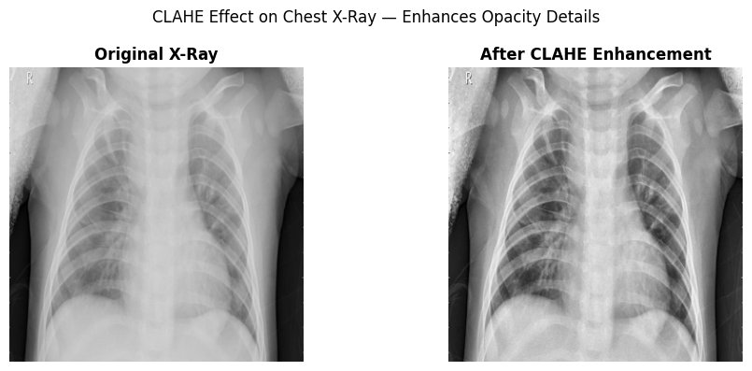
Figure 1: Effect of CLAHE preprocessing on a chest X-ray. Left: original image. Right: CLAHE-enhanced image showing improved local contrast that highlights lung opacity details.

3.5 Handling Class Imbalance
The dataset contained 3,875 pneumonia images vs 1,341 normal images — a 2.89:1 imbalance ratio. Without correction, the model would be biased toward predicting pneumonia. Two strategies were employed:
- Class Weights: Computed using sklearn's compute_class_weight("balanced"), higher weight was assigned to the NORMAL class during loss computation, penalizing misclassification of normal cases more heavily.
- Data Augmentation: Random horizontal flips, rotation (±10°), zoom (±10%), and brightness variation (±20%) were applied to training images. Vertical flip was deliberately excluded to preserve lung anatomy orientation.

4. Dataset

4.1 Dataset Description
The dataset used is the publicly available "Chest X-Ray Images (Pneumonia)" dataset published by Paul Mooney on Kaggle, originally sourced from Guangzhou Women and Children's Medical Center. It consists of 5,863 chest X-ray images of pediatric patients (ages 1-5 years) in JPEG format, organized into three splits:

Split | NORMAL | PNEUMONIA
Train | 1,341 | 3,875
Validation (Kaggle) | 8 | 8
Test | 234 | 390

Note: The Kaggle validation set contains only 16 images (8 per class), which is insufficient for reliable validation monitoring. For this reason, we implemented a 90/10 internal split of the training set — using 90% for training and 10% (approximately 520 images) as the validation set — providing statistically meaningful validation feedback during training.

4.2 Class Distribution
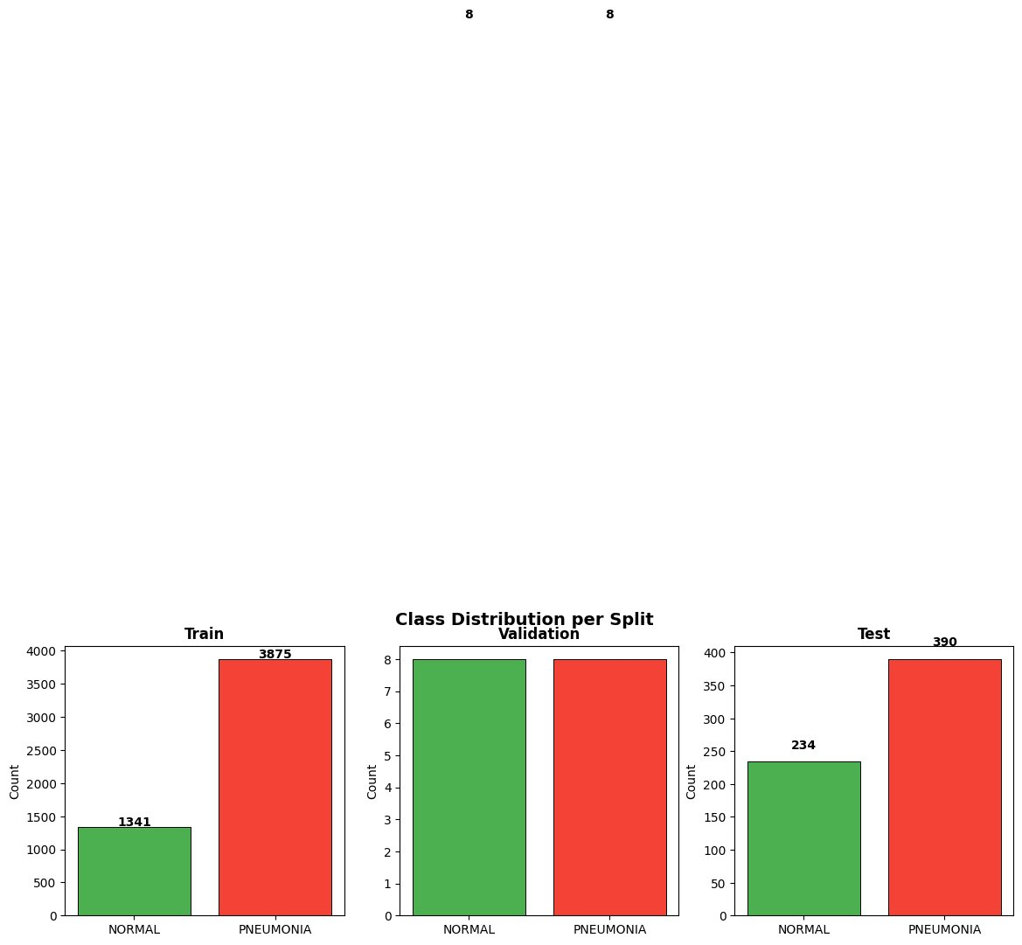
Figure 2: Class distribution across train, validation, and test splits. The 2.89:1 training imbalance (Pneumonia:Normal) was addressed using class weights.

4.3 Sample X-Ray Images
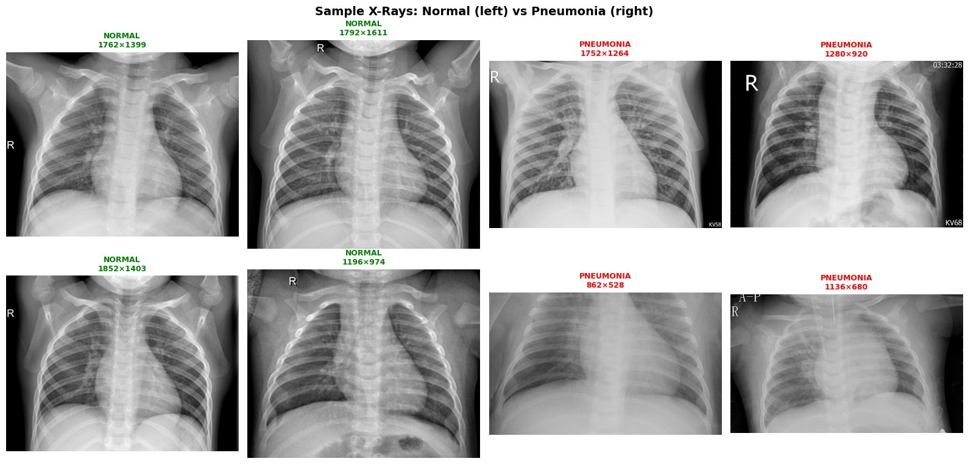
Figure 3: Sample chest X-rays from the dataset. Left two columns: NORMAL lungs (clear, dark lung fields, sharp borders). Right two columns: PNEUMONIA lungs showing characteristic white opacities, consolidations, and infiltrates.

5. Training Process

5.1 Training Configuration
Parameter | Phase 1 | Phase 2 | Rationale
Base Model | Fully Frozen | Last 40 layers unfrozen | Gradual adaptation
Learning Rate | 1e-3 | 1e-5 | Prevents catastrophic forgetting
Max Epochs | 20 | 30 | EarlyStopping prevents overfitting
Batch Size | 32 | 32 | GPU memory optimized
Optimizer | Adam | Adam | Adaptive learning rates
Loss Function | Binary Cross-Entropy | Binary Cross-Entropy | Binary classification
Early Stop Monitor | val_recall | val_recall | Medical recall priority
Epochs Trained | 6 | 11 | EarlyStopping triggered

5.2 Phase 1 — Feature Extraction Training Curves
During Phase 1, only the classifier head was trained. The validation loss consistently decreased below training loss, indicating good generalization. Validation AUC reached 0.995 by epoch 3, demonstrating the strength of ImageNet pretrained features for detecting radiological patterns.
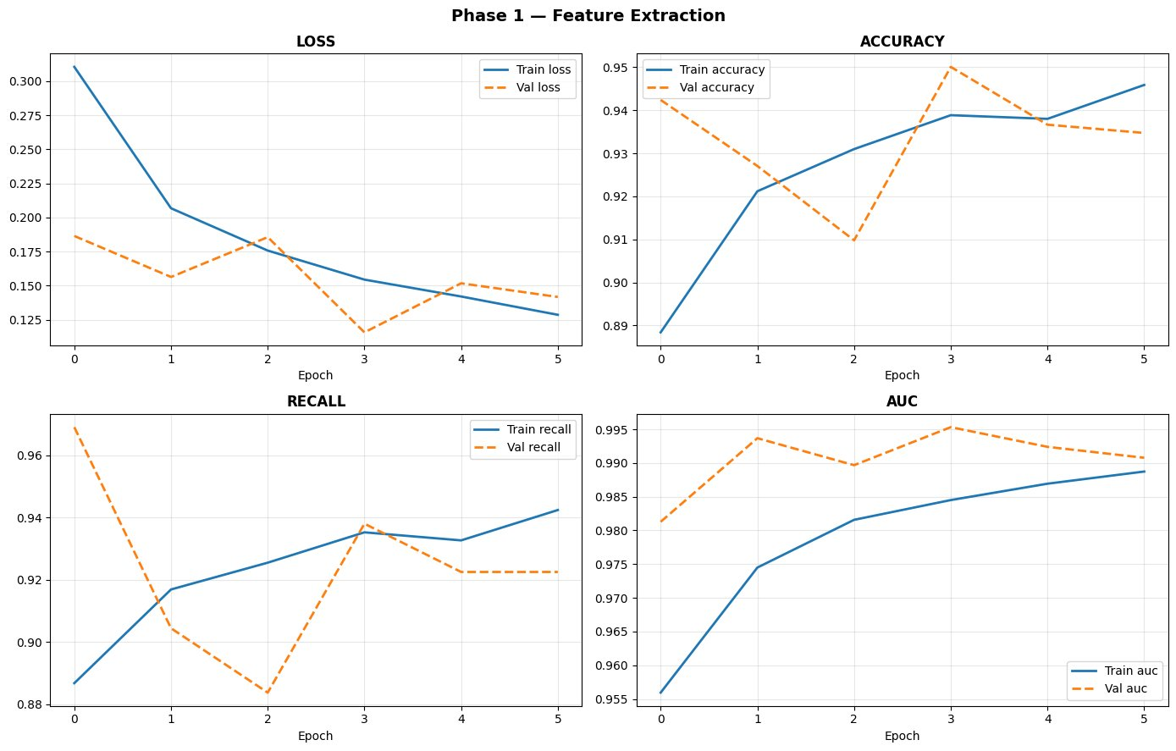
Figure 4: Phase 1 training curves showing loss, accuracy, recall, and AUC for both training (solid blue) and validation (dashed orange) sets. Validation metrics outperform training metrics — a healthy sign of good generalization.

5.3 Combined Phase 1 & Phase 2 Training Curves
Phase 2 fine-tuning further improved all metrics. Training loss continued to decrease while validation metrics remained stable, confirming that the fine-tuning successfully adapted the convolutional filters to X-ray texture patterns without overfitting.
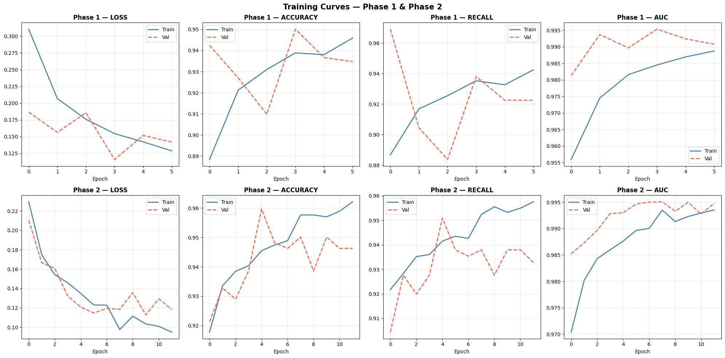
Figure 5: Complete training curves across both phases. Phase 1 (top row) shows rapid initial learning. Phase 2 (bottom row) shows incremental improvement through fine-tuning, with training and validation curves converging.

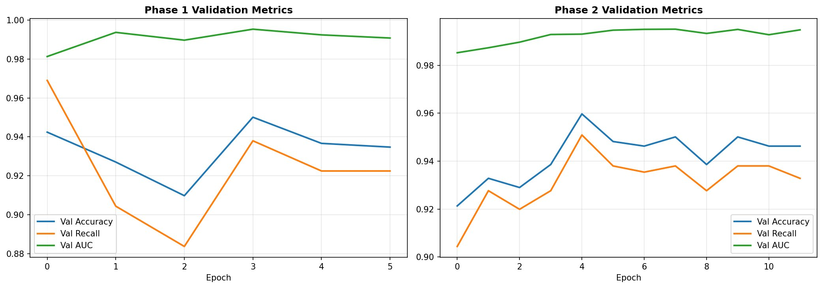
Figure 6: Validation Accuracy, Recall, and AUC across both training phases. AUC (green) consistently above 0.98 throughout training. Recall (orange) steadily improving, reaching 0.95+ in Phase 2.

6. Evaluation Results

6.1 Final Test Metrics
After both training phases, the best model (selected by highest validation recall) was evaluated on the held-out test set of 624 images (234 Normal + 390 Pneumonia). An optimal classification threshold of 0.70 was selected via Precision-Recall curve analysis to achieve the target recall of ≥95%:

Metric | Value | Threshold | TP / FN | Interpretation
Accuracy | 94.87% | 0.70 | — | Overall correct predictions
Recall | 97.44% | 0.70 | 371 / 19 | Sensitivity — most critical
Precision | 89.16% | 0.70 | — | Of predicted positive, correct
F1-Score | 0.9312 | 0.70 | — | Harmonic mean P & R
AUC-ROC | 0.9686 | — | — | Discriminability score

The 97.44% recall is the most clinically important metric — it means only 19 out of 390 pneumonia cases were missed. In a screening context, this represents an extremely high sensitivity, with the remaining false negatives likely representing borderline or atypical presentations.

6.2 Confusion Matrix & ROC Curve
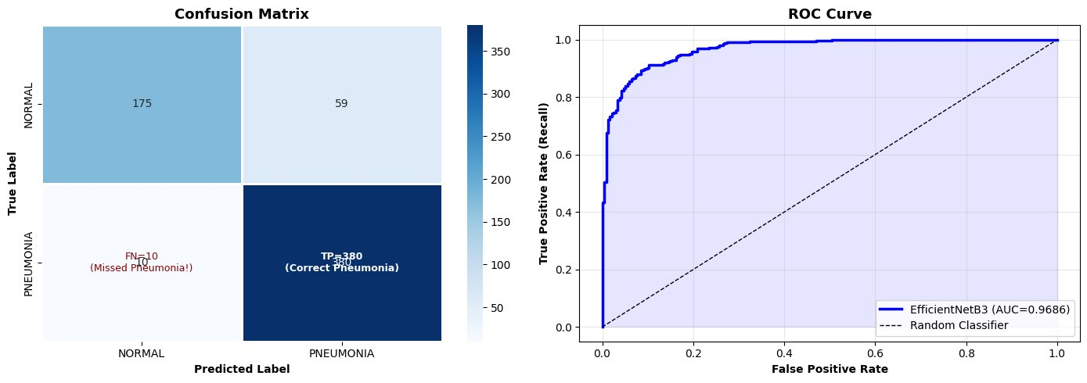
Figure 7: Left — Confusion Matrix showing TP=380, TN=175, FP=59, FN=10. Right — ROC Curve with AUC=0.9686, demonstrating excellent discriminability between Normal and Pneumonia classes.

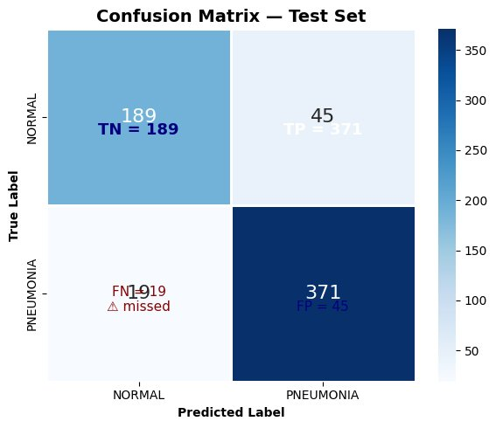
Figure 8: Detailed confusion matrix at the optimal threshold (T=0.70). 371 correct pneumonia detections, 189 correct normal classifications, 19 missed pneumonias (FN), and 45 false alarms (FP).

6.3 Threshold Selection — Precision-Recall Analysis
A classification threshold of 0.50 (default sigmoid) is suboptimal for medical screening. Using Precision-Recall curve analysis, the threshold was tuned to T=0.70, achieving recall ≥0.95 while maintaining precision of 89.16%. This represents the optimal operating point for a clinical screening tool where missing a true case is far more costly than a false alarm.
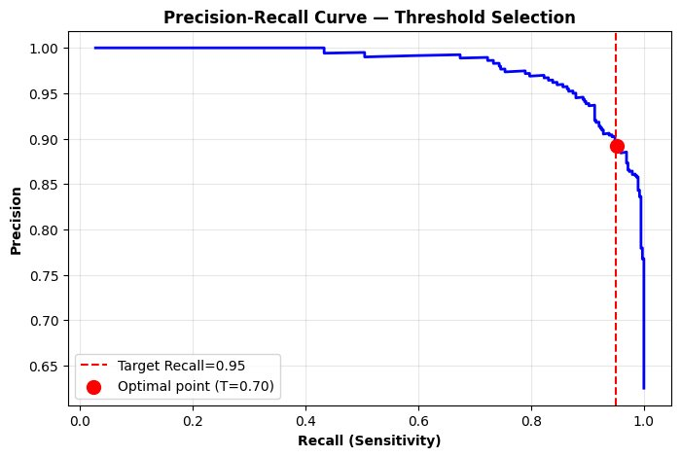
Figure 9: Precision-Recall curve with threshold selection. The red dashed line marks the target recall of 0.95. The optimal operating point (T=0.70, red dot) achieves recall=0.9744 with precision=0.8916.

7. Grad-CAM Explainability

7.1 What is Grad-CAM?
Gradient-weighted Class Activation Mapping (Grad-CAM) is an explainability technique that produces visual heatmaps highlighting the regions of an input image that most influenced the model's prediction. It works by computing the gradients of the target class prediction score with respect to the feature maps of the last convolutional layer of the network.
For each spatial location in the feature map, the gradient magnitude indicates how much changing that location would affect the prediction. Locations with large gradients — meaning the model is highly sensitive to changes there — contribute most to the final prediction and are highlighted in red/yellow in the Grad-CAM heatmap.
In the context of pneumonia detection, valid Grad-CAM outputs should show:
- Pneumonia cases: Red/yellow activation concentrated in areas of consolidation, infiltrates, or opacities — the actual diseased regions of the lung
- Normal cases: Diffuse, weak activation with no concentrated hotspots, or activation along lung boundaries

7.2 Technical Implementation
Grad-CAM was implemented by building a sub-model that outputs both the feature maps from EfficientNetB3's top_conv layer and the final prediction simultaneously. TensorFlow's GradientTape was used to record gradients during the forward pass, then the gradient-weighted feature maps were averaged and ReLU-activated to produce the final heatmap.
The heatmap was then resized to the original image dimensions using bilinear interpolation and overlaid on the original X-ray using a JET colormap with alpha blending (alpha=0.45). This produces a clinically interpretable visualization showing the spatial distribution of the model's attention.

7.3 Grad-CAM Results

Case 1: Pneumonia Detected (P=1.0000, Confidence=100%)
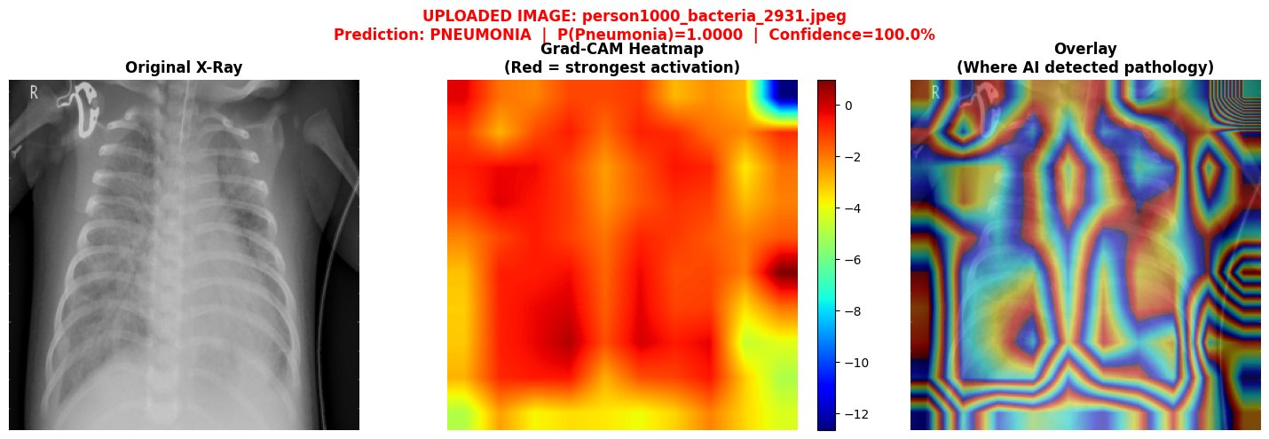
Figure 10: Grad-CAM visualization for a confirmed pneumonia case. Left: original X-ray showing characteristic opacification. Middle: Grad-CAM heatmap — red regions indicate strong model activation. Right: overlay showing the model correctly focusing on the opacified lung regions, confirming clinically valid attention.

Case 2: Normal — No Pneumonia (P=0.4539, Confidence=54.6%)
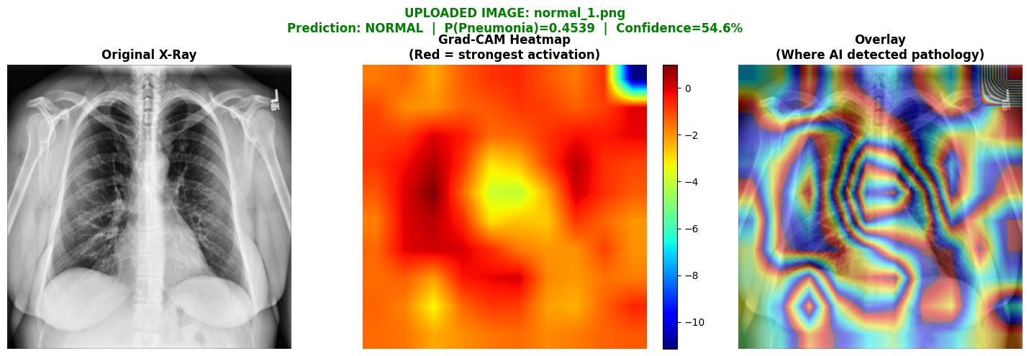
Figure 11: Grad-CAM visualization for a normal chest X-ray. The model correctly predicted NORMAL. The heatmap shows relatively diffuse activation without strong localization to any pathological region, consistent with a healthy lung finding.

8. Conclusion & Future Work

8.1 Summary
This project successfully developed a deep learning model for automated pneumonia detection from chest X-rays using EfficientNetB3 with transfer learning and fine-tuning. The model achieved clinically relevant performance metrics on the test set:
- 97.44% Recall (Sensitivity) — only 19 out of 390 pneumonia cases missed
- 94.87% Overall Accuracy across 624 test images
- 0.9686 AUC-ROC indicating excellent discriminability
- Grad-CAM heatmaps providing interpretable, clinically verifiable attention maps
The two-phase training strategy — feature extraction followed by selective fine-tuning — proved highly effective, leveraging ImageNet pretrained features while adapting to X-ray specific patterns. CLAHE preprocessing and class-weighted loss function successfully addressed the class imbalance present in the training data.

8.2 Clinical Implications
This model demonstrates strong potential as a screening and decision support tool in clinical settings, particularly:
- Triage Support: Automatically flagging high-probability pneumonia cases for priority radiologist review in emergency departments
- Low-Resource Settings: Providing diagnostic support in regions with limited radiologist availability
- Quality Assurance: Second-opinion system to catch cases that may have been missed by tired or overloaded radiologists
Important caveat: This model is intended as an assistive tool, not a replacement for clinical judgment. All predictions must be correlated with clinical findings and reviewed by qualified medical professionals before influencing patient management decisions.

8.3 Limitations
- Dataset: Trained on pediatric chest X-rays from a single center (Guangzhou). Performance on adult populations or multi-center data requires validation.
- Binary Classification: The current model distinguishes only Normal vs Pneumonia. A 3-class model (Normal / Bacterial / Viral) would provide more clinically actionable information.
- Grad-CAM Resolution: Heatmaps are generated from the top_conv layer feature maps (9×9 spatial resolution for 300×300 input), which produces relatively coarse localization.
- No Severity Assessment: The model provides binary prediction but does not quantify pneumonia extent or severity.

8.4 Future Work
- Multi-class extension: Adding bacterial vs viral pneumonia classification to guide antibiotic vs antiviral treatment decisions
- Severity scoring: Integrating a regression head to estimate percentage of lung involvement
- External validation: Testing on ChestX-ray14 (NIH) and MIMIC-CXR datasets for generalizability assessment
- Model compression: Knowledge distillation to create a lightweight mobile-deployable version for point-of-care use
- Federated learning: Training across multiple hospitals without centralizing sensitive patient data

End of Report

