Veterinary Appointment System

- Introduction
The Veterinary Appointment System is a console-based C++ application designed to help veterinary clinics manage pet owners, pets, and appointment schedules efficiently. It replaces manual record-keeping by providing features such as registration, conflict-free scheduling, and file-based data storage. This simple system improves organization and supports the daily workflow of small veterinary clinics. It can also be expanded in the future with GUI, database connection, reminders, and payment gateway.

2. Objective
The main objective of this project is to develop a console-based system that allows veterinary clinics to manage pet owners, pets, and appointments efficiently. It simplifies scheduling, avoids time conflicts, and keeps appointment records in a structured manner.

3. Scope of the Project
The system supports:
- Adding pet owners and pets
- Scheduling appointments
- Checking time conflicts
- Listing and searching appointments
- Canceling appointments
- Saving and loading records from a file
- Payment (QR code)
This system can be used in veterinary clinics to automate daily processes and improve management of consultations.

4. System Requirements
Software:
- C++ compiler
- Code editor (VS Code)
Hardware:
- 2 GB RAM
- Mac processor
- Hard disk 64GB

5. Future Enhancements
- GUI-based interface
- SMS/Email reminders through Agentic AI
- Chat bot AI
- Integration with database (SQL / JSON)

6. Limitations
- No Graphical User Interface (GUI)
Most C++ programs use console-based input/output, which is not user-friendly for real-world clinics.
- No Real-Time Database Support
Without external libraries, C++ does not provide built-in database connectivity (like SQL/MySQL), making data storage limited to files.
- No Notification System
Cannot send SMS/email reminders for appointments without third-party APIs, which are complex to integrate in basic C++.
- No Integrated Payment Gateway(Advance)
Basic C++ programs do not support direct connection with payment services like Paytm, UPI.

7. ER Diagram

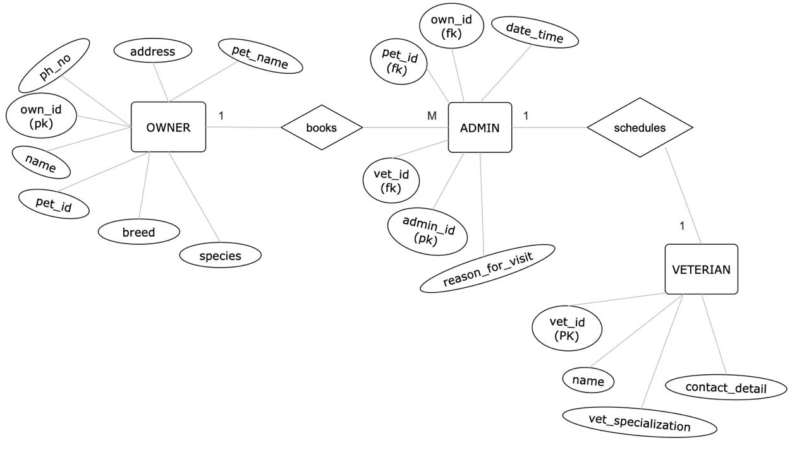

- Gantt Chart
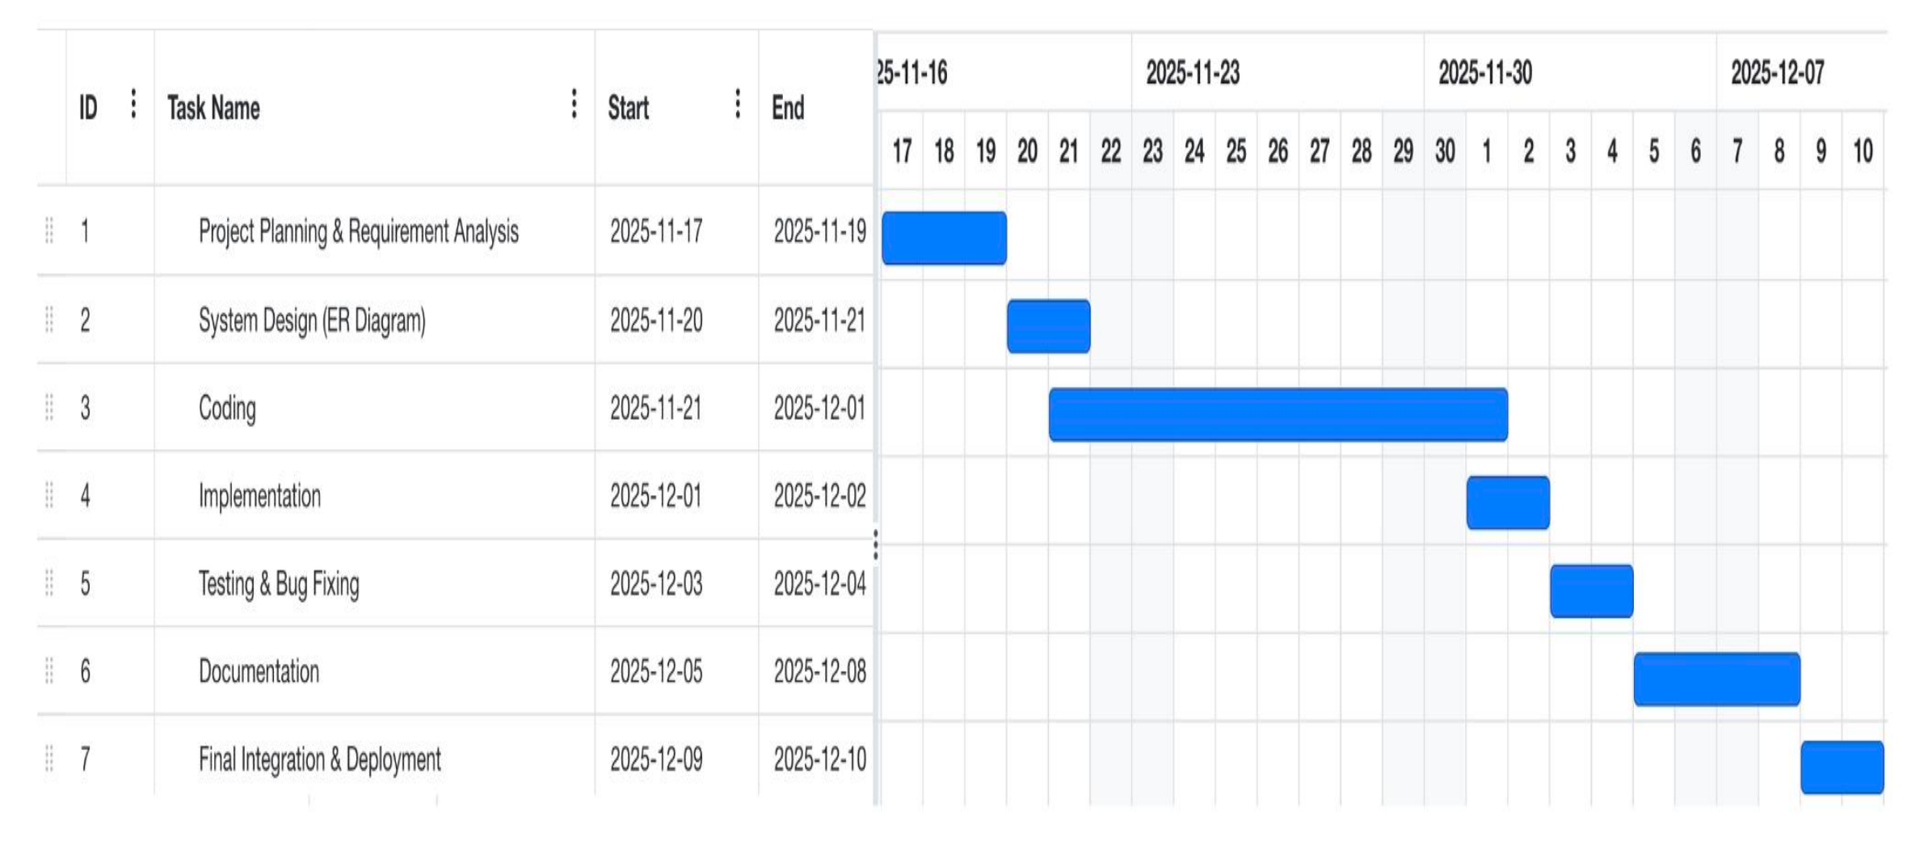

9. Conclusion
This veterinary appointment system provides a basic and efficient solution for managing appointments. It is helpful for small clinics and can be extended into a fully functional management software with additional features.

A Project Report
Submitted in Partial fulfillment
of the Degree of
Master of Computer Applications

Supervisor’s Name - Dr. Manju Arora Submitted By: Gautam Bhardwaj

Enrolment No- 12 Semester- I



Jagannath University
Bahadurgarh (NCR)
(2025-27)

