**AI LAB**

**Assignment 9**

Name: Justin T Joseph

Reg No.: AP21110010978

Section: CSE P

1. Write a PROLOG program to find the number is ODD or EVEN.

**Code:**

even(X):-

0 is mod(X,2).

odd(X):-

1 is mod(X,2).

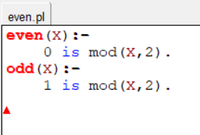

**Output:**

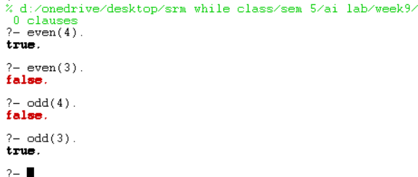

2. Define your family members of the Pandavas of the Mahabharat. Define a  
relationship of grandfather and grandmother using rules.

**Code:**

male(pandu).

male(yudhisthir).

male(bheem).

male(arjun).

male(nakul).

male(sahadev).

male(abhimanyu).

female(kunti).

female(madri).

female(subhadra).

parent(yudhisthir, pandu).

parent(bheem, pandu).

parent(arjun, pandu).

parent(nakul, pandu).

parent(sahadev, pandu).

parent(yudhisthir, kunti).

parent(bheem, kunti).

parent(arjun, kunti).

parent(nakul, madri).

parent(sahadev, madri).

parent(abhimanyu,arjun).

parent(abhimanyu, subhadra).

grand_father(X,Y):-

parent(X,Z),

parent(Z,Y),

male(Y).

grand_mother(X,Y):-

parent(X,Z),

parent(Z,Y),

female(Y).

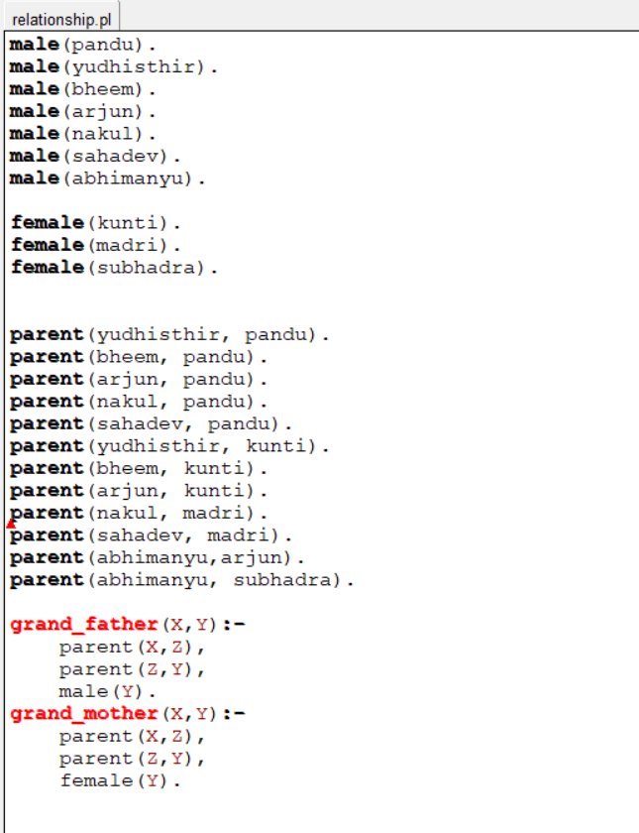

**Output:**

