Statistical Microstructure of INTARIAN_PEPPER_ROOT:
A Deterministic Linear Drift with Imbalance-Mediated Residuals
IMC Prosperity 4 -- Round 1 Research Memo
Team Prosperity 4 (internal)
2026-04-15

Abstract
We perform a holistic statistical analysis of the INTARIAN_PEPPER_ROOT order book data provided for Round 1 of IMC Prosperity 4. The product exhibits a perfectly linear deterministic trend of +0.001 price units per tick, constant across all three historical days with an R-squared of 1.0000. The mid-price residual against this trend is white-noise-like in serial correlation but strongly leptokurtic (excess kurtosis ~ 8). The bid and ask L1 are symmetrically positioned at +/- 6.4 ticks around the fair value in the dominant regime. Most critically, 63% of the residual variance is explained contemporaneously by the L1 volume imbalance, and the same imbalance predicts future mid-moves up to twenty ticks ahead with a correlation of 0.57. We further show that narrow observed spreads (<= 5 ticks) are a reliable signal of one-sided aggression and correspond to the largest absolute mid deviations from fair value. Together these findings suggest that the main modeling challenges for this product are regime detection and imbalance-aware execution, not fair-value estimation.

1. Introduction
INTARIAN_PEPPER_ROOT is one of two products traded during Round 1 of IMC Prosperity 4, the other being ASH_COATED_OSMIUM. This memo isolates the statistical properties of PEPPER_ROOT using the three days of historical order-book data shipped with the competition (days -2, -1, 0, each containing 10,000 ticks at 100-unit timestamps). Our goal is not to provide a trading strategy, but to catalog the observable structural regularities that any reasonable trader must either exploit or respect.
The product has a superficial resemblance to KELP (Prosperity 3 Round 1): a dynamic product paired with a stable anchor product. However, our analysis reveals a structure far more regular than KELP's slow random walk. The drift is deterministic, the residuals are tight, and the order book itself carries a strong pricing signal via volume imbalance.

2. Data

2.1 Source and schema
We use the semicolon-delimited CSV files shipped under stage1/:
* prices_round_1_day_-2.csv (day = -2, 10,000 rows)
* prices_round_1_day_-1.csv (day = -1, 10,000 rows)
* prices_round_1_day_0.csv (day = 0, 10,000 rows)
Each row contains the best three levels of bid and ask prices and volumes, a mid price, and a profit-and-loss column (always zero in the historical files). The trade files trades_round_1_day_*.csv provide executed trades with timestamps, prices, quantities, and (empty in practice) buyer/seller fields.

2.2 Preprocessing
We filter out rows where either L1 side is blank. Such rows account for about 7.7% of the data and represent ticks where one side of the book is empty; the csv-provided mid_price column is also unreliable in these cases (it can collapse to zero when both sides are missing). We compute a clean mid as (bid1 + ask1) / 2 for the remaining 27688 usable rows out of 30000 total.
Table 1. Day-wise linear fit of mid ~ a + b * timestamp on usable rows.
Day | Intercept a | Slope b | Residual std | n
-2 | 9999.9636 | 0.00100001 | 1.1237 | 9216
-1 | 10999.9479 | 0.00100008 | 1.2596 | 9219
0 | 11999.9843 | 0.00099998 | 1.3352 | 9253

3. The deterministic linear trend

3.1 Linear fit
On each of the three days, an ordinary least squares fit of mid on timestamp yields a slope of 0.001 price units per tick, at the eighth-decimal level of agreement. The R-squared is 1.0000 and the residual standard deviation is roughly 1.2 ticks. Figure 1 displays the trajectories; the fitted lines are visually indistinguishable from the mid price series except when zoomed in on the residuals. Crucially, the close of each day equals the open of the next, so the product experiences no overnight reset -- its price history across the three days forms one continuous straight line of slope 0.001.
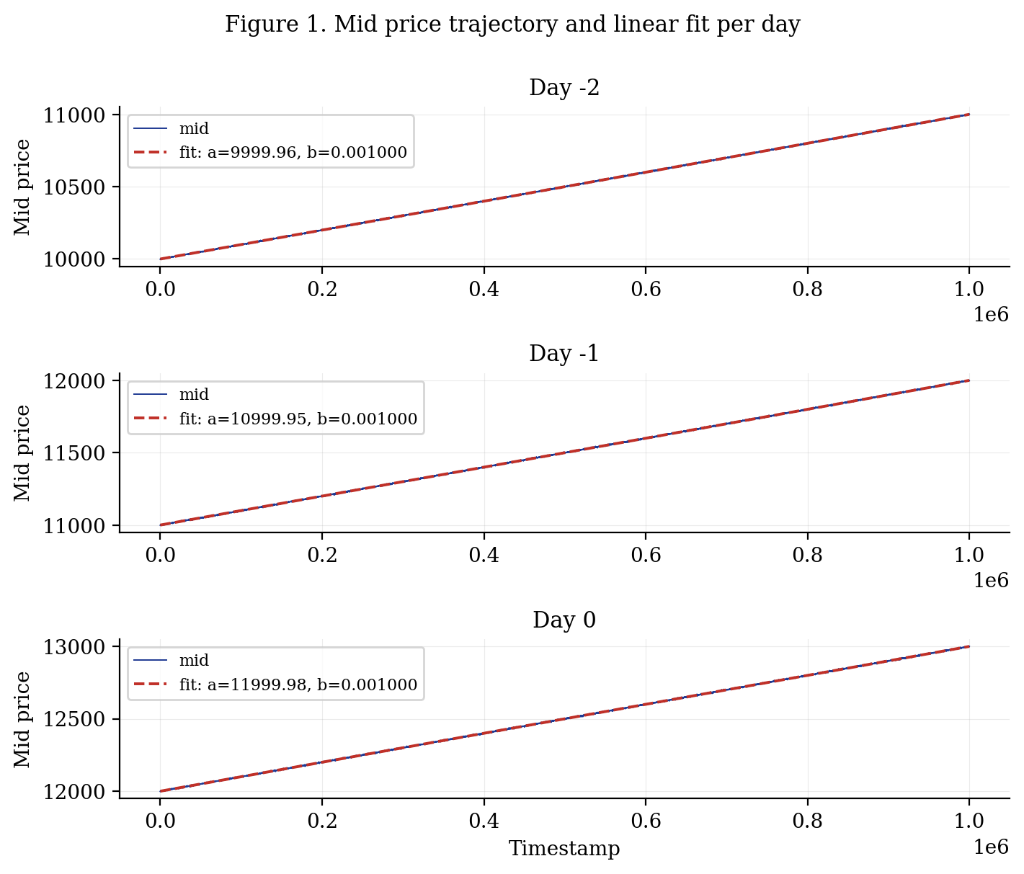
Figure 1. Mid price and fitted linear trend for each of the three historical days.

3.2 Rolling slope stability
To verify that the slope is constant within a day, we recompute it on non-overlapping 500-tick windows during day 0. Across the 18 resulting windows, the mean slope is 0.0009995, with standard deviation 4.17e-06, and the [min, max] interval is [0.0009931, 0.0010077]. The deviations from 0.001 are at the fifth decimal place and are consistent with estimation noise on 500 samples given the residual standard deviation. We conclude that the local slope is effectively constant at any reasonable analysis horizon.
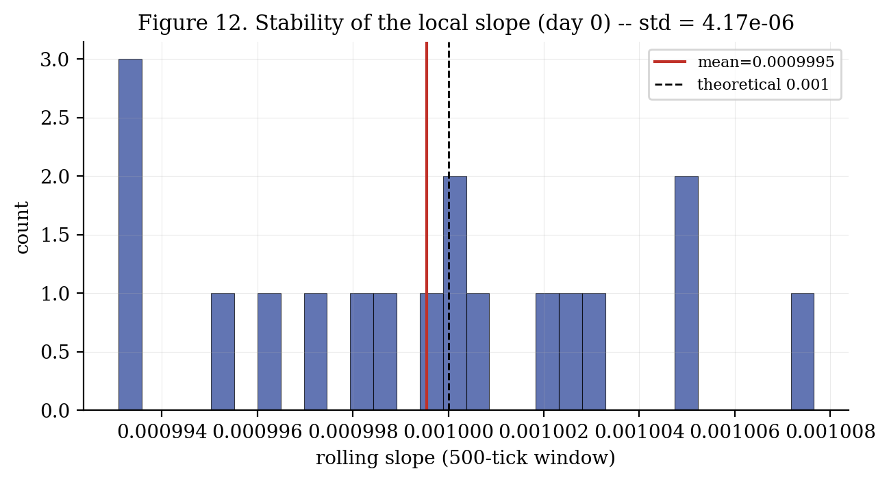
Figure 12. Histogram of rolling-slope estimates on day 0 (500-tick windows).

4. Distribution of the mid-price residual

4.1 Moments
Table 2. Moments and quantiles of eps_mid, the residual of mid against the day-wise linear fit.
Day | Mean | Std | Skew | Excess kurt. | Quantiles q[1,25,50,75,99]
-2 | 0.0000 | 1.1236 | -0.436 | 7.752 | [-4.57, -0.18, 0.03, 0.23, 4.23]
-1 | 0.0000 | 1.2595 | -0.293 | 7.590 | [-5.06, -0.21, 0.01, 0.24, 4.62]
0 | -0.0000 | 1.3351 | -0.374 | 7.999 | [-5.47, -0.18, 0.03, 0.23, 5.02]
ALL | 0.0000 | 1.2426 | -0.364 | 8.013 | [-5.05, -0.20, 0.03, 0.23, 4.59]
The mean is zero by construction. The standard deviation increases slightly with the day index (1.12 -> 1.26 -> 1.34), possibly reflecting mild heteroscedasticity. Skewness is consistently negative and small (-0.3 to -0.4), indicating a slight downside tail. The excess kurtosis is consistently around 8, meaning that tail events are far more frequent than a normal distribution would predict. Figure 3 makes this point visually: in the log-scale panel, the empirical density clearly dominates the fitted normal in the tails beyond two sigma.
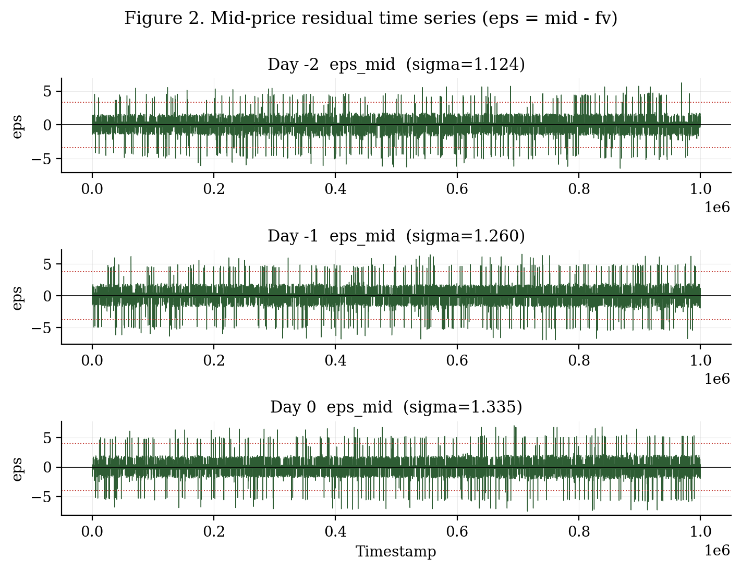
Figure 2. Residual time series on each day. Red dashed lines are at +/- 3 sigma.
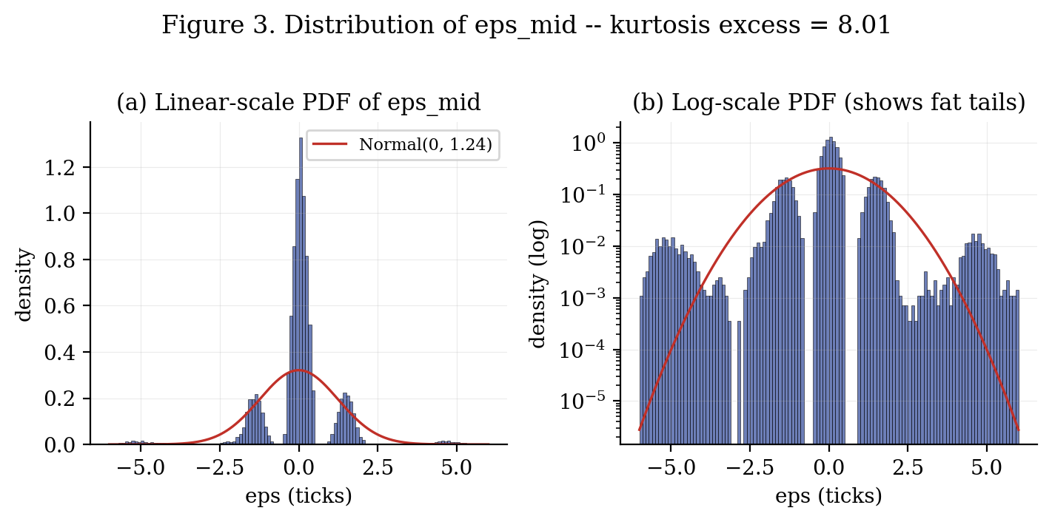
Figure 3. PDF of eps_mid in linear and log scale, with a Gaussian reference.

4.2 Tail behaviour
A quantile-quantile plot against a normal distribution (Figure 4) confirms fat tails. The central region (|z| < 1.5) is well approximated by a normal, but beyond that the empirical quantiles depart upward on the positive side and downward on the negative side. Roughly 2% of the data lies beyond +/- 5 ticks in absolute residual, while under a normal with the same sigma that fraction should be effectively zero. In practical terms, an execution strategy that calibrates its risk budget on sigma ~ 1.25 must include an explicit mechanism for the multi-sigma events.
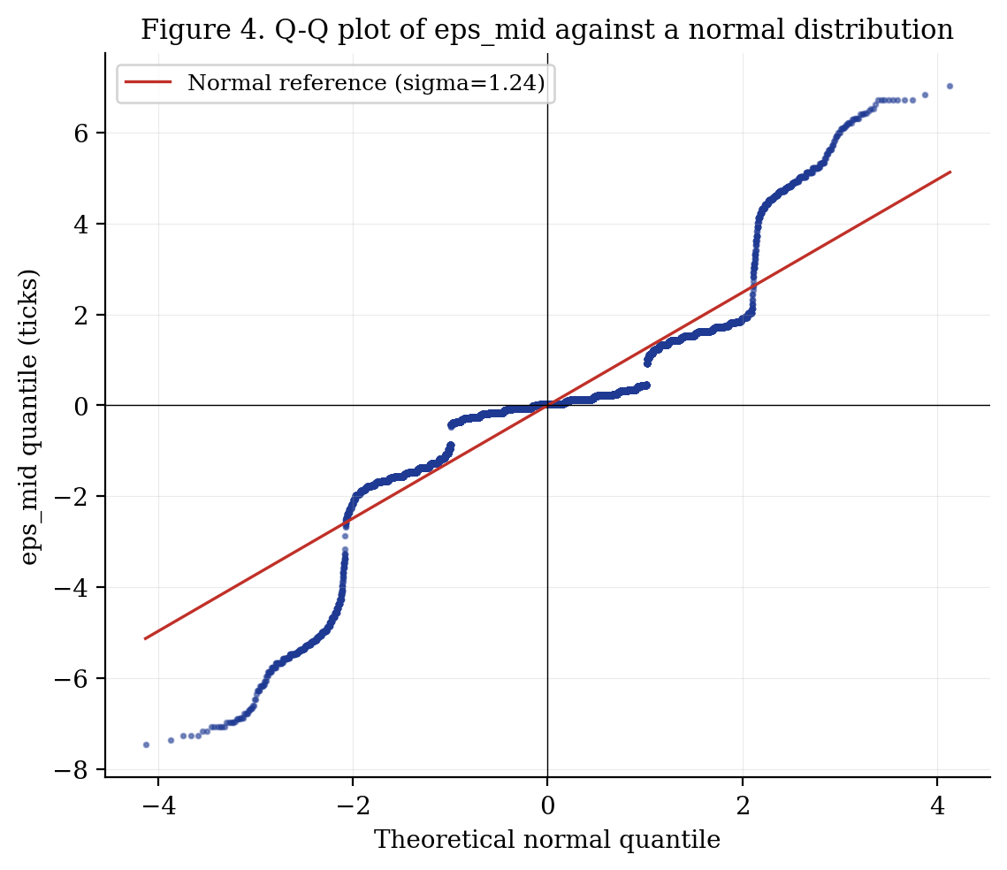
Figure 4. Q-Q plot of eps_mid against a normal distribution.

4.3 Serial correlation
Residual autocorrelations at lags from 1 to 500 are bounded by 0.03 in absolute value on all three days (Figure 11). The residual is, for practical purposes, a white noise. This is an important finding because it rules out simple AR/MA or mean-reversion exploitations of eps_mid viewed in isolation: any predictive structure must come from contemporaneous book state, not from historical residual paths.
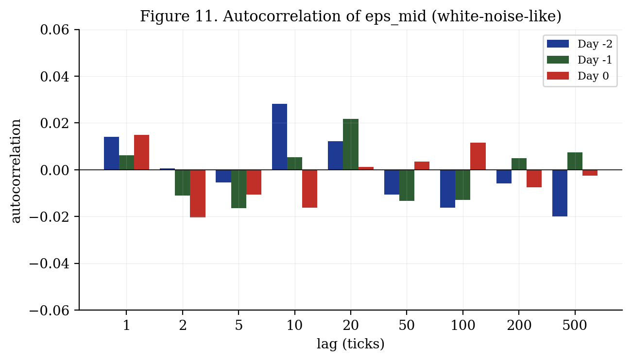
Figure 11. Autocorrelation of eps_mid at lags 1 to 500 ticks.

5. Bid-ask structure

5.1 Symmetric positioning around the fair value
When we compute the residuals of the best bid and best ask against the linear fair value, we find near-perfect symmetry: the median bid sits at fv - 6.37 ticks and the median ask at fv + 6.42 ticks. Their quartile ranges are similarly mirrored. In the dominant regime the order book is therefore centered on the fair value and straddles it with a half-spread of approximately 6.4 ticks. Table 3 details the full quantile profile.
Table 3. Bid and ask L1 relative to the linear fair value (all days pooled).
Quantity | Mean | Std | Median | q[1, 5, 95, 99]
bid - fv | -6.523 | 1.741 | -6.37 | [-10.18, -9.57, -5.27, 2.83]
ask - fv | 6.523 | 1.873 | 6.42 | [-3.78, 5.33, 9.58, 10.23]
spread | 13.047 | 2.627 | 13.00 | [2.00, 11.00, 17.00, 19.00]
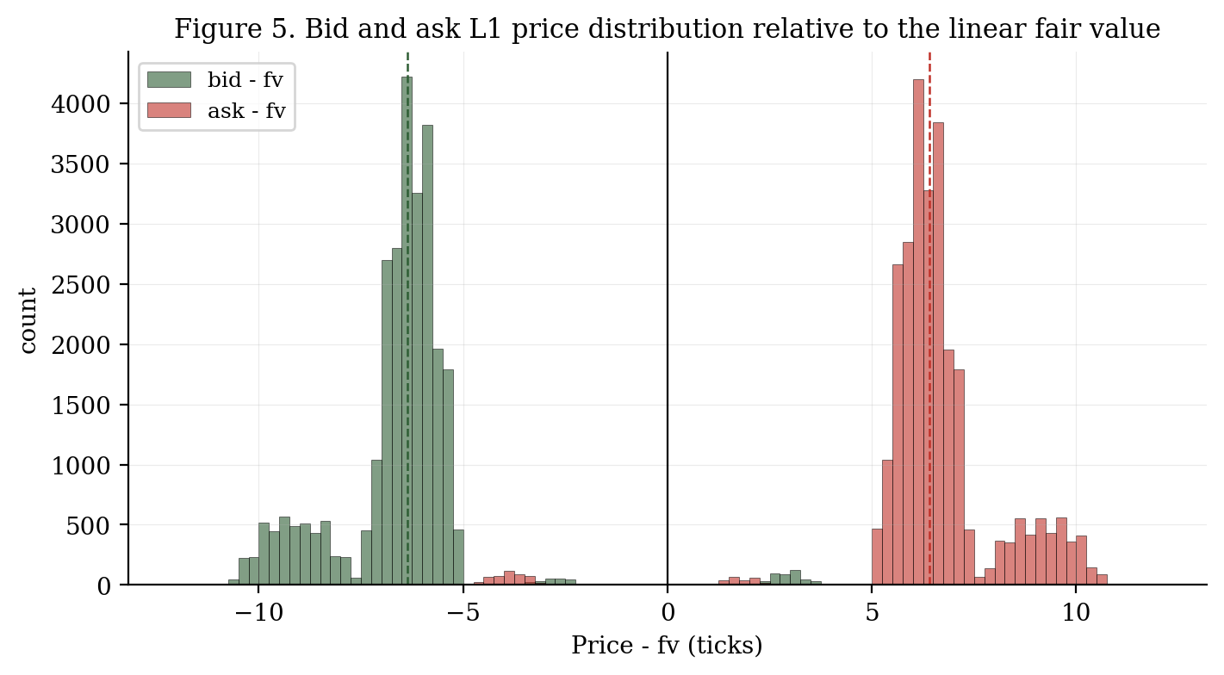
Figure 5. Distribution of bid - fv and ask - fv on L1.
The tails in Table 3 reveal rare but important anomalies. The 99th-percentile of bid - fv is +2.83, meaning the best bid occasionally sits above the fair value. Symmetrically, the 1st-percentile of ask - fv is -3.78. These events correspond to one side of the book being aggressed inside the normal channel and are therefore both informative (they signal deviation) and tradeable (the other side becomes mispriced).

5.2 Order book depth
Table 4. Level occupancy and average depth conditional on the level being filled.
Level | Bid fill (%) | Bid mean vol | Ask fill (%) | Ask mean vol
L1 | 100.0 | 11.55 | 100.0 | 11.52
L2 | 67.3 | 19.74 | 67.7 | 19.72
L3 | 1.5 | 20.13 | 1.6 | 19.91
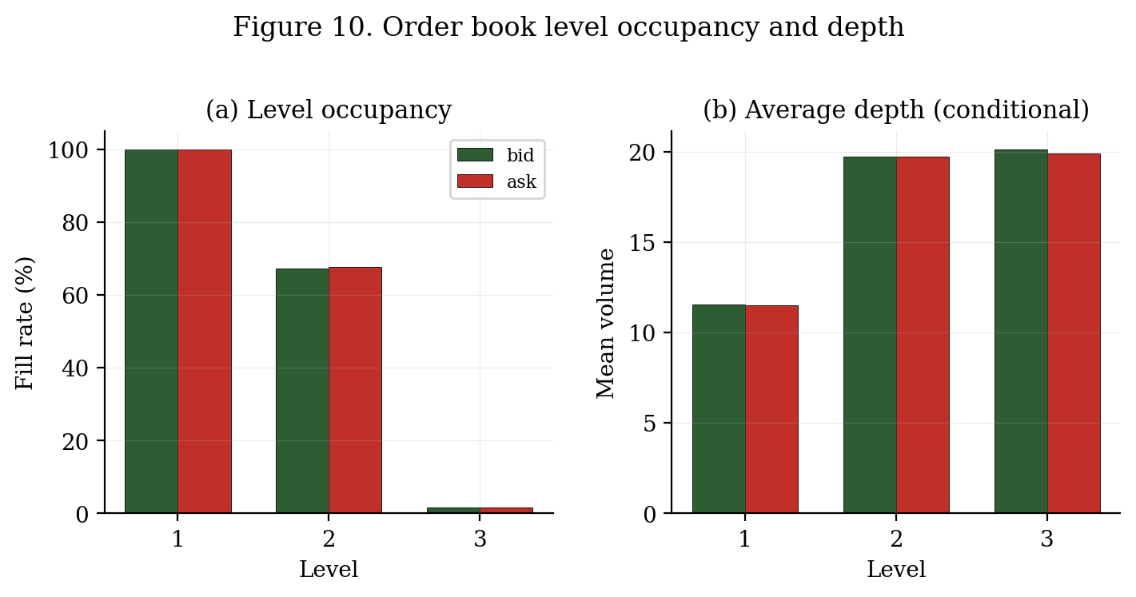
Figure 10. Level occupancy and conditional mean volume.
L1 is always populated on both sides (by construction of our filter). L2 is filled about 67% of the time and carries roughly 20 units of volume when present -- almost twice the L1 volume. L3 is almost never filled (around 1.6% of ticks), so for modeling purposes the book is effectively two levels deep. The median gap between L1 and L2 is 3 ticks with 5th and 95th percentiles at 2 and 4 ticks respectively.

6. Spread regime
The observed spread distribution is bimodal and shifts by one tick per day. The dominant mode moves from 11-12 ticks on day -2 to 12-13 on day -1 and 13-14 on day 0, tracking the absolute price level. A secondary mode exists 2 to 3 ticks above the primary one, and a small tail of very narrow spreads (2-4 ticks) is present every day. The narrow-spread events are of special interest: as we show in section 8, they are not random noise, they correspond to the largest fair-value mispricings.
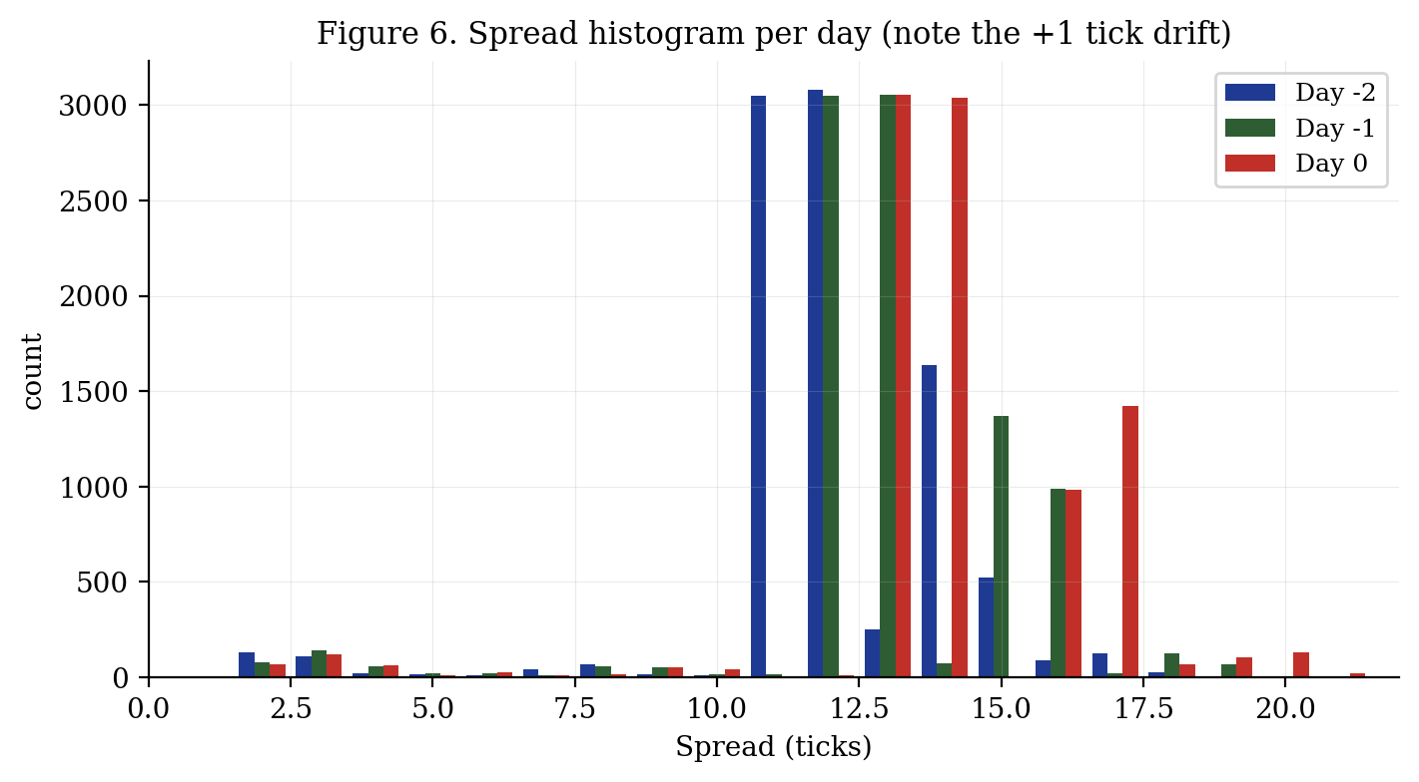
Figure 6. Per-day histogram of the observed spread.
Table 5. Spread counts at selected values. Note the +1-tick shift of the primary mode per day.
Spread | Day -2 | Day -1 | Day 0
2 | 133 | 81 | 68
3 | 111 | 141 | 121
4 | 19 | 56 | 63
11 | 3050 | 16 | 3
12 | 3079 | 3046 | 13
13 | 252 | 3052 | 3051
14 | 1638 | 74 | 3040
15 | 524 | 1370 | 1
16 | 88 | 988 | 982
17 | 128 | 21 | 1425
The autocorrelation of the spread itself is negligible (< 0.04 at all lags tested), meaning that spread regime changes are abrupt rather than persistent. Tight spreads are therefore brief events that must be handled tactically within the same tick or the next, not exploited over long horizons.

7. L1 volume imbalance as a pricing signal

7.1 Contemporaneous regression
Let imb = (bv1 - av1) / (bv1 + av1) denote the L1 volume imbalance. Regressing the residual eps_mid on imb across all three days yields:
eps_mid = +0.006 + (-5.144) * imb R^2 = 0.6349
The regression explains 63.5% of the variance of eps_mid from a single contemporaneous book quantity. This is striking. Figure 7 shows the scatter and the fitted line -- the negative slope of approximately -5.14 means that when the bid side is twice as heavy as the ask side (imb = +0.33), the mid is about 1.7 ticks below the fair value.
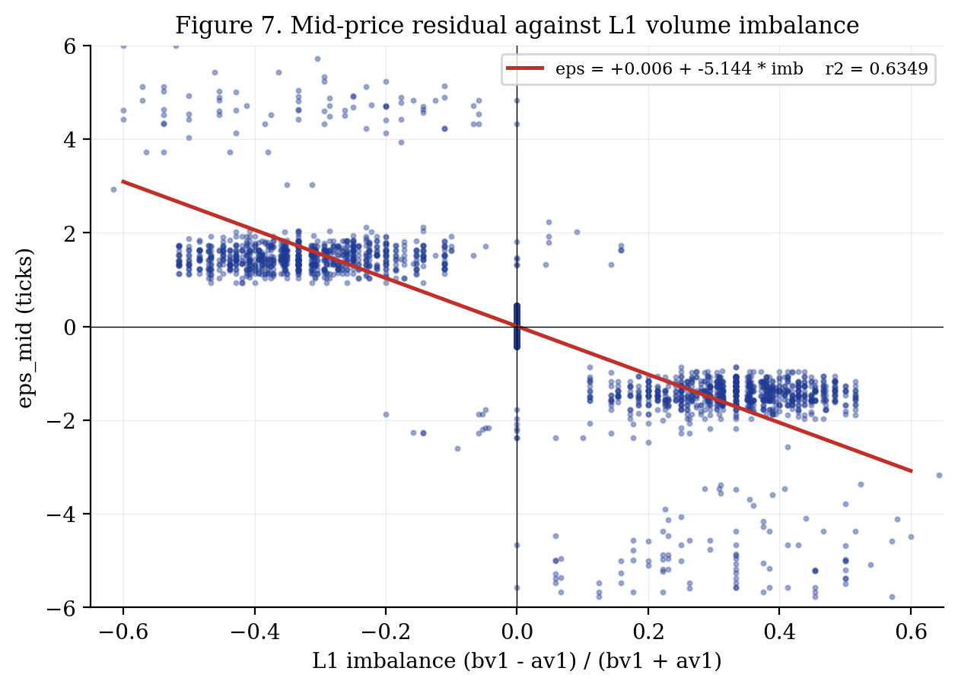
Figure 7. Contemporaneous regression of eps_mid on L1 imbalance.
The economic interpretation is a simple liquidity-mean-reversion story. When a transient shock pushes the mid below the fair value (eps < 0), the heavy side of the book becomes the bid (limit orders accumulate on the side where execution is expected), so imbalance turns positive. The imbalance is a visible footprint of the mispricing. Crucially, we do not need the linear fv to spot the mispricing in real time: the sign of imb already encodes the direction of the deviation. In the absence of a reliable estimate of the linear intercept, imb can serve as a self-contained fair-value proxy of the form fv_struct = mid + 5.14 * imb.

7.2 Predictive correlation
The imbalance does more than identify the current mispricing; it predicts the correction. We compute corr(imb_t, dmid_{t+k}) for k = 1, 2, 5, 10, 20:
Table 6. Correlation of L1 imbalance at time t with cumulative mid change to time t+k.
Day | k=1 | k=2 | k=5 | k=10 | k=20
-2 | 0.5552 | 0.5583 | 0.5632 | 0.5568 | 0.5642
-1 | 0.5690 | 0.5701 | 0.5567 | 0.5671 | 0.5574
0 | 0.5675 | 0.5704 | 0.5624 | 0.5762 | 0.5731
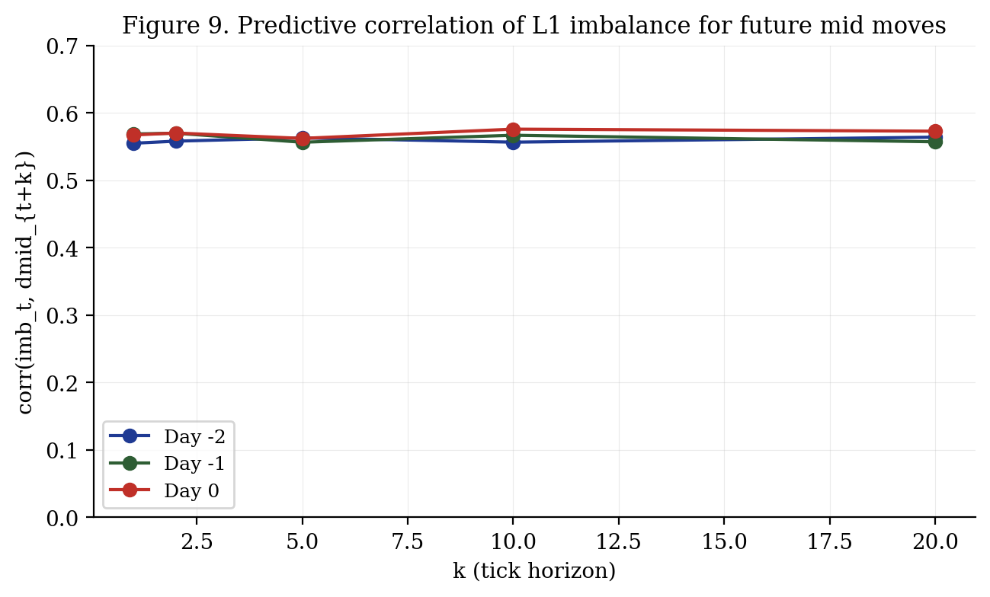
Figure 9. Predictive correlation across horizons and days.
The correlation is roughly 0.56 at k=1 and remains near 0.57 up to k=20. It is stable across the three days. A correlation of this magnitude with next-tick return is large in any microstructure context and, when combined with the linear trend, substantially changes the optimal execution problem: even if a passive quote would not in itself arbitrage the book, sizing and skew should be modulated by the current imbalance.

8. Spread as a regime indicator
Conditioning |eps_mid| on the observed spread exposes a counter-intuitive structure: the absolute deviation is largest when the spread is narrow, not when it is wide. Figure 8 and Table 7 summarize the pattern.
Table 7. Mean absolute residual conditional on the observed spread (only buckets with n > 50).
Spread | n | Mean |eps_mid|
2 | 282 | 4.926
3 | 373 | 4.799
4 | 138 | 4.827
6 | 57 | 6.284
7 | 66 | 3.321
8 | 141 | 1.996
9 | 128 | 1.987
10 | 67 | 2.156
11 | 3069 | 0.206
12 | 6138 | 0.177
13 | 6355 | 0.216
14 | 4752 | 0.581
15 | 1895 | 1.407
16 | 2058 | 1.439
17 | 1574 | 1.449
18 | 219 | 0.598
19 | 171 | 0.168
20 | 133 | 0.166
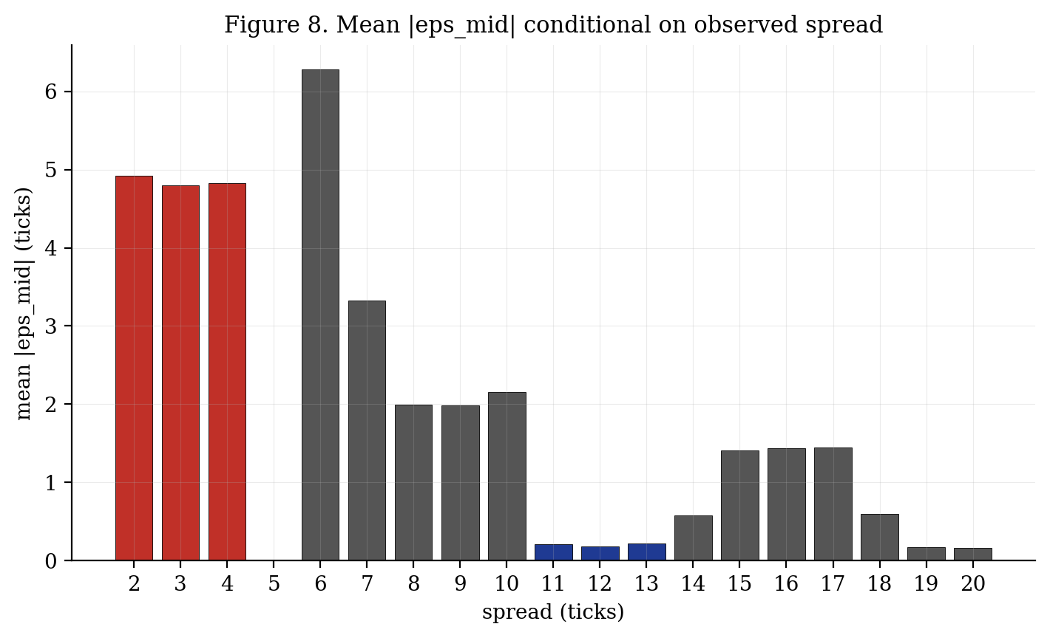
Figure 8. Mean |eps_mid| as a function of observed spread. Red: narrow regime.
In the dominant regime (spreads 11 to 13), the mid sits within 0.22 ticks of the fair value on average. When the spread collapses to 2 to 4 ticks, the mid jumps to roughly 4.8 ticks off. The mechanism is one-sided aggression: a trader places a quote inside the normal bid-ask channel on a single side, shrinking the spread and mechanically pulling the mid toward that side. This is a detectable event that a real-time strategy should either avoid interacting with or explicitly fade on the opposite side.

9. Trade flow
Table 8. Trade flow classification via the Lee-Ready heuristic (trade price vs prevailing mid).
Day | Total trades | Buyer-initiated | Seller-initiated | Mean qty
-2 | 344 | 176 (51.2%) | 168 (48.8%) | 5.07
-1 | 335 | 156 (46.6%) | 179 (53.4%) | 5.24
0 | 332 | 162 (48.8%) | 170 (51.2%) | 5.20
Trade activity is balanced: roughly 50% of trades are buyer-initiated and 50% are seller-initiated on each day. The mean executed quantity is approximately 5 units. The trade price distribution lies mainly at best bid and best ask, within +/- 7 ticks of the mid -- i.e., the half-spread. There is no net order flow imbalance at the day level, confirming that the drift is a property of the quote process rather than a consequence of directional trading pressure.

10. Implications for strategy design
From a modeling standpoint, PEPPER_ROOT is a textbook example of a product with a trivial fair value but non-trivial microstructure. The main actionable conclusions are:
- Fair value should be computed as fv(t) = a + slope, with a re-estimated online. Any estimator based on rolling means or exponential smoothing of the mid is strictly inferior because it ignores the known slope.
- Serial-correlation-based models (AR, OU, GARCH on eps) will find nothing: the residual is white noise. The signal lives in the contemporaneous book state, principally in volume imbalance.
- L1 imbalance should feed both the fair-value estimator (fv_struct = mid + 5.14 * imb) and the execution module (sizing, skew, taking edge). The 0.57 predictive correlation to next-tick mid-move is too large to ignore.
- Narrow spreads (spread <= 5) are a detectable regime in which the mid is biased by roughly 5 ticks. Strategies should either pause quoting in such regimes or actively fade the aggressed side.
- The residual is fat-tailed with excess kurtosis around 8. Risk limits calibrated on Gaussian sigma will underestimate the probability of multi-sigma moves. An explicit jump detector is recommended before enabling reduce-only logic.
- Because the slope is deterministic and positive, an inventory skew that biases target position slightly long (rather than zero) is consistent with the drift and will collect the trend premium for free while market making.
We emphasize that the biggest risk to these conclusions is that the live day of Round 1 may break the clean structure observed in the historical files. The slope could change, the intercept could reset mid-session, or the imbalance-residual relationship could shift. Any production strategy must include a regime check: if the empirical slope drifts more than a few standard errors from 0.001, or if the imbalance-vs-dmid correlation falls below, say, 0.3, the trend-aware logic should automatically degrade to a neutral market-making baseline.

11. Conclusion
INTARIAN_PEPPER_ROOT is a mathematically simple but microstructurally rich product. Its price process is a perfect linear drift of +0.001 per tick plus a fat-tailed, white-noise residual with standard deviation 1.2-1.3 ticks. The order book sits symmetrically at +/- 6.4 ticks around the fair value under normal conditions, with a bimodal spread distribution that drifts by one tick per day. The L1 volume imbalance is the single strongest real-time signal in the data, explaining 63% of the residual variance and predicting next-tick mid-moves with a correlation above 0.55. Narrow spreads are a reliable marker of one-sided aggression and correspond to the largest |eps_mid|. Modeling effort should concentrate on regime detection, imbalance-aware sizing, and robust handling of the 2% tail events, not on fair-value estimation.

Appendix A. Autocorrelation of eps_mid (full table)
Table A1. Autocorrelation of eps_mid at lags 1, 2, 5, 10, 20, 50, 100, 200, 500.
Day | lag 1 | lag 2 | lag 5 | lag 10 | lag 20 | lag 50 | lag 100 | lag 200 | lag 500
-2 | 0.014 | 0.001 | -0.005 | 0.028 | 0.012 | -0.011 | -0.016 | -0.006 | -0.020
-1 | 0.006 | -0.011 | -0.016 | 0.005 | 0.022 | -0.013 | -0.013 | 0.005 | 0.007
0 | 0.015 | -0.020 | -0.011 | -0.016 | 0.001 | 0.003 | 0.011 | -0.007 | -0.003

Appendix B. Reproducibility
All figures and tables in this memo are produced by the single script claude research/build_pepper_paper.py. The data source is the Round 1 stage1 directory. Running the script regenerates all artifacts deterministically.

