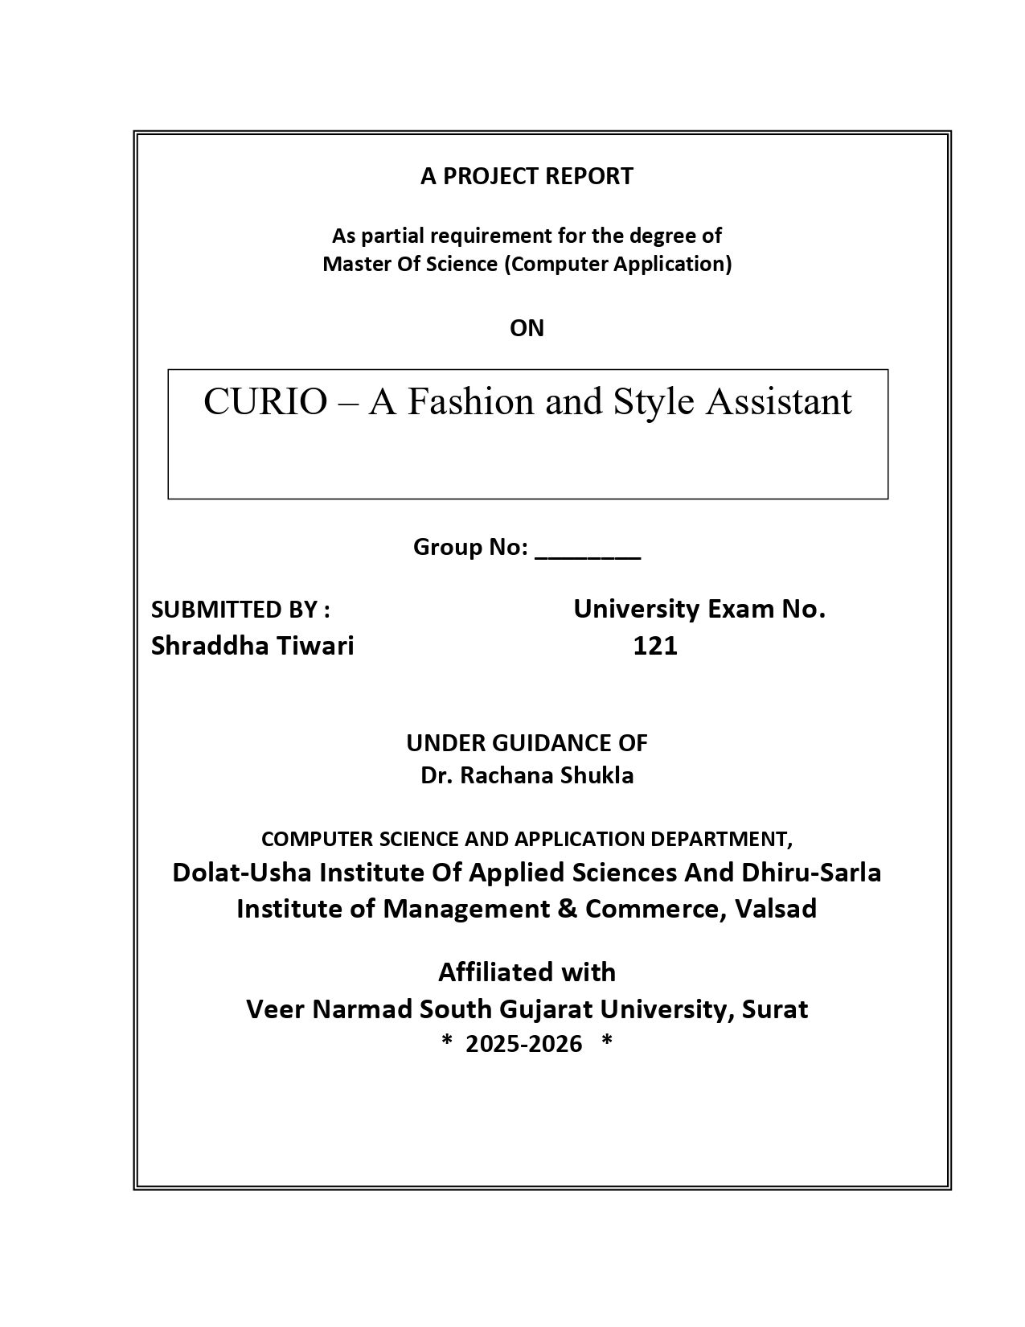
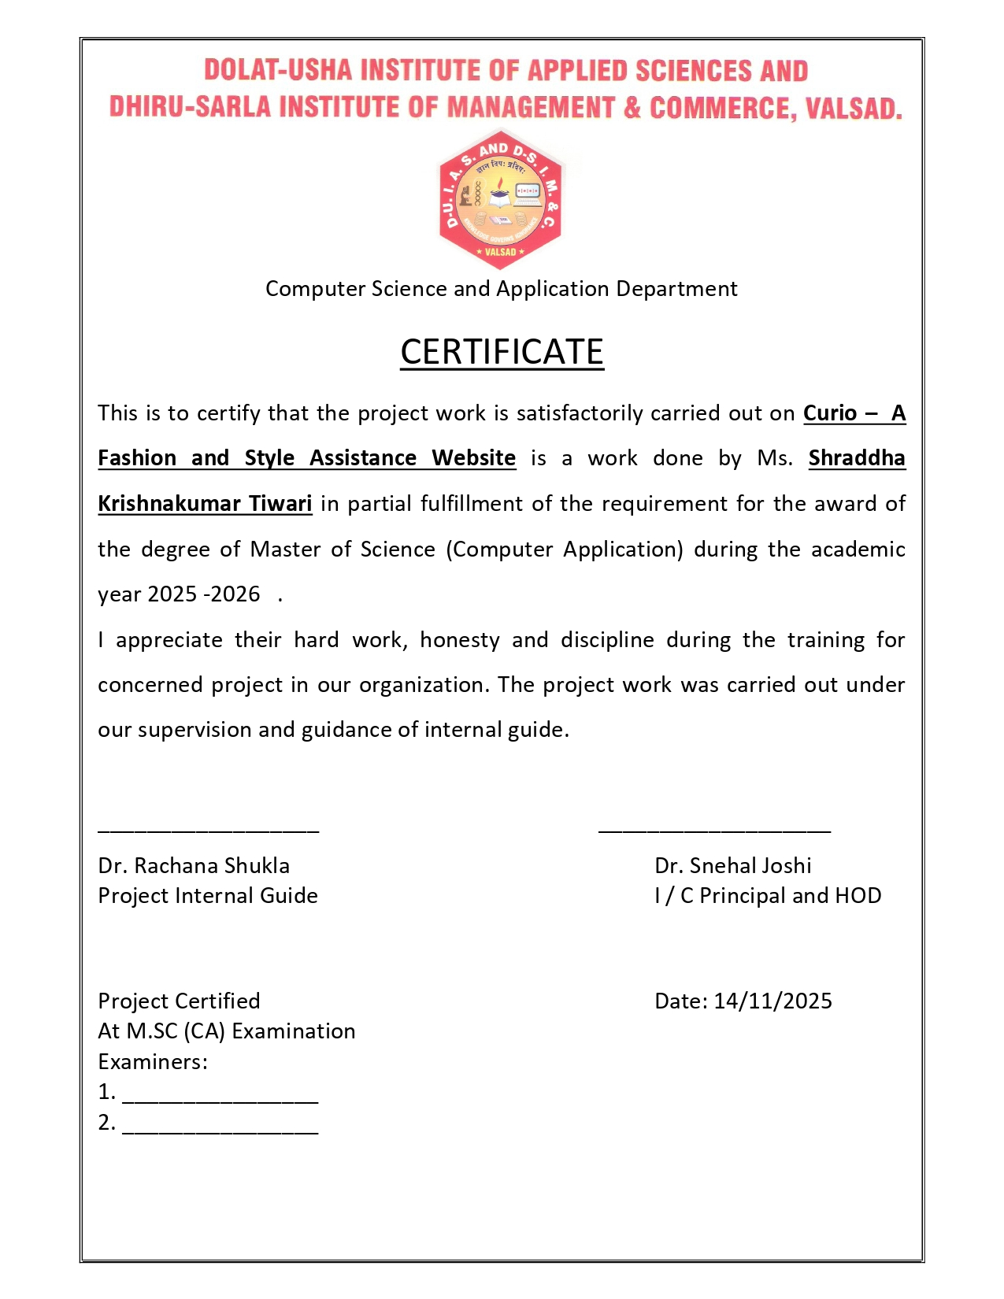
Acknowledgement

I am student of DOLAT-USHA INSTITUTE OF APPLIED SCIENCES AND DHIRUSARLA INSTITUTE OF MANAGEMENT & COMMERCE, VALSAD College of Computer Science Department have worked on the project entitled Curio – A Fashion and Style Assistant.

My guide Dr.Rachana Shukla , for imparting me valuable guidance during the preparation of this projects. She helped me by suggesting many references to emerge out with a perfect presentation. Her expertise in the subject matter greatly contributed to the depth and quality of the project.

I would like to thank the people who helped me in completion of this project and with content and I express my gratitude towards those people who have given me their precious time and guidance in development of this project.

I am sincerely thankful to all other faculty members who helped me and gave the opportunity and support to take this project respectively.

Thanking Sincerely,
Shraddha Krishnakumar Tiwari

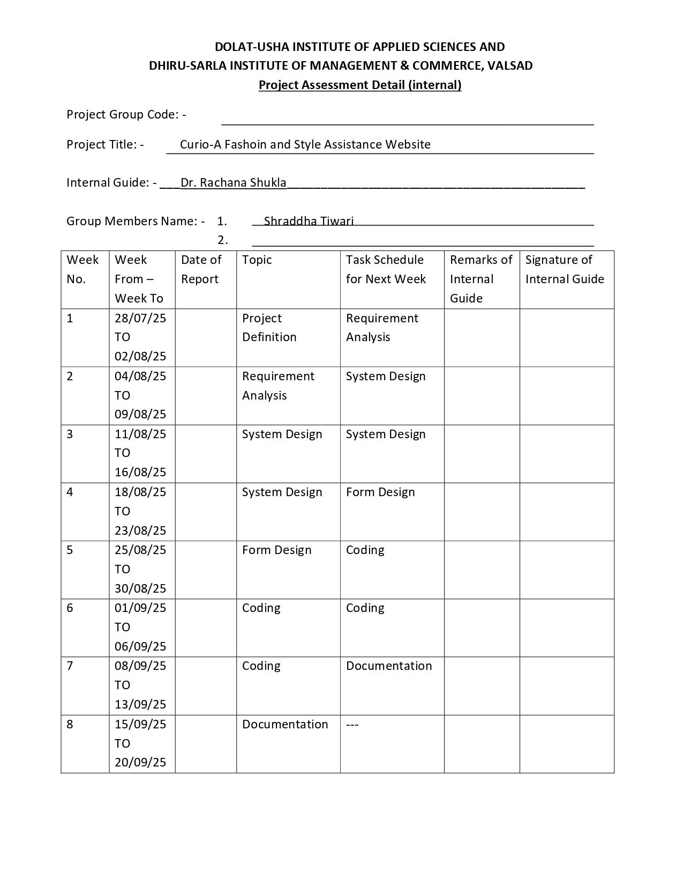
Index

SR. No | Topics | Page No
1  1.1  1.2 | Project Profile  Project goal and objectives  Scope of the project
2 | System Environment  Hardware Software environment
3  3.1  3.2 | Platform Environment  Front End Used  Back End Used
4 | System Requirement Analysis
5  5.1  5.2  5.3 | System Design  System Flow Diagram  Data flow diagram  ER diagram
6 | Data Dictionary
7 | Form Designing and coding
8 | Reports
9 | Testing
10 | Conclusion and Future Enhancement
11 | References/ Bibliography

1 Project Profile
1.1 Project goal and objectives
1.2 Scope of the project

Fashion is one of the most dynamic and rapidly evolving industries, with trends changing frequently and consumer preferences becoming increasingly personalized. With the advent of digital platforms, the way people discover, evaluate, and purchase fashion products has shifted significantly from physical stores to online mediums. While e-commerce platforms provide extensive catalogs of products, they often lack personalization and interactivity, leaving users overwhelmed and unsure about what suits their style, body type, or occasion.
Curio – A Fashion and Style Assistant addresses these challenges by providing a web-based platform that combines fashion information with personalized discovery. Developed using the MERN stack (MongoDB, Express.js, React.js, Node.js), Curio offers both informational and interactive features. Visitors to the website can explore structured content including face shapes and suitable haircuts, hair accessories for different occasions, body shapes with corresponding outfit recommendations, and category-based suggestions such as sandals, hand, or neck accessories. The website also provides login and registration functionality to enable personalized experiences.
Registered users gain the ability to interactively calculate their face shape and body metrics, discover personalized haircuts, accessories, and outfits, and save favorites for future reference. This personalization enhances engagement and helps users make informed fashion choices based on their unique attributes.
From a technical perspective, Curio leverages React.js for a dynamic and responsive frontend, Node.js and Express.js for a robust backend, and MongoDB for flexible and scalable data management. The system also includes an admin module for content management and monitoring, ensuring the platform remains accurate, relevant, and user-friendly.
Overall, Curio demonstrates the effective integration of modern web technologies to create a user-centric, scalable, and interactive fashion assistant, bridging the gap between general information and personalized recommendations in the fashion domain.

2 System Environment
2.1 Hardware Software environment

HARDWARE

SOFTWARE
3 Platform Environment
3.1 Front End Used
3.2 Back End Used

3.1 Front End Description
1. Operating System Requirements:
    - Supported OS: Windows 10/11 ,macOS , Linux (e.g., Ubuntu 20.04 or later)
  - Recommendation: Use macOS or Ubuntu for a seamless development experience.
  - Windows users: Consider using Windows Subsystem for Linux (WSL) for better compatibility.
- Node.js and Package Management:
  - Node.js:
    - Version: v16.x or higher
    - Installed from Node.js Official Website or using nvm (Node Version Manager).
  - npm (Node Package Manager):
    - Comes bundled with Node.js and used to manage frontend dependencies.
- Frontend Framework:
  - React.js:
    - A JavaScript library for building user interfaces.
    - Version: ^19.1.1 (Note: React 18 is the latest stable version).
    - Created using Create React App (CRA), or you can set it up manually.
- Supporting Libraries:
  - React DOM: For rendering React components to the DOM.
    - Version: ^19.1.1
    - Automatically installed with React.
  - React Scripts: A set of scripts for running, building, and testing React apps.
    - Version: 5.0.1
  - React Developer Tools: Chrome/Firefox extension for debugging React components.
- UI & Icon Libraries:
  - Font Awesome:
    - @fortawesome/fontawesome-svg-core: ^7.0.1
    - @fortawesome/free-solid-svg-icons: ^7.0.1
    - @fortawesome/react-fontawesome: ^3.0.2
  - React Icons:
    - Version: ^5.5.0
    - Installation via npm install react-icons.
  - React Modal: For creating modals in the React application.
    - Version: ^3.16.3
- Data Visualization:
  - Chart.js:
    - A library for creating interactive and animated charts.
    - Version: ^4.5.1
  - React Chart.js 2:
    - A wrapper for using Chart.js with React.
    - Version: ^5.3.1
    - Used for embedding charts into React components.
- PDF Generation and Screenshot Capture:
  - jsPDF:
    - Used for generating PDF documents in the frontend.
    - Version: ^3.0.3
  - jsPDF Autotable:
    - A plugin for jsPDF for generating tables in PDFs.
    - Version: ^5.0.2
  - html2canvas:
    - A library for capturing HTML content as images or canvas.
    - Version: ^1.4.1
- Routing and HTTP Requests:
  - React Router DOM:
    - For handling routing and navigation between pages in the app.
    - Version: ^7.9.3
  - Axios:
    - Promise-based HTTP client for making requests to backend APIs.
    - Version: ^1.12.2
- Testing:
  - React Testing Library:
    - @testing-library/react: ^16.3.0
    - @testing-library/jest-dom: ^6.8.0
    - @testing-library/user-event: ^13.5.0
  - Purpose: For unit and integration testing of React components.
- Development Scripts:
  - npm start: Starts the development server with hot-reloading.
  - npm run build: Bundles the app for production deployment.
  - npm test: Runs tests using the testing library.
  - npm run eject: Exposes the configuration files for customization.
- Browsers List:
  - Production Browsers:
    - Supports browsers with more than 0.2% market share.
    - Excludes dead browsers and Opera Mini.
  - Development Browsers:
    - Latest versions of Chrome, Firefox, and Safari.
- Version Control:
  - Use Git for version control.
  - Recommended to host the repository on platforms like GitHub, GitLab, or Bitbucket.
- Code Quality:
  - ESLint: Ensures code quality and adherence to coding standards.
  - Configured with react-app and react-app/jest rules.
3.2 Back End Description

• Operating System:
- Windows 10/11, macOS, or Linux (e.g., Ubuntu 20.04 or later).
• Node.js:
- Version v16.x or higher.
• Core Frameworks:
- Express: Version ^5.1.0.
• Dependencies:
- CORS: ^2.8.5 (Cross-Origin Resource Sharing middleware).
- dotenv: ^17.2.3 (Environment variable management).
- jsonwebtoken: ^9.0.2 (JWT for authentication).
- Nodemailer: ^7.0.10 (Email sending).
- Nodemon: ^3.1.10 (Live-reloading in development).
- MongoDB: ^6.20.0 (Database).
- Mongoose: ^8.18.2 (MongoDB object modeling).
• Scripts:
- npm start: Runs the backend server with live-reload (using nodemon).
- npm test: Placeholder for testing.
• Configuration:
- Use dotenv to manage environment variables (e.g., database URL, JWT secret).
- MongoDB URI to connect to the database.
4 System Requirement Analysis

Methodology
The methodology outlines the structured approach followed during the development of the Curio – Fashion Assistant web application. The project was developed using the MERN stack (MongoDB, Express.js, React.js, Node.js) and followed a systematic software development lifecycle to ensure a robust, scalable, and user-friendly solution.

1. Requirement Gathering
- Functional Requirements:
  - Landing page with header, footer, and main content sections (Hero, Face Shape & Haircuts, Hair Accessories, Body Shape & Outfit Recommendations, Category-based Recommendations).
  - Visitor functionalities: view information, access login/registration.
  - Registered user functionalities: calculate face/body metrics, discover personalized recommendations, save favorites.
  - Admin functionalities: manage content, users, and recommendations.
- Non-Functional Requirements:
  - Responsive and intuitive UI.
  - Secure user authentication.
  - Scalable and maintainable architecture.
- Tools & Technologies:
  - Frontend: React.js, CSS, HTML
  - Backend: Node.js, Express.js
  - Database: MongoDB
  - Version Control: Git & GitHub

2. System Design
- Defined a 3-tier architecture (Frontend, Backend, Database).
- Created wireframes and layouts for all main pages.
- Designed ER diagram for database collections: Users, Favorites, Recommendations, Ratings, Outfits.
- Defined API endpoints for communication between frontend and backend.

3. Development / Implementation
- Frontend Development:
  - Built reusable components for Hero Section, Product/Recommendation Cards, Rating System, and Favorites.
  - Implemented interactive calculations for face and body metrics.
- Backend Development:
  - Created RESTful APIs for user authentication, CRUD operations on recommendations, favorites, and ratings.
  - Implemented business logic for personalized recommendations.
- Database Integration:
  - Designed MongoDB schemas and relationships using Mongoose.
  - Ensured data consistency and optimized queries for faster response.

4. Testing
- Conducted unit testing for individual components and APIs.
- Performed integration testing to ensure smooth frontend-backend communication.
- Verified user flows: Visitor browsing, user calculations, admin content management.

5. Deployment (Future Scope)
- Frontend deployment: Netlify or Vercel.
- Backend deployment: Heroku or Render.
- Database: MongoDB Atlas (cloud-based).
5 Design and Diagram
5.1 System Design
5.1.1 Data Flow Diagram
5.2 Data flow diagram
5.2.1 ER diagram

5.1 System Design

5.1.1 Data Flow Diagram

- Context Level Diagram

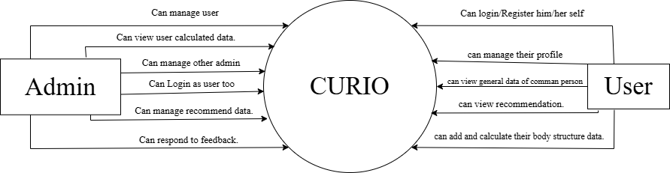

- 1st level diagram

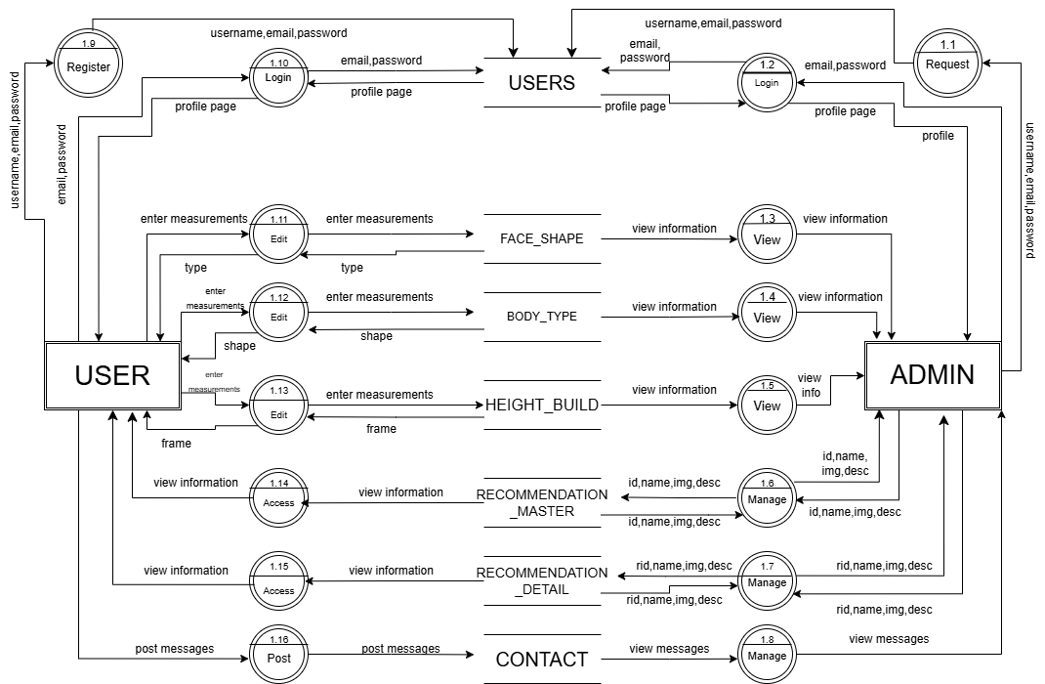

- 2nd level diagram

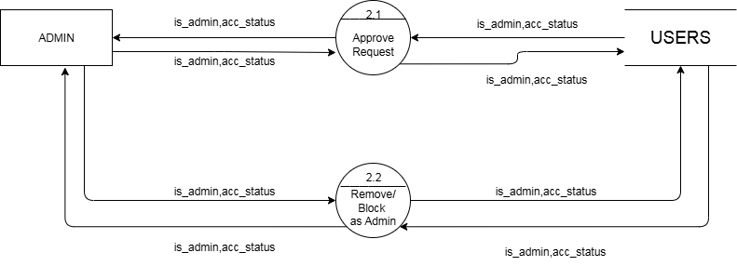

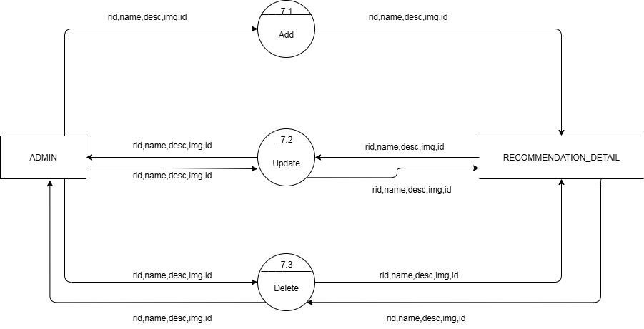

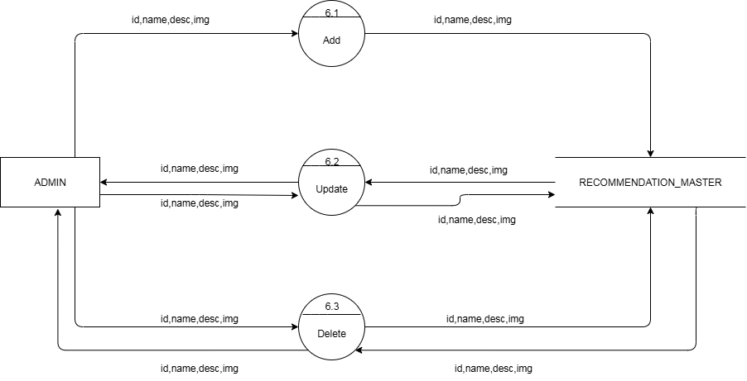
5.2 Data flow diagram
5.2.1 ER diagram
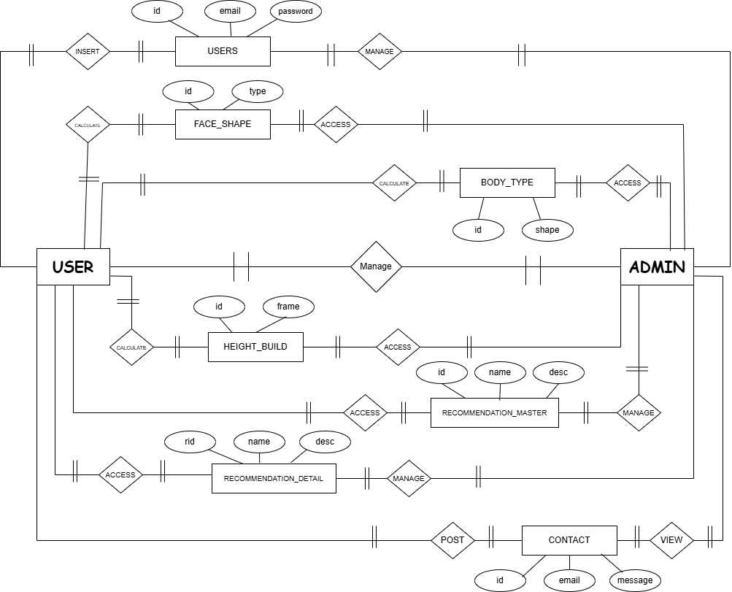
6 Data Dictionary

- Users

Sr | Field Name | Data Type | Constraint | Default Value | Description
1 | _id | String | Primary Key | N/A | Unique identifier for the user
2 | fullname | String | Not Null | N/A | Full name of the user
3 | username | String | Not Null, Unique | N/A | Username of the user
4 | dob | Date | Not Null | N/A | Date of birth of the user
5 | gender | String | Not Null | N/A | Gender of the user
6 | email | String | Not Null, Unique | N/A | Email address of the user
7 | password | String | Not Null | N/A | Password for user authentication
8 | is_admin | Integer | Not Null | 0 (default) | Indicates if the user has admin privileges
9 | acc_status | Integer | Not Null | 0 | Account status (1 = verified, 0 = registered , 2= blocked)
10 | created_at | Timestamp | Not Null | Current Timestamp | Timestamp when the user account was created
11 | updated_at | Timestamp | Not Null | Current Timestamp | Timestamp when the user account was last updated

- Contact
Sr | Field Name | Data Type | Constraint | Default Value | Description
1 | _id | String | Primary Key | N/A | Unique identifier for the contact
2 | name | String | Not Null | N/A | Name of the person contacting
3 | email | String | Not Null, Unique | N/A | Email address of the person contacting
4 | message | String | Not Null | N/A | Message content provided by the person
5 | createdAt | Timestamp | Not Null | Current Timestamp | Timestamp when the contact message was created

- Face_shape
Sr | Field Name | Data Type | Constraint | Default Value | Description
1 | _id | String | Primary Key | N/A | Unique identifier for the face measurement record
2 | user_id | String | Foreign Key | N/A | Reference to the user's ID
3 | faceLength | Float | Not Null | N/A | Length of the face (in cm)
4 | foreheadWidth | Float | Not Null | N/A | Width of the forehead (in cm)
5 | cheekboneWidth | Float | Not Null | N/A | Width of the cheekbones (in cm)
6 | jawlineWidth | Float | Not Null | N/A | Width of the jawline (in cm)
7 | created_at | Timestamp | Not Null | Current Timestamp | Timestamp when the face measurements were recorded
8 | updated_at | Timestamp | Not Null | Current Timestamp | Timestamp when the face measurements were last updated
9 | face_shape | String | Not Null | N/A | The overall shape of the face (e.g., "Oval")

- Body_type
Sr | Field Name | Data Type | Constraint | Default Value | Description
1 | _id | String | Primary Key | N/A | Unique identifier for the body measurement record
2 | user_id | String | Foreign Key | N/A | Reference to the user's ID
3 | gender | String | Not Null | N/A | Gender of the user (e.g., "female")
4 | shoulderWidth | Float | Not Null | N/A | Width of the shoulders (in cm)
5 | bust | Float | Not Null | N/A | Measurement of the bust (in cm)
6 | waist | Float | Not Null | N/A | Measurement of the waist (in cm)
7 | hips | Float | Not Null | N/A | Measurement of the hips (in cm)
8 | body_shape | String | Not Null | N/A | Overall body shape (e.g., "Hourglass")
9 | created_at | Timestamp | Not Null | Current Timestamp | Timestamp when the body measurements were recorded
10 | updated_at | Timestamp | Not Null | Current Timestamp | Timestamp when the body measurements were last updated
- Height_build

Sr | Field Name | Data Type | Constraint | Default Value | Description
1 | _id | String | Primary Key | N/A | Unique identifier for the physical measurement record
2 | user_id | String | Foreign Key | N/A | Reference to the user's ID
3 | gender | String | Not Null | N/A | Gender of the user (e.g., "female")
4 | footSize | Float | Not Null | N/A | Foot size of the user (in cm)
5 | height | Float | Not Null | N/A | Height of the user (in cm)
6 | weight | Float | Not Null | N/A | Weight of the user (in kg)
7 | frame | String | Not Null | N/A | Body frame type of the user (e.g., "Small")
8 | created_at | Timestamp | Not Null | Current Timestamp | Timestamp when the physical measurements were recorded
9 | updated_at | Timestamp | Not Null | Current Timestamp | Timestamp when the physical measurements were last updated

- Recommendation_master

Sr | Field Name | Data Type | Constraint | Default Value | Description
1 | _id | String | Primary Key | N/A | Unique identifier for the outfit inspiration record
2 | icon | String | Not Null | N/A | Emoji representing the category or theme (e.g., "👗")
3 | title | String | Not Null | N/A | Title of the outfit inspiration (e.g., "Outfit Ideas")
4 | desc | String | Not Null | N/A | A description or summary of the outfit ideas content
5 | createdAt | Timestamp | Not Null | Current Timestamp | Timestamp when the outfit inspiration was created
6 | updatedAt | Timestamp | Not Null | Current Timestamp | Timestamp when the outfit inspiration was last updated
7 | updated_at | Timestamp | Not Null | Current Timestamp | Another timestamp indicating when the record was updated
- Recommendation_detail

Sr | Field Name | Data Type | Constraint | Default Value | Description
1 | _id | String | Primary Key | N/A | Unique identifier for the outfit recommendation
2 | recommendationId | String | Foreign Key | N/A | Reference to the related outfit inspiration record
3 | category | String | Not Null | N/A | Category of the recommendation (e.g., "Outfit Ideas")
4 | icon | String | Not Null | N/A | Emoji representing the category or theme (e.g., "👗")
5 | name | String | Not Null | N/A | Name or title of the outfit recommendation (e.g., "Casual Daywear")
6 | img | String | Optional | N/A | Image URL or path for the outfit recommendation
7 | desc | String | Not Null | N/A | Description of the outfit recommendation
8 | gender | String | Not Null | N/A | Gender for which the outfit is recommended (e.g., "female")
9 | bodyType | Array (String) | Not Null | N/A | List of body types suitable for the outfit (e.g., ["Hourglass", "Petite", "Tall"])
10 | occasion | String | Not Null | N/A | The occasion for which the outfit is suited (e.g., "casual")
11 | footwearPairing | Array (String) | Not Null | N/A | List of footwear options that pair with the outfit
12 | season | Array (String) | Not Null | N/A | List of seasons when the outfit is appropriate (e.g., ["Summer", "Fall"])
13 | accessories | Array (String) | Not Null | N/A | List of recommended accessories to pair with the outfit
7 Form Designing and coding

- UI DESIGN FOR ROLES

VISITOR
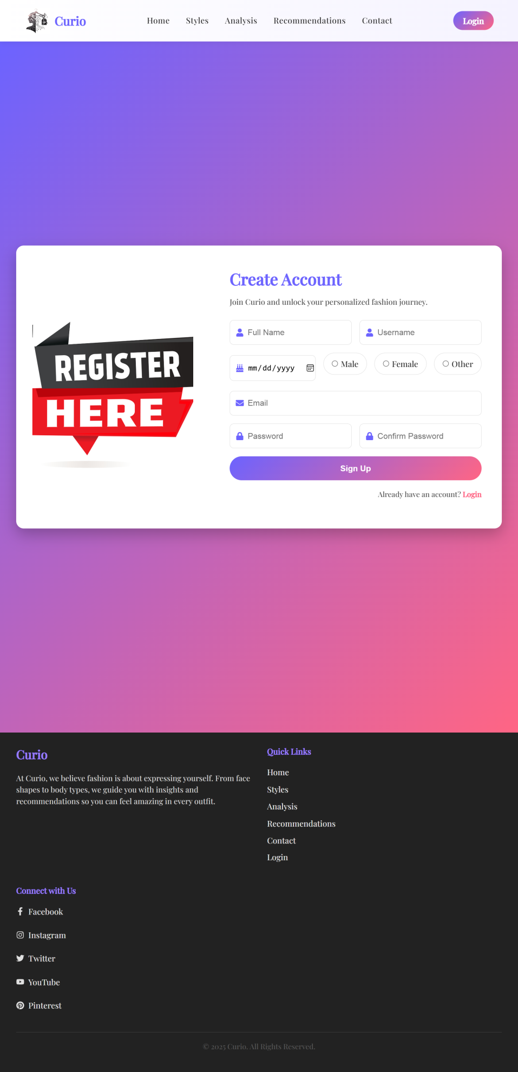

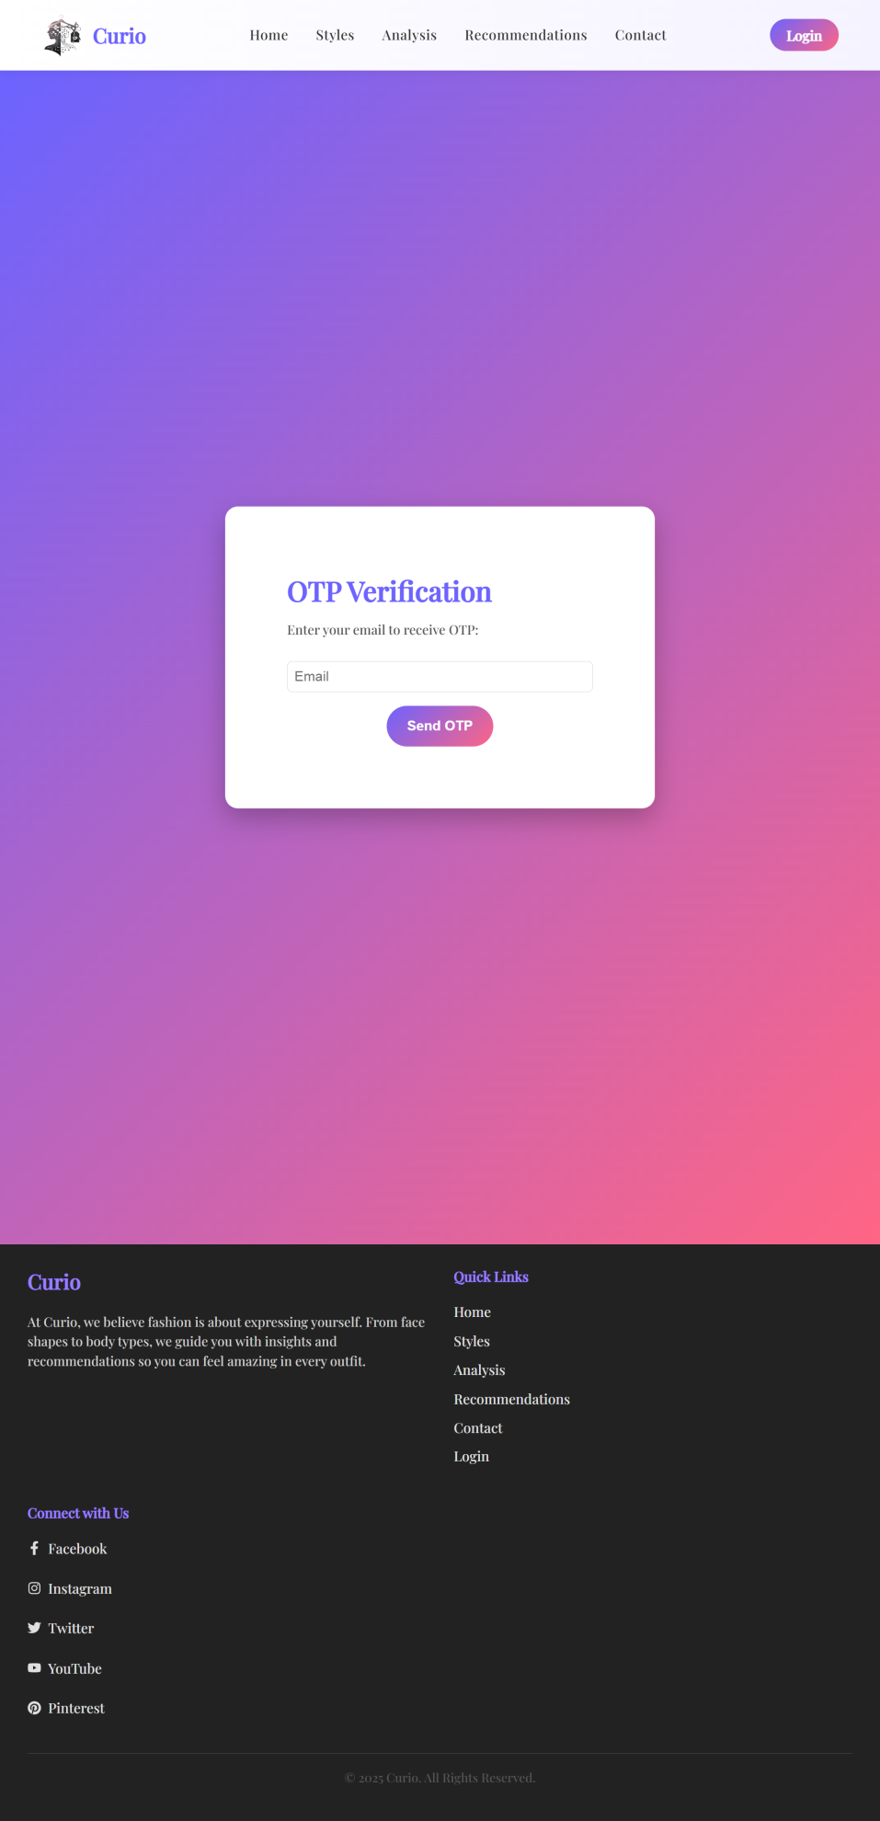
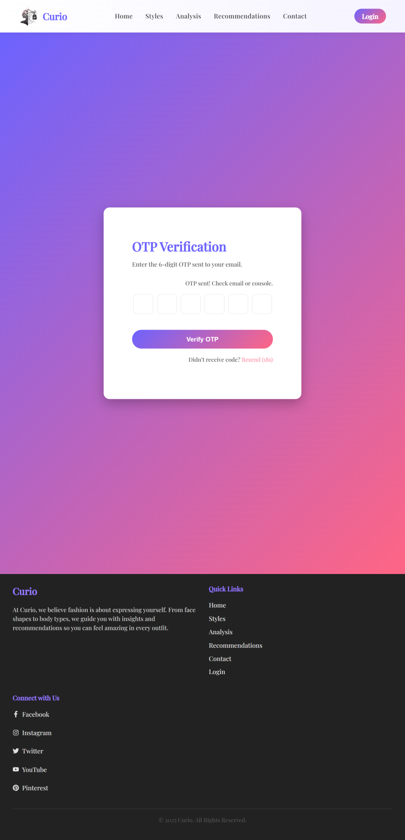
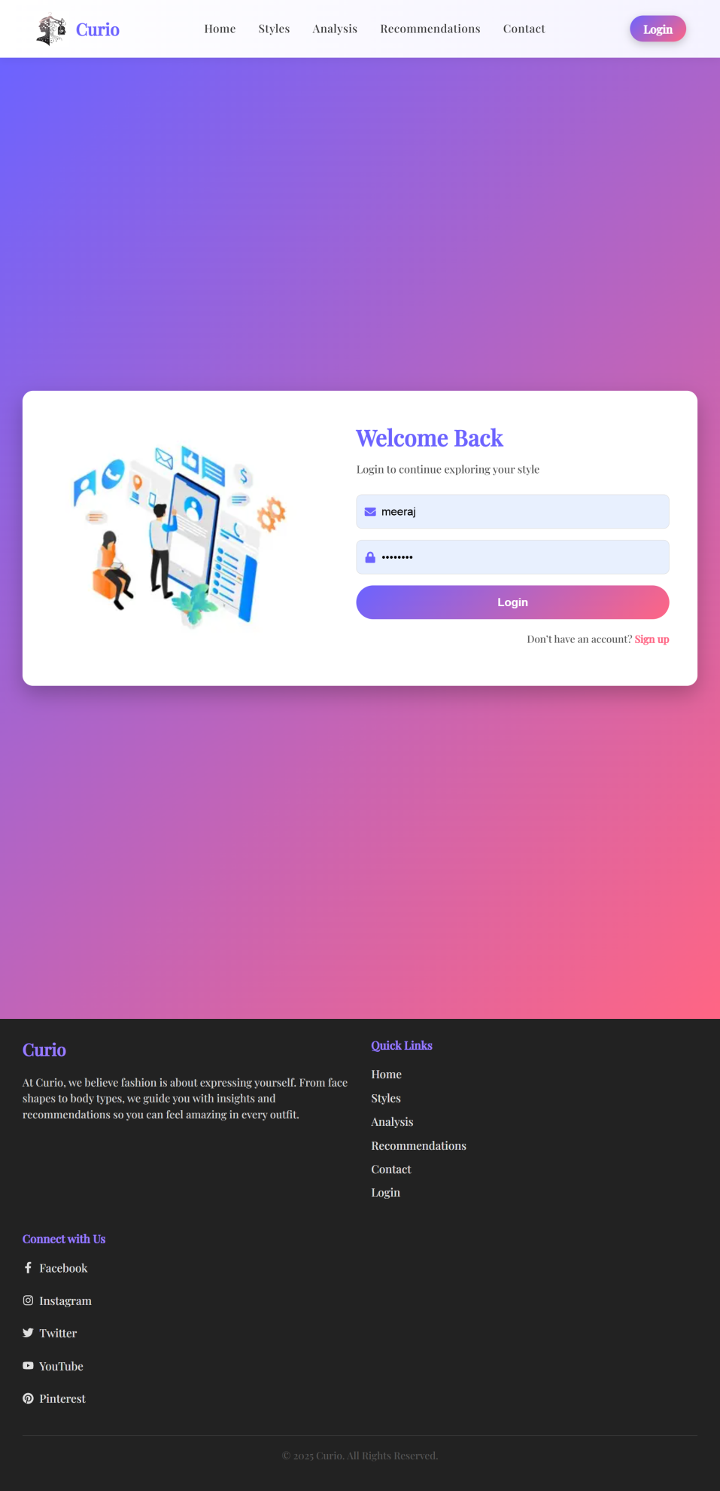
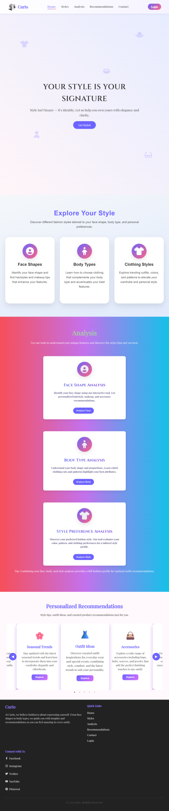
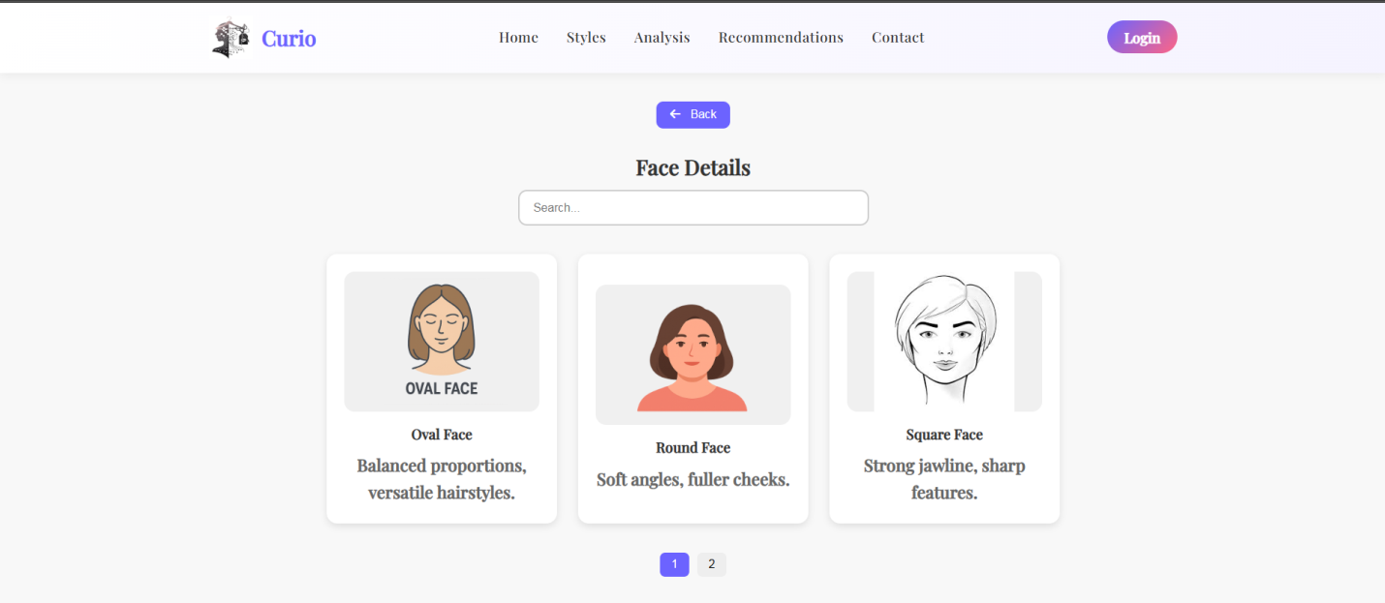
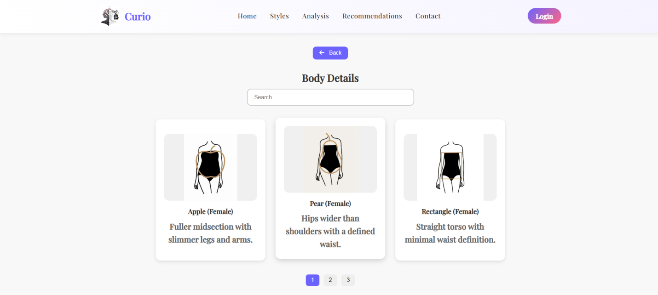
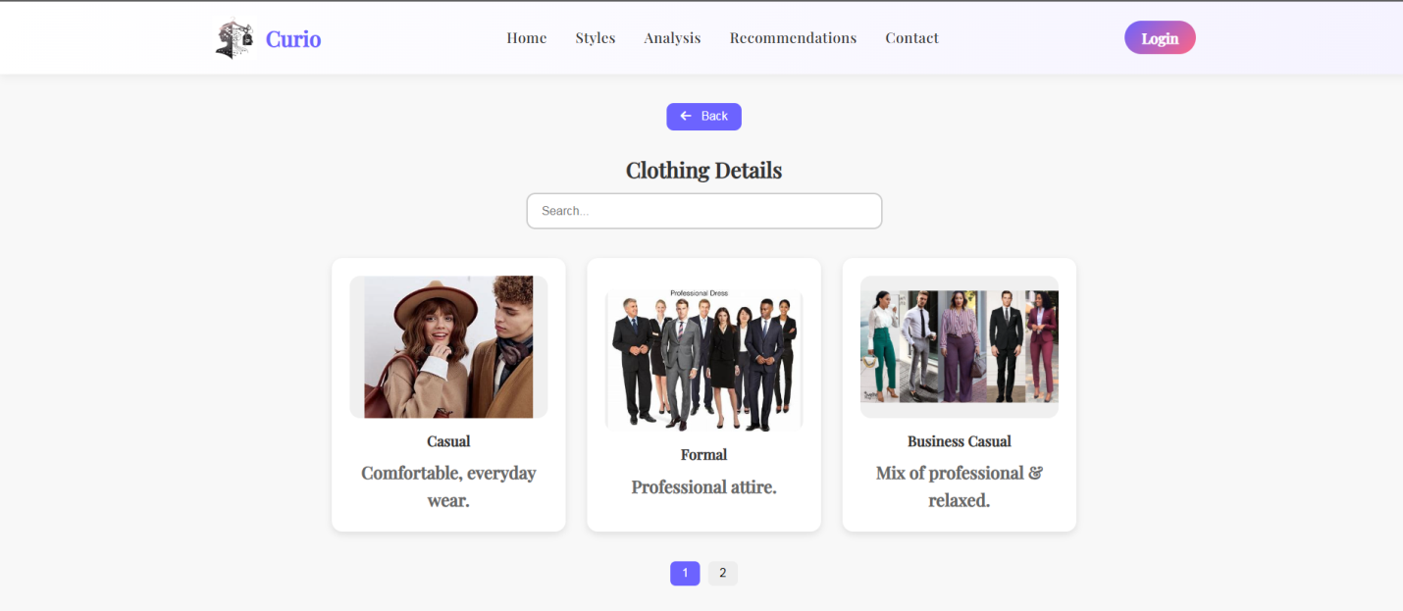
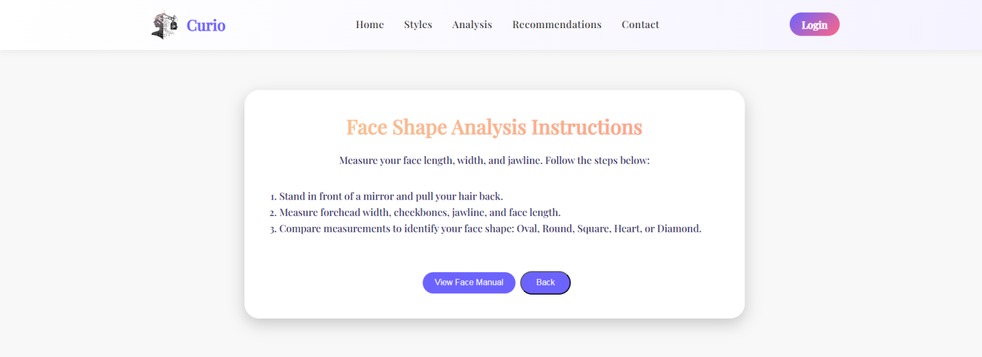
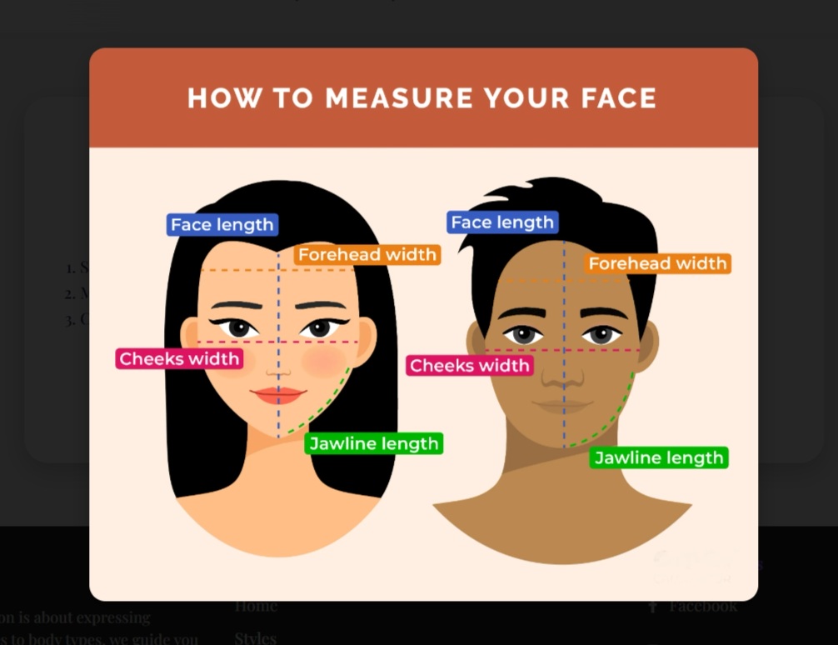
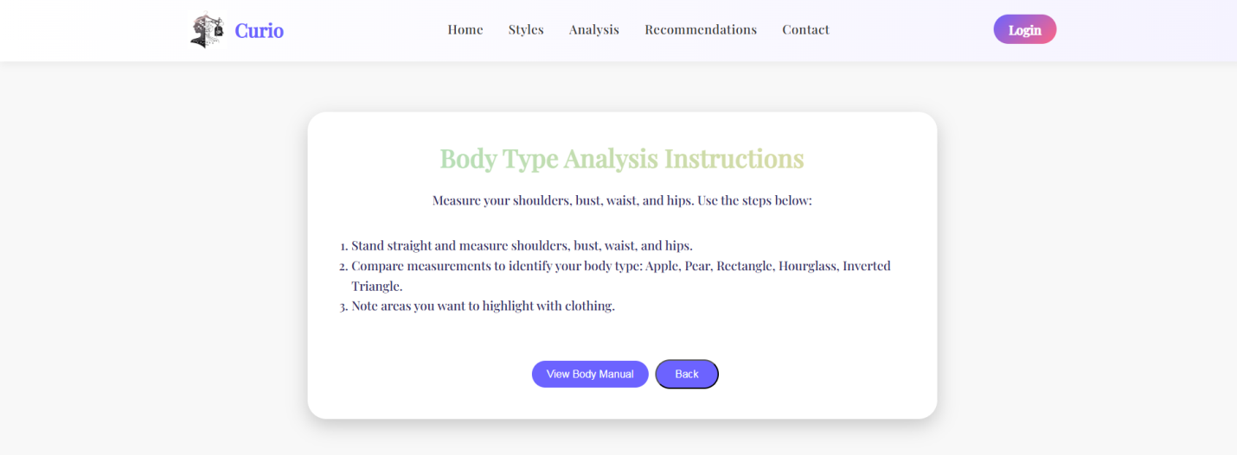

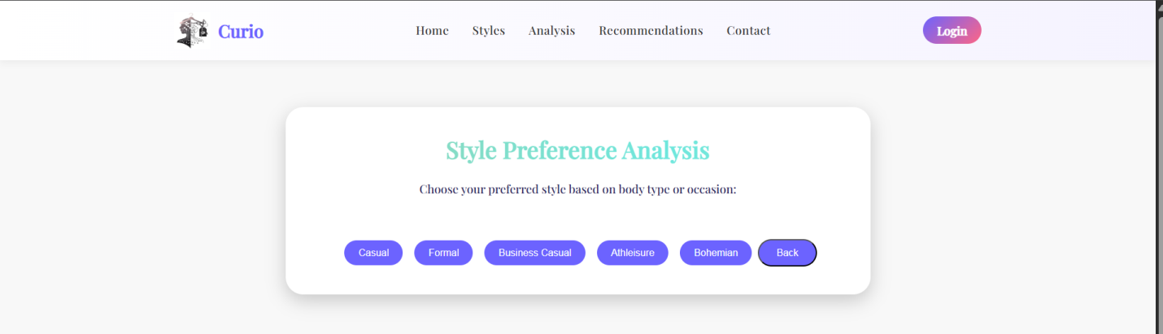
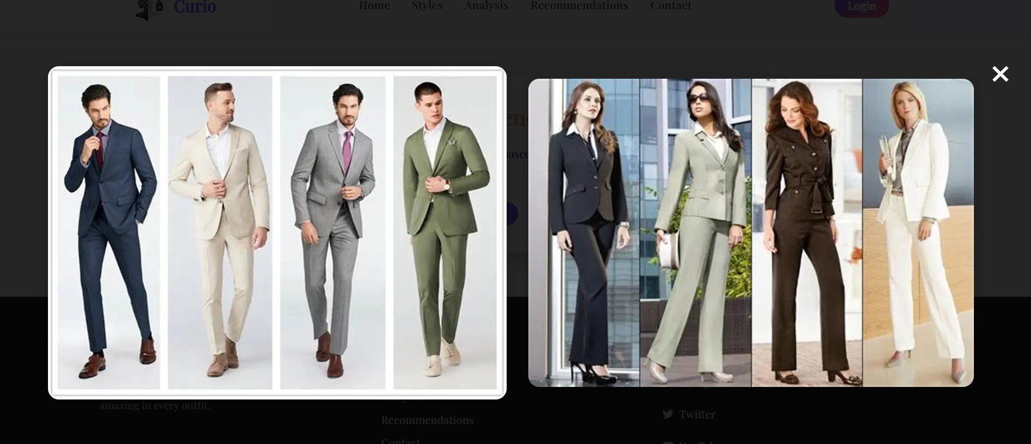
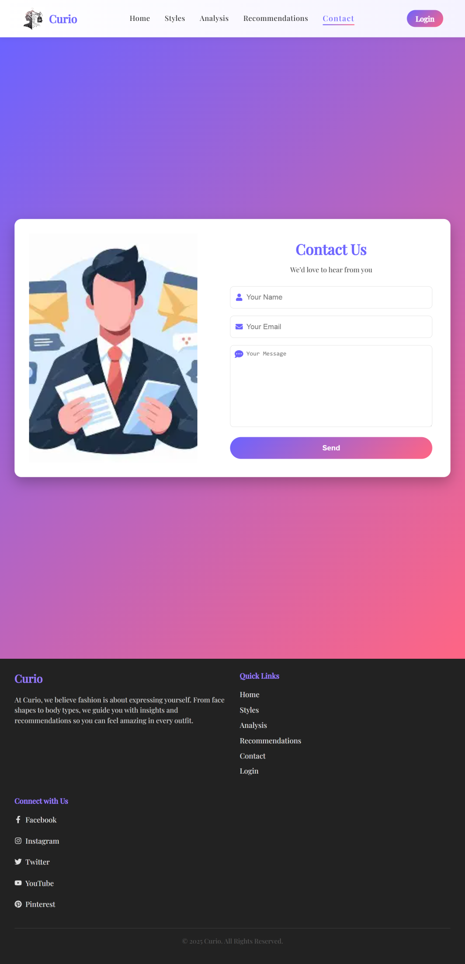
USER
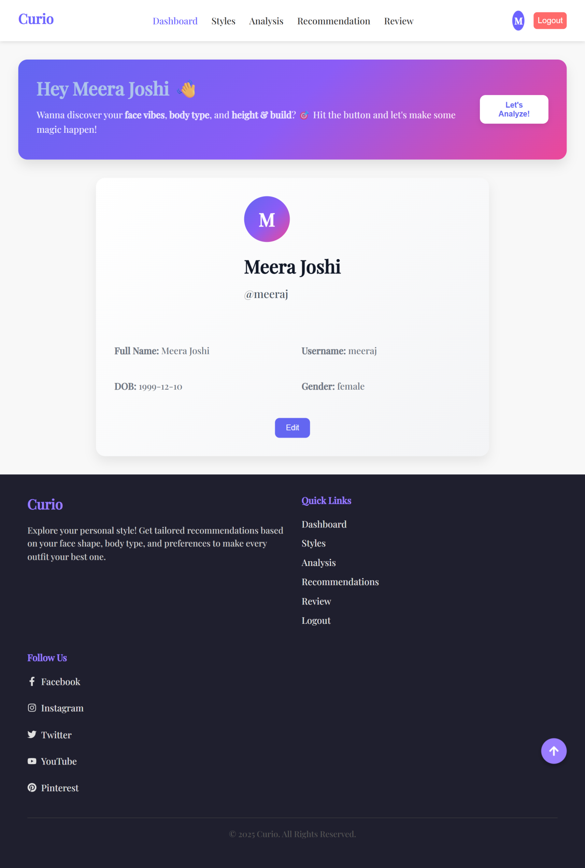
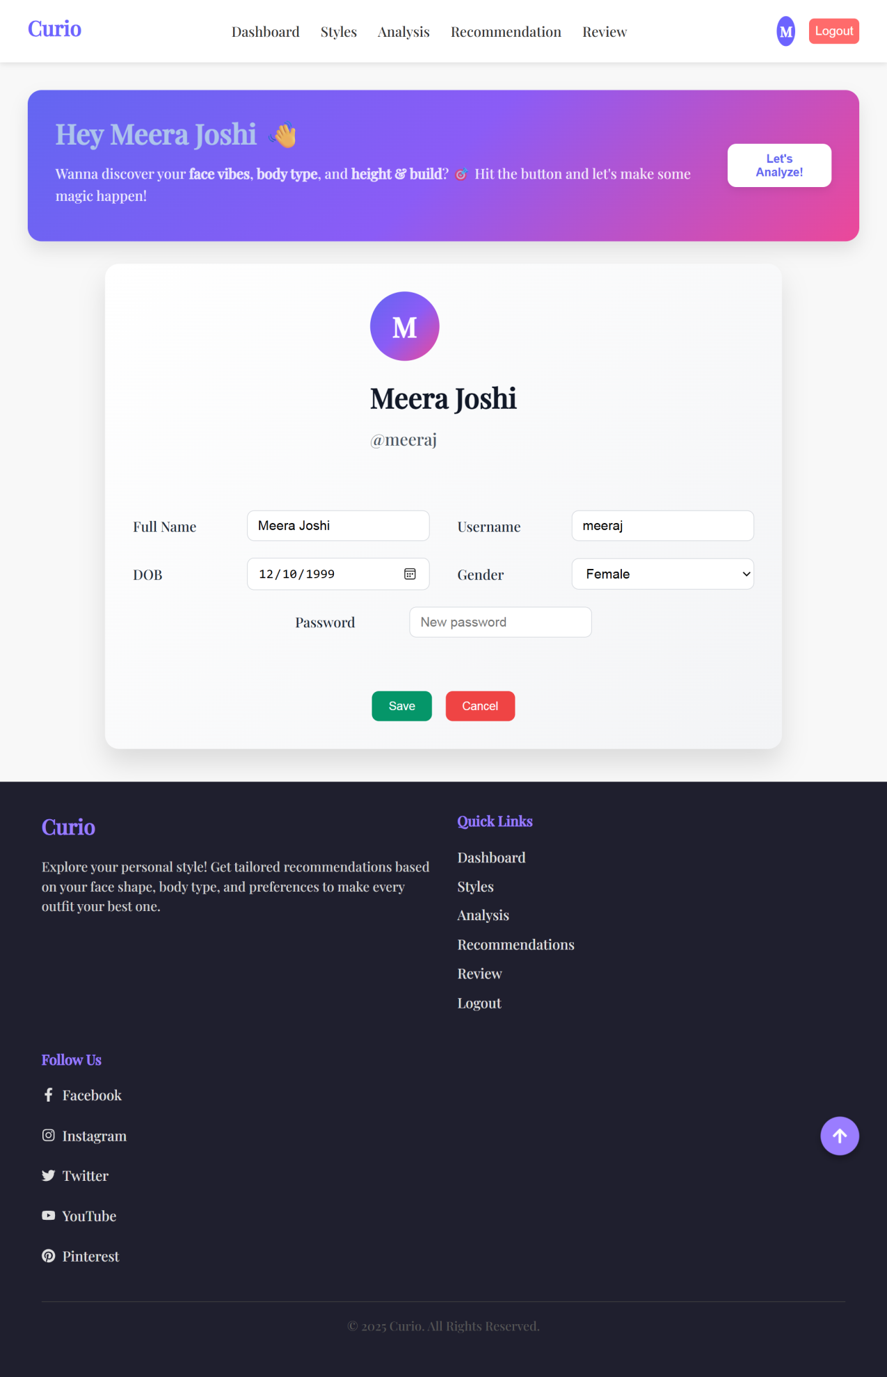
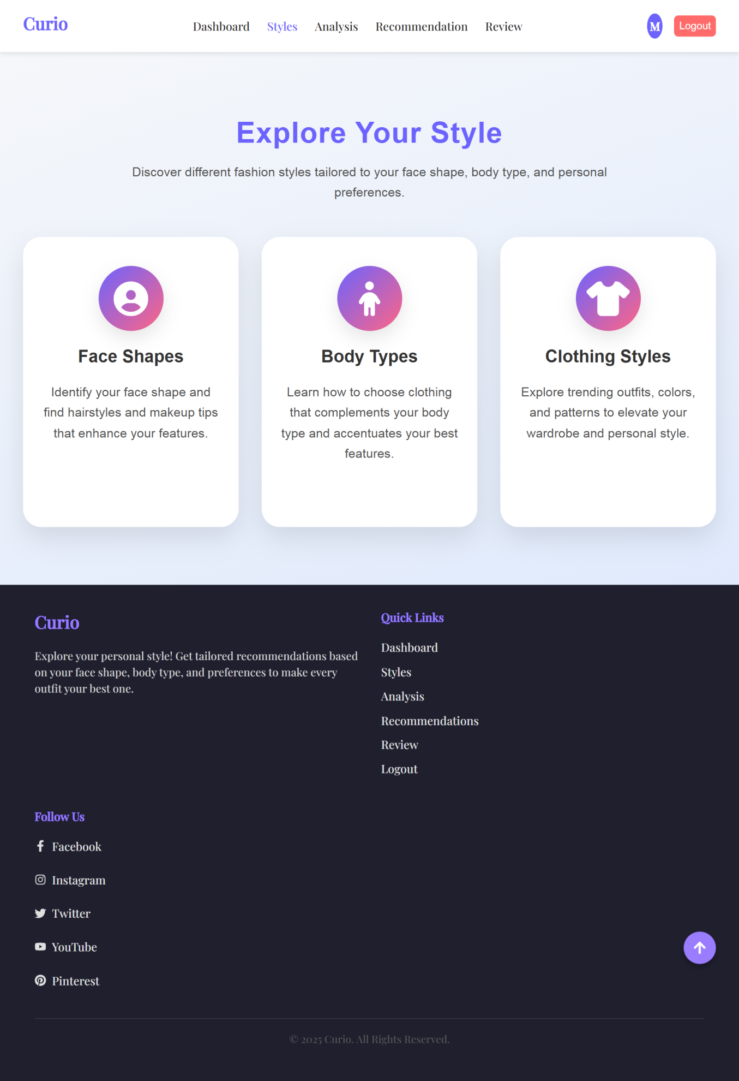
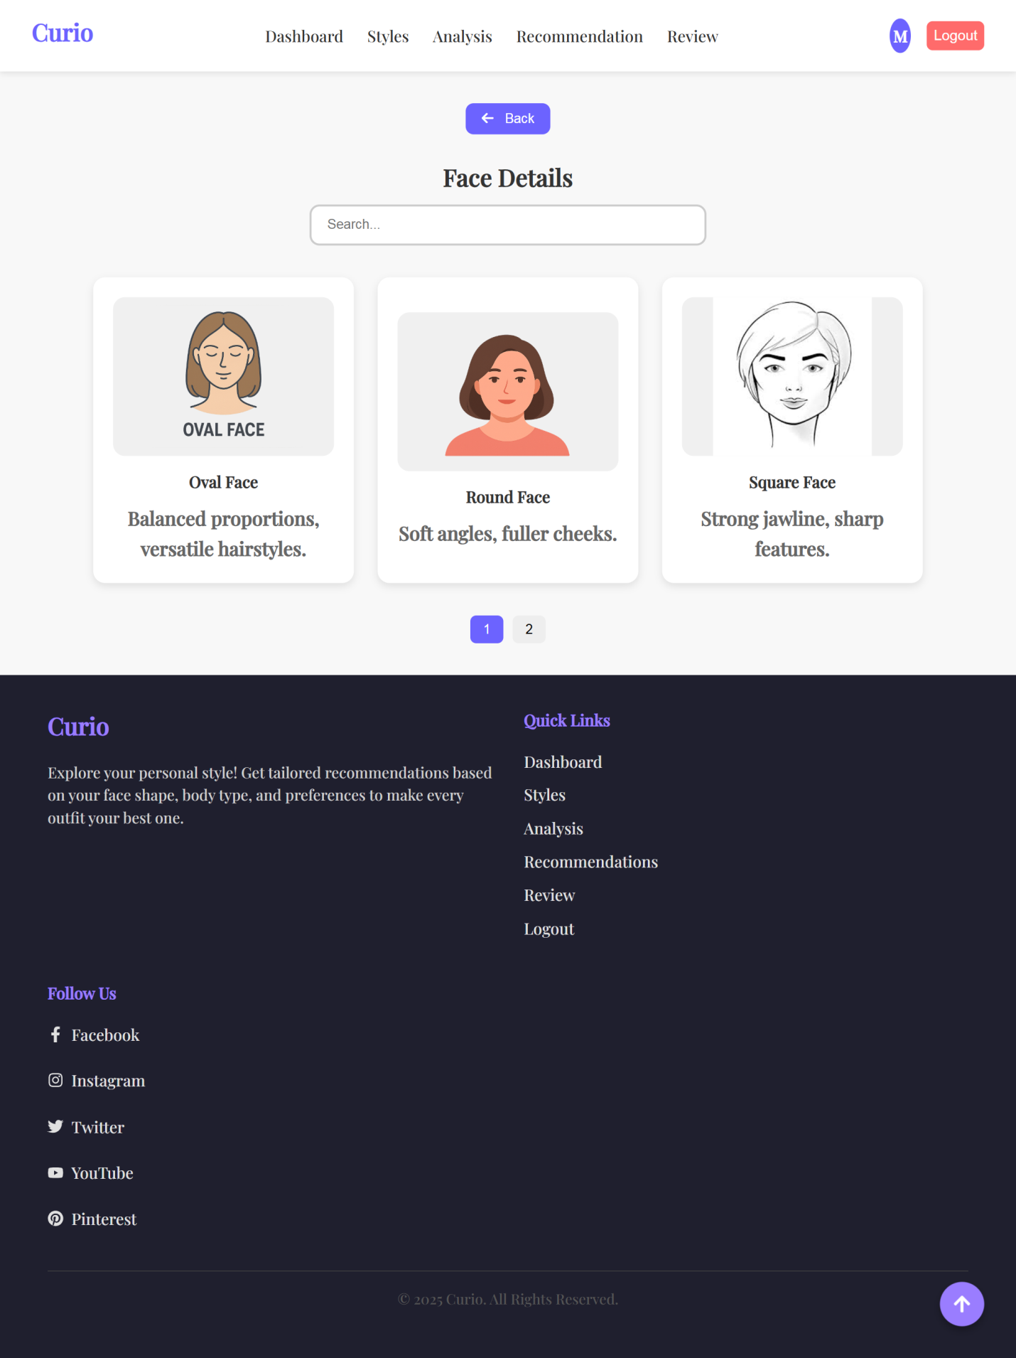

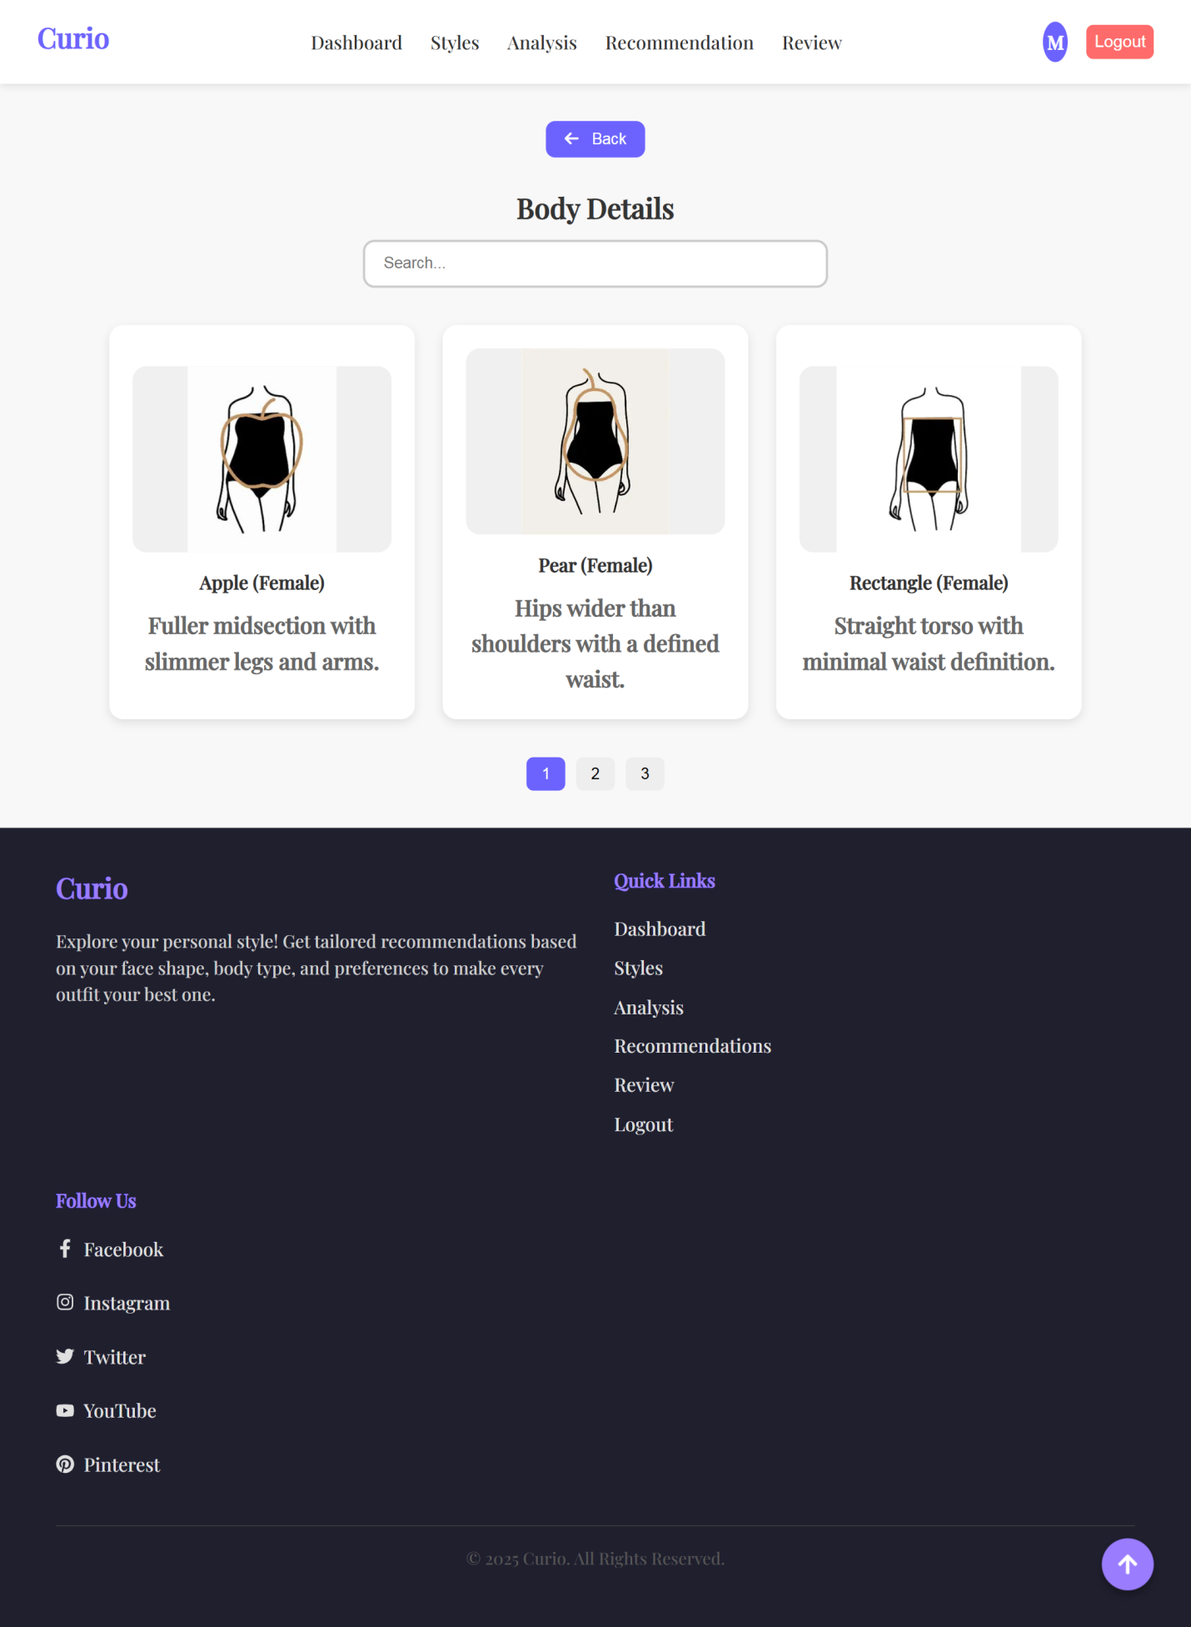

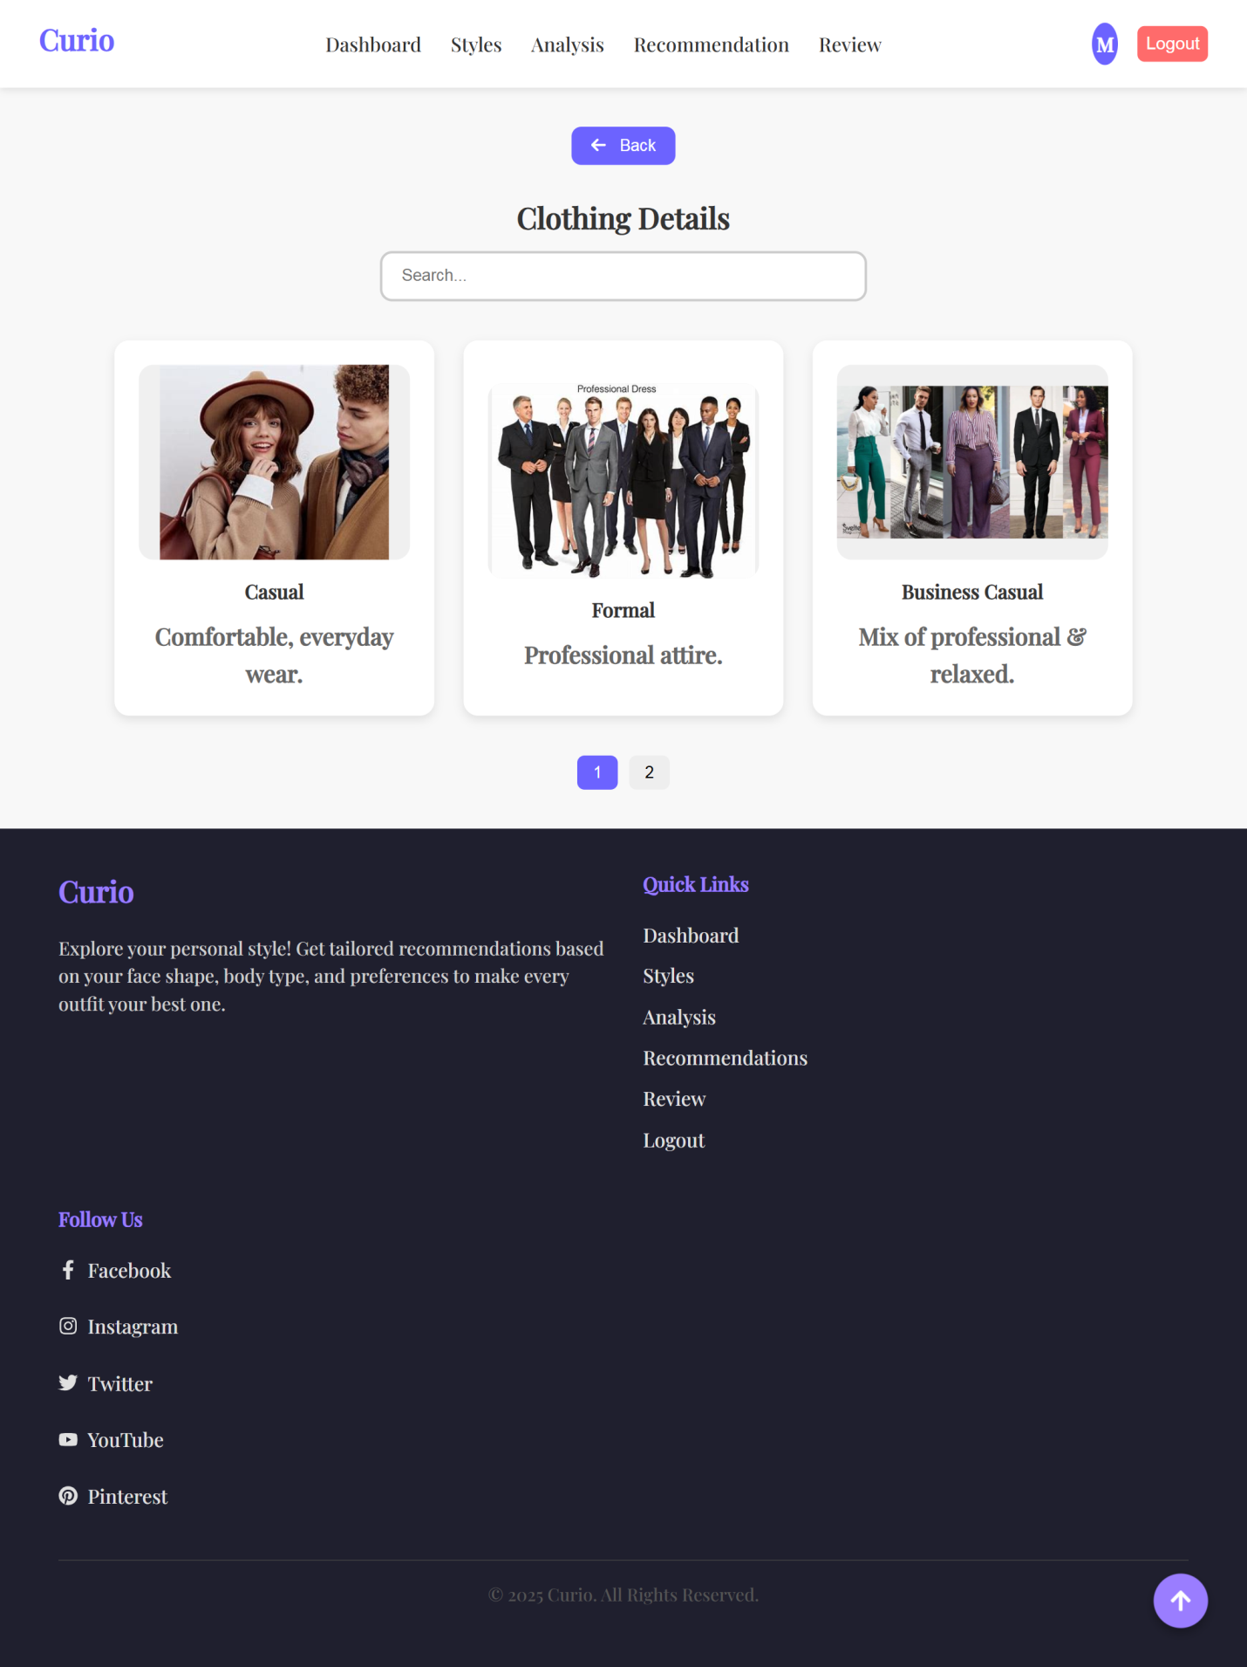

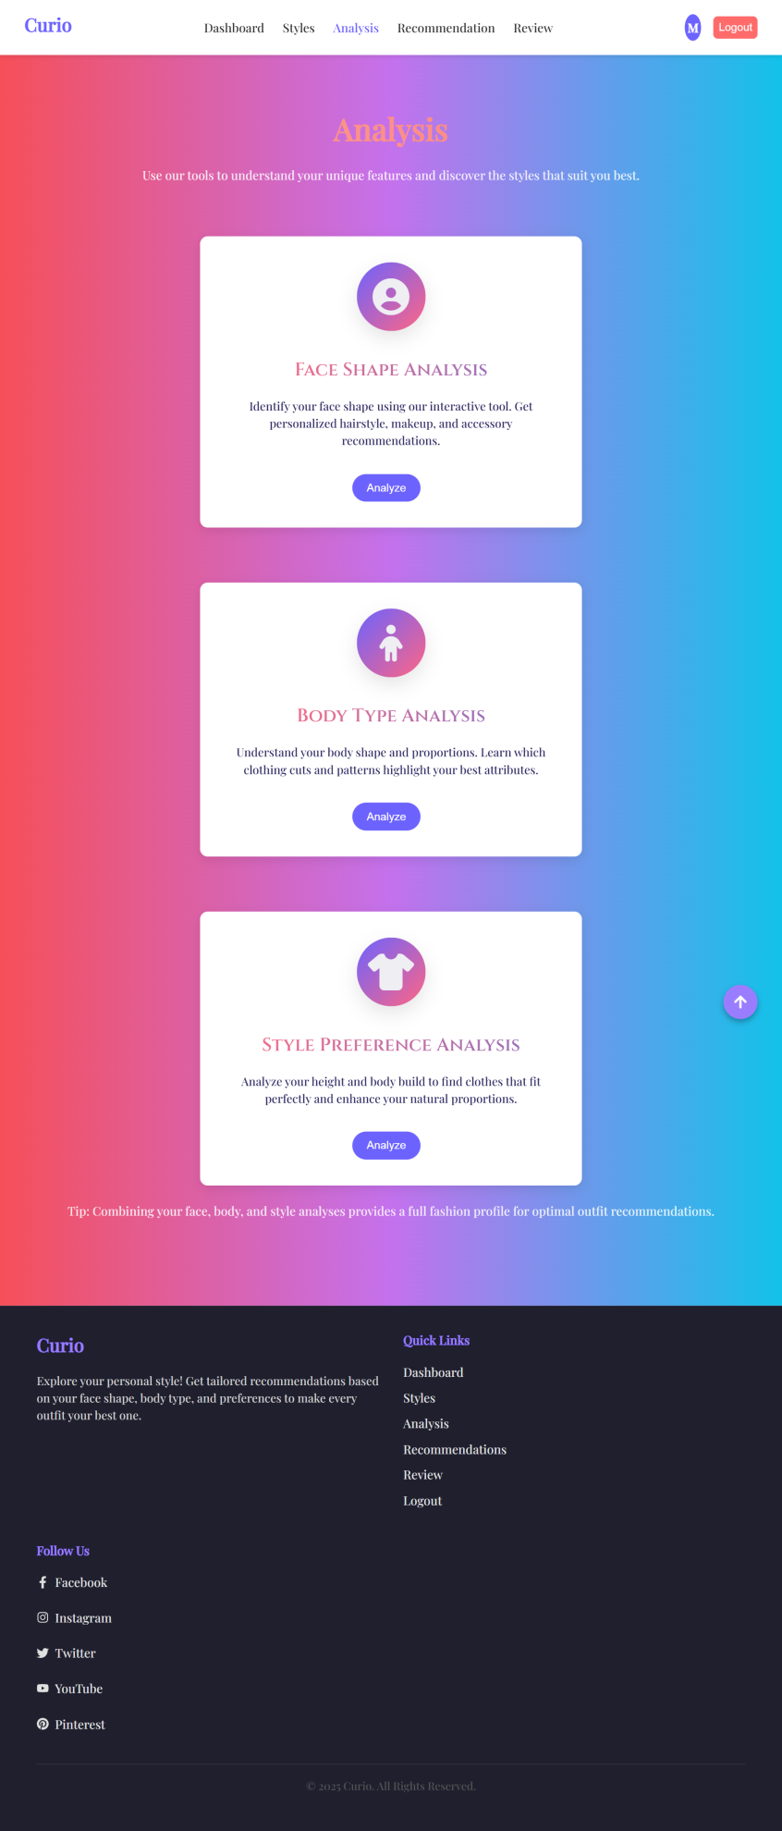
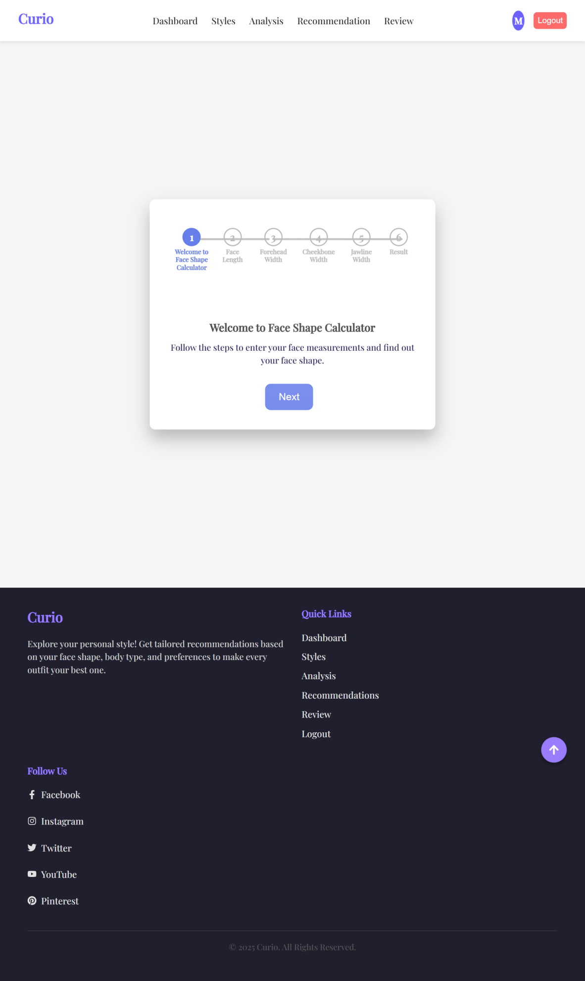
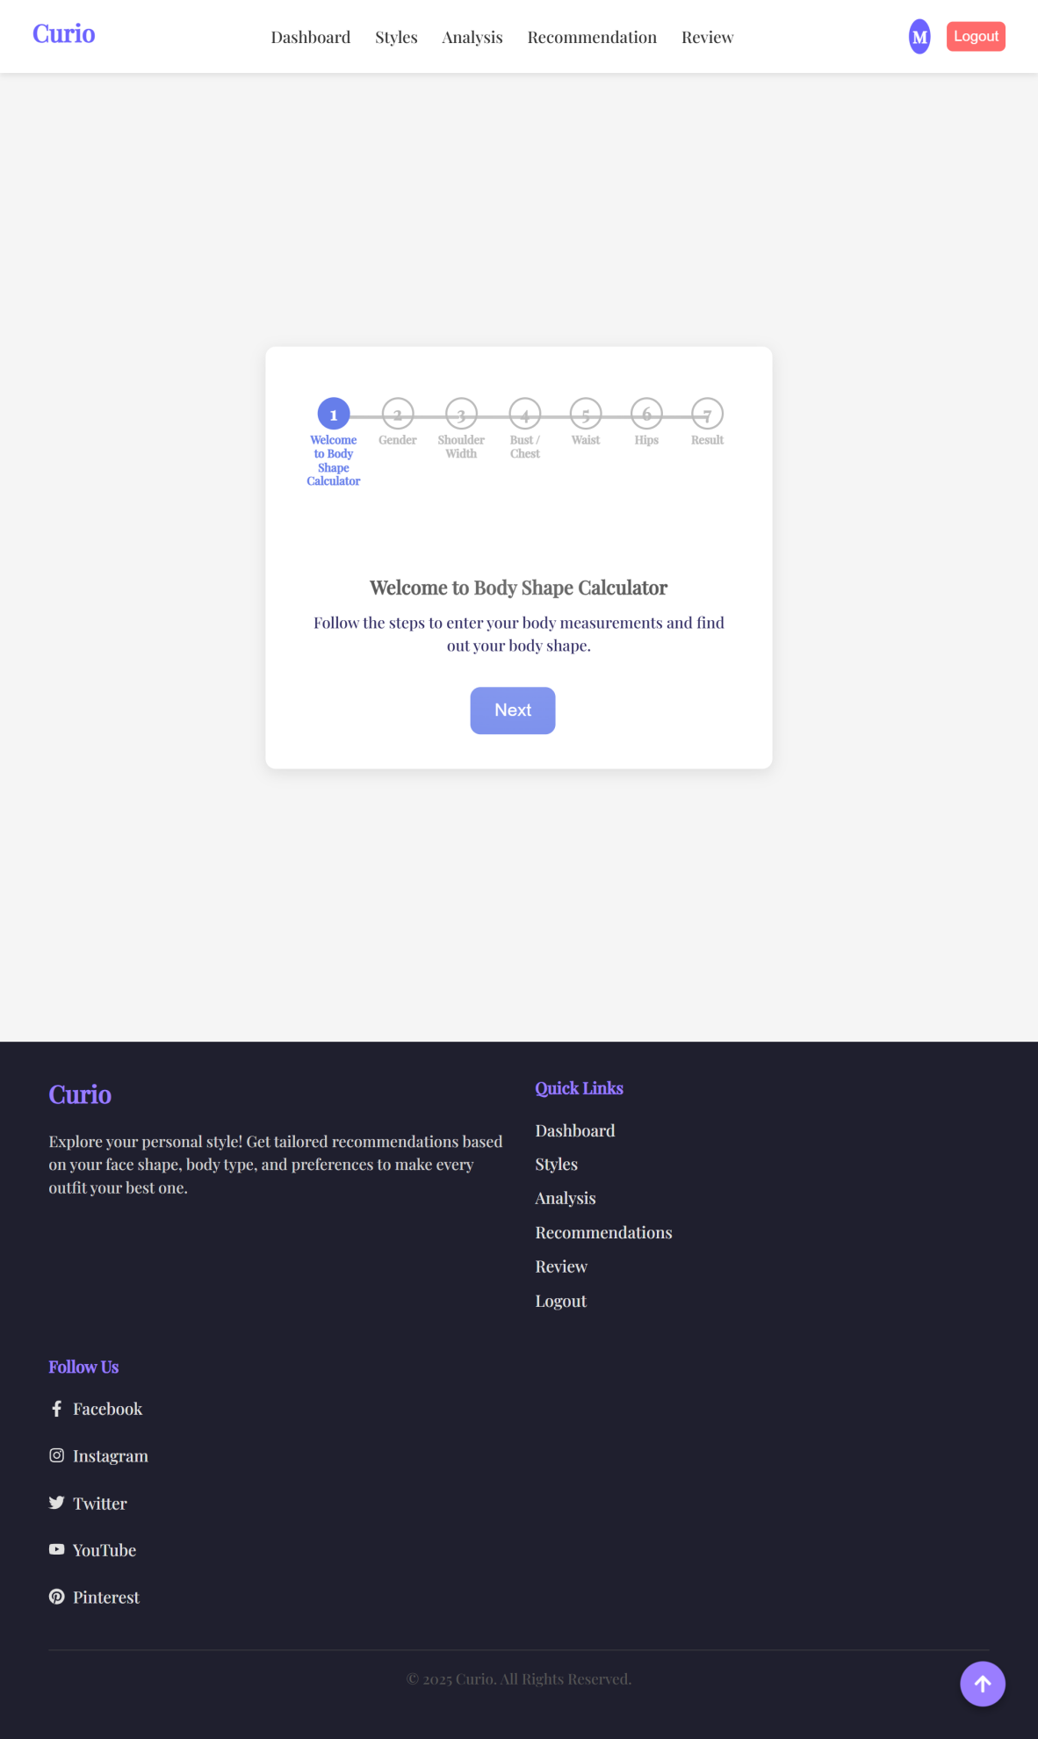
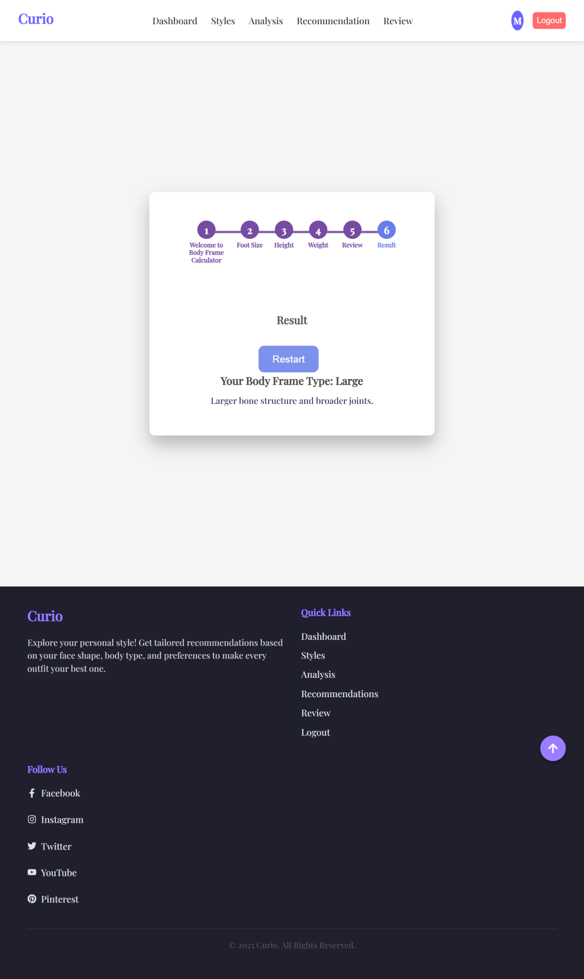
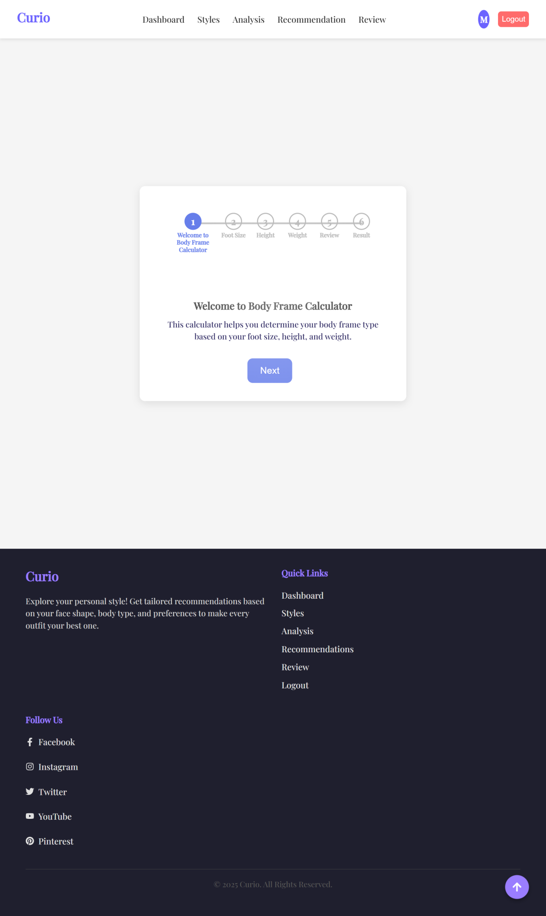
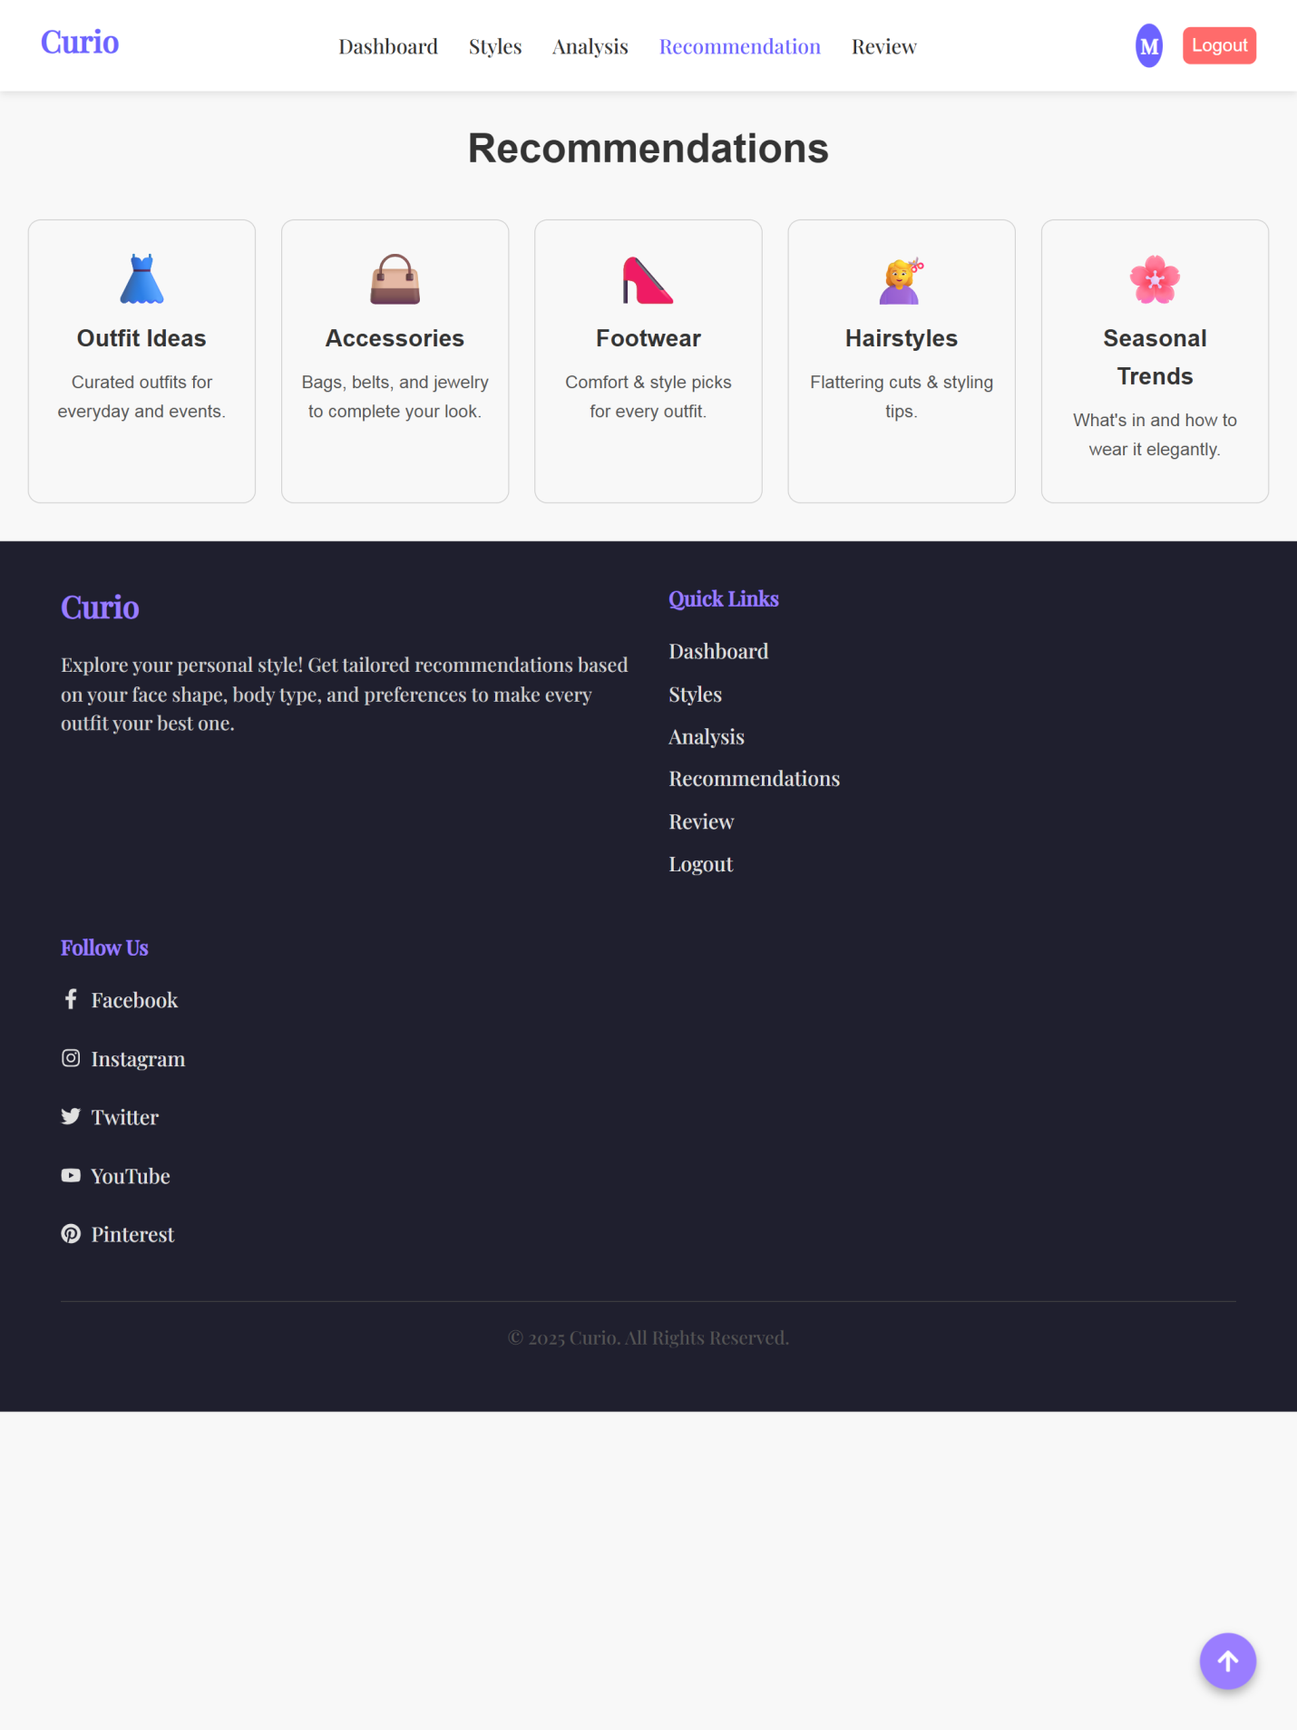
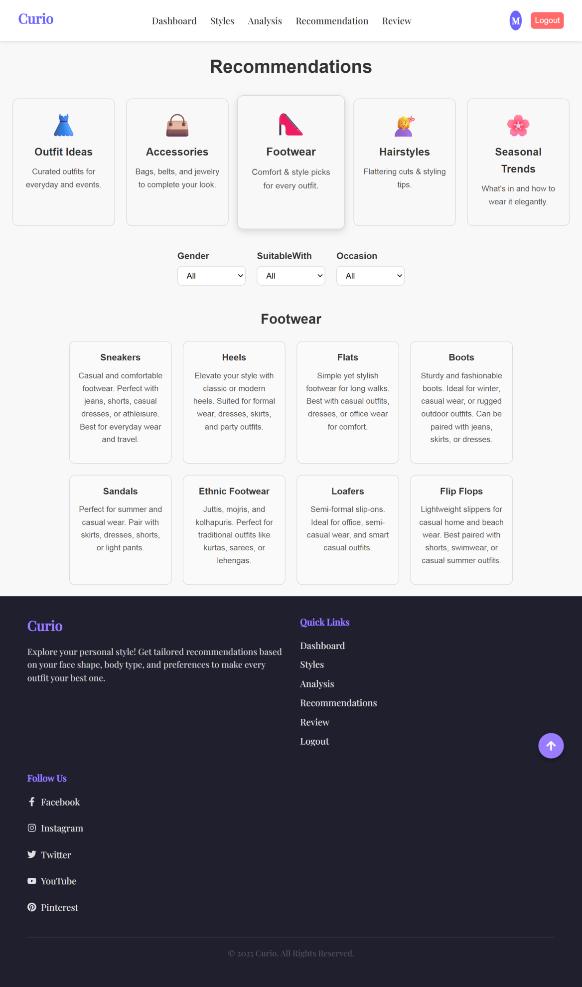
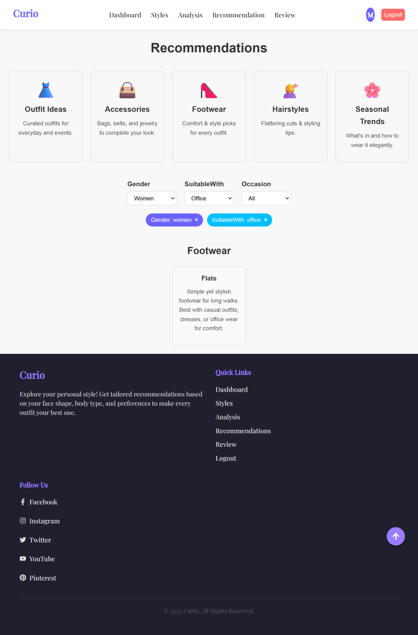
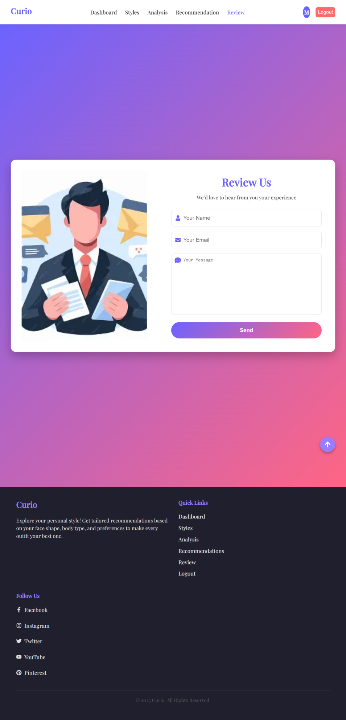
ADMIN
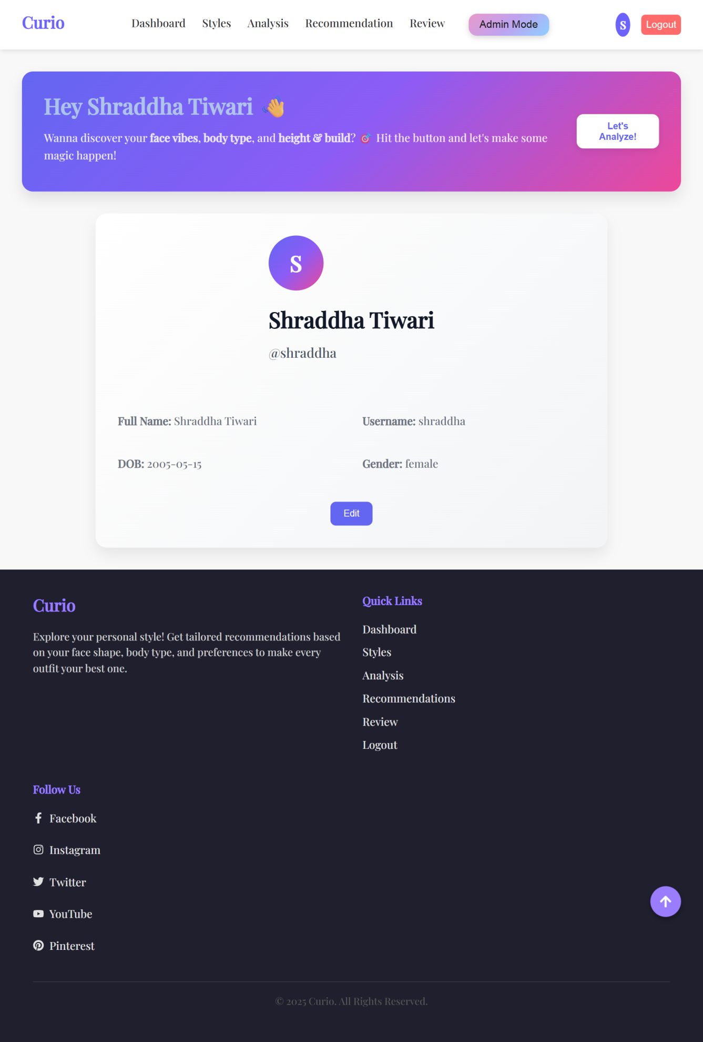

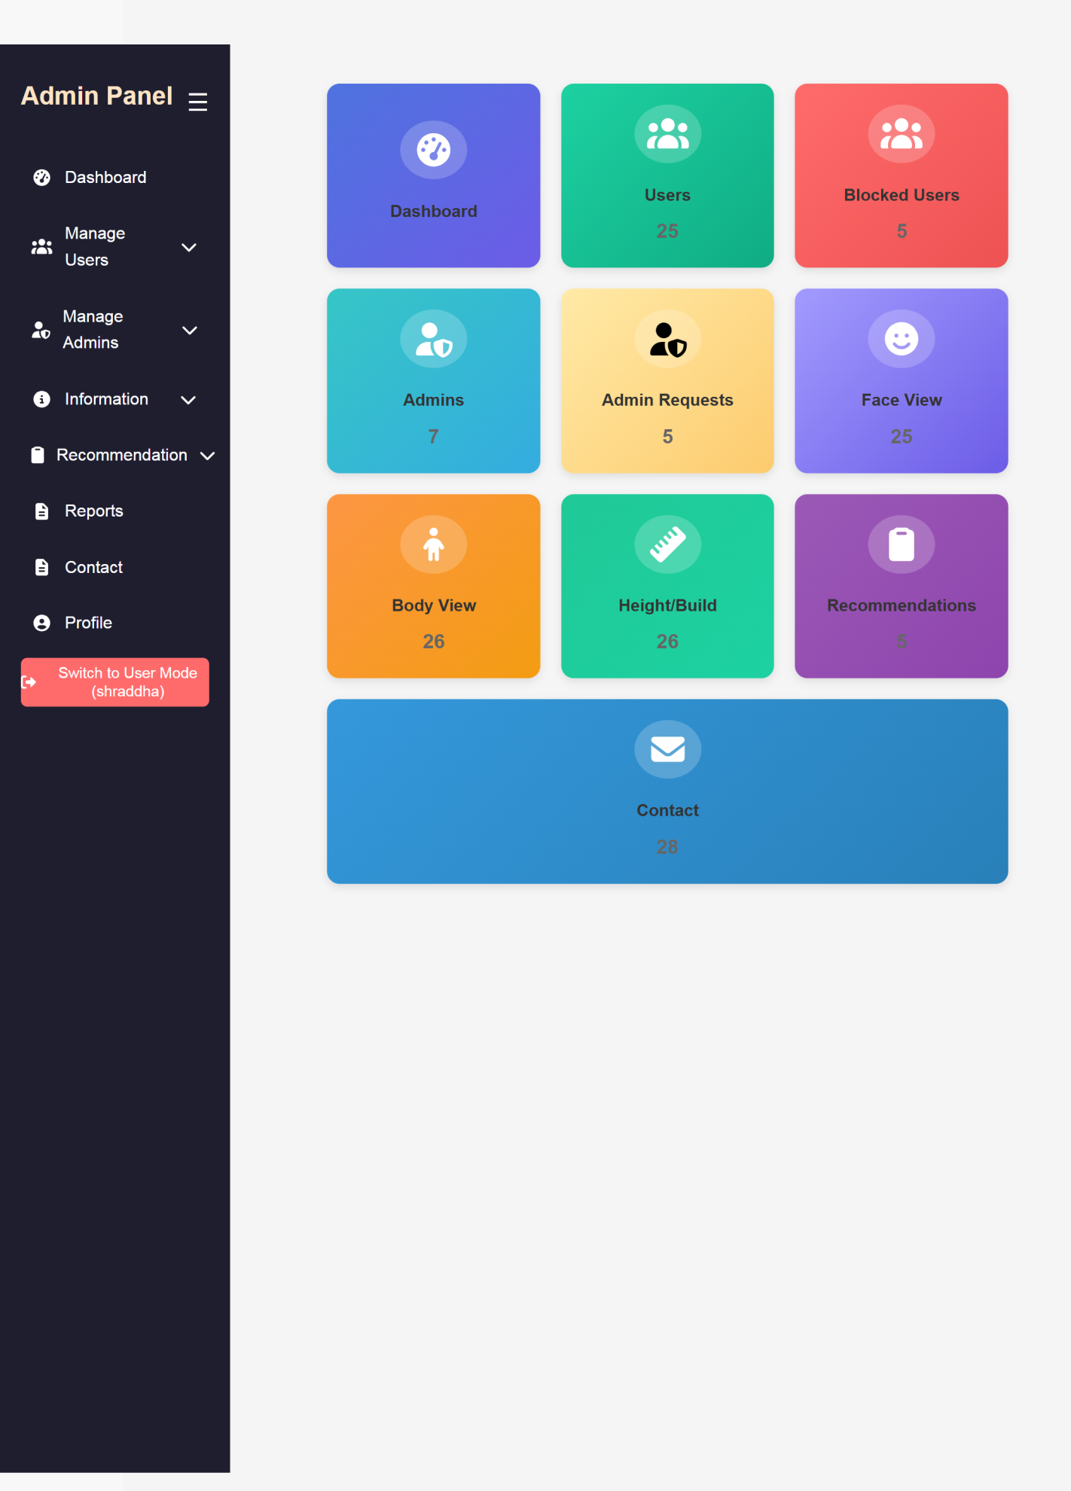
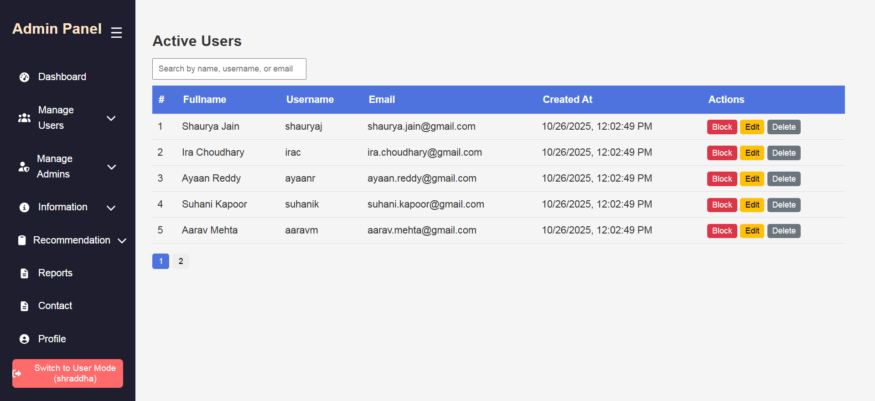

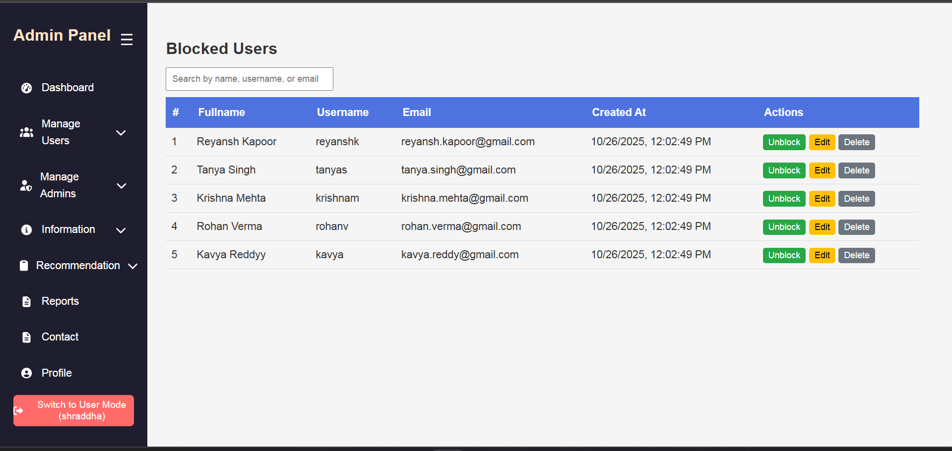
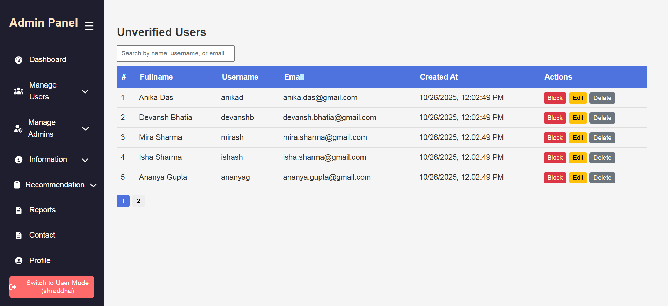

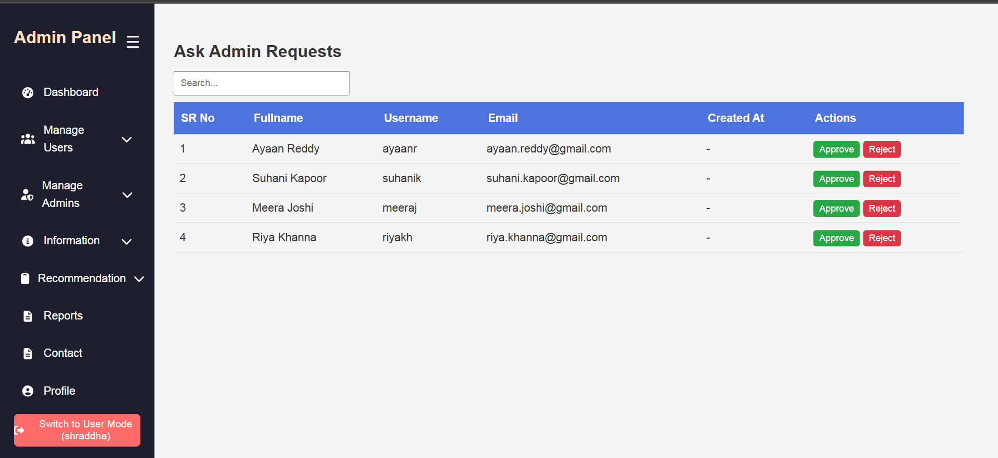
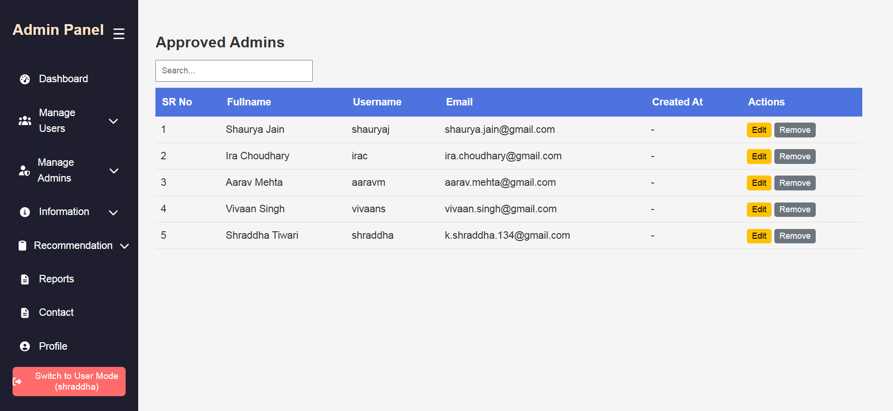

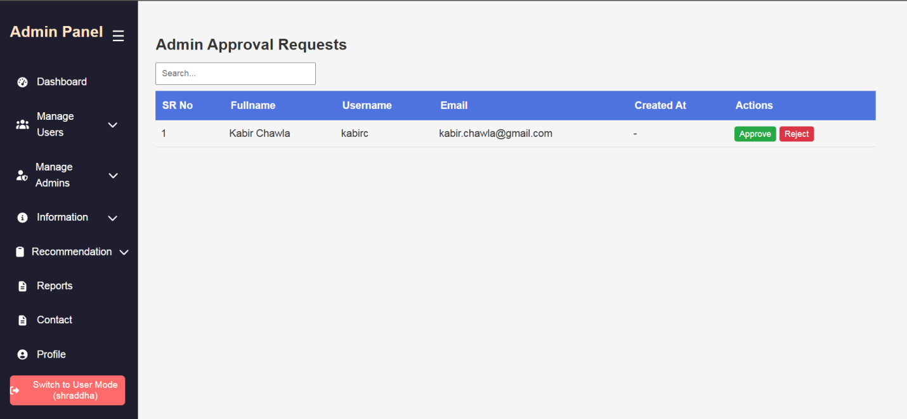
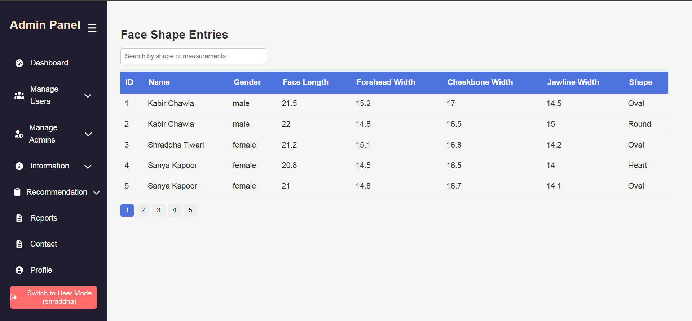

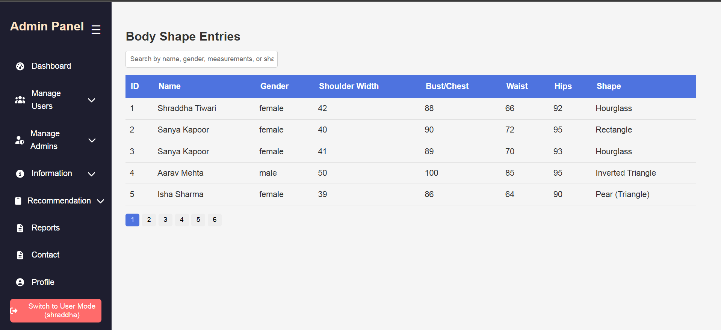
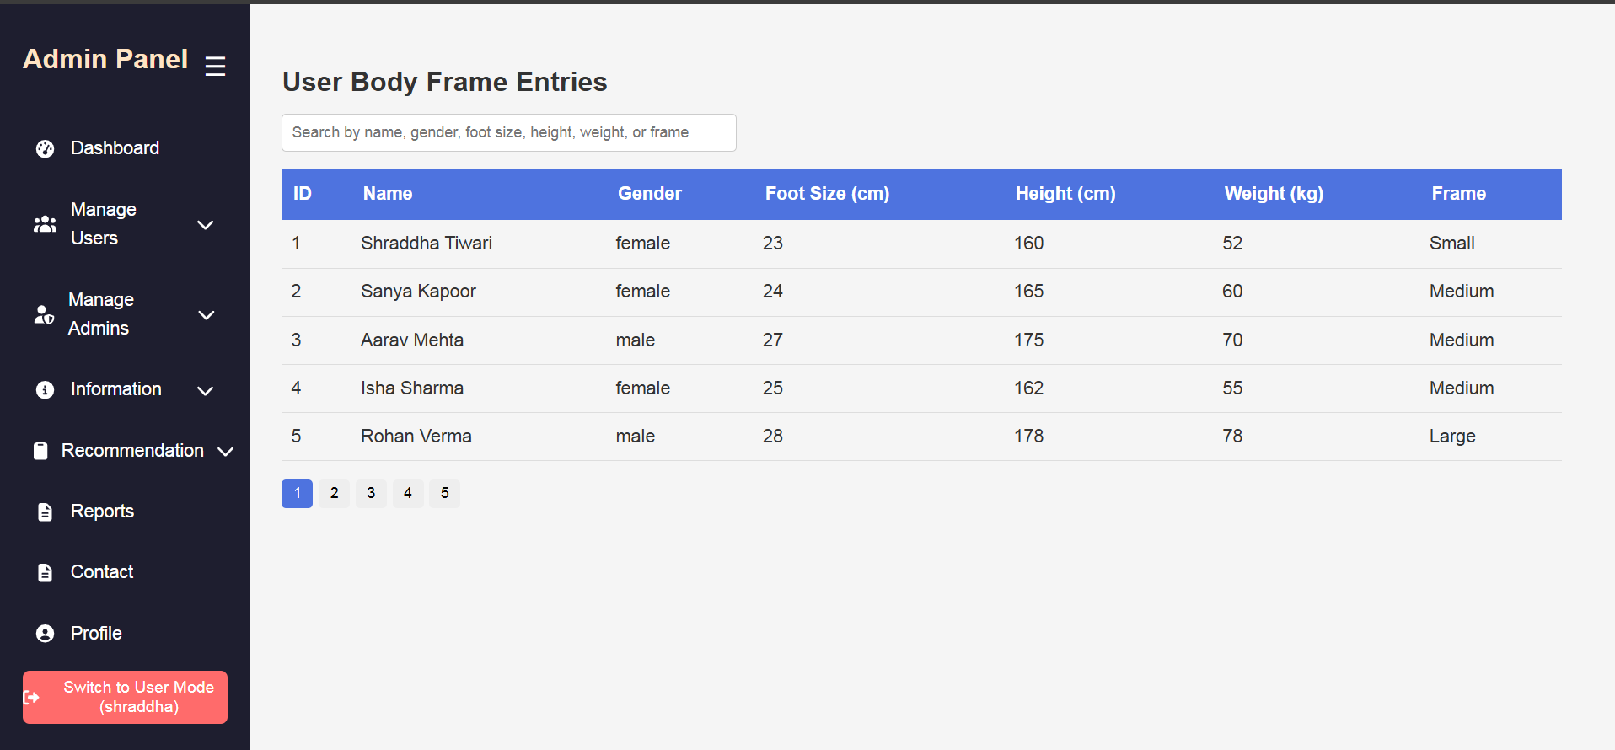

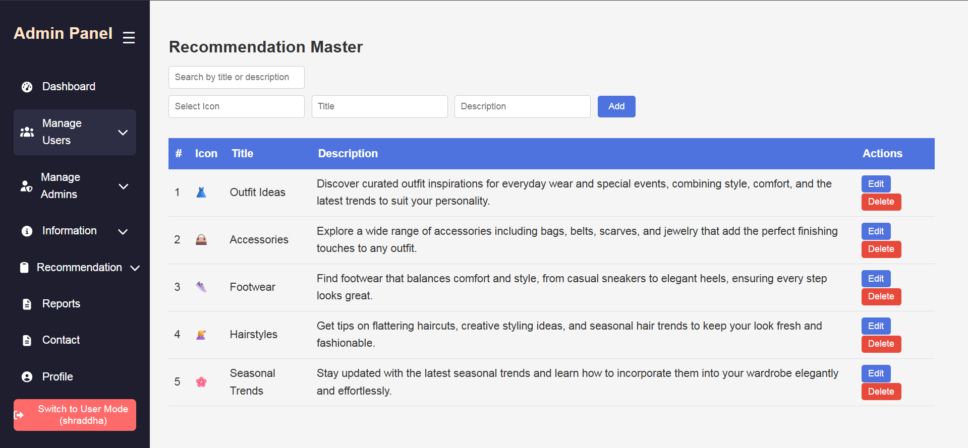

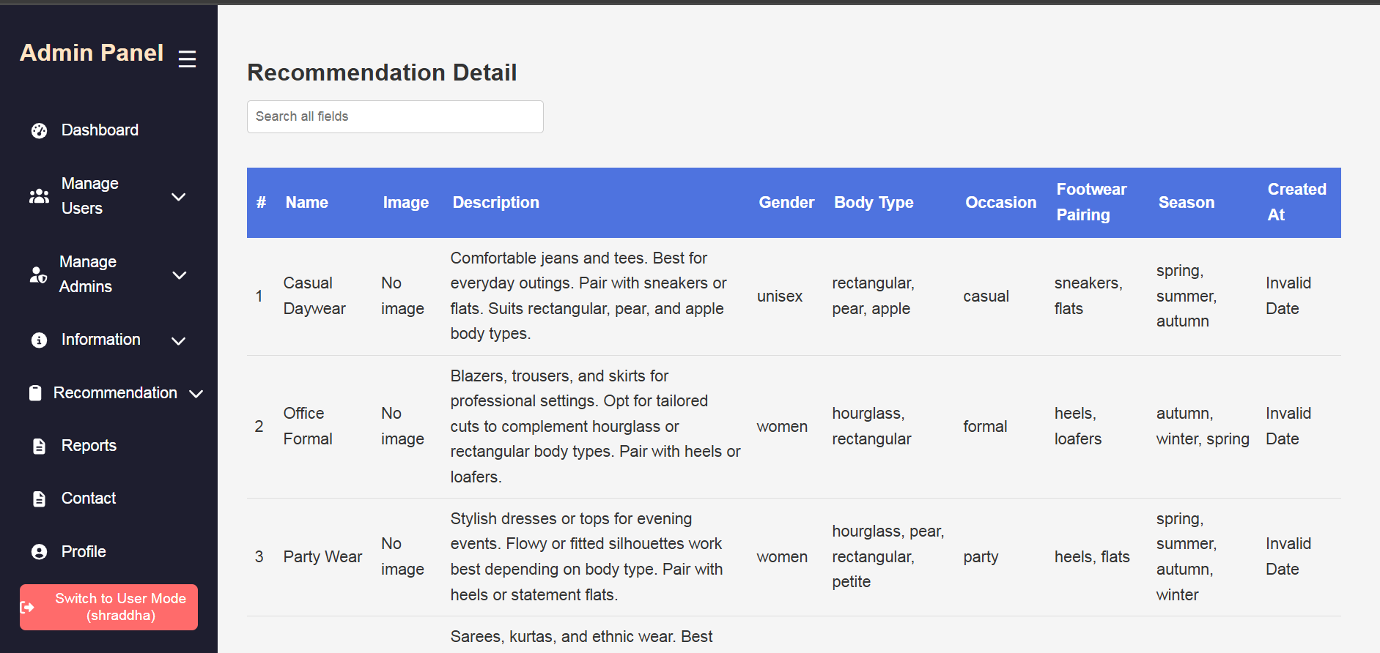
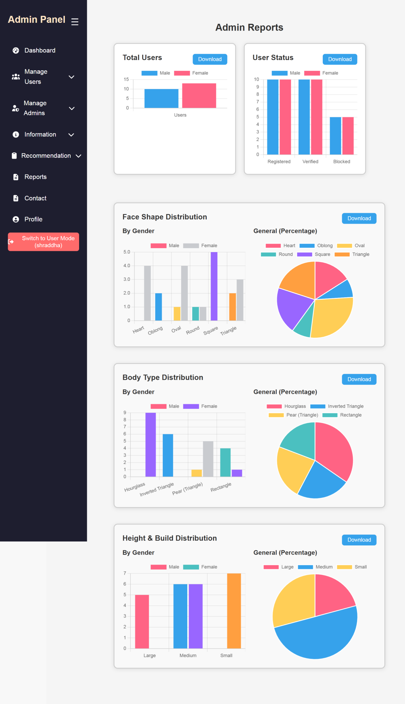
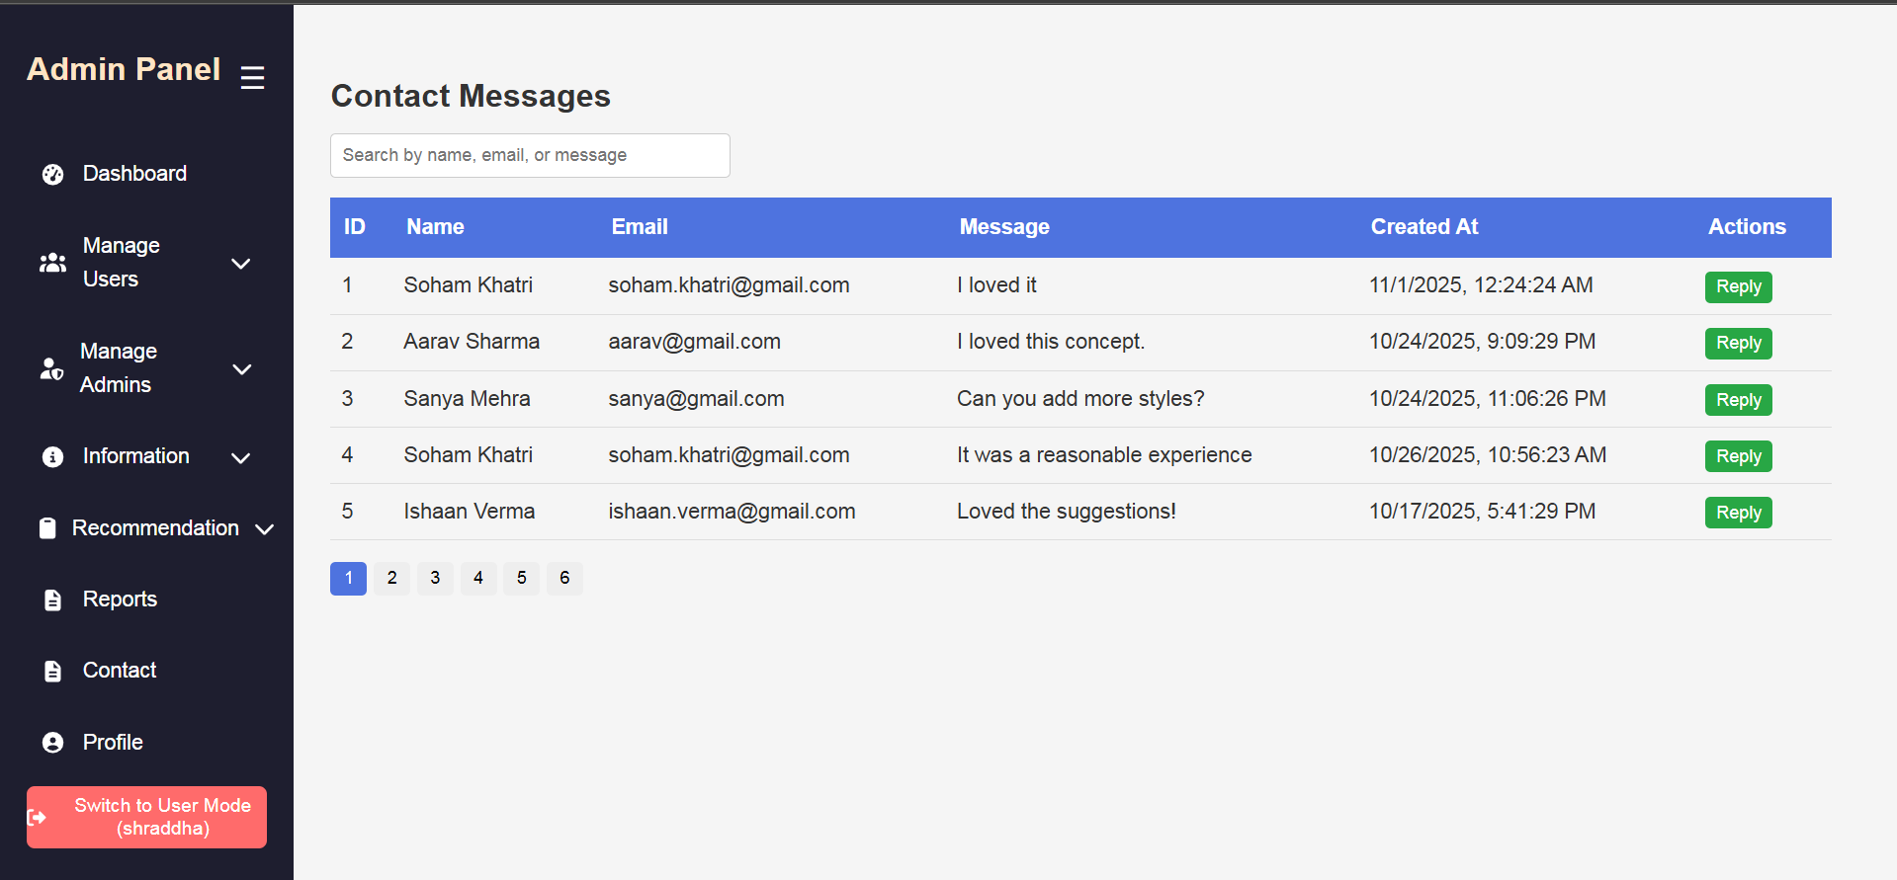

- BACKEND CODE

- FRONTEND CODE
8 Reports
9 Testing
10 Conclusion and Future Enhancement
11 References/ Bibliography

- Shama, U., & Agrawal, R. (2021). Full-Stack Web Development with MERN. Apress.
- Grinberg, M. (2018). Flask Web Development. O’Reilly Media. (for REST API concepts)
- Kumar, A. (2020). Learning React: Modern Patterns for Developing React Apps. O’Reilly Media.
- Holmes, A. (2019). Node.js 8 the Right Way: Practical, Server-Side JavaScript That Scales. Pragmatic Bookshelf.
- Chodorow, K. (2013). MongoDB: The Definitive Guide. O’Reilly Media.
- Pressman, R. S. (2014). Software Engineering: A Practitioner’s Approach. McGraw Hill.
- Sommerville, I. (2015). Software Engineering (10th Edition). Pearson.
- Myntra. (2024). Fashion E-commerce Platform. https://www.myntra.com
- MongoDB Documentation. (2025). MongoDB Manual. https://www.mongodb.com/docs
- ReactJS Documentation. (2025). React Official Docs. https://react.dev
- Node.js Documentation. (2025). Node.js Docs. https://nodejs.org
- Express.js Documentation. (2025). Express Guide. https://expressjs.com

