Sr. No. | Date | Title | Pg. No. | Sign
1 |  | Hiding the Legend in Bokeh Plot
2 |  | Muting the Legend in Bokeh Plot
3 |  | Adding Widgets to the Bokeh Plot
4 |  | Creating Tab Widget in Bokeh

1. Write a Python program to hide the legend in a Bokeh plot.
from bokeh.plotting import figure, output_file, show
output_file("hiding_legend.html")
graph = figure(title="Bokeh Hiding Legend")
graph.vbar( x=1,top=5,width=1,color="violet", legend_label="Violet Bar")
graph.vbar( x=2,top=5, width=1,color="green",legend_label="Green Bar")
graph.vbar( x=3,top=5, width=1,color="yellow", legend_label="Yellow Bar")
graph.vbar( x=4,top=5, width=1,color="red",legend_label="Red Bar")
graph.legend.click_policy = "hide"
show(graph)

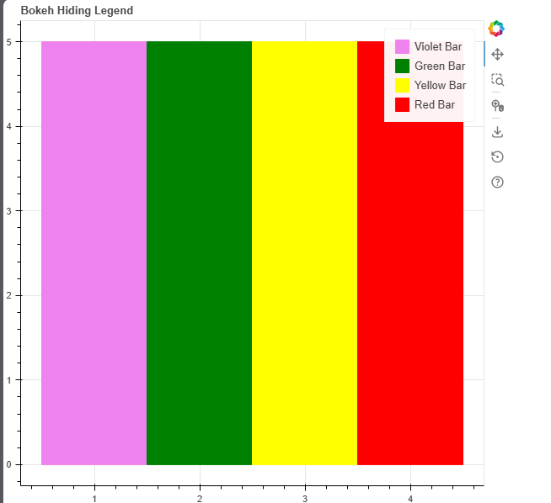

2. Write a Python program to mute the legend in a Bokeh plot.
from bokeh.plotting import figure, output_file, show
output_file("muting_legend.html")
graph = figure(title="Bokeh Muting Legend")
graph.vbar( x=1,top=5, width=1, color="violet",legend_label="Violet Bar",muted_alpha=0.2)
graph.vbar( x=2,top=5, width=1,color="green",legend_label="Green Bar",muted_alpha=0.2)
graph.vbar( x=3,top=5, width=1,color="yellow",legend_label="Yellow Bar",muted_alpha=0.2)
graph.vbar( x=4,top=5,width=1, color="red",legend_label="Red Bar",muted_alpha=0.2)
graph.legend.click_policy = "mute"
show(graph)
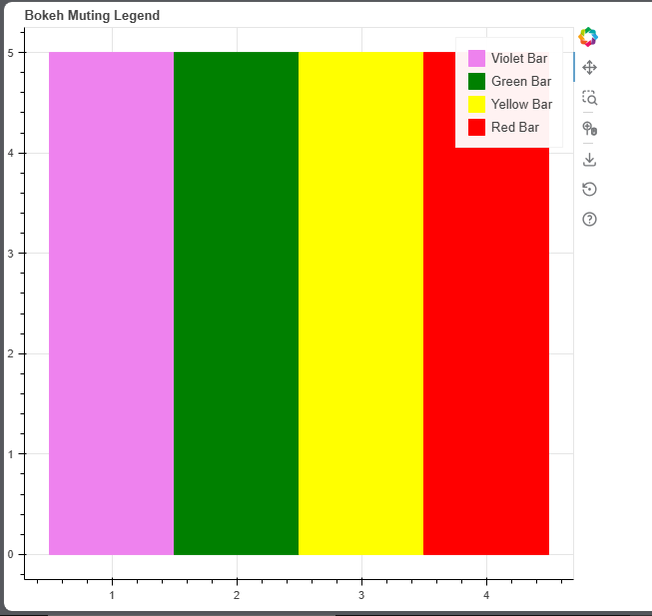

3. Write a Python program to add different widgets to a Bokeh plot.
from bokeh.io import show
from bokeh.layouts import column
from bokeh.models import (
Button,CheckboxGroup,CustomJS,RadioGroup,Slider,Dropdown)
button = Button(label="GFG")
button.js_on_click( CustomJS(code="""console.log('button: click!',this.toString()) """))
labels = ["First", "Second", "Third"]
checkbox_group = CheckboxGroup(
labels=labels,active=[0, 2])
checkbox_group.js_on_change(
"active", CustomJS(code="""console.log('checkbox_group: active=' + this.active,this.toString())"""))
radio_group = RadioGroup( labels=labels,active=1)
radio_group.js_on_change("active",
CustomJS(code="""console.log('radio_group: active=' + this.active, this.toString())"""))
slider = Slider(start=1,end=20,value=1,step=2, title="Slider")
slider.js_on_change("value",
CustomJS(code="""console.log('slider: value=' + this.value,this.toString())"""))
menu = [ ("First", "First"),("Second", "Second"),("Third", "Third")]
dropdown = Dropdown(label="Dropdown Menu",button_type="success",menu=menu)
dropdown.js_on_event("menu_item_click",
CustomJS(code="""console.log('dropdown: ' + this.item,this.toString())""" ))
layout = column( button, checkbox_group,radio_group,slider, dropdown)

show(layout)
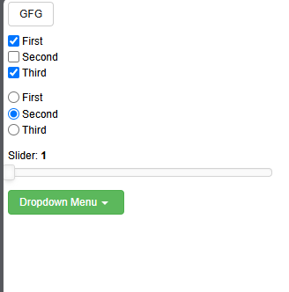

4. Write a Python program to create a Tab Widget in Bokeh.
from bokeh.plotting import figure, show
from bokeh.models import TabPanel, Tabs
fig1 = figure(width=300, height=300, title="Tab 1")
x = [1, 2, 3, 4, 5]
y = [5, 4, 3, 2, 1]
fig1.line(x,y,line_color="green",line_width=2)
fig2 = figure(width=300,height=300,title="Tab 2")
fig2.line( y,x, line_color="red",line_width=2)
tab1 = TabPanel(child=fig1,title="Tab 1")
tab2 = TabPanel(child=fig2,title="Tab 2")
all_tabs = Tabs(tabs=[tab1, tab2])
show(all_tabs)

