Sr. No. | Date | Title | Pg. No. | Sign
1 |  | Line Plot using Matplotlib
2 |  | Bar Chart using Matplotlib
3 |  | Histogram using Matplotlib
4 |  | Pie Chart using Matplotlib
5 |  | Scatter Plot using Matplotlib
6 |  | Box Plot using Seaborn
7 |  | Violin Plot using Seaborn
8 |  | Heatmap using Seaborn
9 |  | Pairplot using Seaborn
10 |  | Count Plot using Seaborn

1. Write a Python program to create a line plot using Matplotlib and display the relationship between two variables with proper labels and grid.
import matplotlib.pyplot as plt
x = [1, 2, 3, 4, 5]
y = [10, 20, 25, 30, 35]
plt.plot(x, y)
plt.title("Line Plot")
plt.xlabel("X Axis")
plt.ylabel("Y Axis")
plt.grid(True)
plt.show()

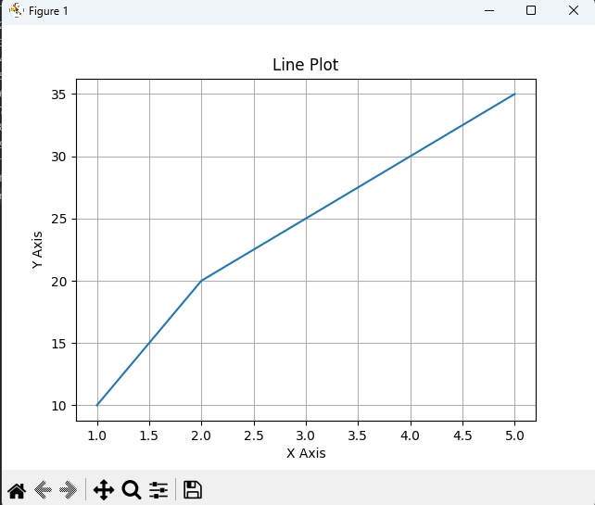

2. Write a Python program to create a bar chart using Matplotlib for representing categorical data.
import matplotlib.pyplot as plt
categories = ['A', 'B', 'C', 'D']
values = [23, 45, 56, 78]
plt.bar(categories, values, color='skyblue')
plt.title("Bar Chart")
plt.show()

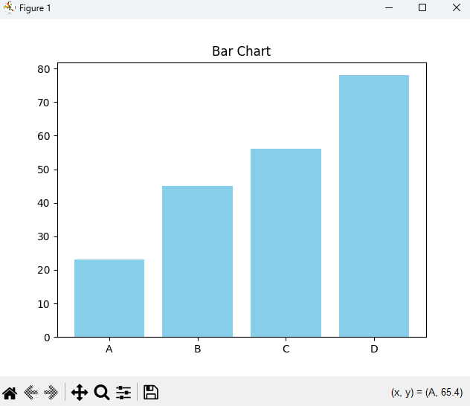

3. Write a Python program to create a histogram using Matplotlib to display the frequency distribution of data values.
import matplotlib.pyplot as plt
data = [12, 15, 22, 23, 23, 24, 25, 26, 28, 30, 35, 40]
plt.hist(data, bins=5, color='orange', edgecolor='black')
plt.title("Histogram")
plt.xlabel("Value")
plt.ylabel("Frequency")
plt.show()

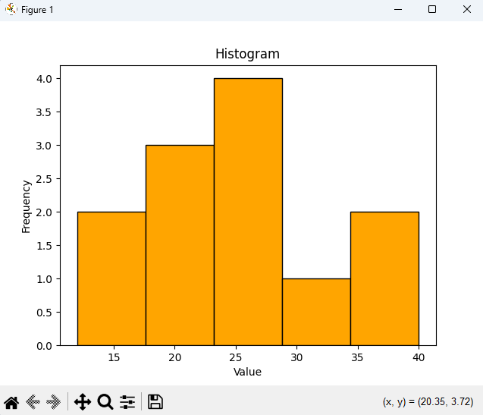

4. Write a Python program to create a pie chart using Matplotlib to represent percentage distribution among different categories.
import matplotlib.pyplot as plt
sizes = [30, 20, 25, 25]
labels = ['Python', 'Java', 'C++', 'JavaScript']
plt.pie(sizes, labels=labels, autopct='%1.1f%%')
plt.title("Pie Chart of Languages")
plt.show()

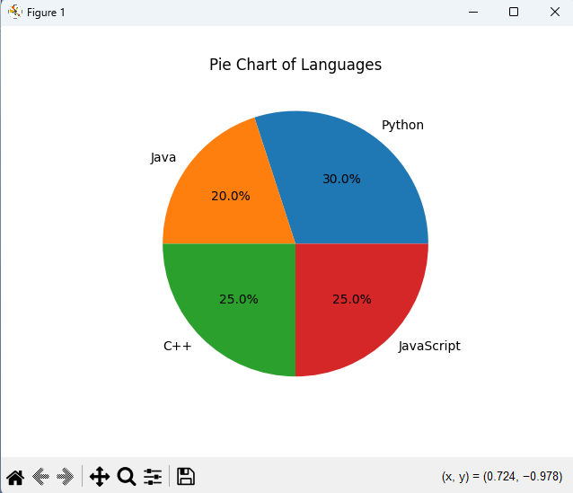

5. Write a Python program to create a scatter plot using Matplotlib to visualize the relationship between two numerical variables.
import matplotlib.pyplot as plt
x = [5, 7, 8, 7, 2, 17, 2, 9, 4, 11]
y = [99, 86, 87, 88, 100, 86, 103, 87, 94, 78]
plt.scatter(x, y, color='red')
plt.title("Scatter Plot")
plt.xlabel("X")
plt.ylabel("Y")
plt.show()

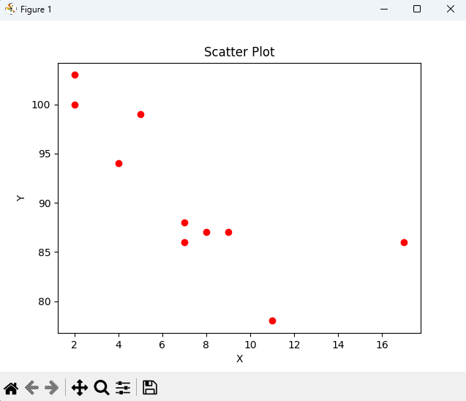

6. Write a Python program to create a box plot using Seaborn for analyzing the distribution of numerical data.
import seaborn as sns
import pandas as pd
import matplotlib.pyplot as plt
df = pd.DataFrame({
"Math": [88, 85, 90, 87, 93],
"Science": [92, 90, 85, 88, 91]
})
sns.boxplot(data=df)
plt.title("Box Plot")
plt.show()

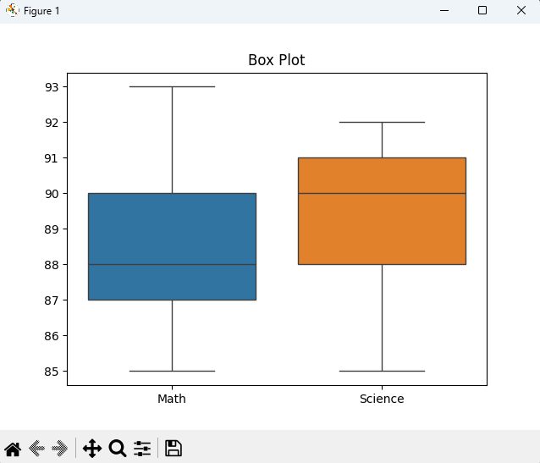

7. Write a Python program to create a violin plot using Seaborn to visualize data distribution across different categories.
import seaborn as sns
import matplotlib.pyplot as plt
tips = sns.load_dataset("tips")
sns.violinplot(x="day", y="total_bill", data=tips)
plt.title("Violin Plot of Bills by Day")
plt.show()
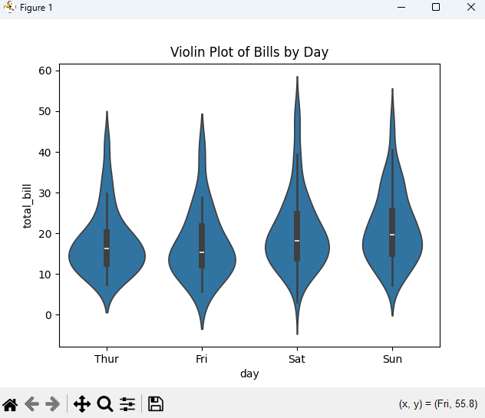

8. Write a Python program to create a heatmap using Seaborn for displaying data patterns using color intensity.
import seaborn as sns
import matplotlib.pyplot as plt
data = sns.load_dataset("flights").pivot(
index="month",
columns="year",
values="passengers"
)
sns.heatmap(data, cmap="YlGnBu", annot=True)
plt.title("Heatmap of Passengers")
plt.show()

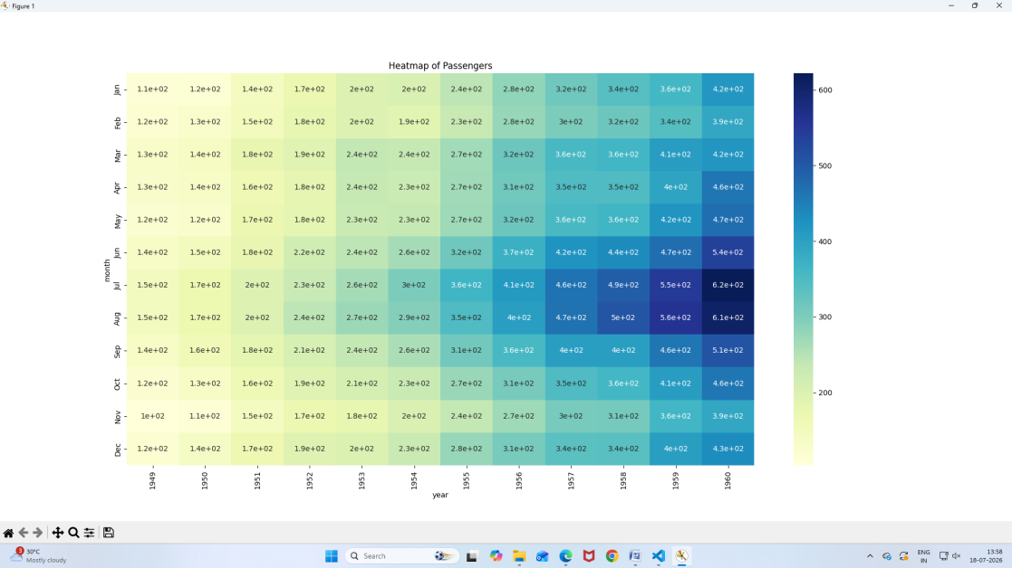

9. Write a Python program to create a pairplot using Seaborn to visualize relationships between multiple features of a dataset.
import seaborn as sns
import matplotlib.pyplot as plt
iris = sns.load_dataset("iris")
sns.pairplot(iris, hue="species")
plt.suptitle("Pairplot of Iris Dataset", y=1.02)
plt.show()

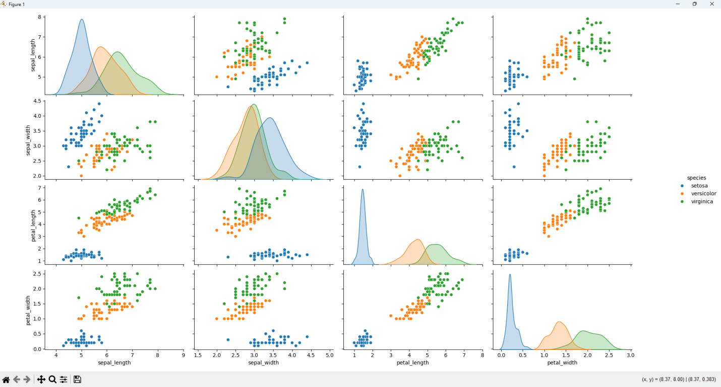

10. Write a Python program to create a count plot using Seaborn for displaying the frequency of records in different categories.
import seaborn as sns
import matplotlib.pyplot as plt
tips = sns.load_dataset("tips")
sns.countplot(x="day", data=tips)
plt.title("Count of Records per Day")
plt.show()

