Sr. No. | Date | Title | Pg. No. | Sign
1 |  | Basic Summary Statistics
2 |  | Categorical Summary Statistics
3 |  | Salary Quantiles Calculation
4 |  | Outlier Detection using Interquartile Range (IQR) Method
5 |  | Visualizing Outliers using Boxplot
6 |  | Outlier Detection using Z-Score Method
7 |  | Handling Outliers using Capping Technique
8 |  | Group-wise Mean and Standard Deviation Calculation
9 |  | Missing Value Detection
10 |  | Replacing Outliers with Median Value

1. Write a Python program to read a dataset and display basic summary statistics using Pandas.
import pandas as pd
df = pd.read_csv("data_assignment4.csv")
print(df.describe())
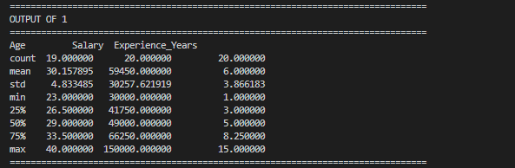

2. Write a Python program to display summary statistics of categorical columns in a dataset.
import pandas as pd
df = pd.read_csv("data_assignment4.csv")
print(df.describe(include='object'))
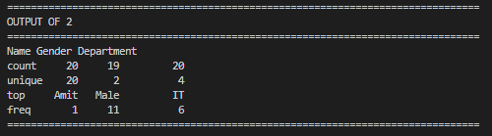

3. Write a Python program to calculate salary quantiles including Q1, median, and Q3 values.
import pandas as pd
df = pd.read_csv("data_assignment4.csv")
salary_quantiles = df["Salary"].quantile([0.25, 0.5, 0.75])
print(salary_quantiles)
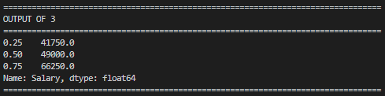

4. Write a Python program to detect salary outliers using the Interquartile Range (IQR) method.
import pandas as pd
df = pd.read_csv("data_assignment4.csv")
Q1 = df["Salary"].quantile(0.25)
Q3 = df["Salary"].quantile(0.75)
IQR = Q3 - Q1
outliers = df[
(df["Salary"] < Q1 - 1.5 * IQR) |
(df["Salary"] > Q3 + 1.5 * IQR)
]
print("Outliers:")
print(outliers)
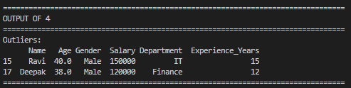

5. Write a Python program to visualize salary outliers using a boxplot.
import pandas as pd
import seaborn as sns
import matplotlib.pyplot as plt
df = pd.read_csv("data_assignment4.csv")
sns.boxplot(x=df["Salary"])
plt.title("Boxplot - Salary")
plt.show()
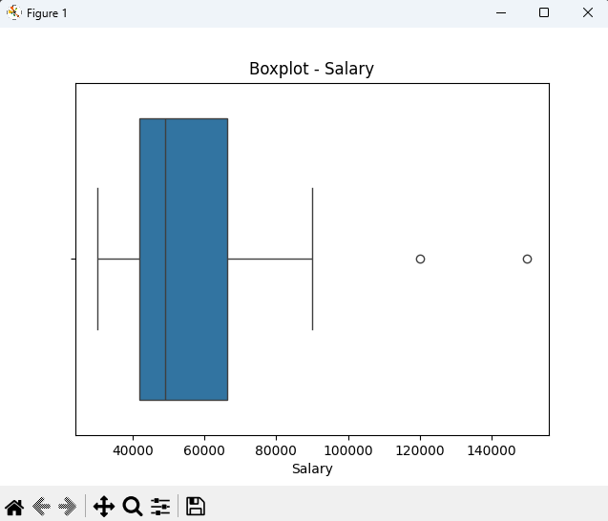

6. Write a Python program to detect salary outliers using the Z-Score method.
import pandas as pd
import numpy as np
from scipy import stats
df = pd.read_csv("data_assignment4.csv")
z_scores = np.abs(stats.zscore(df[["Salary"]]))
outliers = df[(z_scores > 3).any(axis=1)]
print("Outliers:")
print(outliers)
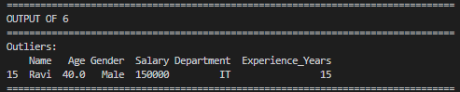

7. Write a Python program to handle salary outliers by applying the capping technique.
import pandas as pd
df = pd.read_csv("data_assignment4.csv")
cap_upper = df["Salary"].quantile(0.95)
cap_lower = df["Salary"].quantile(0.05)
df["Salary_Capped"] = df["Salary"].clip(
lower=cap_lower,
upper=cap_upper
)
print(df[["Salary", "Salary_Capped"]].head())
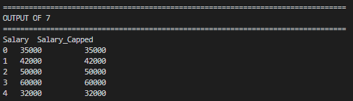

8. Write a Python program to calculate department-wise mean and standard deviation of salary.
import pandas as pd
df = pd.read_csv("data_assignment4.csv")
group_stats = df.groupby("Department")["Salary"].agg(
["mean", "std"]
)
print(group_stats)
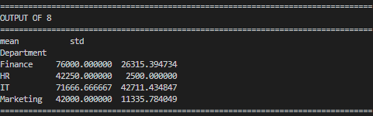

9. Write a Python program to identify missing values present in each column of a dataset.
import pandas as pd
df = pd.read_csv("data_assignment4.csv")
missing_values = df.isnull().sum()
print("Missing values per column:")
print(missing_values)
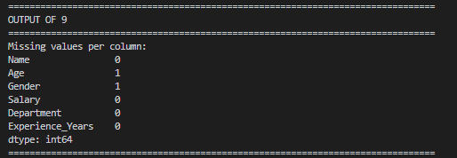

10. Write a Python program to replace salary outliers with the median salary value.
import pandas as pd
import numpy as np
df = pd.read_csv("data_assignment4.csv")
Q1 = df["Salary"].quantile(0.25)
Q3 = df["Salary"].quantile(0.75)
IQR = Q3 - Q1
median_salary = df["Salary"].median()
df["Salary_Replaced"] = np.where(
(df["Salary"] > Q3 + 1.5 * IQR) |
(df["Salary"] < Q1 - 1.5 * IQR),
median_salary,
df["Salary"]
)
print(df[["Salary", "Salary_Replaced"]].head())
