Sr. No. | Date | Title | Pg. No. | Sign
1 |  | Simple Linear Regression – Experience vs Salary
2 |  | Salary Prediction using Linear Regression
3 |  | Regression Line Visualization
4 |  | Multiple Linear Regression
5 |  | Logistic Regression Model
6 |  | Purchase Prediction using Logistic Regression
7 |  | Classification Report Generation
8 |  | Confusion Matrix Visualization
9 |  | Logistic Regression Accuracy Calculation
10 |  | Logistic Regression Probability Distribution

1. Write a Python program to perform Simple Linear Regression using Experience and Salary.
import pandas as pd
from sklearn.linear_model import LinearRegression
df = pd.read_csv("data_assignment5.csv")
X = df[['Experience']]
y = df['Salary']
model = LinearRegression()
model.fit(X, y)
print("Intercept:", model.intercept_)
print("Coefficient:", model.coef_[0])
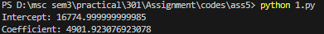
2. Write a Python program to predict salary for 5 years of experience using Linear Regression.
import pandas as pd
from sklearn.linear_model import LinearRegression
df = pd.read_csv("data_assignment5.csv")
X = df[['Experience']]
y = df['Salary']
model = LinearRegression()
model.fit(X, y)
predicted_salary = model.predict(pd.DataFrame([[5]], columns=['Experience']))
print("Predicted Salary for 5 years:", predicted_salary[0])
3. Write a Python program to visualize the Linear Regression line for Experience and Salary.
import pandas as pd
import matplotlib.pyplot as plt
from sklearn.linear_model import LinearRegression
df = pd.read_csv("data_assignment5.csv")
X = df[['Experience']]
y = df['Salary']
model = LinearRegression()
model.fit(X, y)
plt.scatter(X, y, color='blue')
plt.plot(X, model.predict(X), color='red')
plt.title("Experience vs Salary")
plt.xlabel("Years of Experience")
plt.ylabel("Salary")
plt.show()
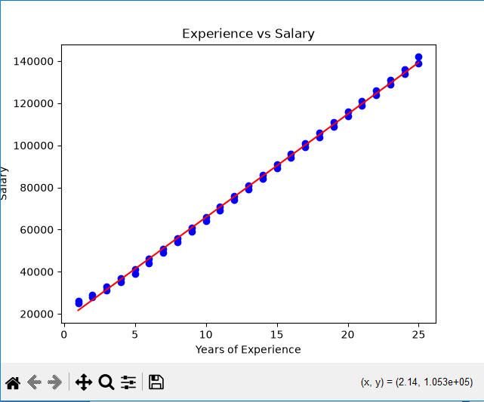
4. Write a Python program to perform Multiple Linear Regression using Experience, Age and Salary.
import pandas as pd
from sklearn.linear_model import LinearRegression
df = pd.read_csv("data_assignment5.csv")
X = df[['Experience', 'Age']]
y = df['Salary']
model = LinearRegression()
model.fit(X, y)
print("Coefficients:", model.coef_)
print("Intercept:", model.intercept_)
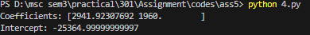
5. Write a Python program to perform Logistic Regression using Age and Income to predict Purchase status.
import pandas as pd
from sklearn.linear_model import LogisticRegression
df = pd.read_csv("data_assignment5.csv")
X = df[['Age', 'Income']]
y = df['Purchased']
model = LogisticRegression()
model.fit(X, y)
print("Coefficients:")
print(model.coef_)
print("Intercept:")
print(model.intercept_)
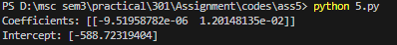
6. Write a Python program to predict purchase outcome using Logistic Regression.
import pandas as pd
from sklearn.linear_model import LogisticRegression
df = pd.read_csv("data_assignment5.csv")
X = df[['Age', 'Income']]
y = df['Purchased']
model = LogisticRegression()
model.fit(X, y)
prediction = model.predict( pd.DataFrame([[30, 45000]], columns=['Age', 'Income']))
print("Prediction (1=Yes, 0=No):", prediction[0])
7. Write a Python program to generate a classification report for Logistic Regression model.
import pandas as pd
from sklearn.linear_model import LogisticRegression
from sklearn.metrics import classification_report
df = pd.read_csv("data_assignment5.csv")
X = df[['Age', 'Income']]
y = df['Purchased']
model = LogisticRegression()
model.fit(X, y)
y_pred = model.predict(X)
print("Classification Report:")
print(classification_report(y, y_pred))
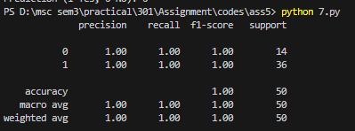
8. Write a Python program to visualize the confusion matrix of Logistic Regression model.
import pandas as pd
import matplotlib.pyplot as plt
import seaborn as sns
from sklearn.linear_model import LogisticRegression
from sklearn.metrics import confusion_matrix
df = pd.read_csv("data_assignment5.csv")
X = df[['Age', 'Income']]
y = df['Purchased']
model = LogisticRegression()
model.fit(X, y)
y_pred = model.predict(X)
cm = confusion_matrix(y, y_pred)
sns.heatmap(cm, annot=True, fmt='d', cmap='Blues')
plt.title("Confusion Matrix")
plt.xlabel("Predicted")
plt.ylabel("Actual")
plt.show()
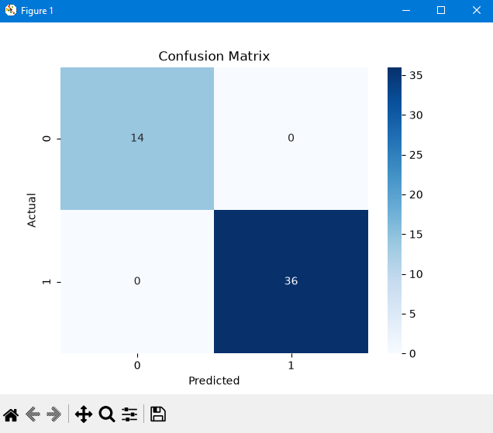
9. Write a Python program to calculate the accuracy score of Logistic Regression model.
import pandas as pd
from sklearn.linear_model import LogisticRegression
from sklearn.metrics import accuracy_score
df = pd.read_csv("data_assignment5.csv")
X = df[['Age', 'Income']]
y = df['Purchased']
model = LogisticRegression()
model.fit(X, y)
y_pred = model.predict(X)
accuracy = accuracy_score(y, y_pred)
print("Accuracy:", accuracy)
10. Write a Python program to visualize the Logistic Regression probability distribution.
import pandas as pd
import matplotlib.pyplot as plt
from sklearn.linear_model import LogisticRegression
df = pd.read_csv("data_assignment5.csv")
X = df[['Age', 'Income']]
y = df['Purchased']
model = LogisticRegression()
model.fit(X, y)
probabilities = model.predict_proba(X)[:, 1]
plt.hist(probabilities, bins=10, color='green')
plt.title("Purchase Probability Distribution")
plt.xlabel("Probability")
plt.ylabel("Frequency")
plt.show()
