Sr. No. | Date | Title | Pg. No. | Sign
1 |  | Reading and Parsing Time Series Data
2 |  | Line Plot of Sales Over Time
3 |  | Monthly Sales Resampling and Aggregation
4 |  | Moving Average Calculation using Rolling Mean
5 |  | Seasonal Decomposition of Sales Data
6 |  | ADF Test for Stationarity Check
7 |  | Differencing to Remove Trend
8 |  | Autocorrelation and Partial Autocorrelation Analysis
9 |  | ARIMA Model Forecasting
10 |  | Forecast vs Actual Sales Visualization

1. Write a Python program to read a dataset and parse time series data using Pandas.
import pandas as pd
df = pd.read_csv( "data_assignment6.csv", parse_dates=['Date'])
df.set_index('Date', inplace=True)
print(df.head())
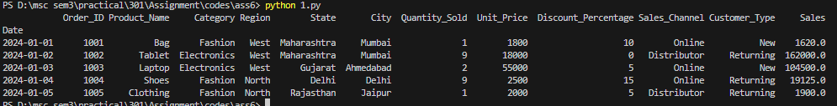
2. Write a Python program to visualize sales over time using a line plot.
import pandas as pd
import matplotlib.pyplot as plt
df = pd.read_csv( "data_assignment6.csv", parse_dates=['Date'])
df.set_index('Date', inplace=True)
df['Sales'].plot( title='Sales Over Time', figsize=(10, 4))
plt.ylabel('Sales')
plt.grid(True)
plt.show()
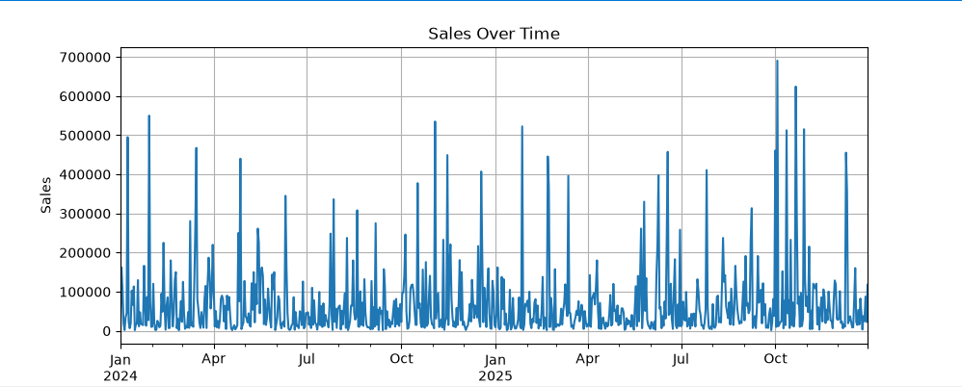
3. Write a Python program to perform monthly resampling and aggregation of sales data.
import pandas as pd
df = pd.read_csv( "data_assignment6.csv", parse_dates=['Date'])
df.set_index('Date', inplace=True)
monthly_sales = df['Sales'].resample('ME').sum()
print(monthly_sales.head())
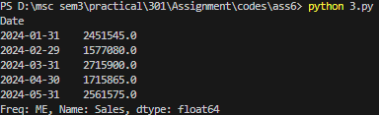
4. Write a Python program to calculate moving average using rolling mean method.
import pandas as pd
import matplotlib.pyplot as plt
df = pd.read_csv( "data_assignment6.csv", parse_dates=['Date'])
df.set_index('Date', inplace=True)
df['Rolling_Mean'] = df['Sales'].rolling( window=3).mean()
df[['Sales', 'Rolling_Mean']].plot()
plt.title('3-Month Rolling Average')
plt.show()
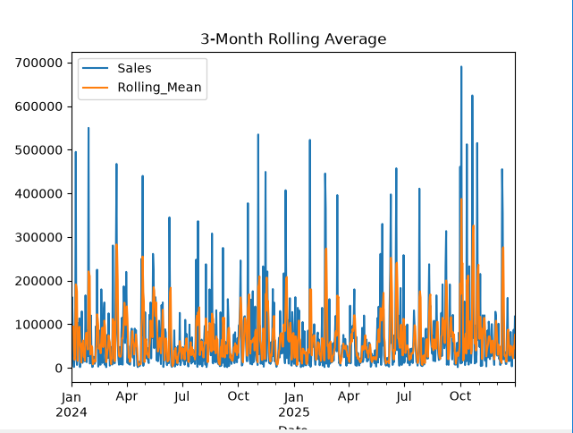
5. Write a Python program to perform seasonal decomposition of sales data.
import pandas as pd
import matplotlib.pyplot as plt
from statsmodels.tsa.seasonal import seasonal_decompose
df = pd.read_csv("data_assignment6.csv",parse_dates=['Date'])
df.set_index('Date', inplace=True)
decomp = seasonal_decompose( df['Sales'],model='additive',period=12)
decomp.plot()
plt.show()
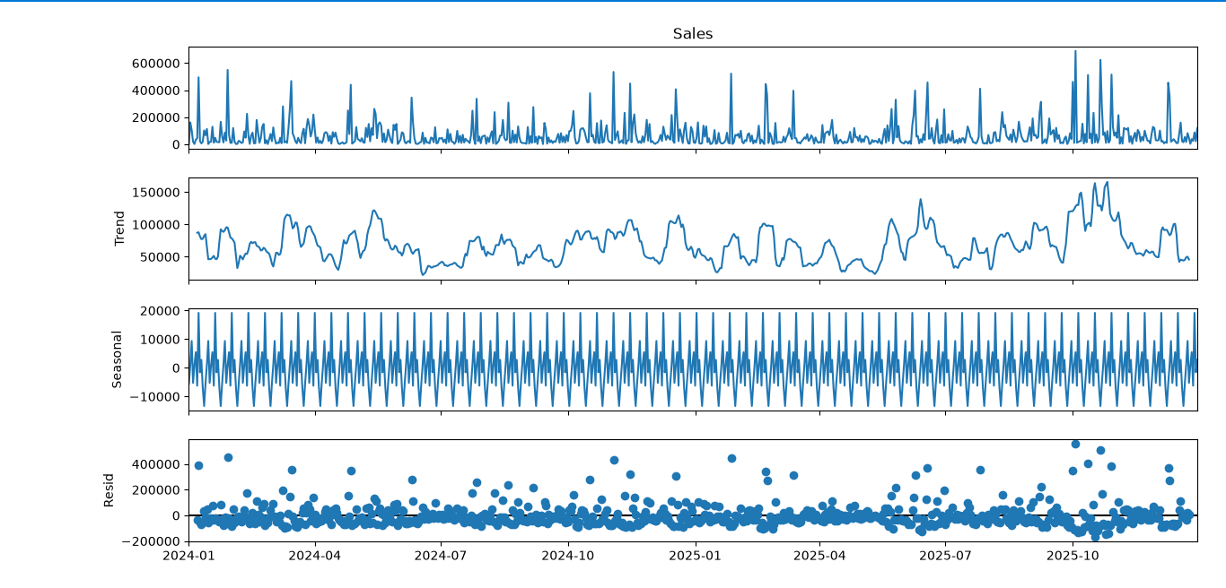
6. Write a Python program to perform ADF test for checking stationarity of time series data.
import pandas as pd
from statsmodels.tsa.stattools import adfuller
df = pd.read_csv( "data_assignment6.csv", parse_dates=['Date'])
df.set_index('Date', inplace=True)
result = adfuller( df['Sales'].dropna())
print("ADF Statistic:", result[0])
print("p-value:", result[1])
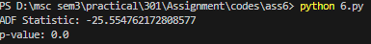
7. Write a Python program to remove trend from sales data using differencing method.
import pandas as pd
import matplotlib.pyplot as plt
df = pd.read_csv( "data_assignment6.csv",parse_dates=['Date'])
df.set_index('Date', inplace=True)
df['Sales_Diff'] = df['Sales'].diff()
df[['Sales', 'Sales_Diff']].plot( subplots=True)
plt.show()
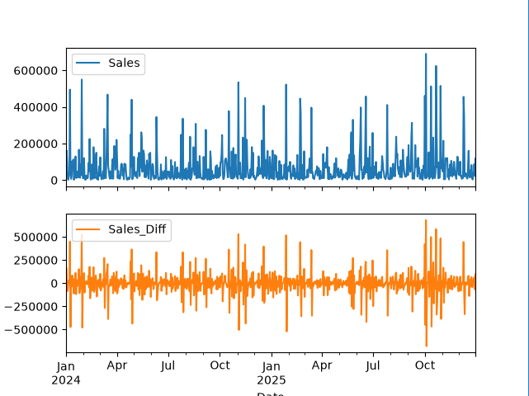

8. Write a Python program to generate Autocorrelation and Partial Autocorrelation plots.
import pandas as pd
import matplotlib.pyplot as plt
from statsmodels.graphics.tsaplots import plot_acf, plot_pacf
df = pd.read_csv( "data_assignment6.csv", parse_dates=['Date'])
df.set_index('Date', inplace=True)
plot_acf( df['Sales'].dropna(), lags=20)
plt.show()
plot_pacf( df['Sales'].dropna(), lags=20)
plt.show()
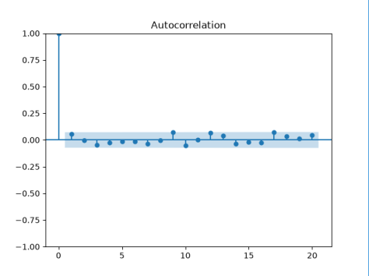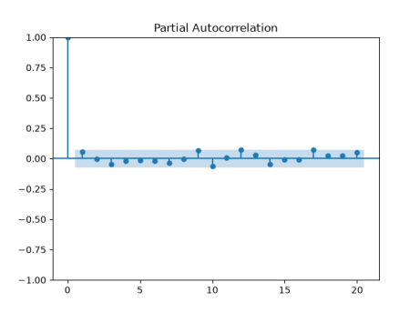
9. Write a Python program to perform ARIMA model forecasting for future sales.
import pandas as pd
from statsmodels.tsa.arima.model import ARIMA
df = pd.read_csv( "data_assignment6.csv", parse_dates=['Date'])
df.set_index('Date', inplace=True)
df = df.asfreq('D')
model = ARIMA( df['Sales'],order=(1, 1, 1))
model_fit = model.fit()
forecast = model_fit.forecast( steps=5)
print("Next 5 forecasts:")
print(forecast)
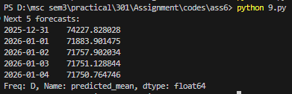
10. Write a Python program to plot forecast values against actual sales values.
import pandas as pd
import matplotlib.pyplot as plt
from statsmodels.tsa.arima.model import ARIMA
df = pd.read_csv( "data_assignment6.csv", parse_dates=['Date'])
df.set_index('Date', inplace=True)
df = df.asfreq('D')
model = ARIMA( df['Sales'], order=(1, 1, 1))
model_fit = model.fit()
forecast = model_fit.forecast( steps=5)
plt.plot( df['Sales'], label='Actual')
plt.plot( forecast.index,forecast, label='Forecast', color='red')
plt.legend()
plt.title('Forecast vs Actual Sales')
plt.show()
