Sr. No. | Date | Title | Pg. No. | Sign
1 |  | Data Cleaning and Pre-processing using Pandas and NumPy (Employee Data)
2 |  | Data Cleaning and Pre-processing of Customer Sales Data
3 |  | Data Cleaning, Transformation and EDA using Retail Sales Data
4 |  | Data Cleaning, Pre-processing and Basic Analysis of Sales Data

1. Write a Python program to perform data cleaning and preprocessing on employee data using Pandas and NumPy.
import pandas as pd
import numpy as np
data = pd.read_csv("employee_data.csv")
print("Original Data:")
print(data)
data['salary'] = data['salary'].fillna(data['salary'].mean())
data['bonus'] = data['bonus'].fillna(data['bonus'].mean())
data['age'] = data['age'].fillna(data['age'].mean())
data['join_date'] = data['join_date'].ffill()
data = data.loc[:, ~data.columns.duplicated()]
data = data.drop_duplicates()
data.columns = [col.capitalize() for col in data.columns]
data['Join_date'] = pd.to_datetime(data['Join_date'],format='%d-%m-%Y')
data['Salary'] = pd.to_numeric(data['Salary'])
data['Bonus'] = pd.to_numeric(data['Bonus'])
data = data.dropna(thresh=len(data.columns)-2)
data['Salary_Normalized'] = (
(data['Salary'] - data['Salary'].min()) /
(data['Salary'].max() - data['Salary'].min())
)
print("\nCleaned Dataset:")
print(data)
print("\nData Information:")
print(data.info())
print("\nStatistical Summary:")
print(data.describe())
OUTPUT:
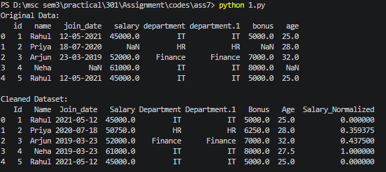
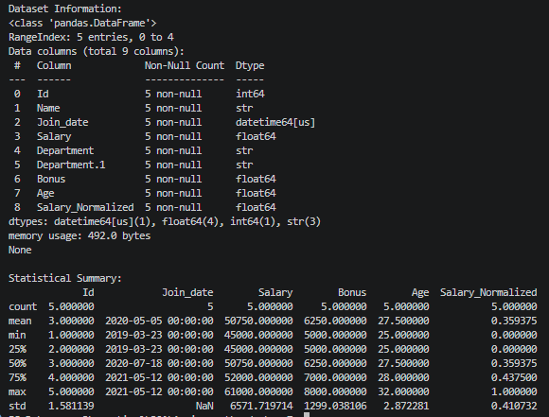
2. Write a Python program to perform data cleaning and preprocessing of customer sales data using Pandas and NumPy.
import pandas as pd
import numpy as np
data = pd.read_csv("customer_sales.csv")
print("Original Data:")
print(data)
data['amount'] = data['amount'].fillna(data['amount'].mean())
data['discount'] = data['discount'].fillna(data['discount'].mean())
data['age'] = data['age'].fillna(data['age'].mean())
data['purchase_date'] = data['purchase_date'].ffill()
data = data.loc[:, ~data.columns.duplicated()]
data = data.drop_duplicates()
data.columns = [col.capitalize() for col in data.columns]
data['Purchase_date'] = pd.to_datetime(data['Purchase_date'],format='%Y-%m-%d')
data['Amount'] = pd.to_numeric(data['Amount'])
data['Discount'] = pd.to_numeric(data['Discount'])
data = data.dropna(thresh=len(data.columns)-2)
data['Amount_Normalized'] = (
(data['Amount'] - data['Amount'].min()) /
(data['Amount'].max() - data['Amount'].min())
)
print("\nCleaned Dataset:")
print(data)
print("\nData Information:")
print(data.info())
print("\nStatistical Summary:")
print(data.describe())
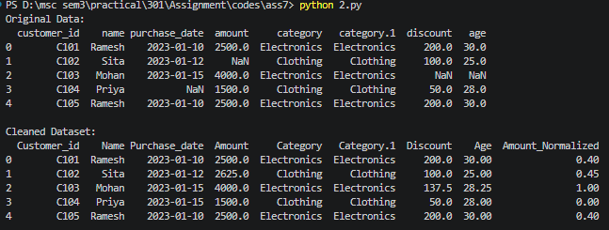
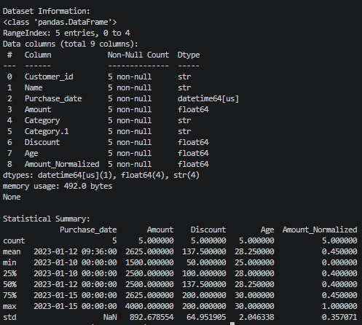
3. Write a Python program to perform data cleaning, transformation, normalization and exploratory data analysis on retail sales data.
import pandas as pd
import numpy as np
import matplotlib.pyplot as plt
import seaborn as sns
df = pd.read_csv("retail_sales.csv")
print("Initial Data:")
print(df.head())
df['Product'] = df['Product'].fillna("Unknown")
df['Quantity'] = df['Quantity'].fillna(df['Quantity'].median())
df['Price'] = df['Price'].fillna(df['Price'].mean())
df['Total_Sales'] = (df['Quantity'] * df['Price'])
df.drop_duplicates(inplace=True)
df['Date'] = pd.to_datetime(df['Date'])
df['Log_Sales'] = np.log1p(df['Total_Sales'])
df['Price_Normalized'] = (
(df['Price'] - df['Price'].min()) /
(df['Price'].max() - df['Price'].min())
)
print("\nData After Transformation:")
print(
df[
['Price','Price_Normalized','Total_Sales','Log_Sales']
].head()
)
print("\nSummary Statistics:")
print(df.describe())
plt.figure(figsize=(6,4))
sns.barplot(x="Category",y="Total_Sales",data=df,estimator=np.sum)
plt.title("Total Sales by Category")
plt.show()
plt.figure(figsize=(6,4))
sns.histplot( df['Price'],bins=10, kde=True)
plt.title("Distribution of Product Prices")
plt.show()
plt.figure(figsize=(6,4))
sns.boxplot(x="Category",y="Price",data=df)
plt.title("Outlier Detection in Product Prices")
plt.show()
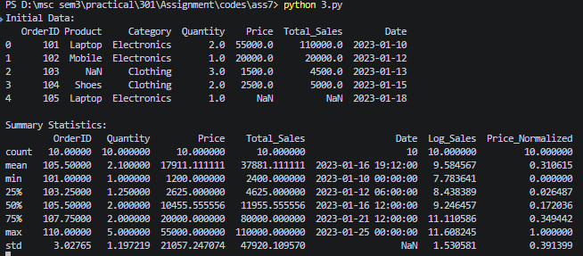
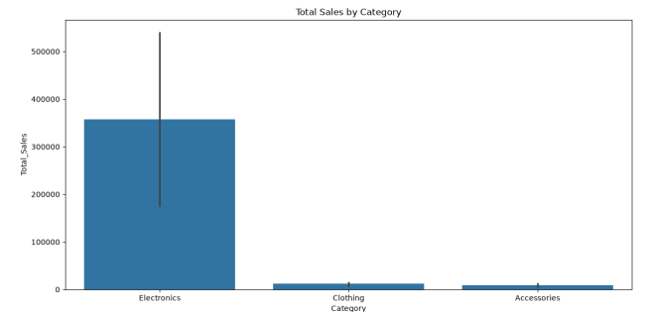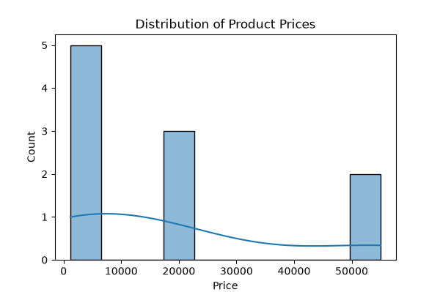
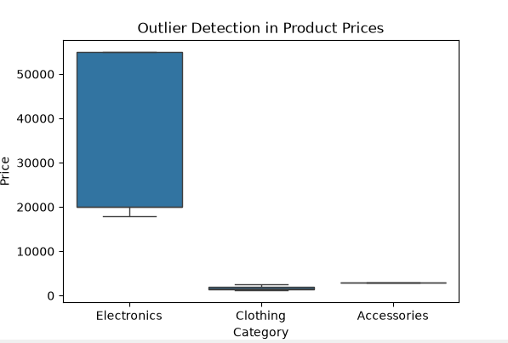

4. Write a Python program to perform data cleaning, preprocessing and basic analysis of sales data.
import pandas as pd
import numpy as np
import matplotlib.pyplot as plt
import seaborn as sns
df = pd.read_csv("sales_data.csv")
print("Original Data:")
print(df)
df['Quantity'] = df['Quantity'].fillna(df['Quantity'].mean())
df['Price'] = df['Price'].fillna(df['Price'].mean())
df['Total_Sales'] = df['Total_Sales'].fillna(df['Total_Sales'].mean())
df['Region'] = df['Region'].fillna(df['Region'].mode()[0])
df = df.drop_duplicates()
df = df[
['Sale_ID','Customer','Product',’Category','Quantity','Price',’Total_Sales','Date']
]
df.columns = [ col.capitalize() for col in df.columns]
df['Date'] = pd.to_datetime(df['Date'],format='%Y-%m-%d')
df['Quantity'] = pd.to_numeric(df['Quantity'])
df['Price'] = pd.to_numeric(df['Price'])
df['Total_sales'] = pd.to_numeric(df['Total_sales'])
df['Category_Code'] = ( df['Category'].astype('category').cat.codes)
df['Total_Sales_Normalized'] = (
(df['Total_sales'] - df['Total_sales'].min()) /
(df['Total_sales'].max() - df['Total_sales'].min())
)
filtered_data = df[ df['Total_sales'] > 5000]
print("\nCleaned Dataset:")
print(filtered_data)
print("\nData Information:")
print(filtered_data.info())
print("\nStatistical Summary:")
print(filtered_data.describe())
plt.figure(figsize=(6,4))
sns.barplot(x='Category', y='Total_sales',data=filtered_data,estimator=np.sum)
plt.title("Total Sales per Category")
plt.show()
