Sr. No. | Date | Title | Pg. No. | Sign
1 |  | Applying Seaborn Style to Matplotlib Plots
2 |  | Customizing Seaborn Line Plot using Matplotlib
3 |  | Overlaying Seaborn and Matplotlib Plots
4 |  | Enhancing Seaborn Histogram with Matplotlib Annotations

1. Write a Python program to apply Seaborn style to Matplotlib plots.
import matplotlib.pyplot as plt
import seaborn as sns
sns.set_theme(style="darkgrid")
x = [1, 2, 3, 4, 5]
y = [10, 12, 15, 18, 22]
plt.plot(x, y, marker='o', linestyle='-', color='blue', label="Trend")
plt.xlabel("X-axis")
plt.ylabel("Y-axis")
plt.title("Matplotlib Plot with Seaborn Theme")
plt.legend()
plt.show()
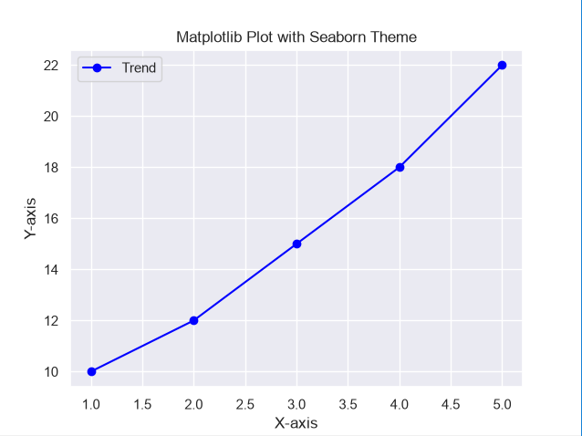
2. Write a Python program to customize a Seaborn line plot using Matplotlib functions.
import matplotlib.pyplot as plt
import seaborn as sns
import pandas as pd
data = pd.DataFrame({'Year':[2018,2019,2020,2021,2022],'Sales':[100,150,200,250,300]})
plt.figure(figsize=(8,5))
sns.lineplot(x='Year', y='Sales', data=data, marker='o')
plt.title("Yearly Sales Growth", fontsize=14, fontweight='bold')
plt.xlabel("Year", fontsize=12)
plt.ylabel("Total Sales", fontsize=12)
plt.xticks(rotation=45)
plt.grid(True, linestyle='--')
plt.show()
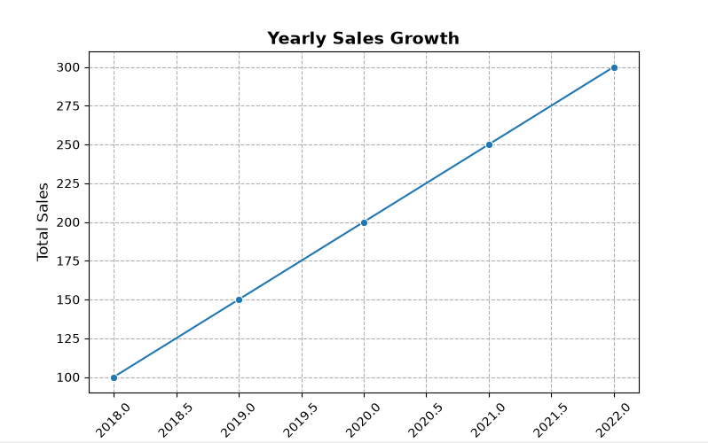
3. Write a Python program to overlay Seaborn and Matplotlib plots.
import numpy as np
import matplotlib.pyplot as plt
import seaborn as sns
x = np.linspace(0, 10, 20)
y = np.sin(x)
plt.figure(figsize=(8,5))
sns.lineplot(x=x, y=y, color='blue', label='Sine Wave')
plt.scatter(x, y, color='red', marker='o', label="Data Points")
plt.title("Seaborn Line Plot with Matplotlib Scatter Overlay")
plt.xlabel("X-axis")
plt.ylabel("Y-axis")
plt.legend()
plt.show()
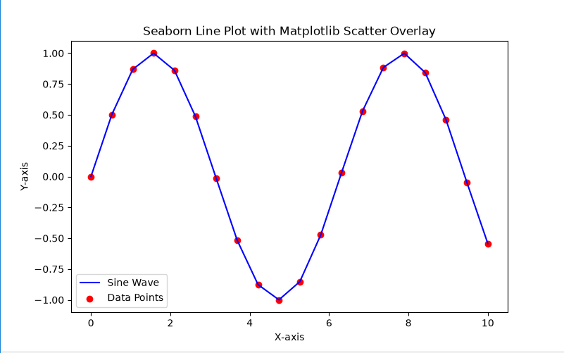
4. Write a Python program to enhance a Seaborn histogram using Matplotlib annotations.
import numpy as np
import matplotlib.pyplot as plt
import seaborn as sns
data = np.random.randn(1000)
plt.figure(figsize=(8,5))
sns.histplot(data, kde=True, bins=30, color='purple')
mean_value = np.mean(data)
plt.axvline(mean_value, color='red', linestyle='dashed', linewidth=2)
plt.text(mean_value + 0.1, 50, f'Mean: {mean_value:.2f}', color='red')
plt.title("Distribution with Seaborn and Matplotlib Customization")
plt.xlabel("Value")
plt.ylabel("Frequency")
plt.show()
