Report view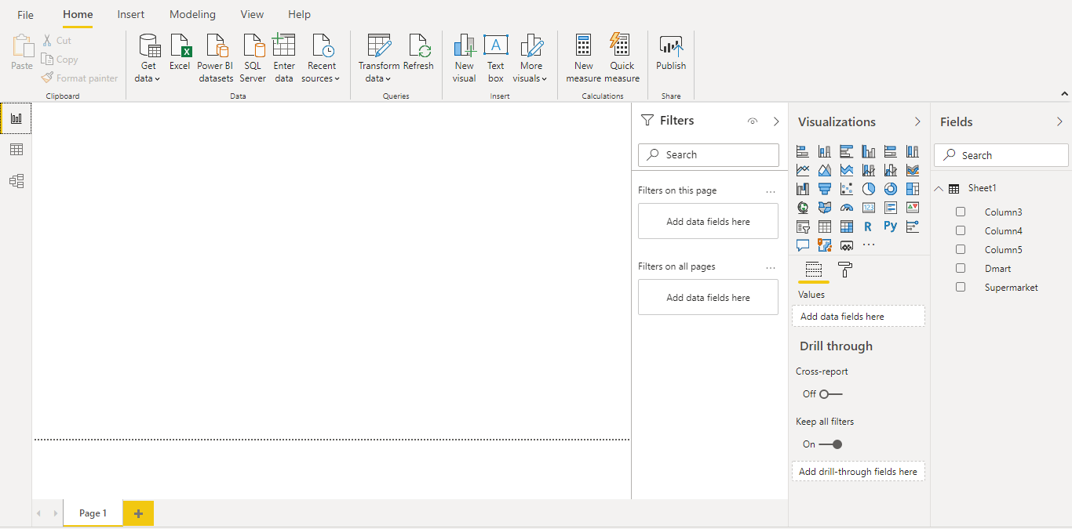

Data view

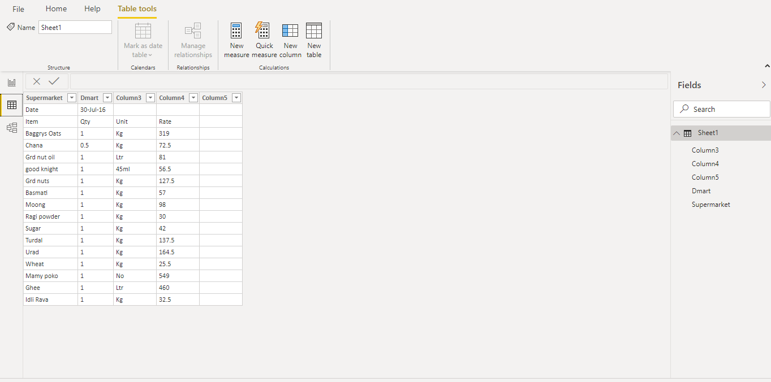

Model view

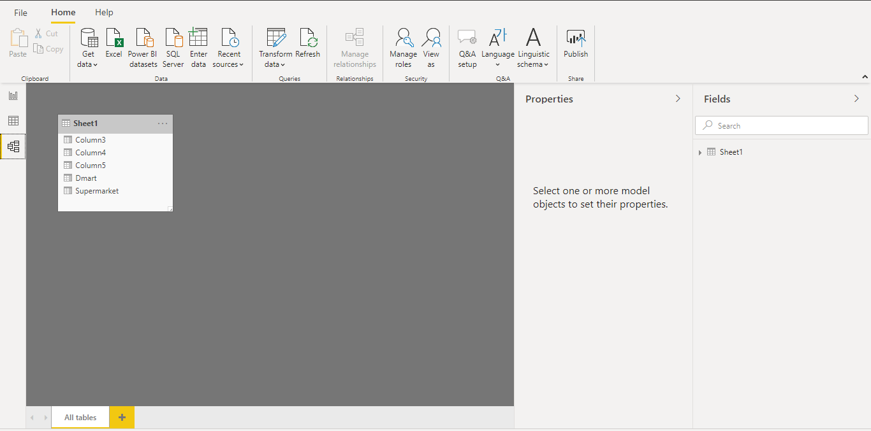

Power Query Editor

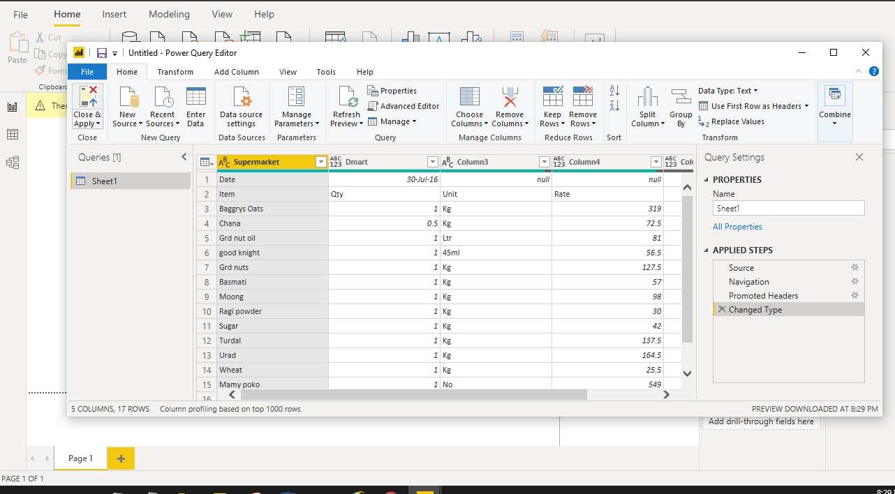

Advanced editor

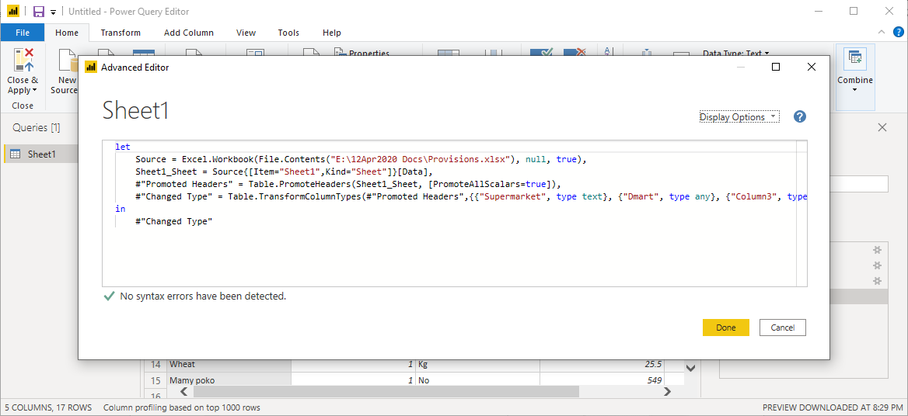

Power BI desktop

Create rich, interactive reports with visual analytics at your fingertips—for free

Power BI Pro

* Self-service and modern BI in the cloud
* Collaboration, publishing, sharing, and ad-hoc analysis
* Fully managed by Microsoft

$9.99 : Monthly price per user

Power BI Premium

* Enterprise BI, big data analytics, cloud and on-premises reporting
* Advanced administration and deployment controls
* Dedicated cloud compute and storage resources
* Allows any user to consume Power BI content

$4,995 : Monthly price per dedicated cloud compute and storage resource with annual subscription