- SELECT name, surname, status, photo FROM account WHERE id_account = 1;
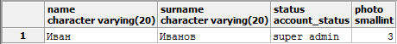

- INSERT INTO account(name, surname, status, login, password) VALUES('Дмитрий', 'Дмитриев', 'client'::account_status, 'dmitriy', 'password');
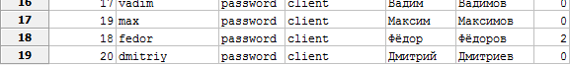

- DELETE FROM account WHERE id_account = 20;
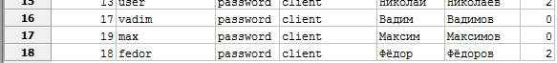

- UPDATE account SET name = 'Федор', surname = 'Федоров', photo = 0 WHERE id_account = 18;
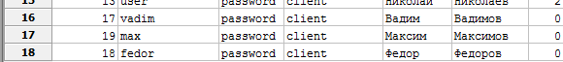

- SELECT id_account, name, surname, status, photo FROM account WHERE login = 'fedor' AND password = 'password';
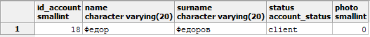

- SELECT avg(m.value) FROM mark AS m WHERE m.id_answer IN (SELECT a.id_answer FROM answer AS a WHERE a.id_author = 5);
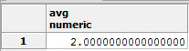

- INSERT INTO category(name, description, image) VALUES ('Автомобили', 'Всё, что связано с авто', 0); 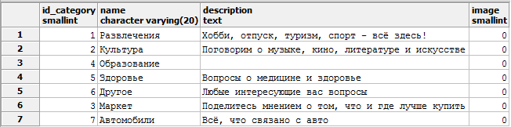

- DELETE FROM category WHERE id_category = 7;
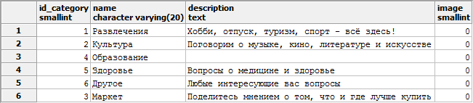

- SELECT name, description, image FROM category WHERE id_category = 6;
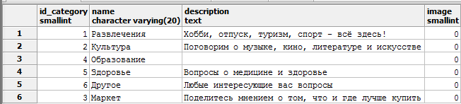

- UPDATE category SET name = 'Образование', description = 'Вопросы об образовании', image = 0 WHERE id_category = 4;
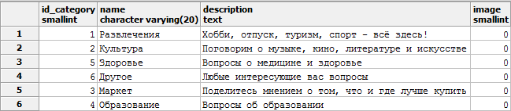

- SELECT id_category, name, description, image FROM category;

- INSERT INTO message(name, text, id_category, id_author, date_of_posting) VALUES ('Купить хомячка', 'Где в Минске можно купить хомячка?', 3, 18, '2016-06-25 18:38:19');
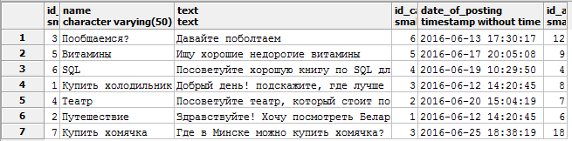

- DELETE FROM message WHERE id_message = 7;
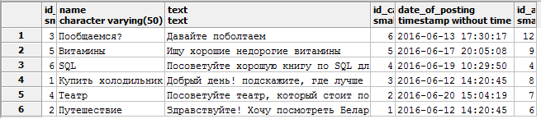

- SELECT name, text, id_author, date_of_posting FROM message WHERE id_message = 4;

- SELECT id_message, name, text, id_author, date_of_posting FROM message WHERE id_category = 6;
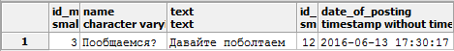

- UPDATE message SET name = 'Витамины', text = 'Добрый день! Посоветуйте хорошие недорогие витамины', id_author = 9, id_category = 5 WHERE id_message = 5;

- INSERT INTO answer(id_message, text, date_of_posting, id_author) VALUES (5, 'Какие именно вам нужны?', '2016-06-04 12:17:03', 18);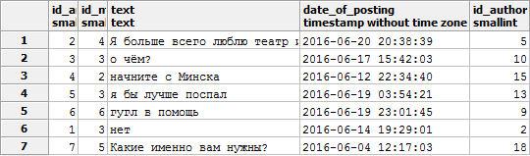

- DELETE FROM answer WHERE id_answer = 7;
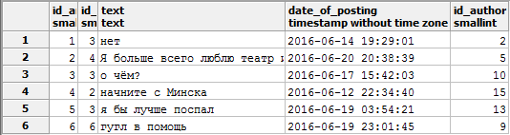
- SELECT text, date_of_posting, id_author FROM answer WHERE id_answer = 2;
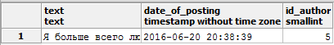

- SELECT id_answer, text, date_of_posting, id_author FROM answer WHERE id_message = 3;
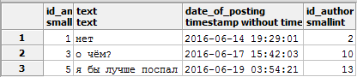

- UPDATE answer SET id_message = 3, text = 'Нет!', id_author = 2 WHERE id_answer = 1;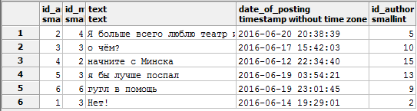

- SELECT avg(m.value) FROM mark AS m WHERE m.id_answer = 5;
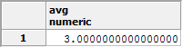

- INSERT INTO mark(id_answer, id_author, value, date_of_voting) VALUES (2, 18, 3, '2016-06-24 22:07:42');
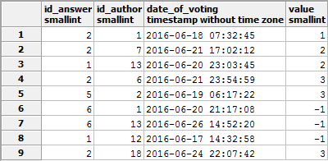

- DELETE FROM mark WHERE id_answer = 2 AND id_author = 18;
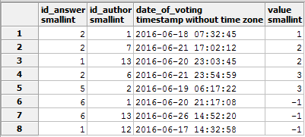

- SELECT id_author, value, date_of_voting FROM mark WHERE id_answer = 1;
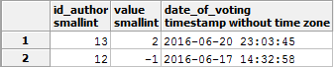

- UPDATE mark SET value = 1 WHERE id_answer = 1 AND id_author = 12;
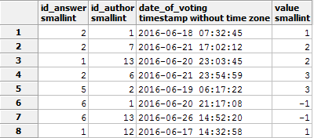

- INSERT INTO image(path, format) VALUES ('E:', 'png');
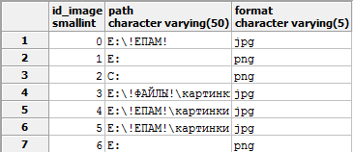

- DELETE FROM image WHERE id_image = 6;
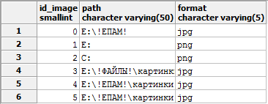

- SELECT path, format FROM image WHERE id_image = 0;
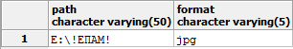

- UPDATE image SET path = 'E:\!ЕПАМ!', format = 'png' WHERE id_image = 2;
