**FOUND**

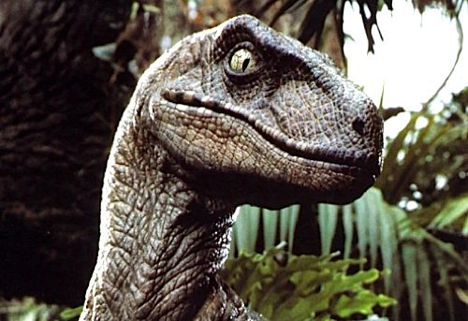

* 2m tall velociraptor
* Very bitey
* May have come from a bad home
* He doesn’t answer to ANYTHING
* HE IS VERY ANGRY

PLEASE COME PICK HIM UP IMMEDIATELY