Abstract template for the ICCAES 2020 conference

Corresponding author,1,∗ Contributing author,1 and Contributing author2

1Aﬃliation 1, address, city, country

2Aﬃliation 2, address, city, country

*Corresponding author: icces@iemcal.com

This is an abstract template for submission to the International Conference on Chemical and Environmental Sciences 2020 (ICCAES 2020), to be held at Institute of Engineering & Management, during **18-20 December, 2020**. Your abstract will serve a dual purpose of (1) selection of presentations by the Program Committee and (2) publication in the conference Book of Abstracts. Abstracts will be accepted in Microsoft word (doc or docs) file format **only.** Your abstract will not be edited upon acceptance, so please ensure it is submitted in its final publishable form.

Instructions for preparing the abstract are as follows:

* No more than 1 page (Maximum 250 words), A4 or letter size. All margins should be at least 2.5 cm. Maximum one figure and two references are allowed in the abstract.
* Please use the Times font family.
* Single-spaced lines.
* Please use the following layout.
  1. Title: 15 pt, boldface, centered
  2. Authors: 11 pt, boldface, centered, presenting author underlined if known
  3. Aﬃliations: 11 pt, italic, centered
  4. Presenting author’s e-mail address
  5. Main text: 11 pt, one column
  6. References [1]
  7. Table and figure captions should use font size 10.
* The total size of your contribution should not exceed 5MB.

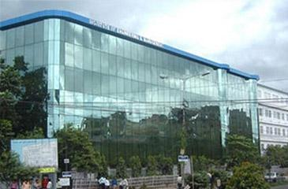

Figure 1: International Conference on Chemical and Environmental Sciences 2020 (ICCAES 2020)

To submit your word Abstract please visit the conference abstract submission webpage:

References

[1] X. Yyyyyy, Phys. Rev B vol, pppppp (2016).