Module: INM706 Deep Learning for Sequence Analysis
Professor: Dr. Alex Ter-Sarkisov

Image Captioning on MS Coco Dataset Using ConvNets and RNNs

Authors:

Benjamin Dwumah - 210002482
Rachana Shantappa Bhankur – 210036872

- Introduction

Image captioning is defined as the task of expressing image contents in words. The task falls somewhere between computer vision and natural language processing. Caption generation models should not only be strong enough to solve the computer vision problems of deciding which objects are in an image, but also effective in capturing and expressing their connections in natural language. As a result, caption generation has long been regarded as a difficult problem. It is a major challenge for machine learning algorithms because it involves simulating the phenomenal human ability to compress large amounts of salient visual information into descriptive language. The presence of attention is one of the most perplexing aspects of the human visual system (Rensink, 2000; Corbetta & Shulman, 2002). Rather than compressing an entire image into a fixed representation, attention allows significant features to take hold dynamically as needed. This is particularly necessary when an image contains a lot of clutter. One practical approach that has been commonly applied in early research is to use representations that distil information in an image down to the most notable objects. Regrettably, one significant downside is that information that could be helpful for richer, more narrative captions is lost.
The majority of image captioning applications utilize the encoder-decoder framework, where input images are encoded into an abstract representation of their information and then decoded into an explanatory text. There are two critical requirements for developing a high-quality captioning system. The captioning model must first extract a representative and valuable visual depiction from an image. Recent methods (Anderson et al., 2018; Lu et al., 2017; Xu et al., 2016) have shown great progress as a direct outcome of success in image classification (Krizhevsky, Sutskever and Hinton, 2017) and object recognition (He et al., 2014; Ren et al., 2017), which primarily benefited from the enhanced quality of derived visual features. The second, and often overlooked, requirement is to consider making the generated captions logical and intelligent. Similar to the human language, it must infer and reason through the generation stage relying on what has been generated and watched. This is usually done by using RNN to store the sequential information during caption decoding. An example of captions generated from an image can be seen in Fig. 1. In our coursework, we implemented the image captioning model using the encoder-decoder framework.

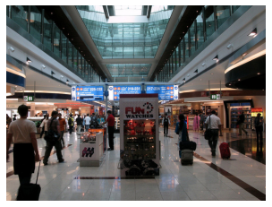
A crowded airport filled with people carrying luggage.

Travelers making their way through a busy transport hub.

An airport lobby in which several people stroll by with their luggage.

An airport terminal with many people carrying their luggage.

A busy airport with many people walking around.

Fig. 1: Generated Image With Captions

Image Source: http://images.cocodataset.org/val2017/000000084270.jpg

- Dataset

The image captioning task is performed on Microsoft Coco dataset (Lin et al., 2015), taken from the cocodaset website. It is a large-scale dataset used for Computer Vision tasks such as object detection, segmentation, and captioning. We specifically used the 2017 dataset, and it has the following features:
- Object Segmentation
- Recognition in context
- Superpixel stuff segmentation
- 1.5 million object instances
- 80 object categories
- 91 stuff categories
- 5 captions per image

The dataset consists of 330,000 images with over 200,000 labeled. It is divided into two which are the images and the annotations which we used for the project. The image set is group into training, testing, validation and unlaled set. The training set contains 118,287 images, the test set contains 40,670 images, the validation set contains 5,000 images and the unlabeled set contains 123,403 images. The dataset has several annotation types for object detection, keypoint detection, stuff segmentation, panoptic segmentation, image captioning, etc. The annotations are stored in a json file format in the annotation folder whiles the images are stored in a jpg format.

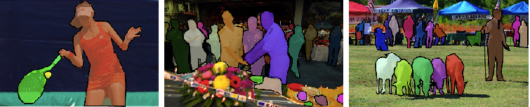
Fig. 2: Object Detection (Segmentation) image from the dataset
Image Source: https://www.immersivelimit.com/tutorials/create-coco-annotations-from-scratch

For our project, we used the images together with the image captioning annotations which are very simple. There are no categories in the image captioning file. It contains only annotations with caption descriptions. Each caption describes the image in question, and each image has at least five captions. The format in json file is seen as follows:

annotation{
"id"
: int,
"image_id"
: int,
"caption"
: str,
}

- id : it is an integer type object that uniquely identifies each annotation.
- image_id : it is an integer type object that uniquely identifies each image.
- Caption : it is a string object that describes the content of the image. It uses contains at 5 or more.

An example of an image and its annotation details can be seen in Fig. 6.


annotation{
"id"
: 426331,
"image_id"
: 327592,
"caption"
: A woman with glasses eating a piece of cake., a person holding a plate with food on it in one hand and a spoon in the other., A happy woman digging in to chocolate cake with a spoon, Woman showing delight with plated chocolate desert dish., an image of a woman about to eat a slice of cake
}

Fig. 6: Image with its annotation.
Image Source: http://images.cocodataset.org/val2017/000000327592.jpg

Data Loader and Pre-Processing: A data loader module was written using the PyTorch dataloader class to load the dataset in batches. The data loader was initialized using the get_loader function which takes a number of arguments that can be explored in the data loader as input. Only a few of the arguments are modified for our project and they are:

- transform: this parameter specifies how to pre-process and convert the image to PyTorch tensors before forwarding them as input to the CNN encoder.

- mode: this parameter accepts two strings which are ‘train’ and ‘test’. The ‘train’ loads the training data in batches while the ‘test’ load the test batch

- batch_size: this parameter determines the batch size of the image-caption pairs used to ammend the model weights when training the model.

- vocab_threshold: this parameter determines the total number of times that a word must appear in the training captions before used as part of the vocabulary.

- vocab_from_file: this parameter is a boolean that decides whether to load the vocabularies from a file
Once the data loader is initialized, we can access the dataset which is an instance of the CoCoDataset class in the data loader module. A get_item function in the CoCoDataset class determines how image-caption pairs are pre-processed before being passed into a batch. This is true for PyTorch dataset classes. If the mode of the data loader get_loader is ‘train’, the method first obtains the file from the file path of the training image and it’s corresponding caption. The image pre-processing is relatively straight forward. The images are converted to tensors and preprocessed using the transform parameter. The captions needs to be pre-processed for training as well. We do it by turning the captions associated to the images into a list of tokenized words before forwarding it to a PyTorch tensor. The tokenization format is similar to that of Oriol et al., 2015 where we use a special start word to mark the beginning of the caption, a special end word to mark the end of the caption and a special unknown word to collect all the unknown words which are not available in the image captions. The captions of the images in the dataset vary in length. The batches of the training data is generated by sampling the caption length, where the probability that any length drawn is proportional to the number of captions with the same length in the dataset. Thereafter, we extract a batch of size of the image-caption pairs, where all captions have the sampled length. This method for assembling batches is similar to the method described in Xu et al., 2016 and it has been proved to be computationally efficient without sacrificing performance.

- Model
The model we used was ConvNets + RNN architecture using the encoder-decoder framework. The encoder is a CNN and the decoder is a RNN. CNNs which are known as Convolutional Neural Networks are a kind of neural network that has thrived in a number of computer vision and image processing competitions. One of CNN's best attributes is its ability to use temporal correlation in data. CNN is divided into several learning stages, each of which includes a combination of convolutional layers, nonlinear processing units, and subsampling layers. RNNs, also known as the Recurrent Neural Networks are a class of neural networks usually used in the fields of natural language processing and speech recognition. It allows prior outputs to be used as inputs while having hidden states. While classical deep neural networks presume that inputs and outputs are independent of one another, the output of recurrent neural networks is reliant on the sequence's prior elements.
The CNN encoder that we used is a ResNet-50 model. This type of model help with regards to the vanishing and exploding gradient type of problems. ResNets are constructed from what is known as a residual block. This is based on the idea of "skip-connections" and employs extensive batch-normalization to effectively train hundreds of layers without compromising speed over time.

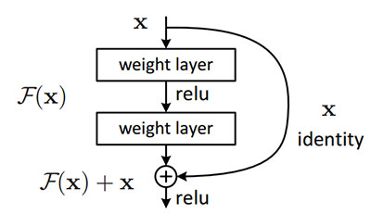

Fig. 7: Resnet Structure

We used ResNet-50 pre-trained model because it is one of the best performing model on imagenet dataset. The RNN decoder that we used is LSTM which is a special kind of RNN that contains a

