CSC319 - Group5

Jukrapop Kongkaew 58130500203

Piyathida Pongsaphan 58130500226

Ponsmith Fuangfung 58130500231

**A+D Report**

In the beginning of the project, we managed to talk together. We decided to divide the work into parts. Updated works have been look after by every member in the group to maintain the same level of understanding in the work.

Burndown Chart – 21/3/2017

Visit us at GitHub for more information:  
<https://github.com/justAoy/CSC319-Group-05>

We designed 3 diagrams for this project

**Class Diagram**

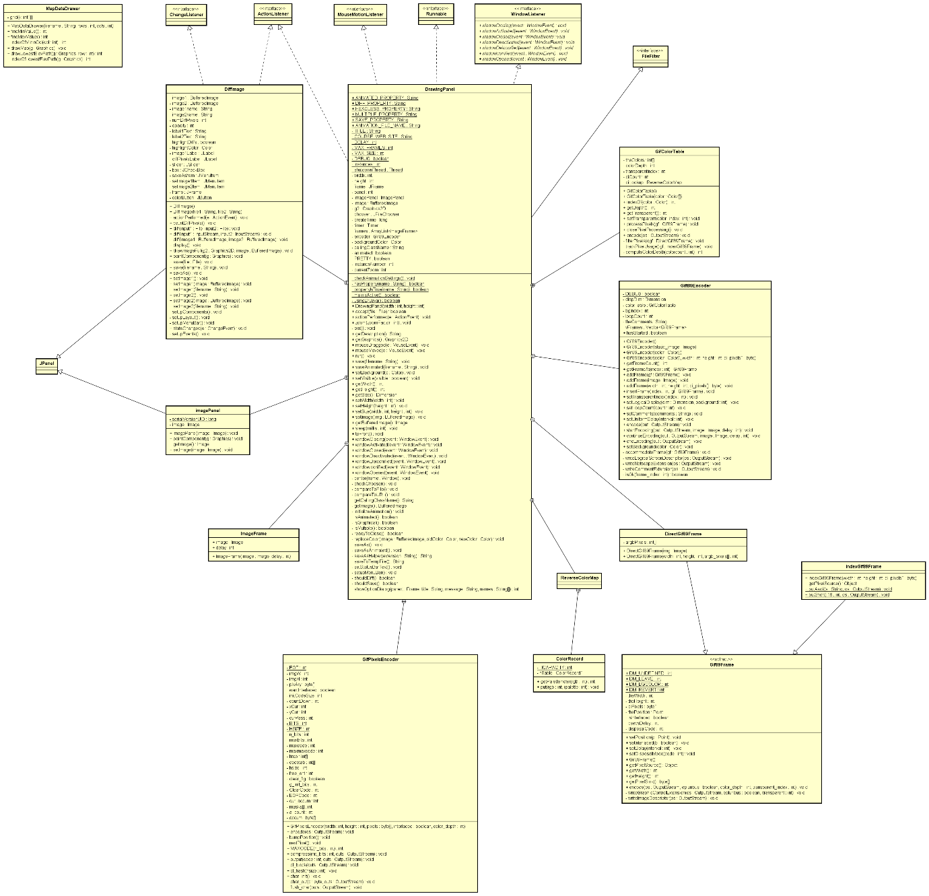

More detail:   
<https://raw.githubusercontent.com/justAoy/CSC319-Group-05/master/UML%20Diagram.png>

**Use Case Diagram**

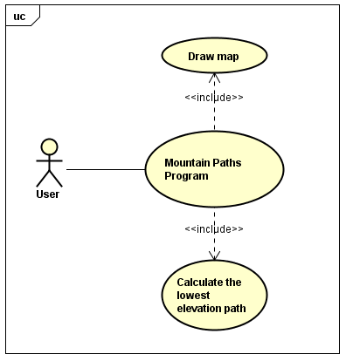

**Activity Diagram**

