Problem 1

*This program prompts the user for a measurement in meters, and then converts it*

*into miles, feet, and inches.*

begin

import Scanner

double meters, miles, feet, inches

Scanner keyboard

display "Hello out there."

display "I will change meters to miles, feet, and inches for you."

display "Enter your measurement in meters: "

accept input into meters

miles = meters / 1609

feet = meters \* 3.28

inches = meters \* 39.37

display meters + "m = " + miles + "mi"

display meters + "m = " + feet + "ft."

display meters + "m = " + inches + "in"

end

Problem 2

*This program reads in an integer, and breaks it into a sequence of individual digits.*

*It displays each digit on a separate line.*

begin

import Scanner

int number

String numberString

Scanner keyboard

display "Hello out there."

display "I will read an integer, and breaks it into a sequence of individual digits for you."

display "Enter your number: "

accept input into number

numberString = number into String

for(i = 0; i < length of numberString; i++)

begin

display char at i in numberString

end

end

Problem 3

*The program will asks the user to input:*

*the number of gallons of gas in the tank,*

*the fuel efficiency in miles per gallon, and*

*the price of gas per gallon.*

*Then it prints the cost per 100 miles and how far the car can go with the gas in the car.*

begin

import Scanner

double gallons, efficiency, price, perHundred, distance

Scanner keyboard

display "Hello out there."

display "I will read an integer, and breaks it into a sequence of individual digits for you."

display "Enter the number of gallons of gas in the tank: "

accept input into gallons

display "Enter the fuel efficiency in miles per gallon: "

accept input into efficiency

display "Enter the price of gas per gallon: "

accept input into price

perHundred = (100 / efficiency) \* dollar

distance = gallons \* efficiency

display "The car can go "+ distance + "mi with the gas in the tank."

display "The cost per 100 miles is " + perHundred

end

Problem 4

*This program asks the user to enter the name of his or her favorite city. It uses a String variable to*

*store the input. The program will display the following:*

*the number of characters in the city name,*

*the name of the city in all uppercase letters,*

*the name of the city in all lower-case letters, and*

*the first character in the name of the city*.

begin

import Scanner

String city, cityUc, cityLc

char cityFl

int cityLength

Scanner keyboard

display "Hello out there."

display "What is your favorite city?"

display "Enter name of city: "

accept input into city

cityLength = city length

cityUc = city to Upper Case

cityLc = city to Lower Case

cityFl = character at 0 in city

display "The number of characters in the city name is " + cityLength

display "The name of the city in all uppercase letters " + cityUc

display "The name of the city in all lowercase letters " + cityLc

display "The first character in the name of the city " + cityFl

end

Problem 5

*This will read a word from the user and display the string with the letters shifted to the right by two positions and with the letters shifted to the left by two positions in the string.*

begin

import Scanner

String word, last2, first4, last4, first2, right, left

Scanner keyboard

display "Enter a word: "

accept input into word

last2 = substring of last 2 letters of word

first4 = substring of first 2 letters of word

last4 = substring of last 2 letters of word

first2 = substring of first 2 letters of word

right = last2 + first4;

left = last4 + first2;

display "Given Term: " + word

display "Right-Shifted: " + right

display "Left-Shifted: " + left

end

Results

Program 1

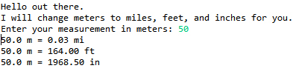

Program 2

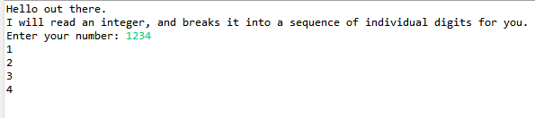

Program 3

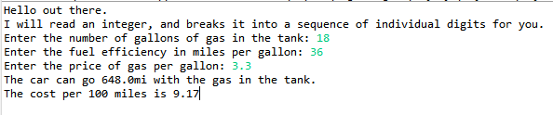

Program 4

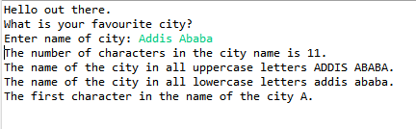

Program 5

