Problem 1

*This program will allow the user to save and display airline flight information.*

begin

class Flight{

initalize airline, origin, destination

function Flight(String airline, String origin, String destination, int flightNumber){

save the arguments into the respective variables of the class

}

function getAirline(){

returns airline

}

function setAirline(String airline){

updates the argument airline as the value of the airline in the class

}

function getOrigin(){

returns origin

}

function setOrigin(){

updates the argument origin as the value of the origin in the class

}

function getDestination(){

returns destination

}

function setDestination(){

updates the argument destination as the value of the destination in the class

}

function getFlightNumber(){

returns flightNumber

}

function setFlightNumber(){

updates the argument flightNumber as the value of the flightNumber in the class

}

function toString(){

returns (airline) (flightNumber) from (origin) to (destination)

}

}

End

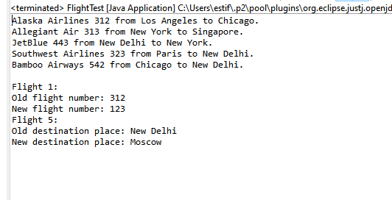

Program 2

*This program will allow the user to count and reset count.*

begin

class Counter{

initalize count = 0

function resetCount(){

count = 0

}

function increaseCounter(){

count = count + 1

}

function decreaseCounter(){

if count > 0

count = count - 1

else

display "Counter is zero. A negative counter is not allowed."

}

function getCounterValue(){

return int

}

function toString(){

return "Counter = " + counter

}

}

end

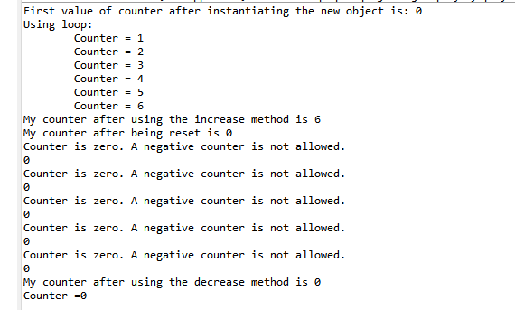

Program 3

*This program will stimulate a pair of dice.*

begin

class PairOfDice{

initiate num1, num2

initiate Die die1, die2

function PairOfDice(num1, num2){

save num1 and num2 as the value of num1 and num2 of the class

create the 2 objects die1 and die2 using the 2 numbers

}

function setValue1(num){

set num as argument of die1

}

function setValue2(num){

set num as argument of die2

}

function getValue1(){

return value of die1

}

function getValue2(){

return value of die2

}

function rollDice(){

roll both die

}

function getSumSides(){

return getValue1 + getValue2

}

}

End

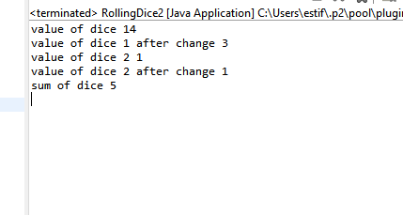

Program 4

*This program will stimulate a hang man game.*

begin

class HangMan{

initiate SecretWord = "abracadabra", disguisedWord = "???????????", name

create secretLetters as a char array of the letters in SecretWord

create disguisedLetters as a char array of the letters in disguisedWord

initiate c, numberOfGuesses = 0, numberOfIncorrectGuesses = 0,

maxNumberOfGuesses = 15

function HangMan(name){

save this name as name of the function

}

function getDisguisedWord(){

save disguisedLetters as a string into disguisedWord

return disguisedWord

}

function getSecretWord(){

return SecretWord

}

function getGuessCount(){

return numberOfGuesses

}

function getNumberOfGuesses(){

return maxNumberOfGuesses - numberOfGuesses

}

function MakeGuess(c){

save this c as c of class

run gameDone()

}

funtion isWordFound{

if the disguisedLetters and secretLetters match

returns true

return false

}

function gameOn(){

if getNumberOfGuesses() != 0 or isWordFound() == false

return true

return false

}

function isLetterFound(){

for int i = 0, i < secretLetters.length, i++ {

if secretLetters[i] == c {

display "Correct Guess"

run ifLetterFound()

return true

}

}

display "Incorrect Guess"

numberOfIncorrectGuesses++

return false

}

function ifLetterFound(){

for int i = 0, i < secretLetters.length, i++ {

if secretLetters[i] == c && disguisedLetters[i] != c{

disguisedLetters[i] = c

break

}

}

}

function gameDone(){

numberOfGuesses++

if gameOn(){

isLetterFound()

}

else{

display (name) " has guessed the word wrong and ran out of guesses."

}

}

}

End

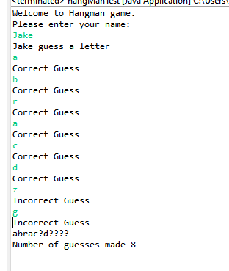

Program 5

*This program can store and display movie title and rating.*

begin

class Movie{

initiate movieName, mpaaRating

initiate terribleCount, badCount, okCount, goodCount, greatCount, count = 0, sum = 0

function Movie(movieName){

save this movieName as movieName

}

function getMovieName(){

return movieName

}

function setMovieName(movieName){

save this movieName as movieName of the class

}

function getMpaaRating(){

return getMpaaRating

}

function setMpaaRating(mpaaRating){

save this mpaaRating as mpaaRating

}

function addRating(rating){

if rating >= 1 and rating <= 5{

count++

if rating == 1 {

terribleCount++

sum = sum + (terribleCount \* 1)

} else if rating == 2 {

badCount++

sum = sum + badCount \* 2

} else if rating == 3 {

okCount++

sum = sum + okCount \* 3

} else if rating == 4 {

goodCount++

sum = sum + goodCount \* 4

} else if rating == 5 {

greatCount++

sum = sum + greatCount \* 5

} else {

display "A value not equal to 1 - 5 was enter."

}

}

}

function getAverage(){

average = sum / count

return average

}

}

