**Problem 1**

*This program will allow the used to store, view and compare address containing a house number, a street, an optional apartment number, a city, a state, and a postal code.*

begin

class Address{

initialize int houseNumber, apartNumber, postalCode

initialize String street, city, state

function Address(int houseNumber, String street, int apartNumber, String city, String state, int postalCode){

save the arguments into the respective variables of the class

}

function Address(int houseNumber, String street, String city, String state, int postalCode){

save the arguments into the respective variables of the class

}

function printAddress(){

display street

display {city}, {state}, {postalCode}

}

function getPostalCode(){

return postalCode

}

function comesBefore(Address other){

returns true if the calling address postal code comes before other's

else returns false

}

}

End

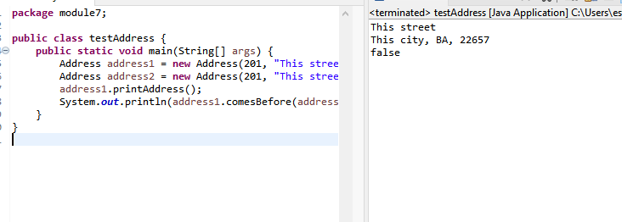

**Problem 2**

*This program will find the surface area and volume of a cylinder*

begin

class CanSurfaceAreaVol{

initiate double height, radius, surfaceArea, volume

function CanSurfaceAreaVol(double height, double radius){

save the arguments into the respective variables of the class

}

function getSurfaceArea(){

surfaceArea = 2 * (radius * radius) * PI + 2 * PI * radius * height;

return surfaceArea

}

function getVolume(){

volume = height * PI * (radius * radius);

return volume

}

}

End

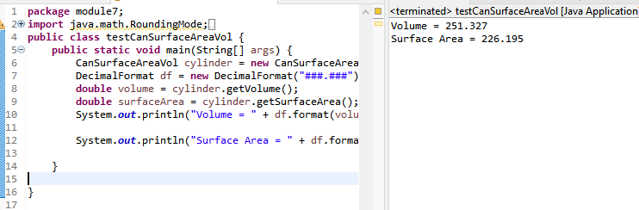

**Problem 3**

*This program will be able to display the month name and/or month number as long as one is given.*

begin

class Month{

initiate monthNumber, monthName

function Month(){

monthNumber = 1

}

function Month(int monthNumber){

if monthNumber <= 12 || monthNumber >= 1{

this.monthNumber = monthNumber

}

else{

this.monthNumber = 1

}

this.monthName = setMonthName(monthNumber)

}

function Month(String monthName){

use a case-switch to match the month name to month number

}

function getMonthNumber(){

return monthName

}

function setMonthNumber(int monthNumber){

if monthNumber <= 12 || monthNumber >= 1{

this.monthNumber = monthNumber

}

else{

this.monthNumber = 1

}

function getMonthName(){

this.monthName = setMonthName(monthNumber)

return monthName

}

function toString(){

return monthName

}

function equals(Object obj){

if (this and obj are equal){

return true

}

if (obj is empty or not in the same class){

return false

}

Month other = (Month) obj

return monthNumber == other.monthNumber

}

function greaterThan(Month other){

if this month > month of other {

return true

}

else {

return false

}

}

function lessThan(Month other){

if this month < month of other {

return true

}

else {

return false

}

}

function setMonthName(int monthNumber){

use switch-case to assign monthName to monthNumber

}

}

End

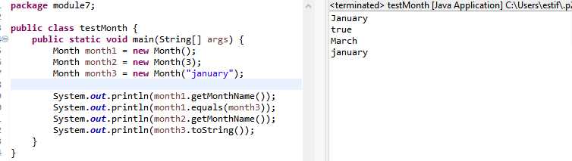

**Problem 4**

*This program will calculate the fuel amount after traveling based of the efficeny of the car.*

begin

class Car{

initiate double fuelEfficiency, fuelAmount, fuelUsed

function Car(double fuelEfficiency){

store this value to that of class

}

function drive(int miles){

fuelUsed = miles / fuelEfficiency

fuelAmount = fuelAmount - fuelUsed

}

function getGasLevel(){

return fuelAmount

}

function addGas(double fuelAdded){

fuelAmount = fuelAmount + fuelAdded

}

}

End

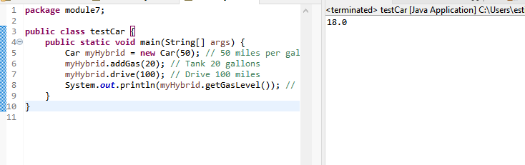

**Problem 5**

*This program will hold and display the data about an item in a retail store.*

begin

class RetailItem{

initialize description, unitsOnHand, price

function RetailItem(String description, int unitsOnHand, double price){

save the arguments into the respective variables of the class

}

function toString(){

display "RetailItem: "+ description + "{next line, tab}UnitsOnHand: " + unitsOnHand + "{next line, tab}Price: " + price

}

}

End

