**Unit 4 Programming Problems Worksheet**

# Programming Problem 1 – Sports Statistics

Design and implement a set of classes that keeps track of various sports statistics. Have each low-level class represent a specific sport. Tailor the services of the classes to the sport in question, and move common attributes to the higher-level classes as appropriate. Create a main driver class to instantiate and exercise several of the classes.

**Grading Rubric**

|  |  |
| --- | --- |
| **Task** | **Points** |
| Working solution for the problem | 8 |
| Overall best practices in writing the program | 2 |
| **Total** | **10** |

# Screenshots

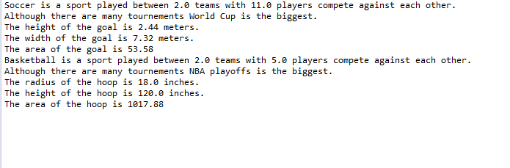

# Programming Problem 2 – Reading Materials

Design and implement a set of classes that define various types of reading material: books, novels, magazines, technical journals, textbooks, and so on. Include data values that describe various attributes of the material, such as the number of pages and the names of the primary characters. Include methods that are named appropriately for each class and that print an appropriate message. Create a main driver class to instantiate and exercise several of the classes.

### Grading Rubric

|  |  |
| --- | --- |
| **Task** | **Points** |
| Working solution for the problem | 8 |
| Overall best practices in writing the program | 2 |
| **Total** | **10** |

# Screenshots

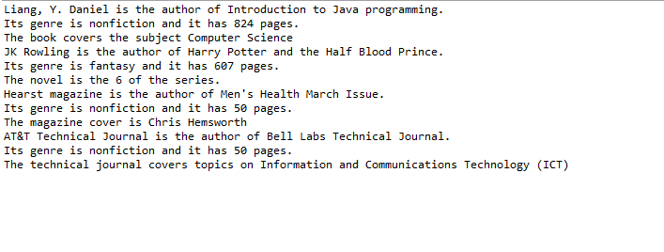

# Programming Problem 3 - Courses

Design and implement a set of classes that define various courses in your curriculum. Include information about each course such as the title, number, description, and department that teaches the course. Consider the categories of classes that constitutes your curriculum when designing your inheritance structure. Create a main driver class to instantiate and exercise several of the classes.

### Grading Rubric

|  |  |
| --- | --- |
| **Task** | **Points** |
| Working solution for the problem | 8 |
| Overall best practices in writing the program | 2 |
| **Total** | **10** |

# Screenshots

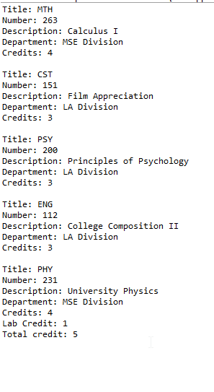

# Programming Problem 4 – Electronic Equipment

Design and implement a set of classes that define various types of electronics equipment (computers, cell phones, pagers, digital cameras, etc.). Include data values that describe various attributes of the electronics, such as the weight, cost, power usage, and the names of the manufacturers. Include methods that are named appropriately for each class and that print an appropriate message. Create a main driver class to instantiate and exercise several of the classes.

**Grading**

|  |  |
| --- | --- |
| **Task** | **Points** |
| Working solution for the problem | 8 |
| Overall best practices in writing the program | 2 |
| **Total** | **10** |

# Screenshots

