成绩

南京工程学院

Java EE 技术课程
综合作业说明书

题 目 养老院管理系统

班 级 软工中外211
学 生 姓 名 李德斌
学 号 202211228

2024 年6月 24日

- 课题背景：
随着社会老龄化趋势的加剧，养老服务需求日益增加。养老院作为重要的社会养老服务机构，其管理和运营的效率直接关系到老年人的生活质量。传统的手工管理方式存在效率低下、数据易出错等问题，因此，开发一个基于信息技术的养老院管理系统显得尤为重要。该系统能够实现养老院信息化、规范化管理，提高管理效率，改善服务质量。
- 技术分析：
我利用了Spring Boot，一个简化新Spring应用搭建的框架，基于Java，提供了多种开箱即用的功能，如自动配置、嵌入式服务器等。
以及Spring MVC 实现了Model-View-Controller（模型-视图-控制器）模式，用于处理Web请求，封装业务逻辑和视图。MyBatis一个优秀的持久层框架，支持定制SQL、存储过程以及高级映射。数据库:使用MySQL数据库存储养老院的信息，
ID: 老人的唯一标识符image: 老人的照片（图像）路径或URLname: 老人的姓名age: 老人的年龄room: 老人所在的房间disease: 老人患有的疾病marriageStatus: 老人的婚姻状况phoneNumber: 老人的电话号码前端技术:通过简单的css设计，实现按钮的处理变化
- 需求与分析：

功能需求:老人信息管理:添加老人信息: 系统能够添加老人的基本信息，包括照片、姓名、年龄、房间、疾病、婚姻状况和电话号码。修改老人信息: 允许对已存储的老人信息进行修改，以确保数据的准确性和及时性。删除老人信息: 可以删除不再需要的老人信息，保持数据库的整洁和高效。查询老人信息: 提供按姓名查询老人的功能，便于快速查找和查看老人的详细信息。非功能需求:安全性:数据访问控制: 通过权限管理控制数据的访问，确保只有授权用户能够进行敏感操作。用户身份验证: 实现用户登录和认证机制，保护系统免受未授权访问。可维护性:代码清晰: 采用良好的编码规范和注释，提高代码的可读性和可维护性。易于扩展: 设计系统时考虑到未来可能的功能扩展需求，确保系统具有良好的可扩展性。用户体验:界面友好: 提供直观易用的用户界面，使操作简单明了。

操作简便: 通过优化用户交互流程，减少用户的学习成本和操作时间。
- 系统实现：
项目结构:
- controller层：处理HTTP请求，调用service层。
- service层：封装业务逻辑，调用mapper层。
- mapper层：与数据库进行交互，执行CRUD操作。
关键代码:
controller层：package com.example.test1.controller;import com.example.test1.POJO.Elderly;import com.example.test1.POJO.Result;import com.example.test1.service.ElderlyService;import lombok.extern.slf4j.Slf4j;import org.springframework.beans.factory.annotation.Autowired;import org.springframework.http.HttpStatus;import org.springframework.http.ResponseEntity;import org.springframework.web.bind.annotation.*;import java.util.List;@Slf4j@RestController@CrossOrigin(origins = "http://127.0.0.1:5500")public class ElderlyController { @Autowired private ElderlyService elderlyService; @GetMapping("/getElderly") public Result getElderly() { List<Elderly> elderlyList = elderlyService.getElderly(); return Result.success(elderlyList); } @PostMapping("/addElderly") public Result addElderly(@RequestParam Integer ID, @RequestParam String image, @RequestParam String name, @RequestParam Integer age, @RequestParam String room, @RequestParam String disease, @RequestParam String marriageStatus, @RequestParam String phoneNumber) { Elderly elderly = new Elderly(ID, image, name, age, room, disease, marriageStatus, phoneNumber); elderlyService.addElderly(elderly); return Result.success(); } @GetMapping("/deleteElderly") public Result deleteElderly(@RequestParam String name) { elderlyService.deleteElderly(name); return Result.success(); } @GetMapping("/searchElderly") public Result searchElderly(@RequestParam String name) { List<Elderly> elderlyList = elderlyService.searchElderly(name); return Result.success(elderlyList); }}

service层：
package com.example.test1.service;import com.example.test1.POJO.Elderly;import java.util.List;public interface ElderlyService { public List<Elderly> getElderly(); public void addElderly(Elderly elderly); public void deleteElderly(String name); public List<Elderly> searchElderly(String name);}
mapper层：package com.example.test1.mapper;import com.example.test1.POJO.Elderly;import org.apache.ibatis.annotations.Delete;import org.apache.ibatis.annotations.Insert;import org.apache.ibatis.annotations.Mapper;import org.apache.ibatis.annotations.Select;import java.util.List;@Mapperpublic interface ElderlyMapper { @Select("SELECT ID, image, name, age, room, disease, marriageStatus, phoneNumber FROM elderly") public List<Elderly> getElderly(); @Insert("INSERT INTO elderly (ID, image, name, age, room, disease, marriageStatus, phoneNumber) VALUES (#{ID}, #{image}, #{name}, #{age}, #{room}, #{disease}, #{marriageStatus}, #{phoneNumber})") public void addElderly(Elderly elderly); @Delete("DELETE FROM elderly WHERE name = #{name}") public void deleteElderly(String name); @Select("SELECT ID, image, name, age, room, disease, marriageStatus, phoneNumber FROM elderly WHERE name = #{name}") public List<Elderly> searchElderly(String name);}

POJO.Eldly
package com.example.test1.POJO;import lombok.AllArgsConstructor;import lombok.Data;import lombok.NoArgsConstructor;@Data@AllArgsConstructor@NoArgsConstructorpublic class Elderly { private Integer ID; private String image; private String name; private Integer age; private String room; private String disease; private String marriageStatus; private String phoneNumber;}POJO.Result:
package com.example.test1.POJO;import lombok.AllArgsConstructor;import lombok.Data;import lombok.NoArgsConstructor;@Data@NoArgsConstructor@AllArgsConstructorpublic class Result { private Integer code; //响应码，1 代表成功; 0 代表失败 private String msg; //响应信息 描述字符串 private Object data; //返回的数据 public static Result success(){ return new Result(1,"success",null); } public static Result success(Object data){ return new Result(1,"success",data); } public static Result error(String msg){ return new Result(0,msg,null); }}数据库设计:
CREATE DATABASE elderlyCare;USE elderlyCare;CREATE TABLE elderly( ID INT PRIMARY KEY, image VARCHAR(100) NOT NULL, name VARCHAR(100) NOT NULL, age INT NOT NULL, room VARCHAR(50) NOT NULL, disease VARCHAR(100), marriageStatus VARCHAR(50) NOT NULL, phoneNumber VARCHAR(20) NOT NULL);-- 插入数据INSERT INTO elderly (ID, image, name, age, room, disease, marriageStatus, phoneNumber)VALUES (1, 'image001.jpg', '万豪', 82, 'Room 101', 'Diabetes', 'Widowed', '555-1234'), (2, 'image002.jpg', '鳄鱼', 85, 'Room 102', 'Hypertension', 'Married', '555-5678'), (3, 'image003.jpg', '皎月', 78, 'Room 103', NULL, 'Single', '555-8765'), (4, 'image004.jpg', '蜘蛛', 90, 'Room 104', 'Arthritis', 'Widowed', '555-4321'), (5, 'image005.jpg', '豹女', 81, 'Room 105', 'Alzheimer\'s', 'Divorced', '555-9876'), (6, 'image006.jpg', '艾克', 80, 'Room 102', 'Alzheimer\'s', 'Widowed', '555-9876'), (7, 'image007.jpg', '飞机', 71, 'Room 103', NULL, 'Divorced', '555-9876'), (8, 'image008.jpg', '卡莎', 61, 'Room 105', NULL, 'Widowed', '555-9876');-- 验证插入数据SELECT * FROM elderly;
前端展示主页：
<body>
<header>
<h1>养老院管理系统</h1>
</header>
<nav>
<a href="#">主页</a>
<a href="searchElderly.html" onclick="fetchElderlyData()">查询老人</a>
<a href="addElderly.html">添加老人</a>
<a href="deleteElderly.html">删除老人</a>
</nav>
<div id="backend-response">
<!-- 这里将会接受后端传来的请求 -->
</div>

<script>
document.addEventListener('DOMContentLoaded', (event) => {
fetchElderlyData();
});

function fetchElderlyData() {
fetch('http://localhost:8080/getElderly')
.then(response => response.json())
.then(responseData => {
if (responseData.code === 1 && responseData.msg === "success") {
displayElderlyData(responseData.data);
} else {
console.error('Error fetching data:', responseData.msg);
}
})
.catch(error => console.error('Error fetching data:', error));
}

function displayElderlyData(data) {
const userDataDiv = document.getElementById('backend-response');
userDataDiv.innerHTML = ''; // Clear existing content
if (data && data.length > 0) {
data.forEach(user => {
const userDiv = document.createElement('div');
userDiv.classList.add('elderly-item');
userDiv.innerHTML = `
<img src="${user.image}" alt="User Image" class="elderly-image">
<div class="elderly-details">
<p>ID: ${user.id}</p>
<p>Name: ${user.name}</p>
<p>Age: ${user.age}</p>
<p>Room: ${user.room}</p>
<p>Disease: ${user.disease || 'N/A'}</p>
<p>Marriage Status: ${user.marriageStatus}</p>
<p>Phone Number: ${user.phoneNumber}</p>
</div>
`;
userDataDiv.appendChild(userDiv);
});
} else {
userDataDiv.innerHTML = '<p>No data available</p>';
}
}
</script>
</body>

添加功能：
<div class="form-container">
<h2>添加老人</h2>
<form id="add-elderly-form">
<label for="ID">ID:</label>
<input type="number" id="ID" name="ID" required>

<label for="image">Image URL:</label>
<input type="text" id="image" name="image" required>

<label for="name">Name:</label>
<input type="text" id="name" name="name" required>

<label for="age">Age:</label>
<input type="number" id="age" name="age" required>

<label for="room">Room:</label>
<input type="text" id="room" name="room" required>

<label for="disease">Disease:</label>
<input type="text" id="disease" name="disease">

<label for="marriageStatus">Marriage Status:</label>
<input type="text" id="marriageStatus" name="marriageStatus" required>

<label for="phoneNumber">Phone Number:</label>
<input type="text" id="phoneNumber" name="phoneNumber" required>

<button type="submit">添加</button>
</form>
</div>
<script>
document.getElementById('add-elderly-form').addEventListener('submit', function (event) {
event.preventDefault();

const formData = new FormData(event.target);
const elderly = {
ID: parseInt(formData.get('ID')), // 将 ID 转换为整数
image: formData.get('image'),
name: formData.get('name'),
age: parseInt(formData.get('age')), // 将 age 转换为整数
room: formData.get('room'),
disease: formData.get('disease') || '', // 确保 disease 是一个字符串
marriageStatus: formData.get('marriageStatus'),
phoneNumber: formData.get('phoneNumber')
};

const queryString = new URLSearchParams(elderly).toString();
console.log(queryString);

fetch(`http://localhost:8080/addElderly?${queryString}`, {
method: 'POST',
headers: {
'Content-Type': 'application/x-www-form-urlencoded'
}
})
.then(response => response.json())
.then(responseData => {
if (responseData.code === 1 && responseData.msg === "success") {
alert('添加成功');
event.target.reset(); // 重置表单
} else {
console.error('Error response:', responseData);
alert('添加失败: ' + (responseData.msg || 'Unknown error'));
}
})
.catch(error => {
console.error('Fetch error:', error);
alert('添加失败: ' + error.message);
});
});
</script>
</body>

删除数据：
<div class="form-container">
<h2>删除老人</h2>
<form id="delete-elderly-form">
<label for="name">Name:</label>
<input type="text" id="name" name="name" required>
<button type="submit">删除</button>
</form>
</div>
<div id="backend-response"></div>

<script>
document.getElementById('delete-elderly-form').addEventListener('submit', function (event) {
event.preventDefault();

const formData = new FormData(event.target);
const name = formData.get('name');

fetch(`http://localhost:8080/deleteElderly?name=${encodeURIComponent(name)}`, {
method: 'GET'
})
.then(response => response.json())
.then(responseData => {
const responseDiv = document.getElementById('backend-response');
if (responseData.code === 1 && responseData.msg === "success") {
alert('老人信息删除成功');
responseDiv.innerHTML = `<p>老人信息删除成功</p>`;
responseDiv.style.color = 'green';
event.target.reset(); // 重置表单
} else {
console.error('Error deleting elderly:', responseData.msg);
responseDiv.innerHTML = `<p>删除老人信息失败: ${responseData.msg}</p>`;
查询老人：

responseDiv.style.color = 'red';
}
})
.catch(error => {
console.error('Error deleting elderly:', error);
const responseDiv = document.getElementById('backend-response');
responseDiv.innerHTML = `<p>删除老人信息失败</p>`;
responseDiv.style.color = 'red';
});
});
</script>
</body>
<div class="form-container">
<h2>查询老人</h2>
<form id="search-elderly-form">
<label for="searchName">姓名:</label>
<input type="text" id="searchName" name="searchName" required>
<button type="submit">搜索</button>
</form>
</div>
<div id="elderly-list" class="elderly-list">
<!-- 这里将显示搜索结果 -->
</div>
<script>
document.getElementById('search-elderly-form').addEventListener('submit', function (event) {
event.preventDefault();

const formData = new FormData(event.target);
const name = formData.get('searchName');

fetch(`http://localhost:8080/searchElderly?name=${encodeURIComponent(name)}`, {
method: 'GET',
headers: {
'Content-Type': 'application/json'
}
})
.then(response => response.json())
.then(responseData => {
displayElderlyData(responseData.data);
})
.catch(error => {
console.error('Error searching elderly:', error);
alert('查询老人信息失败');
});
});

function displayElderlyData(data) {
const elderlyList = document.getElementById('elderly-list');
elderlyList.innerHTML = ''; // 清空现有内容

if (data && data.length > 0) {
data.forEach(user => {
const userDiv = document.createElement('div');
userDiv.classList.add('elderly-item');
userDiv.innerHTML = `
<img src="${user.image}" alt="User Image" class="elderly-image">
<div class="elderly-details">
<p>ID: ${user.ID}</p>
<p>姓名: ${user.name}</p>
<p>年龄: ${user.age}</p>
<p>房间: ${user.room}</p>
<p>疾病: ${user.disease || 'N/A'}</p>
<p>婚姻状态: ${user.marriageStatus}</p>
<p>电话号码: ${user.phoneNumber}</p>
</div>
`;
elderlyList.appendChild(userDiv);
});
} else {
elderlyList.innerHTML = '<p>未找到匹配的老人</p>';
}
}
</script>
</body>

- 测试：
数据库测试：
使用SELECT * FROM elderly 测试数据库
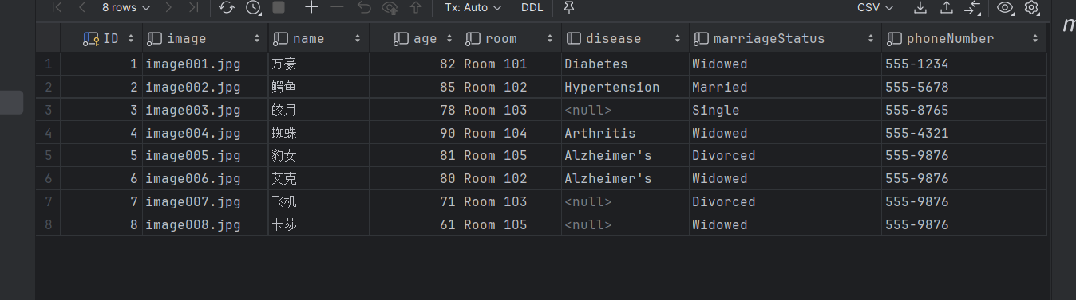
Spring Boot启动
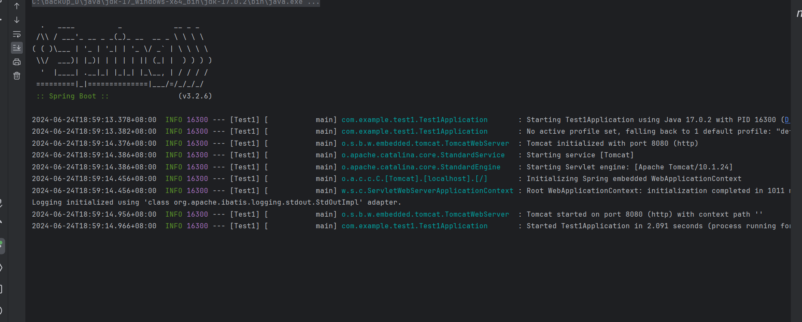
Postman测试
通过postman测试后端数据是否发送到相应端口，
{
"code": 1,
"msg": "success",
"data": [
{
"image": "image001.jpg",
"name": "万豪",
"age": 82,
"room": "Room 101",
"disease": "Diabetes",
"marriageStatus": "Widowed",
"phoneNumber": "555-1234",
"id": 1
},
{
"image": "image002.jpg",
"name": "鳄鱼",
"age": 85,
"room": "Room 102",
"disease": "Hypertension",
"marriageStatus": "Married",
"phoneNumber": "555-5678",
"id": 2
},
{
"image": "image003.jpg",
"name": "皎月",
"age": 78,
"room": "Room 103",
"disease": null,
"marriageStatus": "Single",
"phoneNumber": "555-8765",
"id": 3
},
{
"image": "image004.jpg",
"name": "蜘蛛",
"age": 90,
"room": "Room 104",
"disease": "Arthritis",
"marriageStatus": "Widowed",
"phoneNumber": "555-4321",
"id": 4
},
{
"image": "image005.jpg",
"name": "豹女",
"age": 81,
"room": "Room 105",
"disease": "Alzheimer's",
"marriageStatus": "Divorced",
"phoneNumber": "555-9876",
"id": 5
},
{
"image": "image006.jpg",
"name": "艾克",
"age": 80,
"room": "Room 102",
"disease": "Alzheimer's",
"marriageStatus": "Widowed",
"phoneNumber": "555-9876",
"id": 6
},
{
"image": "image007.jpg",
"name": "飞机",
"age": 71,
"room": "Room 103",
"disease": null,
"marriageStatus": "Divorced",
"phoneNumber": "555-9876",
"id": 7
},
{
"image": "image008.jpg",
"name": "卡莎",
"age": 61,
"room": "Room 105",
"disease": null,
"marriageStatus": "Widowed",
"phoneNumber": "555-9876",
"id": 8
}
]
}

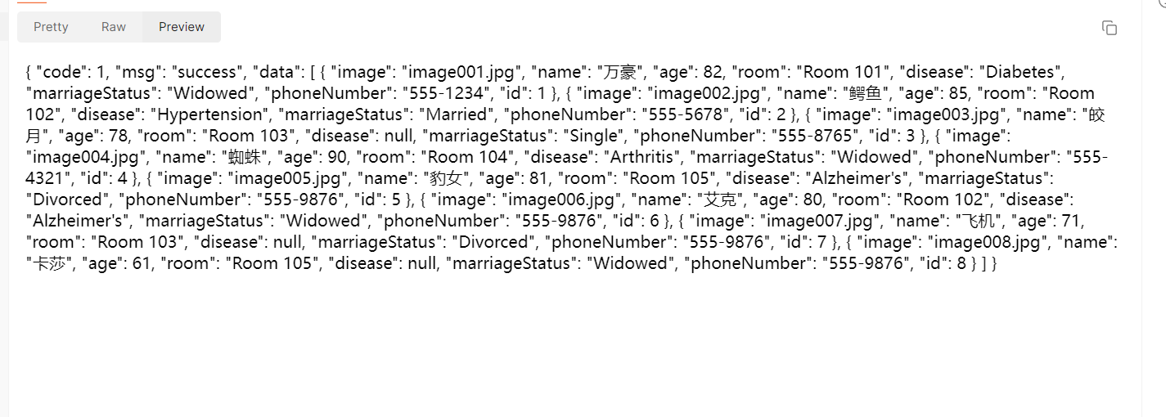
前端接收测试：
前端主页在后端指定接口发送数据后，显示到前端
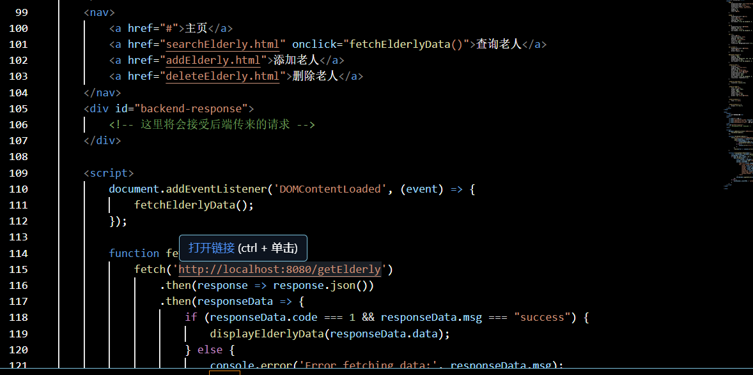
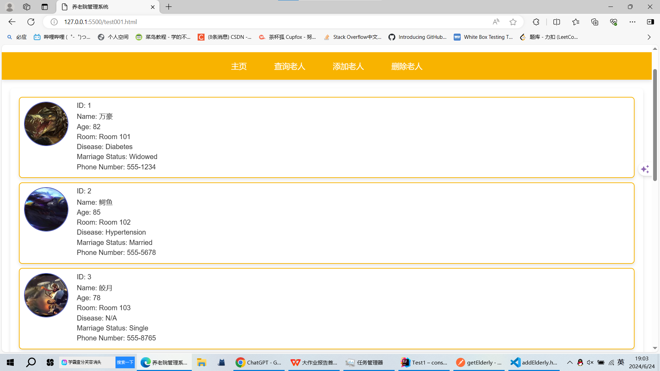

接收测试
1：增加测试：
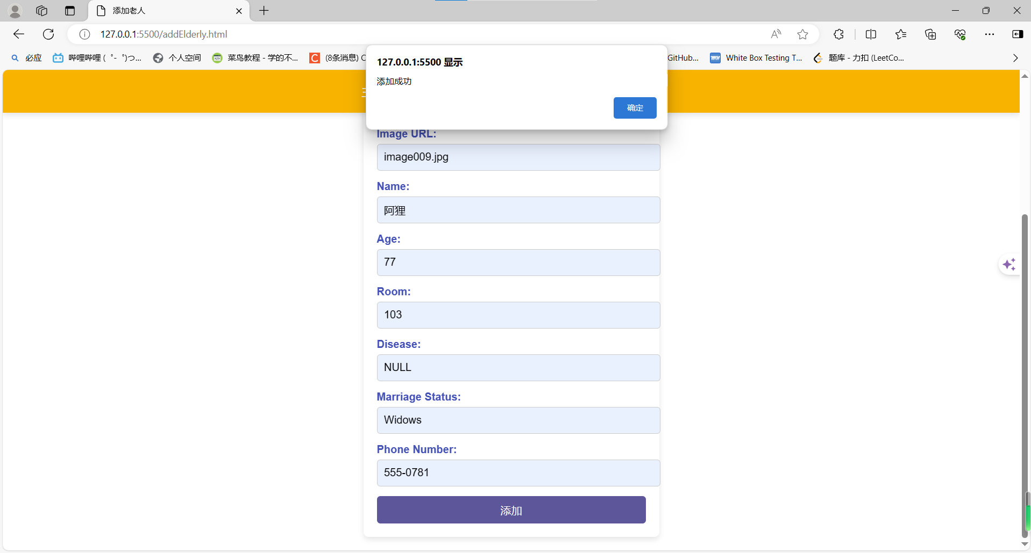
- 查询测试：
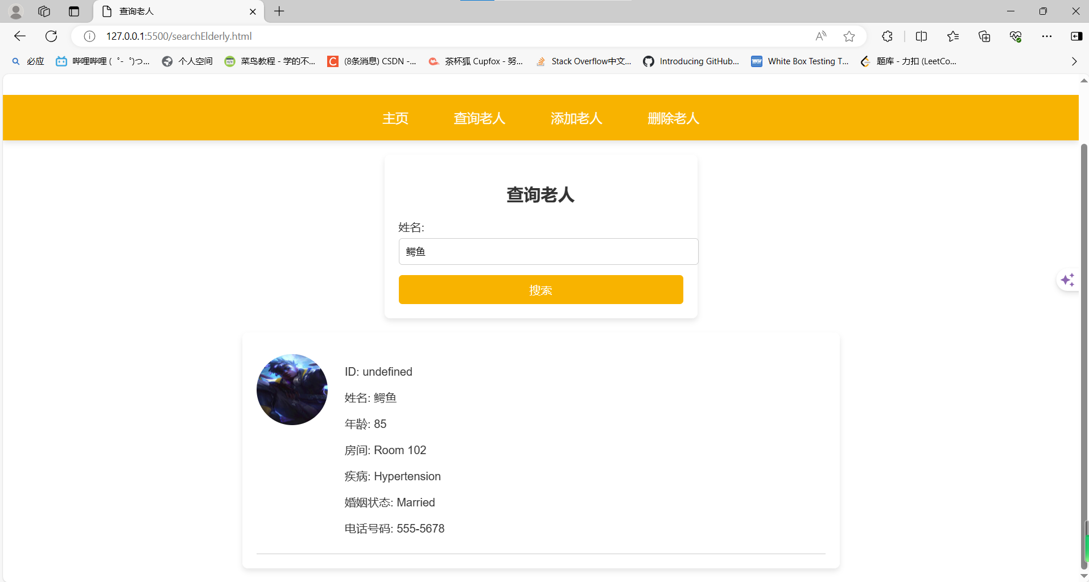
- 删除测试：
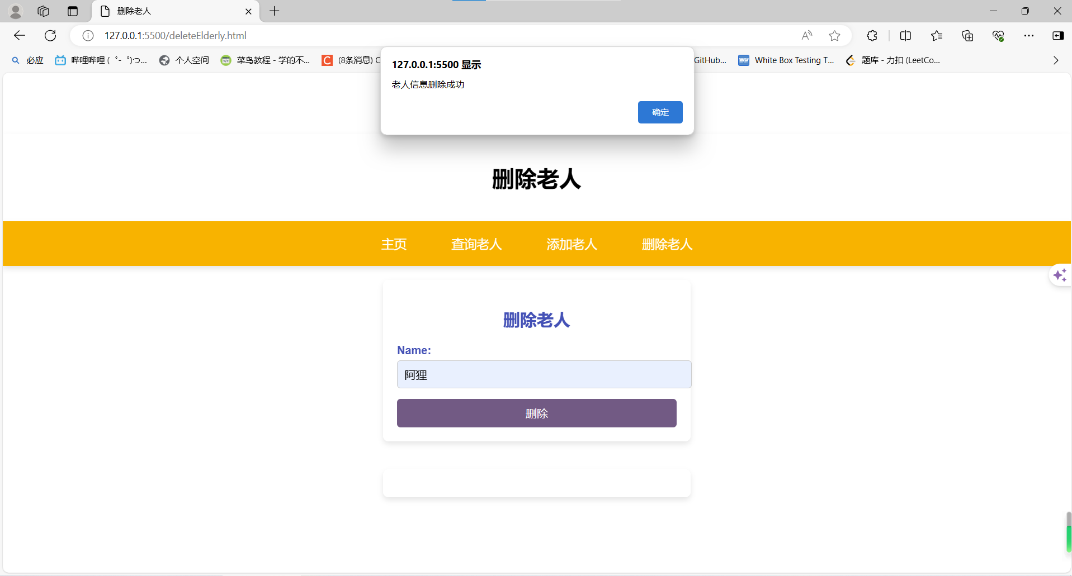
- 总结：

养老院管理系统的开发过程是一个综合运用各种技术的实践过程。通过Spring Boot、MyBatis等技术的使用，实现了系统的主要功能，满足了养老院的信息化管理需求。测试阶段发现并解决了系统中的一些问题，进一步提升了系统的稳定性和用户体验。未来可以继续扩展系统功能，如增加健康监测、家属访问等模块，使系统更加完善。
教师评分(满分100分)：

项 目 |  | 分 值 | 得分
态度与整体表现 |  | 10
验收结果 | 程序的界面效果 | 10
验收结果 | 概念应用及理解能力 | 30
验收结果 | 创新能力 | 10
报告质量 | 格式规范 | 10
报告质量 | 内容完整性 | 30
总 计

