
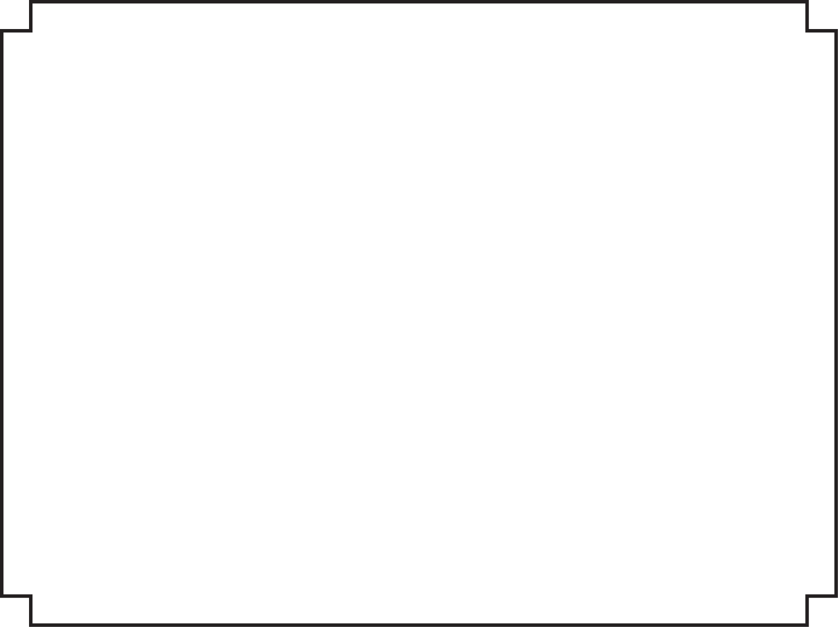
Certificate Of Attendance

PRESENTED TO

attended
These People Drive Me Crazy
Presented By: | Honey Shelton  Wednesday, April 2, 2014

