# Research and Planning for 3D Assets in a Pirate Environment

#### Introduction

#### As part of my resit assessment, I have been assigned the task of creating a portfolio of 3D assets and interactive work within a pirate-themed environment. This project serves as an excellent opportunity to apply and showcase my skills in 3D modelling and texturing using Maya, as well as my ability to create an immersive scene in Unity. The three objects I have been tasked to create are a drinking vessel, a box that can open and close, and a fruit. Each object is inspired by distinct elements from history, folklore, and popular culture. In this document, I will elaborate on the inspirations behind these objects, the processes involved in their creation, and how they will be integrated into the final interactive scene.

#### Drinking Vessel: Liturgical Chalice

#### For the drinking vessel, I drew my primary inspiration from the design of a liturgical chalice. Historically, liturgical chalices have played a significant role in religious ceremonies, particularly within Christianity, where they are used in the sacrament of Holy Communion. These chalices are often elaborately crafted, symbolising the sanctity and importance of the ceremony. The intricate details and luxurious appearance of these chalices fascinated me, and I aimed to capture this essence in my 3D model.

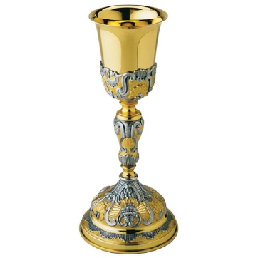In recreating the chalice, I wanted to give it a sense of history, as though it had been used and treasured for many years. Therefore, I modelled the chalice in Maya to have a broken and weathered look, suggesting that it has survived numerous adventures and hardships. This approach meant incorporating fewer intricate details, focusing instead on the overall form and the textures that convey its age and wear.

To make the chalice usable in Unity, I plan to import the 3D model and apply appropriate materials and textures to achieve a realistic look. The chalice will be interactive, allowing users to view it from various angles and perhaps even pick it up within the virtual environment.

In addition to historical inspiration, I also drew creative influence from the popular anime "One Piece." The world of "One Piece" is replete with unique artifacts and treasures, much like the chalice I sought to recreate. "One Piece" tells the story of pirates on a quest for the ultimate treasure, the One Piece, and features a wide array of fantastical elements. The anime’s detailed and vibrant style influenced my approach to texturing the chalice, as I aimed to imbue it with a similar level of richness and detail.

#### Box that Can Open and Close: Davy Jones' Chest

#### The second object, a box that can open and close, is inspired by the legendary Davy Jones' chest from the "Pirates of the Caribbean" film series. Davy Jones is a mythic figure associated with the sea, embodying the spirit of sailor folklore and the terrifying tales of the ocean depths. His chest, which holds his heart, represents the ultimate treasure and curse, making it an ideal addition to a pirate-themed environment.

Pirate chests have traditionally been depicted as repositories for treasure, central to the pirate’s quest for wealth and adventure. This thematic significance makes the chest a crucial element in my scene. By including a chest, I aim to convey the allure of hidden treasures and the inherent mystery of the pirate world.

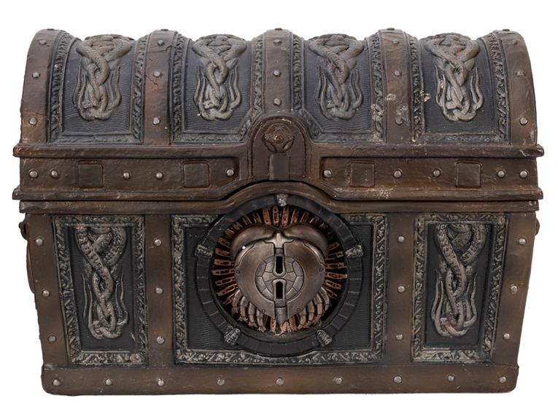In Maya, I focused on modelling the chest with intricate details, such as weathered wood textures and reinforced metal bindings, to give it an authentic, aged appearance. The chest’s design includes a functional mechanism that allows it to open and close, revealing the treasures inside. The texturing process involved creating materials that reflect the chest's history and use, enhancing its visual appeal. In Unity, this chest will serve as an interactive element, allowing users to open and close it, adding to the scene's engagement and realism.

#### Fruit: Devil Fruit from One Piece

#### The final object, the fruit, is inspired by the Devil Fruits from "One Piece." These mythical fruits grant extraordinary powers to those who consume them, but they also curse the consumer with the inability to swim, a significant drawback in a world dominated by the sea. The distinctive and vibrant designs of the Devil Fruits make them a fascinating subject for 3D modelling and texturing.

In my project, the Devil Fruit will be presented as a mystical and powerful item within the pirate environment. The modelling process in Maya involved capturing the unique shapes and intricate surface patterns that define each type of Devil Fruit. Texturing was a critical part of this process, as it required vivid colours and detailed patterns to accurately represent the fruits’ fantastical nature.

Once imported into Unity, the Devil Fruit will be placed in a prominent and accessible location within the scene, inviting users to interact with it. This interaction will not only enhance the immersive experience but also allow users to engage with the lore and significance of the Devil Fruit within the pirate world.

#### Conclusion

#### This project has provided me with a valuable opportunity to blend historical, mythical, and popular cultural influences into a cohesive and engaging digital environment. By creating a liturgical chalice, a Davy Jones-inspired chest, and a Devil Fruit, I have aimed to enrich the narrative and visual experience of the pirate-themed scene. Each object serves a unique purpose, adding depth and intrigue to the environment.

Through meticulous modelling and texturing in Maya, and subsequent integration into Unity, I have strived to create realistic and interactive assets that enhance the user experience. This project not only showcases my technical skills but also my ability to draw inspiration from diverse sources and translate them into compelling digital creations.

However, due to planning issues, the project will lack the desired level of interactivity and creativity. As a result, only the minimum requirements have been met. The final interactive scene will, nonetheless, stand as a testament to my creativity, technical proficiency, and passion for 3D art and design, even if it falls short of the original vision.