Wayfair.com — Technology Stack & Infrastructure Analysis
Date: | March 18, 2026
Author: | Derek
Subject: | Passive reconnaissance and technology fingerprinting of wayfair.com
Methods: | DNS-over-HTTPS, HTTP header analysis, TXT record enumeration, GitHub OSINT, public tech profiles

Executive Summary
Using only publicly available, passive reconnaissance techniques (no authentication, no active scanning), we mapped Wayfair’s complete external technology footprint. Wayfair operates a multi-CDN architecture (Cloudflare for storefront, Fastly for API/assets), runs on Google Cloud Platform with Kubernetes, and uses an Envoy service mesh across all endpoints. Their application stack is a React frontend backed by PHP (legacy monolith being decomposed), Java, Python, and C# microservices behind Apollo GraphQL Federation. DNS TXT records alone revealed 20+ SaaS integrations.

Infrastructure Architecture
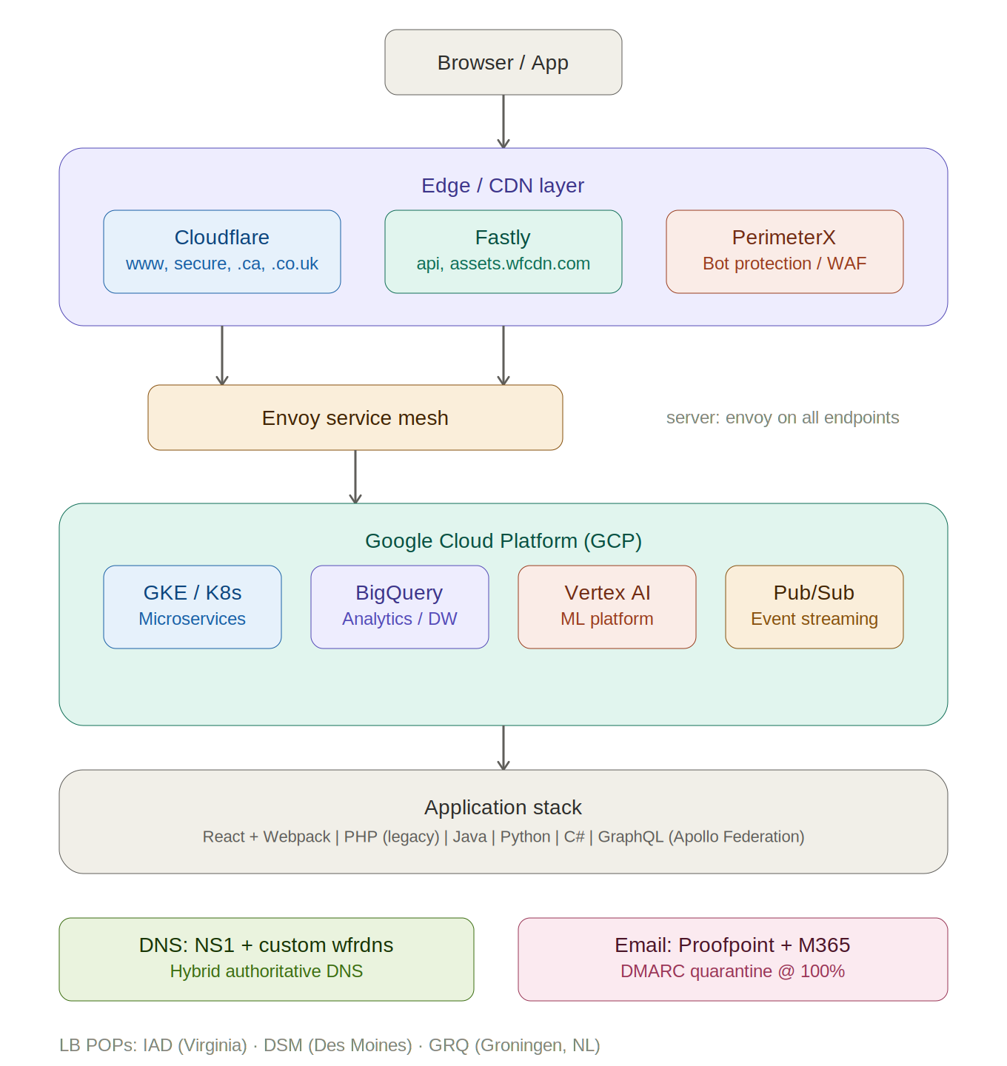

Key Findings
Category | Details
CDN / Edge | Dual-CDN: Cloudflare (storefront WAF/DDoS) + Fastly (API via csnzoo.wayfair.map.fastly.net, static assets via assets.wfcdn.com). PerimeterX (HUMAN Security) for bot protection. HSTS preload enabled.
Service Mesh | Envoy proxy on all endpoints (server: envoy header universal). x-envoy-upstream-service-time exposed on every response.
Cloud / Infra | GCP primary (migrated 2020–2022). GKE/K8s, BigQuery, Vertex AI, Pub/Sub, Dataproc, Looker. Buildkite CI/CD. HashiCorp Vault for secrets. LB POPs in IAD, DSM, GRQ (Groningen, NL).
Application | React + Webpack + vanilla-extract frontend. Apollo GraphQL Federation API gateway. PHP legacy monolith (active decomposition). Java, Python, C# microservices. Hypernova SSR.
Data Platform | Custom “Scribe” event platform (20TB/day). BigQuery + Dataproc (Hive/Presto/Spark). Aerospike (low-latency KV). Kafka. RocksDB state machines.
DNS | Hybrid authoritative: NS1 (nsone.net) + custom wfrdns.com nameservers. DNSSEC enabled. Separate NS pools per TLD (.com, .ca, .co.uk, .de, .io).
Email Security | Proofpoint gateway. SPF includes M365, Google Workspace, Salesforce, Pardot. DMARC p=quarantine, pct=100, fo=1 — strong enforcement.
Security Tooling | Wiz (cloud security posture), Jamf (Apple MDM), OneTrust (privacy/consent), PerimeterX (bot), GlobalSign (TLS CA). Bug bounty at bugbounty@wayfair.com.
SaaS (from TXT) | Stripe (8+ verifications), DocuSign, Slack, Miro, Smartsheet, TeamViewer, Meta Workplace, Adobe IDP, Apple Business, Twilio, Cursor (AI code editor), OSSRH (Maven Central publishing).
Open Source | Two GitHub orgs (wayfair + wayfair-incubator). Notable: dociql (GraphQL docs), pylift (uplift modeling), node-froid (Apollo Federation), statsdcc (C++ StatsD), Backstage (dev portal), Tremor (event processing).

Notable Observations
Legacy artifacts: CSN Stores naming persists in DNS (csnzoo.wayfair.map.fastly.net) and cookies (CSNUtId). The partners portal still runs nginx + PHP behind Varnish, with server_id headers leaking host identifiers.
Information leakage: lb_id headers expose datacenter topology (iad1, dsm1, grq1). x-envoy-upstream-service-time reveals backend latency. The partners portal sets cookies with domain-wide scope and no secure flag on some values.
Modern investments: Cursor domain verification suggests adoption of AI-assisted development. Wiz for cloud security posture management. Active GCP migration with Vertex AI for ML workloads. Buildkite for CI/CD replacing older tooling.
Methodology: All data gathered from publicly accessible sources using passive techniques only. No active vulnerability scanning, authentication bypass, or intrusive testing was performed.

